DELEGATED APPLICATION REPORT - Application No.: 180646 Target Expiry: 20/6/18 (ext)
Address: 69a Hamilton Road
Proposal: Erection of a front gabled bay extension, flat roofed rear dormer, replacement boundary wall and gates.
Case officer: Alison Amoah

Site Description and Surrounding Area:
The property is a detached one and a half storey house (first floor accommodation in the roof space), a converted coach house originally serving no. 71 to the south (historic map extracts included in DAS), on the eastern side of Hamilton Road. It is sited forward of the building line of no 69 to the north. To the front there is driveway parking for one car, and a small garden area. To the rear is a small garden and to the south is an access way to a group of dilapidated garages. To the north and south the residential properties are large two storey dwellings. The wider area is characterised by a mix of properties detached, semi-detached houses and purpose built flats.

A Leylandii tree to the front of the property was recently removed under permission 180371/TCA.

It is within the South Park Conservation Area and the group 63-71 Hamilton Road is described as an important building group as follows “Interesting mix of larger detached Victorian properties, but including two small modern infills arguably not in keeping with the character of the Conservation Area (but pre-dating its designation). Number 63 is particularly prominent, with a tile hung frontage and stained glass windows, and having a virtually identical twin at number 69. Between them, numbers 65 red brick) and 67 (grey brick) form a distinct contrast. Number 67 appears to have benefited from recent attention, including pale blue paint to ground floor masonry and new wall, railings and gate piers.”

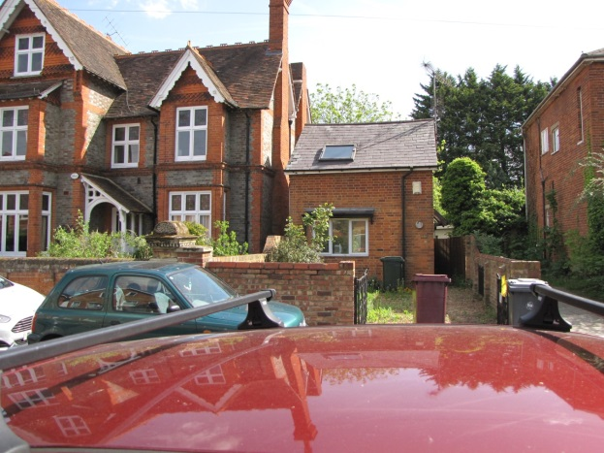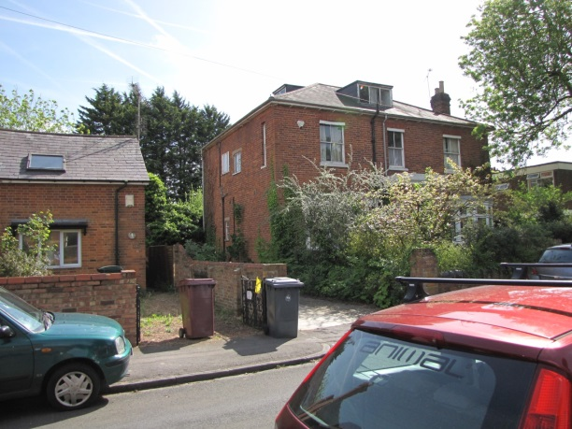

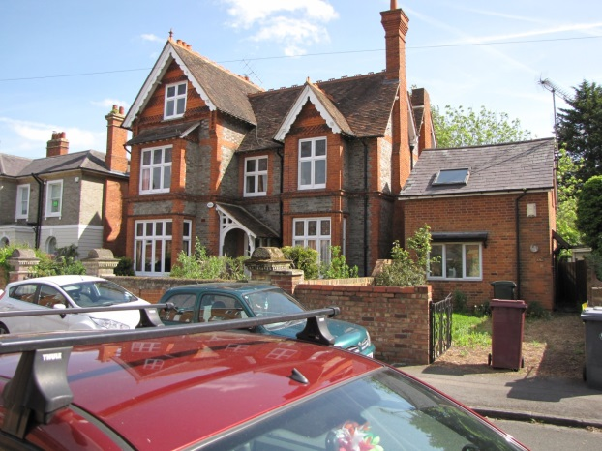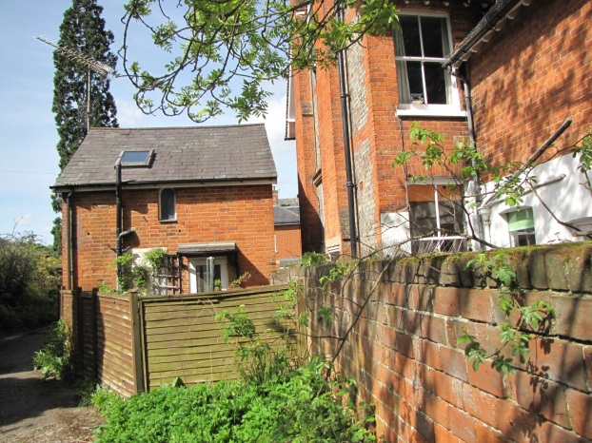

Proposal: The development involves:

- The erection of a brick gabled bay extension at the front 3.4m wide, 5.5m at its highest and 1.5m deep with timber framed sash window to first floor and timber framed bi-fold door to ground floor.
- Rear flat roofed dormer 3.4m wide and 1.6m high with parapet feature with brickwork to match existing, natural slate dormer cheeks and coping to parapet.
- Conservation rooflights (2 no.) to the front) and 1 no. to the rear.
- Relocated entrance door, removal of entrance canopy, new window, and blocking up of existing door and window openings to side elevation (south).
- Internal alterations include opening up the ground floor to create an open plan kitchen / dining / lounge area with two bedrooms and shower room on the first floor.
- Landscaping improvements to front garden, including replacement boundary wall and gates.

Plans considered: As received 17th April 2018:
Location & Block Plans – Drawing no: 18002-PL-01
Existing Plans & Elevations – Drawing no: 18002-PL-02
Proposed Plans & Elevations- Drawing no: 18002-PL-03
Proposed Street Elevation - Drawing no: 18002-PL-04
Design and Access Statement, ref: 18002.9.1_DAS_18.04.13, prepared by Weston & Co Architects

Officer note: In response to neighbour comments the agent submitted further plans as follows:

Proposed Site Plan [to show 45 degree line) – Drawing no: 18002-PL-06, received 14th June 2018
Proposed Plans & Elevations- Drawing no: 18002-PL-03 Rev A, received 14th June 2018

Officer note: In response to the requirements to show details of materials for the front wall further amended plans were submitted.

Amended Plans received 20th June 2018:
Proposed Plans & Elevations- Drawing no: 18002-PL-03 Rev B
Proposed Street Elevation - Drawing no: 18002-PL-04 Rev A

Relevant Planning History:
180371 – Fell conifer tree on frontage – Agreed 2/3/18

Consultation Responses: No: 69 & 71 Hamilton Road were consulted. One response was received (comments) as follows:

Overlooking
A new bedroom is proposed to the rear at 1st floor served by new window on the rear (east) elevation. There is concern that this new window would allow views from the bedroom onto a well used terrace at No.69 accessed from the back door of the house. In areas where the backs of houses tend to sit on a similar line, the effects of views out from the rear tend to be more to the very rear of rear gardens, however, No.69A is set back from the rear building line and this presents the opportunity for views into a more private part of the garden and terrace at No.69, which we trust will be properly assessed by officers, both in terms of actual and perceived overlooking.

As it exists there is only one rear window at 1st floor level at No.69A which is obscure glazed and doesn't present any problems. Light to the existing first floor bedroom window is provided by a window in the side (south) elevation and, where that is an existing situation, perhaps the proposed bedroom could be served by a side window rather than a window that may take views to the rear where none currently exist. Further to this, however, we note that none of the 1st floor rear facing windows are proposed as being obscure glazed, even the shower room.

Loss of light/outlook
The proposed front extension extends the building further forward of the front elevation at No.69, close to a window serving a front reception room. There do not appear to be any plans submitted with the application that consider this issue but we would expect to see evidence that the proposed front extension does not obstruct a line taken at 45 degrees from the centre of that window.

Front boundary wall
Approximately two years ago the common boundary wall to the front between Nos 69 and 69A collapsed and was re-built as a joint responsibility between the two then owners. As part of that process a structural engineer surveyed the remaining piers and front boundary wall at No.69 and found that, whilst in a stable condition at the time, the brick pier to the front of the common side boundary wall was leaning slightly. As part of the proposals at No.69A existing piers and walls along the front boundary at that property are to be demolished and re-built and there is concern that there may be some de-stabilising effect on the existing pier and front wall at No.69 through that process.

Whilst this may not strictly be a planning matter we feel it important that this is put on public record and that the pier and walls to the front of No.69 are not damaged as part of the development at No.69A.

Notwithstanding that, it is noted that a new tree is to be planted adjacent the common boundary wall and we trust that appropriate measures to limit the root spread of that tree will be imposed and adhered to during the development where the damage to the wall referred to above was undoubtedly caused by trees, since removed with the consent of the Council's Tree Officer.

It is also hoped that construction/materials details of the front boundary wall will be secured to ensure it is an appropriate addition to the Conservation Area.

Conclusion
Subject to an appropriate assessment on the effects of the proposed rear facing 1st floor window on both actual and perceived overlooking, and to confirmation that the front extension would not result in material harm to light quality and outlook from the front reception room window at No.69, we do not object to the application.

However, we also wish to place on public record our concerns over construction impacts of the new front fence and pier on the existing walls and pier at No.69.

A site notice was displayed.

Conservation Area Advisory Committee (CAAC) were consulted - no comments received

Ecology: The application site comprises a converted coach house where it is proposed to erect a 2-storey front extension and dormer rear extension. As per the photographs included in the Design and Access Statement, the building appears to be in a good condition and it is unlikely that features potentially suitable for use by roosting bats will be affected by the proposals. This is also considering the poor suitability of the neighbouring habitat for use by commuting or foraging bats. As such, since the proposals are unlikely to adversely affect bats or other protected species, there are no objections to this application on ecological grounds.

Transport: The Design and Access statement states that the existing access is to be widened, however recent google images appear to show that there is no existing dropped kerb access to the front garden area of the property.

There is an existing access point adjacent to the property that serves a number of garages situated to the rear of No.69a Hamilton Road.

Visibility splays are required to be illustrated on revised plans for the proposed access point. Please ask the applicant to resubmit revised plans.

Equality Act 2010:
In determining this application the Council is required to have regard to its obligations under the Equality Act 2010. However, there is no indication or evidence (including from consultation on the application) that the protected groups identified by the Act have or will have different needs, experiences, issues and priorities in relation to this particular planning application. Therefore in terms of the key equalities protected characteristics it is considered there would be no significant adverse impacts as a result of the development.

Relevant Planning Policy and Guidance
Section 38(6) of the Planning and Compulsory Purchase Act 2004 requires that proposals be determined in accordance with the development plan unless material considerations indicate otherwise. Material considerations include relevant policies in the National Planning Policy framework (NPPF) - among them the 'presumption in favour of sustainable development'.

The following local and national planning policy and guidance is relevant to this application:

Reading Borough Local Development Framework Core Strategy (2008)
CS7: Design and the Public Realm

Sites and Detailed Policies Document (2012)
DM9: House Extensions and Ancillary Accommodation;
DM4: Safeguarding Amenity

Supplementary Planning Guidance:
A Design Guide to House Extensions (2003)
South Park Conservation Area Appraisal (2008)

Appraisal Checklist:
DM9 states: An extension to a house will be acceptable where it:

- Respects the character of the house in terms of scale, location, materials and design;

To assess this, the following has been considered – would the proposal:

- Detract from the appearance of the original building through the use of ill-matching materials and by not fitting in with the design, scale and proportions of the original building; No

- Reduce the amount of usable amenity space for the property to an unacceptable degree; No

- Require the loss of trees in the garden or put significant trees at risk; No – proposed landscaping will be secured through condition.

- Respects the character and pattern of neighbouring properties and the street as a whole in terms of scale, location, materials and design, and any important existing building line; Respects neighbour’s amenities and does not present a large blank façade to public areas.

To assess this, the following has been considered – would the proposal:

- Significantly reduce the amount of daylight and sunlight enjoyed by neighbouring properties; No – the respondent requested that evidence be presented that the proposed front extension would not obstruct a line taken at 45 degrees from the centre of the front reception room window at no. 69. The agent has provided a plan which illustrates that there would be no conflict (Proposed Site Plan drawing no. 18002-PL-06).

- Invade the privacy of neighbouring properties through overlooking from windows or balconies; No – one respondent identified that there would loss of privacy from the proposed rear facing windows serving the proposed dormer to an external terrace of the property to the north. The rear elevation of the application site is 3.5m back from the rear elevation of no. 69. Although there would be some overlooking from the proposed rear facing first floor bedroom window, this is not considered would be so significant to be deemed harmful, especially in the context of significant areas of amenity space serving no. 69. The set back of the rear building lines also serves to limit more direct and broader views which would be possible if the building lines were in line.

The respondents’ suggestion of a side facing window serving a habitable room at first floor is not considered to be acceptable.

An amended plan has been submitted which shows the rear facing bathroom window to be obscure glazed with opening restrictions.

- Detract from the character of neighbouring properties through siting, excessive bulk, ill-matching materials or inconsistent design; No

- Detract from the appearance of the street or area by using ill-matched materials, glazing and detailing; No

DM4 states: Development will not cause a significant detrimental impact to the living environment of existing or new residential properties, in terms of:
• Privacy and overlooking; NO (see above)
• Access to sunlight and daylight; NO (see above)
• Visual dominance and overbearing effects of a development; NO
• Noise and disturbance; NO
• Artificial lighting; NO
• Vibration; NO
• Dust and fumes; NO
• Smell; or NO
• Crime and safety. NO

Other:
Boundary works:
The respondent raised concerns regarding existing piers and walls along the front boundary of no.69 and to have it put on record that they are concerned that the rebuilding of walls and pier at the application site could have a de-stabilising effect on the existing pier and front wall at No.69. This is not a planning matter.

Hard and soft landscaping works:
There is a request from the respondent that appropriate measures to limit root spread of the proposed tree are imposed. A condition is recommended with regard to the submission and approval of a detailed landscape (hard and soft) scheme, which would include details for a tree pit.

Materials:
It is also hoped that construction/materials details of the front boundary wall will be secured to ensure it is an appropriate addition to the Conservation Area.

Driveway:
There were issues raised by Transport with regard to there being no existing dropped kerb and that no visibility splays had been shown on the originally submitted plans. An amended plan was submitted (18002-PL-06), which shows the visibility splay from the proposed driveway. This indicates that there would be an improvement to the existing driveway as a result of the proposed widening of the access between the boundary brick piers. Of relevance however, is that the visibility splays are currently constrained by parked vehicles on both sides of Hamilton Road, and the proposal would not have a differeing effect in this regard.

At present although there is no formal dropped kerb the driveway has always been accessed via a very low kerb at this point. However, the applicant has confirmed that a dropped kerb / application for vehicle crossing has been submitted to Reading Borough Council Neighbourhood Support Services. It is considered therefore that there would not be a significant detrimental effect with regard to road safety from the proposed scheme.

RECOMMENDATION

APPROVE subject to conditions and informatives.

Proposed Conditions:

- Standard Time limit TL1

- The development hereby permitted shall be carried out in accordance with the following approved plans:

Location & Block Plans – Drawing no: 18002-PL-01, received 17th April 2018
Proposed Plans & Elevations- Drawing no: 18002-PL-03B, received 20th June 2018
Proposed Street Elevation - Drawing no: 18002-PL-04A, received 20th June 2018
Proposed Site Layout - Drawing no: 18002-PL-06, received 14th June 2018

- The materials to be used in the construction of the external surfaces of the development hereby permitted shall match those used on the existing building and be as shown on the approved plans.

Reason: in the interests of ensuring that the new development appears in keeping with the existing building, in accordance with Policy CS7, CS33, and DM9Details of the materials for the proposed front boundary matching materials

- Notwithstanding the provisions of the Town and Country Planning (General Permitted Development) (England) Order 2015 (or any Order revoking and/or re-enacting that Order) the proposed bathroom window on the rear elevation (east) shall be fixed non-opening and glazed with obscure glass on parts below 1.7m as a minimum when measured from the floor level of the respective rooms, before occupation of that room, and shall be permanently maintained thereafter as non-opening and obscure glazed.

Reason: To safeguard the amenities of the adjoining premises from overlooking and loss of privacy in accordance with Policy DM4 and DM11.

- No development shall take place until details of the proposed tree and tree pit specifications have been submitted to and been approved in writing by the local planning authority.

Reason: in the interest of ensuring that the landscaping of the development enhances the visual local environment and in accordance with Policy CS7.

- No extension hereby permitted shall be occupied until the vehicle access serving it has been constructed in accordance with the approved drawing.

Reason: In the interests of road safety in accordance with Policy CS20 and Policy DM12. Vehicle access

Informatives:

Terms and conditions
Building regulations
Encroachment
Complaints re noise during construction
Highways
Positive and proactive

