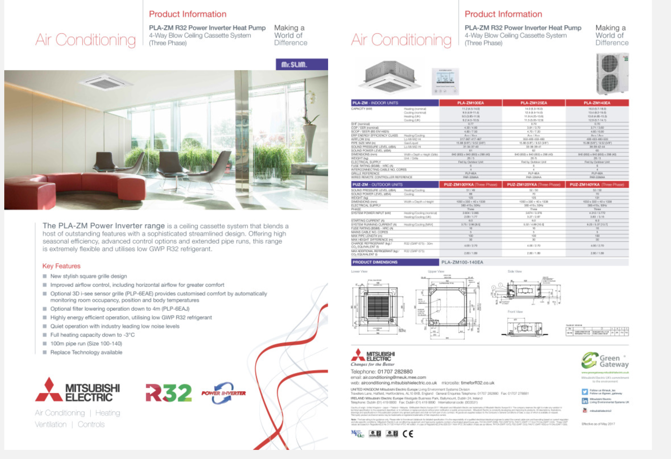
Mitsubishi Electric unit – proposed condensing unit

