Delegated Application
Ward: Whitley
Application Number: 171137FUL
Address: Worton Grange, Imperial Way.
Case Officer: Ralph Chakadya

SITE DESCRIPTION
- The application site outlined in red below is part of the wider Worton Grange site previously occupied by Hewlett Packard that was granted planning permission (151944) for a new commercial development as a part of a mixed use scheme that includes residential development.

- The scheme (151944) is being implemented and unit C that is subject to this application is substantially complete.
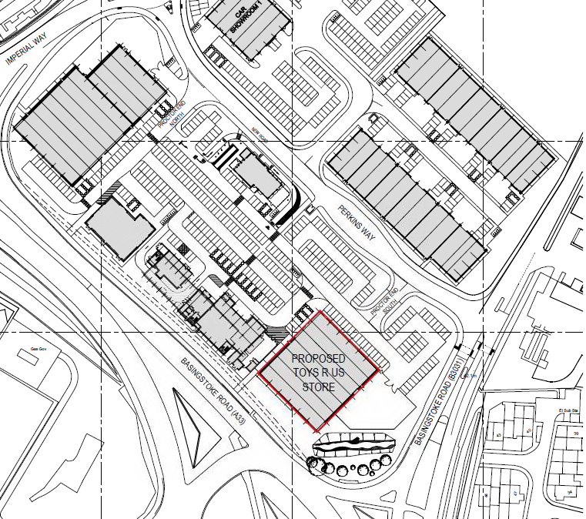
Location plan (not to scale)

- Unit C is located at the corner of Basingstoke Road and the A33. Along the A33, land set aside for the Mass Rapid Transit (MRT) forms a buffer between to the site.

PROPOSAL
- Permission is sought for the Installation of 6 No. louvres onto the external elevations of retail unit C and installation of 2 No. natural ventilation turrets onto the roof of retail unit C.

- As highlighted in the introduction above, permission was granted for a mixed use scheme on the wider site to establish three large format retail units, a hotel, a pub/restaurant, coffee shop, bank, 12 trade counter units and two car showrooms. The current proposal is for changes to retail unit C to suit the requirements of the occupying tenant, Toys R Us.

- The signage on the elevations is subject to a separate application for advertisement consent.

- RELEVANT PLANNING HISTORY
- 151944 - A Hybrid application seeking outline planning permission for the development of up to 175 new homes, including affordable housing(with all matters reserved apart from access), and full planning permission for the development of 12 commercial units in flexible use within Classes B1(c),B2 and B8,two car showrooms with MOT and servicing(Sui Generis), three retail warehouse units (Class A1),120 bed hotel (Class C1),pub with restaurant facility (Class A4),coffee shop (Class A1), restaurant (Class A3), and bank (Class A2). New vehicular access from Basingstoke Road and Imperial Way. Bus stop facilities, hard and soft landscaping and other ancillary development. Granted 14/04/2017

- 06/00999/CLE- Certificate of Lawfulness for Existing Use as B1 offices with ancillary storage, distribution and vehicular parking. APPROVED 12/10/06.

- 07/01227/SCR and 07/01264/SCO - Request for a Screening and Scoping Opinions on a mixed use redevelopment comprising office and retail uses in towers (up to 40 storeys) and blocks (up to 7 storeys) with 140,000 sq m floorspace, housing with up to 90,000 sq m floorspace, community uses, mixed use buildings (including a hotel), new access arrangements from Basingstoke Road and Imperial Way, MRT and other public transport facilities, on-site energy generation and waste management facilities, open space and landscaping. ES required on any subsequent application (ES parameters defined in scoping opinion) 29/10/07.

- 08/00699/SCR - Request for a Screening Opinion for the erection of two buildings (42,000m2) to be used for warehousing and distribution (B8) purposes together with 225 car parking spaces, 50 lorry parking spaces and associated landscaping.ES not required (07/10/08)

- 10/00264/SCR -Request for Screening Opinion mixed-use redevelopment including 150-300 homes, 7,000sq m retail, community uses, new access/egress, MRT/bus link, on-site energy generation, car parking and landscaping.ES not required (18/03/10)

- 10/01784/OUT-Outline application for redevelopment for two warehouse buildings (Class B8) with ancillary office, comprising 39,664m2 floorspace (GEA), car, lorry, motorcycle and cycle parking, landscaping and associated works (access, layout and scale only).Approved Subject To s106 (24/02/11).

- 131527/OUT -Outline application (with Landscaping and Appearance matters reserved) for the erection of two warehouse buildings (Use Class B8) with ancillary office accommodation, comprising a total of 39,664sqm floorspace (GEA), car, lorry, motorcycle and cycle parking, landscaping and associated works. Approved subject to s106 (24/02/2014)

- 151680 - Screening opinion for proposed redevelopment of Worton Grange, Imperial Way, for mixed use development comprising retail, a hotel, other commercial uses and residential. ES not required 4/11/2015

- CONSULTATIONS
- RBC Environmental Health – no comments received

Public consultation
- No letters were received from consulted neighbours

- RELEVANT PLANNING POLICY AND GUIDANCE
- National planning policy guidance
- National Planning Policy Framework

Reading Borough Local Development Framework Core Strategy Document, (adopted 2008 revised 2015)
- Policy CS1 (Sustainable Construction and Design)
- Policy CS5 (Inclusive Access)
- Policy CS7 (Design and the Public Realm)
- Policy CS34 (Pollution and Water Resources)

Sites and Detailed Policies Document, (SDPD) (Adopted 2012 revised 2015)
- Policy SD1 (Presumption in Favour of Sustainable Development)
- Policy DM1 (Adaption to Climate Change)
- Policy DM19 (Air Quality)
- Policy SA2a (South Reading Strategic Development Sites – Worton Grange)

Other relevant local planning documents:
- Sustainable Design and Construction SPD (July 2011).
- Community Infrastructure Levy (CIL) Charging Schedule (April 2015

Appraisal
- Principle of the development
- Design and Appearance
- Other Considerations

Principle of development
- The principle of the development has already been considered acceptable in terms of the granted permission 151944 for a mixed use scheme on the wider site. The proposed installation of louvres to the elevations and turrets to the roof to improve ventilation would not depart from principle of the permitted retail unit as part of the wider scheme. The additions to the permitted retail unit comply with the relevant local and national policies. As such the principle of the development is considered acceptable.

Design and Appearance
- As a result of the installation of louvres and ventilation turrets, the size and scale of the building is not materially different from the originally approved building (unit C -permission 151944 for the wider site). The elevational changes and introduction of ventilation turrets to retail unit C are commensurate with the approved scheme 151944 and therefore considered acceptable.

Equality
- In determining this application the Council is required to have regard to its obligations under the Equality Act 2010. The key equalities protected characteristics include age, disability, gender, gender reassignment, marriage and civil partnership, pregnancy and maternity, race, religion or belief, sexual orientation. It is considered that there is no indication or evidence (including from consultation on the current applications) that the protected groups have or will have different needs, experiences, issues and priorities in relation to this particular planning application.

- In terms of the key equalities protected characteristics it is considered there would be no significant adverse impacts as a result of the development.

CONCLUSION

Grant Permission

