DELEGATED APPLICATION REPORT - CERTIFICATE OF LAWFULNESS
Target Date: 12/06/2018 Extended Target Date: 17/08/2018
APPLICATION NUMBER: 180377/CLE
SITE ADDRESS: 12 Winchester Road, Reading
PROPOSAL: Certificate of lawfulness of existing use of outbuilding as a self-contained studio flat.
CASE OFFICER: Ralph Chakadya

SITE DESCRIPTION & PROPOSAL
The property is situated to the rear bottom end of the garden to number 12 Winchester Road. The outbuilding is fenced off from the rest of the garden to 12 Winchester Road. The outbuilding referred as ‘Winchester Mews’ is accessed from Winchester Road through a walkway between numbers 6 and 8 Winchester Road.

RELEVANT PLANNING HISTORY OF THE SITE
None

RELEVANT PLANNING POLICY AND GUIDANCE
Section 10 of the Planning and Compensation Act 1991 established a procedure that enables anyone who wishes to do so, to apply to the local planning authority to determine whether a proposed use or operation, or an existing operational development or an existing use of land, or any other matter constituting a failure to comply with any condition or limitation subject to which planning permission has been granted, is lawful, and if so, be granted a certificate to that effect.

A Lawful Development Certificate is a legal document stating the lawfulness of past, present or future development. If granted by the local planning authority, the certificate means that enforcement action cannot be carried out to the development referred to in the certificate. However, the certificate will not protect from enforcement action by the planning authority if the specified use or development is then changed 'materially' without a planning application for it.

The certificate is not a planning permission. The planning merits of the use, operation or activity in the application are not relevant. The issue of a certificate depends entirely on factual evidence about the history and planning status of the building or other land and the interpretation of any relevant planning law or judicial authority. The responsibility is on the applicant to provide evidence to support the application.

In determining an application for a Certificate of Existing Use or Development under Section 191 of the Town & Country Planning Act a local planning authority must be satisfied of the lawfulness at the time of the application of the use and if so they shall issue a certificate to that effect.

RESPONSE TO CONSULTATIONS

RBC Enforcement – Investigation E18033 for the unauthorised conversion of the outbuilding into a self-contained residential unit.

RBC Legal – satisfied with the evidence submitted.

RBC Electoral Services – The Electoral Services Department have only supplied details of the Electoral Register for the single main property, number 12. There is no record for the outbuilding.

RBC Council Tax - Available council tax records only show number 12 as a dwelling and banded for c/tax purposes since at least 01.04.1997. There is no record for the outbuilding.

RBC Environmental Health (Private Sector Housing Team) – There may be some concerns as to whether the property will comply with Housing Act 2004 with regards to the Housing Health and Safety Rating System (HHSRS) due to it being of timber construction.

EVIDENCE SUBMITTED
The following documents were submitted:
- Location plan and Existing Floor Plans
- Statutory Declarations by the joint owners
- Tenancy Agreements for the main dwelling and the outbuilding (Winchester Mews) from 2006
ANALYSIS OF EVIDENCE (ASSESSMENT)
The applicant has submitted signed Statutory Declarations by the joint owners of the property confirming that the outbuilding at 12 Winchester Road was converted into a self-contained residential unit and has been in use as a separate dwelling from the main dwelling at 12 Winchester Road since 2006. The Council has no evidence to the contrary.

The submitted existing floor plans (Exhibit AF2) show the property as a self-contained residential unit with facilities that include a separate entrance, bathroom, and kitchen and living accommodation. The outbuilding is currently occupied. The applicant has provided some of the Assured Short Tenancy Agreements for the outbuilding for the period 2007-present. As proof that the outbuilding is occupied separately from the main dwelling, copies of Assured Short Tenancy Agreements for the main dwelling with separate tenants have also been submitted.

Having reviewed the information submitted as outlined above, it has been concluded that on the balance of probability, the property known as ‘Winchester Mews’ 12 Winchester Road, RG2 0EY has been in use as a self-contained unit for a period in excess of 4 years with no enforcement action having been taken on the property in connection with the use. It should be noted that whilst the relevant 4 year period is 27/02/2014 to 27/02/2018, evidence submitted confirm that the outbuilding has been in use as an independent residential unit from 2006 to present. In these circumstances, it is considered appropriate to grant a certificate of Lawfulness to that effect.

Other issues
The Councils’ Environmental Health (Private Sector Housing Team) have highlighted that there may be some concerns as to whether the property complies with Housing Act 2004 with regards to the Housing Health and Safety Rating System (HHSRS) due to it being of timber construction. This is a matter for them to consider and an informative would be added advising the applicant that the outbuilding would need to comply with building control regulations.

Conclusion
Sufficient evidence has been provided to demonstrate that a Certificate of Lawfulness for the use of the outbuilding known as ‘Winchester Mews’ at 12 Winchester Road, Reading, as an independent residential unit should be granted on the basis that a period of 4 years has lapsed since the conversion of the property and is now therefore immune to enforcement action and is now lawful.

Submitted drawings:
Unnumbered Location and Block Plans
Drawing No.PL-01 Existing Floor Plans
Therefore the Local Planning Authority will, on this occasion, issue the applicant with a Certificate of Lawfulness for the use of existing outbuilding as a self-contained residential unit.

Recommendation:
GRANT Certificate
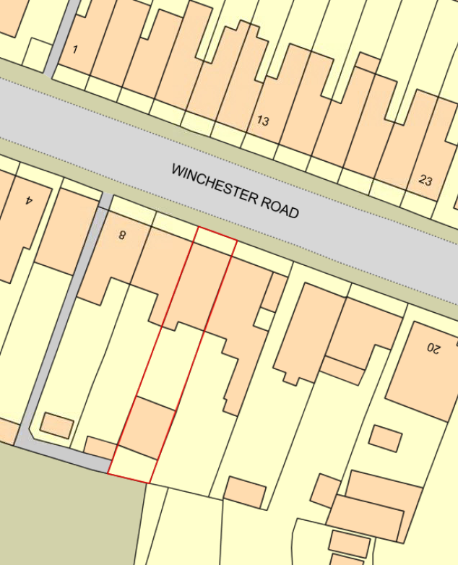
Location/Block Plan (not to scale)

