DELEGATED APPLICATION REPORT
Application No: 171539/LBC Target Date: 3/5/19 (ext)
Address: 35 Coley Hill
Proposal: Installation of Fire System (amended)
Case officer: Alison Amoah

Site Description and Surrounding Area:
The application site is a Grade II, three storey, with basement, terraced house, listed as part of a group (31-35 odd) of terraces on the eastern side of Coley Hill. It lies within the Russell Street/ Castle Street Conservation Area.

The property was formerly owned by Reading Borough Council and used as a hostel. It was evident from a site visit there is already a fire system in place and other internal alterations have taken place including more modern ceilings.

Proposal:
It is proposed to use the property as an HMO and the applicant is seeking permission for upgrading the fire alarm system. This would comprise the following works:
- 16 smoke detectors – 3 ground floor, 4 first floor, 4 second floor and 5 basement
- 4 no. would be replaced in the same locations and the remainder would be fixed with screws on the smooth section of the ceiling away from the coving and centre rose. They would be attached to the existing mains cables feeding the light fitting.

Documents Considered:
As received 6th September 2017:
- Design and Access Statement
- Location Plan
- Basement Plan
- Ground Floor Plan
- First Floor Plan
- Second Floor Plan

Correspondence during the course of the application:
Email from officer to applicant 15/9/17 requesting details of the size of the fire alarm and smoke alarms, locations (in terms of inside elevations) and methods of fixing, channels for wires etc that might be required.

Email from agent to officer 22/9/17
I had a meeting with my electrician and he said that he could upgrade the smoke alarms which were installed when Reading Council owned the property as a refuge. They are ceiling mounted wired smoke and CO2 detectors which are radio linked. This seems to be the perfect solution as it will not require any channeling of the walls etc…

Email from applicant to officer 19/12/17
I have made another site visit and checked the ceilings which have all been replaced by the Council when it was in their ownership. They seem to be hour fire resistant with expanded metal structure. The ceiling roses are also not even plaster and clearly relatively new. The location of the smoke alarms will be on the flat part of the ceiling and will not interfere with the ceiling roses. They cannot be located on the walls as they will not function properly there. Further this will require ugly surface wiring to provide power. This is not necessary when located on the ceiling as the power will come from the central light pendant and will be in the floor void above. This is the method used by the Council when they fitted their smoke alarms on site.

As the alarms are all radio linked they require no channelling. The main fire alarm board will be located by the front door where there is already power which I presume was put in by the Council when they would have had an alarm in the building. The electrician said that the smoke alarms will be the standard size and no different from the ones installed by the Council which are still on site. The location of all the fire equipment is marked on the plan originally submitted as part of the application.

I do not believe that the installation will be any more intrusive than erecting a picture and may not actually need permission.

Email from applicant 8/9/18
The Four existing smoke alarms will be replaced with new in the same locations. The rest will be fixed on the smooth section of the ceiling away from the coving and centre rose. There will not be a control box in the hall.

The smoke alarms will be screwed to the ceiling and attached to the existing mains cable feeding the light fitting. The ceilings are not original lath and plaster as they were replaced by Reading Council during their ownership of the property.

Planning Officer note: details of the proposed smoke alarms were provided as follows:
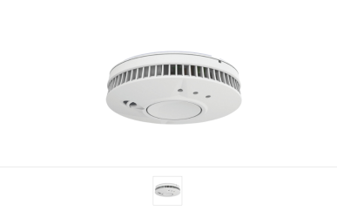

The product proposed is: Fire Angel Pro, Wireless Interlink Thermoptek, the dimensions of which is 52mm deep and 141mm diameter.

Relevant Planning History:
83/TP/0267 – Change of use form 2 flats and 4 bedsitting rooms with shared facilities to 13 bed hostel with warden accommodation – Approved 29/7/1983
83/TP/0276 – Minor internal alterations to permit change of use to 13 bed hostel with warden accommodation – Approved 29/7/1983
83/TP/1041 – Minor alterations to east elevation – Approved 12/1/1984
98/00150/LBC (980571) - Replacement fire alarms and emergency lighting systems, fire resistant doors upgrading understairs cupboards and staircase ballustrades – Consent 17/4/98
10/01164/FUL (100728) - Change of use from hostel to dwellinghouse with internal alterations – Consent 11/8/10
10/01165/LBC (100729) - Change of use from hostel to dwellinghouse with internal alterations – Consent 11/8/10
10/01778/FUL (101936) - Repairs to fence and reinstatement of gate and pillars – Consent 21/4/11
10/01779/LBC (101573) - Listed Building Consent for reinstatement of fence and gate – Consent 21/4/17

Consultations
A press notice was published, a site notice erected, and letters were sent to no. 2 and no. 4 Field Road and 33 Coley Hill (four flats). One response was received as follows:

I don't feel this house should be turned into an HMO without some consideration of the parking issues. Coley Hill and Castle Crescent already suffer from too many cars being parked in the street and from drivers using it as a short cut to avoid the lights - adding more cars will make both parking and traffic worse.

Planning Officer note: this relates to the change of use to an HMO, which is a permitted change.

Conservation Consultant:
From your photo it would seem they suggesting an alarm centrally in the ceiling rose. This wouldn’t be a good idea, as visually it would be intrusive and the ceiling rose could be Victorian.

Does the system have to be mains operated? I would suggest any alarms are confined to places which are less visible e.g along return walls. Cabling, if required, should be surface mounted and run along (not in) any mouldings.
Equality Act 2010:
In determining this application the Council is required to have regard to its obligations under the Equality Act 2010. However, there is no indication or evidence (including from consultation on the application) that the protected groups identified by the Act have or will have different needs, experiences, issues and priorities in relation to this particular planning application. Therefore in terms of the key equalities protected characteristics it is considered there would be no significant adverse impacts as a result of the development.

LEGAL AND PLANNING POLICY CONTEXT
Section 16(2) of the Planning (Listed Buildings and Conservation Areas) Act 1990 requires the local planning authority to have special regard to the desirability of preserving the listed building or its setting or any features of special interest which it possesses.

Section 72 (1) of the Planning (Listed Buildings and Conservation Areas) Act 1990 requires the local planning authority in the exercise of its functions to pay special attention to the desirability of preserving or enhancing the character or appearance of a conservation area.

Section 38(6) of the Planning and Compulsory Purchase Act 2004 requires that proposals be determined in accordance with the development plan unless material considerations indicate otherwise. Material considerations include relevant policies in the National Planning Policy framework (NPPF) - among them the 'presumption in favour of sustainable development'. However the NPPF does not change the statutory status of the development plan as the starting point for decision making (NPPF paragraph 12).

In this regard, the NPPF states that due weight should be given to the adopted policies of the Local Development Framework (LDF) (Core Strategy, Sites and Detailed Policies Document and Central Area Action Plan) according to their degree of consistency with the NPPF (the closer the policies in the plan to the policies in the NPPF, the greater the weight that may be given).

National Planning Policy and Guidance
National Planning Policy Framework (NPPF)
National Planning Practice Guidance

Reading Borough Local Development Framework Adopted Core Strategy (2008) (Altered 2015):
CS33: Protection and Enhancement of the Historic Environment

APPRAISAL
The property has been the subject of a range of internal alterations over the years, shown by the planning history. This has included installation and replacement of fire alarms and lighting systems. The existing situation is that there are existing smoke detectors, and the applicant would like to upgrade these and also install some additional ones on the ceilings adjacent to ceiling lights (some with ceiling roses (see photos below), although the Applicant has stated that the ceiling roses and ceilings are not original, having been replaced at some point in the past).

The Conservation consultant expressed a preference for these to be installed on the walls, but the Applicant has stated that they would not function properly on the walls.

It is considered that siting the smoke alarms on the ceiling would avoid the need for surface wiring, as these alarms can be powered from the central light pendant within the floor void above, as has already taken place at this property. The alarms would be radio-linked so they would require no channelling. In this property, where the ceiling and ceiling roses do not appear to be original, it is considered that this would not be harmful to the fabric or historic significance of the building. The proposed smoke detectors would be white and round, as shown above, i.e. similar to those already fitted within the property (see photo below).

Photos of existing central lights within the property

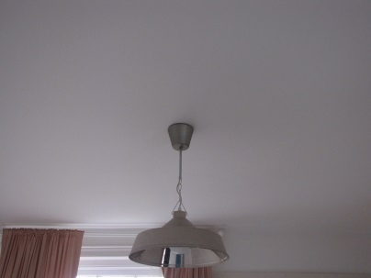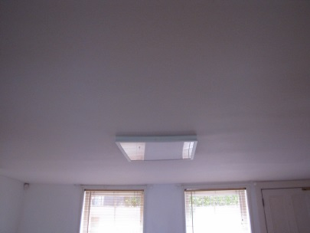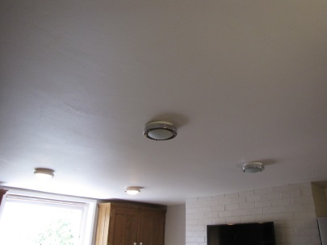
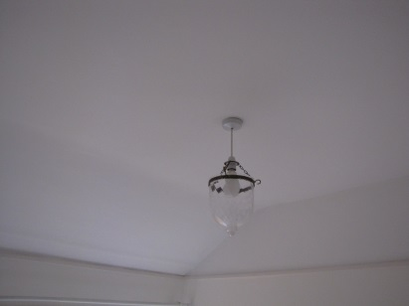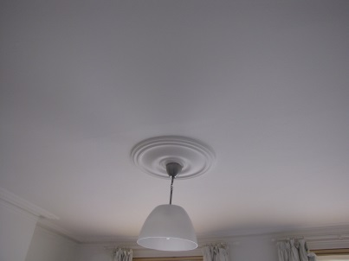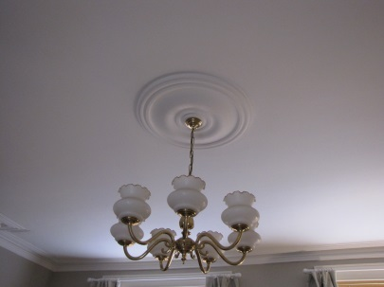

Eg of existing smoke detector in property

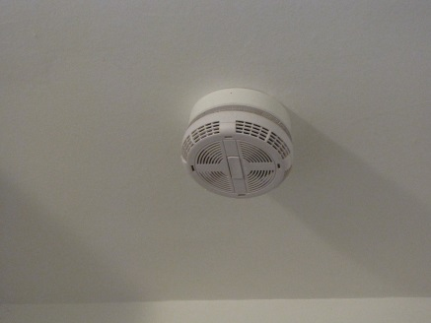

Given the existing situation with a range of non-original ceilings and ceiling roses, locating smoke detectors adjacent to the central light fitting is not considered to be harmful to the historic fabric of the building. Indeed the proposed approach would remove the need for channelling/ or surface mounted wiring, which, it is considered would be more harmful, particularly as these may be areas where less change has already occurred. Therefore it is considered that the proposed works would respect and preserve the historic character and appearance of the building and would accord with Core Strategy policy CS33

RECOMMENDATION:

GRANT Listed Building Consent subject to conditions

- The works to which this consent relate shall be begun not later than the expiration of three years from the date of this consent.

Reason: in accordance with Section 18 of the Planning (Listed Building and Conservation Areas) Act 1990 as amended by Section 51 of the Planning and Compulsory Purchase Act 2004.

- The consent relates only to the following plans/drawings/documents, and the works hereby approved shall be carried out in all respects in accordance with the submitted application and accompanying drawings:

As received 6th September 2017:
Basement Plan
Ground Floor Plan [excluding the fire alarm box]
First Floor Plan
Second Floor Plan

Emails from applicant with further details, marked as 1st May 2019

Reason: to ensure that the works carried out are fully in accordance with the approved drawings and details in order to protect the special historic and architectural character of the listed building, in accordance with Policy CS33 of the Reading Borough Local Development Framework Core Strategy 2008 (Altered 2015).

Informatives

1. IF1

2. For the avoidance of doubt, no other works are approved except those as authorised by this Consent. Any other works required to the Listed Building may require a separate application for Listed Building Consent and/or an application for Permitted Works to a Listed Building.

