DELEGATED APPLICATION REPORT - Application No.: 180562 Target Expiry: 29/5/18
Address: 10 Deepdene Close
Proposal: Single storey side and rear extension
Case officer: Alison Amoah

Site Description and Surrounding Area:
The property is a semi-detached house in a cul-de-sac. The boundary to no. 11 (detached for the application site) is slightly splayed. There is an existing attached single storey garage, currently used as storage, to the side, with a mono-pitched roof 2.8m high to the front and 2.2m to the rear, up to the boundary wit no. 11 to the north.

There is a good sized rear garden. Existing trees (not protected) have been cut back.

There is an existing single storey side extension at no.11.

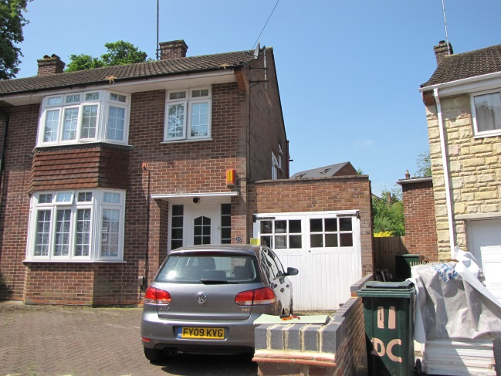

Proposal: The proposal is to partly demolish the existing garage, which measures 2.6m wide to the front and 3m to the rear, and 5.3m deep, and rebuild with the addition of an extension of a further 6.8m deep (4m beyond existing rear elevation of the main house), which widens up to 3.7m to the rear. The front 2.4m depth is marked for garage space (although too small for garage provision) with utility, shower room and office/ bed room within the remainder of the space. The building would follow the boundary line as far as the back of the house and then ‘square’ up, i.e. pull off the boundary with no 11 very slightly. The proposed roof would be flat, higher than existing, at 3.2m.

The garage doors would be retained to the front. Rear window and side facing door and window are proposed.

The proposed materials would be to match the existing house.

Plans considered: As received 3rd April 2018:

Block Plan – Drawing no: 098
Site Location Plan – Drawing no: 099
Existing Floor Plans – Drawing no: 100
Existing Elevations – Drawing no: 101
Proposed Floor Plans – Drawing no: 102
Proposed Elevations – Drawing no: 103

Relevant Planning History: None

Consultation Responses: Nos. 9 & 11 Deepdene Close, and Nos. 32, 26c and 26d Brunswick Hill were consulted. No responses were received. A site notice was displayed.

Transport: The proposed extension will result in the loss of the existing garage and thereby displacing 1 parking space; submitted plans do not illustrate the proposed parking layout. In accordance with the adopted Parking Standards and Design SPD, a 3 bedroom development in this zone would be required to provide off road parking provision for 2 parking spaces. Revised plans are required illustrating the proposed parking provision.

Please ask the applicants agent to resubmit revised plans to address the points made above so that this application can be fully determined.

Planning Officer Note: The garage is not currently used for parking for vehicles, and indeed would not meet current standards. There is existing hard standing which can accommodate 2 vehicles, (observed during the site visit) therefore no further details were sought.

Equality Act 2010:
In determining this application the Council is required to have regard to its obligations under the Equality Act 2010. However, there is no indication or evidence (including from consultation on the application) that the protected groups identified by the Act have or will have different needs, experiences, issues and priorities in relation to this particular planning application. Therefore in terms of the key equalities protected characteristics it is considered there would be no significant adverse impacts as a result of the development.

Relevant Planning Policy and Guidance
Section 38(6) of the Planning and Compulsory Purchase Act 2004 requires that proposals be determined in accordance with the development plan unless material considerations indicate otherwise. Material considerations include relevant policies in the National Planning Policy framework (NPPF) - among them the 'presumption in favour of sustainable development'.

The following local and national planning policy and guidance is relevant to this application:

Reading Borough Local Development Framework Core Strategy (2008)
CS7: Design and the Public Realm

Sites and Detailed Policies Document (2012)
DM9: House Extensions and Ancillary Accommodation;
DM4: Safeguarding Amenity

Supplementary Planning Guidance: A Design Guide to House Extensions (2003)

Appraisal Checklist:
DM9 states: An extension to a house will be acceptable where it:

- Respects the character of the house in terms of scale, location, materials and design;

To assess this, the following has been considered – would the proposal:

- Detract from the appearance of the original building through the use of ill-matching materials and by not fitting in with the design, scale and proportions of the original building; No

- Reduce the amount of usable amenity space for the property to an unacceptable degree; No

- Require the loss of trees in the garden or put significant trees at risk; Yes - however the former well-established trees (as partially viewable from the front using Google Street view (2014)) have largely been cut down – there are trunks remaining, but with no branches or foliage. These are not protected trees.

- Respects the character and pattern of neighbouring properties and the street as a whole in terms of scale, location, materials and design, and any important existing building line; Respects neighbour’s amenities and does not present a large blank façade to public areas.

To assess this, the following has been considered – would the proposal:

- Significantly reduce the amount of daylight and sunlight enjoyed by neighbouring properties; No

- Invade the privacy of neighbouring properties through overlooking from windows or balconies; No

- Detract from the character of neighbouring properties through siting, excessive bulk, ill-matching materials or inconsistent design; No

- Detract from the appearance of the street or area by using ill-matched materials, glazing and detailing; No

DM4 states: Development will not cause a significant detrimental impact to the living environment of existing or new residential properties, in terms of:
• Privacy and overlooking; NO
• Access to sunlight and daylight; NO
• Visual dominance and overbearing effects of a development; NO
• Noise and disturbance; NO
• Artificial lighting; NO
• Vibration; NO
• Dust and fumes; NO
• Smell; or NO
• Crime and safety. NO

Other matters: Conditions are recommended to ensure that the extension remains ancillary to the main dwelling and permitted development rights removed for new doors and windows.

RECOMMENDATION

APPROVE subject to conditions and informatives.

Proposed Conditions:

- Standard Time limit TL1
- The development hereby permitted shall be carried out in accordance with the following approved plans received 3rd April 2018:

Block Plan – Drawing no: 098
Proposed Floor Plans – Drawing no: 102
Proposed Elevations – Drawing no: 103

- Matching materials
- PD6 - No separate occupation of extension
- PD rights removed for new windows and doors.

Informatives:

Terms and conditions
Building regulations
Encroachment
Complaints re noise during construction
Positive and proactive

