DELEGATED APPLICATION REPORT - CERTIFICATE OF LAWFULNESS
APPLICATION NUMBER: 171860/CLE
SITE ADDRESS: 2 Amity Street, Reading
CASE OFFICER: Ralph Chakadya
SITE DESCRIPTION
The site is an end-terrace two-storey building with rooms in roofspace at the corner of Amity Street and Cumberland Road.
PROPOSAL
The application seeks a Certificate of lawfulness for existing use of property as a large House in Multiple Occupation (10 persons HMO).
The granted HMO license submitted as part of the evidence is that of a large HMO (10persons) and the details on the application claim that the property has been in use as an HMO for a period of more than 10 years before the date of this application. The application is therefore to confirm the lawfulness of a large HMO (10 persons).
PLANS SUBMITTED
The agent provided the following drawings:
Unnumbered Location Plan received 8th November 2017
RELEVANT PLANNING HISTORY OF THE SITE
1350821 - Enforcement investigation following unauthorised use of outbuilding within the curtilage of 2 Amity Street as an independent dwelling. Resolved following compliance
010475 – Single storey flat roof rear extension. Permitted 17/7/2001
011046 - Demolition of existing single storey rear extension and rebuilding of a single/two storey pitched roof side/rear extension. Refused 19/4/2001
RELEVANT PLANNING POLICY AND GUIDANCE
Section 10 of the Planning and Compensation Act 1991 established a procedure that enables anyone who wishes to do so, to apply to the local planning authority to determine whether a proposed use or operation, or an existing operational development or an existing use of land, or any other matter constituting a failure to comply with any condition or limitation subject to which planning permission has been granted, is lawful, and if so, be granted a certificate to that effect.
A Lawful Development Certificate is a legal document stating the lawfulness of past, present or future development. If granted by the local planning authority, the certificate means that enforcement action cannot be carried out to the development referred to in the certificate. However, the certificate will not protect from enforcement action by the planning authority if the specified use or development is then changed 'materially' without a planning application for it.
The certificate is not a planning permission. The planning merits of the use, operation or activity in the application are not relevant. The issue of a certificate depends entirely on factual evidence about the history and planning status of the building or other land and the interpretation of any relevant planning law or judicial authority. The responsibility is on the applicant to provide evidence to support the application.
The NPPG states that “In the case of applications for proposed development, an applicant needs to describe the proposal with sufficient clarity and precision to enable a local planning authority to understand exactly what is involved. In determining an application for a prospective development under section 192 of the Town & Country Planning Act a local planning authority needs to ask “if this proposed change of use had occurred, or if this proposed operation had commenced, on the application date, would it have been lawful for planning purposes."
RESPONSE TO CONSULTATIONS
RBC Electoral Services – The Electoral Services Department have supplied details of the Electoral Register for this property showing occupancy of the property in 2007 only by 5 residents.
RBC Council Tax - Council tax records show this property is banded under one single dwelling since at least 01.04.1997.
RBC Environmental Health – No objection to the use of the property as an HMO
RBC Enforcement – no record of the property being an HMO
EVIDENCE SUBMITTED
The following documents were submitted:
Completed Application form
Unnumbered Location Plan
HMO Licence No.544437 issued 10/08/2017
Despite written requests to the applicant, no additional information as evidence in support of the application was received.
ANALYSIS OF EVIDENCE (ASSESSMENT)
The applicant submitted a Certificate of Lawfulness application in order to regularise the use of 2 Amity Street as a large HMO. The certificate is sought on the grounds that the use began more than 10 years before the date of this application. The applicant has stated that the use began in 2002. The relevant time period is therefore October 2007 to October 2017.
Apart from information on the application form regarding the grounds of the application, the only supporting evidence submitted by the applicant is a copy of the recently granted HMO licence dated 10/08/2017 that permits the occupation of the property by up to 10 people. As highlighted within the ‘Submitted Evidence’ section above, no additional evidence was submitted by the applicant despite written requests to do so by officers.
The submitted HMO licence only covers the period from August 2017 to present and therefore is insufficient to demonstrate that the property has been in use as a large HMO between October 2007 and October 2017. In addition the details obtained from Council Tax records indicate that the property has been banded under one single dwelling since at least 01/04/1997 and the Council’s Electoral Services register also show occupancy of the property in 2007 only by 5 residents.
The law on applications for existing use certificates is clear and in relation to the submitted application it is incumbent on the applicant to prove, on the balance of probabilities that 2 Amity Street has been in continuous use as a large HMO for more than 10 years before the date of this application. In this instance the applicant has been unable to demonstrate this.

RECOMMENDATION
Refuse Certificate

Submitted drawings:
Unnumbered Location Plan received 20th October 2017
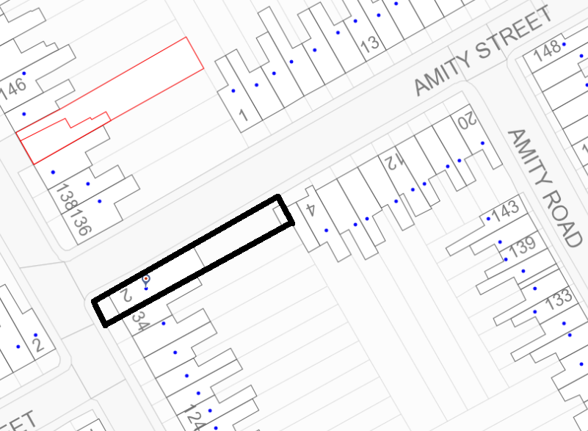
Location/Block Plan (not to scale)

