DELEGATED APPLICATION REPORT - Application 190471
Address: 88 Blenheim Road
Proposal: Retrospective Planning Permission for C4 use (Small HMO)
Case officer: Brian Conlon

Site Description and Surrounding Area

The site is a terraced house on the western side of Blenheim Road. There is on-street parking, but within a Residents Parking Permit Area Zone. There is a small front yard and long rear garden. The property is located within an Article 4 Area which removes permitted development rights to change from C3 to C4 small HMO.

Background

In July 2018 the property was occupied by students, resulting in a change of use to a C4 small HMO without the relevant planning permission. The Council’s Planning Enforcement Team advised of the unlawful nature of the use and invited a retrospective change of use application be submitted.

Proposal

The proposal is for the retrospective change of use from C3 to C4. At the time of the Officer’s site visit on 28 May 2019, the house was occupied as C4 small HMO by students, with a bedroom at ground floor, 3 no. at first floor and 1 no. at second floor. Communal space was provided in the form of a kitchen/living room.

Relevant Planning History

171712 - Certificate of lawfulness for proposed single storey rear extension, amendments to front fenestration and related works.
PERMITTED 17/11/17

Consultation Responses

Each neighbouring property was notified and a site notice displayed for the requisite period. One letter of representation received from 82 Blenheim Road as follows:

- “There are already lots of HMOs in the area and we do not need another one. There have been issues already with excess rubbish in the front garden of this property”.

RBC Environmental Protection – No objections.

RBC HMO Team – No comments received.

RBC Waste Team – No comments received.

RBC Transport Team – No comments received.

Equality Act 2010

In determining this application the Council is required to have regard to its obligations under the Equality Act 2010. However, there is no indication or evidence (including from consultation on the application) that the protected groups identified by the Act have or will have different needs, experiences, issues and priorities in relation to this particular planning application. Therefore in terms of the key equalities protected characteristics it is considered there would be no significant adverse impacts as a result of the development.

Relevant Planning Policy and Guidance

Section 38(6) of the Planning and Compulsory Purchase Act 2004 requires that proposals be determined in accordance with the development plan unless material considerations indicate otherwise. Material considerations include relevant policies in the National Planning Policy framework (NPPF) - among them the 'presumption in favour of sustainable development'.

The following local and national planning policy and guidance is relevant to these applications:

National Planning Policy Framework

Part 6 – Delivering a wide choice of high quality homes
Reading Borough Local Development Framework Core Strategy (2008)

CS18 (Residential Conversions)
CS24 (Car/ Cycle Parking)

Reading Borough Local Development Framework Sites and Detailed Policies Document (2012)

DM4 (Safeguarding Amenity)
DM8 (Residential Conversions)
DM10 (Private and Communal Outdoor Space)

Supplementary Planning Documents

Residential Conversions SPD (2013)
Revised Parking Standards and Design SPD (2011)

Legal context

Reading Borough Council made an Article 4 Direction in May 2012, which came into force on 16th May 2013, which removes permitted development rights to convert from a dwellinghouse (C3 use) to a house in multiple occupation (C4 – small HMO for 3-6 unrelated persons sharing at least one basic amenity) in parts of Redlands, Katesgrove and Park Wards. The application site is within the Article 4 Direction Area.

Appraisal

The main issues are considered to be:

- Whether the conversion of the property to C4 use has resulted in unduly diluting or harming a mixed and sustainable community;
- Is the property of the appropriate size for conversion?
- Amenity of future residents and those of existing neighbouring properties
- Effect on car/ cycle parking

Along with the adopted local planning polices this assessment has mainly been based on the Adopted Residential Conversions SPD (2013). Section A of the SPD, deals with the ‘General Assessment of all Conversions’ (i.e. from C3 dwellinghouses to flats or HMOs (both small C4 use and sui generis HMOs). Section B specifically covers the assessment of applications for HMOs within the area covered by the Article 4 Direction. This application has been considered against both sections. The SPD sets out 26 no. checklist items; the relevant ones of these are used to form the basis of the assessment within this report.

(a) Whether the conversion of the property to C4 use has resulted in unduly diluting or harming a mixed and sustainable community

The Residential Conversions SPD identifies that the ‘tipping point is when the concentration of HMOs becomes over dominant and the community is no longer considered to be mixed and sustainable.’ The SPD defines that “planning permission will not normally be granted where the proportion of HMOs will result in HMOs representing 25% or more or the residential properties within a circle of 50m radius measured from the application site” (para. 5.43). The concentration of HMOs in the area surrounding the application site has been calculated as a percentage of the total estimated number of existing HMOs (C4 or sui generis) against the total number of residential properties, i.e. those falling with C3, C4 or sui generis HMO use. Available data from Environmental Health, Council Tax, extant (unimplemented) permissions for HMOs, and data on sites such as Rightmove, and data held by the Enforcement Team, has been used. The total number of residential properties within the 50m radius, including the application site, has been calculated as 54. The total number of properties within HMO use, using the above sources of data, is estimated to be 30 no. and therefore the overall percentage is calculated as 55.5%, which is well above the threshold of a maximum of under 25%. In this regard the principle of the conversion of the application property to a C4 small HMO is not considered acceptable.

Despite the housing stock along Blenheim Road consisting of almost entirely of properties capable of being family dwellings, the Council’s research shows conservatively that a majority of houses have been converted to HMOs. Upon visiting the site and assessing the condition of the frontage of this property and street, considerable amounts of refuse, glass recycling and unsorted waste associated with student living was observed dumped to the front of No. 88 and a great number of other houses along the street. There was also very little on-street parking available despite visiting early afternoon on a week day. Whilst not determinative, it is visibly evident from the prevailing character of the area that whilst residential in nature, the area was being negatively affected by an overconcentration of dwellings within HMO use, placing pressure under available space for waste collection and parking.

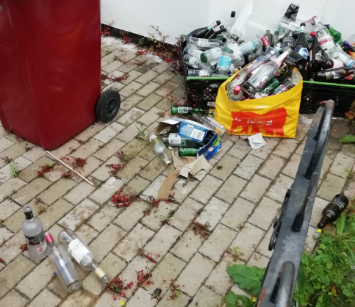
Front yard of 88 Blenheim Road

Whilst there is a recognised need for a mix of accommodation options within the Borough along with the specific needs of the University, there is also a competing need to maintain a adequate supply of family housing, whilst preventing an over-proliferation of any single type of accommodation in a particular area. An overconcentration of houses within HMO use exists in this location and its consequences witnessed. This is considered to negatively affect the character and appearance of Blenheim Road and the wider area. The approval of this retrospective change of use to an additional HMO use would further exacerbate the harm identified and importantly further reduce the opportunity for the Council to achieve a balanced or appropriate mix of dwellings in the area.

In summary, an additional C4 small HMO would not contribute to achieving an appropriately mixed and sustainable community and is considered to have a detrimental impact on the physical character of the area. It is therefore considered to be contrary to Sites and Detailed Policies Policy DM8: Residential Conversions, and the adopted Residential Conversions SPD.

(b) Is the property of the appropriate size for conversion?

The original property is approximately 99sqm in size and traditionally contained 3 bedrooms considered. It therefore would not meet the size requirement for such a conversion in accordance with Policy DM8 of the Sites and Detailed Policies.

(c) Amenity of future residents and those of existing neighbouring properties

The Residential Conversions SPD sets out a number of checklist items which provide further detail related to adopted policies DM4, DM8, DM9 and DM10 of the Sites and Detailed Policies Document.

Room Sizes - The SPD identifies minimum internal floorspace standards (Appendix 1) as 6.5sqm for a single bedroom and 7sqm for a kitchen. The bedrooms and kitchen exceed these dimensions.

Communal Space – There is a lounge and large kitchen, which are considered acceptable for a small HMO.

Amenity Space – There is a good sized rear garden in accordance with Policy DM10 of the Sites and Detailed Policies.

External windows - All habitable rooms benefit from external windows.

Access to sunlight/daylight – this is acceptable for proposed residents and existing

Layout/Stacking of Rooms - The Council’s SPD seeks to avoid layouts which locate living rooms, bathrooms and kitchens, next to, above, or below, proposed or neighbouring bedrooms. The layout largely achieves this.

Sound Insulation – Policy DM8 refers to sound insulation between proposed and neighbouring units. This would only be a building regulations requirement where independent units were being created (Self-contained flats).

Privacy and Overlooking - No issues of overlooking/ loss of privacy are identified.

Noise and disturbance: In terms of noise and disturbance there is no evidence to suggest that an HMO for up to six individuals would create significantly greater levels of noise than a fully occupied 4 bedroom family house (assuming bedrooms only at first and second floor). However, even if there were a greater level of noise and disturbance caused through residential use, it is not considered to be so significant as to warrant refusal on this basis.

Bin storage: Bins would be stored to the front of the property, although not ideal from an aesthetic point of view, as there is no side access to get to the rear garden there is no other viable option, without having to carry bins through the house, and this would not be significantly different in effect to other properties in the street.

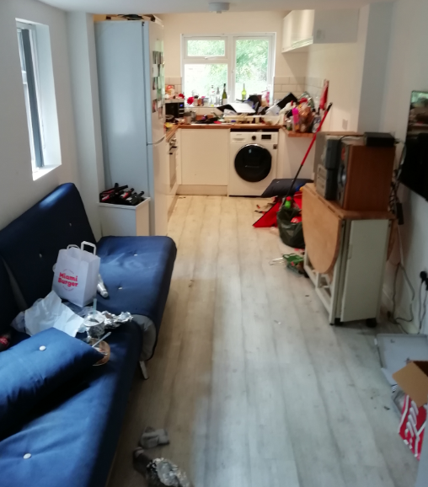
Communal Space (Ground floor) 88 Blenheim Road

(d) Effect car/cycle parking provision

The parking standard would require 0.25 spaces per bedroom, which would equate to 2 spaces. There is no on-site parking provision and street parking is controlled through permits. If the change of use was deemed acceptable in principle, which the above assessment identifies that it is not, then conditions and informatives could have been attached to a decision to restrict the right to parking permits for this property. Therefore, the lack on on-site parking provision would not constitute a reason for refusal.

Cycle storage can/is able to be provided within the rear garden, although the practicalities of taking bikes through the house would make this undesirable. However, as this is an accessible location, the lack of suitable cycle storage would itself not constitute a reason to withhold permission.

RECOMMENDATION:

REFUSE

Reasons:

- The retrospective conversion of this property to a C4 small HMO has a detrimental effect on the character of the area by exacerbating the number of HMOs in the area and further reducing the number of single dwelling houses available for occupation. The percentage of applicable properties in HMO use within 50m of the property (including the site) is approximately 55.5%, in excess of the target threshold of under 25% as defined in Reading Borough Council’s adopted Residential Conversions Supplementary Planning Document (2013). This use has a detrimental impact on the physical character and appearance of the area and does not contribute to achieving an appropriately mixed and sustainable community. Furthermore, the original property does not meet the size requirement for such a conversion. For these reasons, the conversion is contrary to Adopted Core Strategy (2008, altered 2015) Policy CS18: Residential Conversions, Adopted Sites and Detailed Policies Document (2012, altered 2015) Policy DM8: Residential Conversions, and the adopted Residential Conversions SPD (2013).

Informatives:

Refused Plans
Positive and proactive
Enforcement

