Design & Access Statement

Proposed Theatre for Reading Rep at Reading College, Reading, Berks.

February 2019.

This application is in respect of a New Theatre at Reading College, Reading.

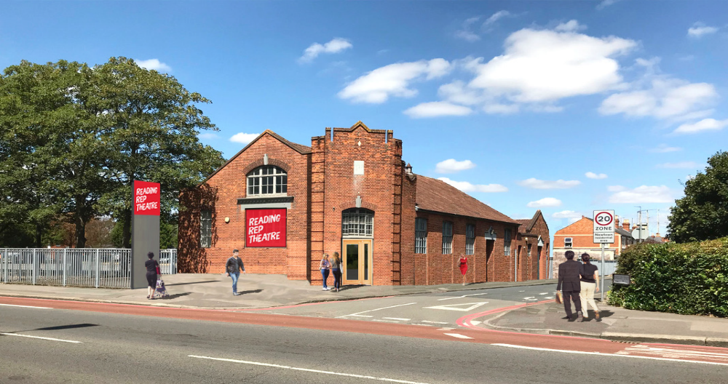



Background and Use

The project/application seeks to utilise the semi-redundant ex-Salvation Army meeting house, on the Reading College, Kings Road site.

The facility will incorporate a 170 seat theatre, front of house areas and a rehearsal space, store areas, W.C. hygiene and circulation spaces, as well as a courtyard area for theatre goers to gather, a ramp for accessibility, steps and associated landscaping.

The design reflects compliance with all relevant Parts contained within the Approved Documents.

Activate Learning will be leasing the building to Reading Rep, so Reading Rep can convert it into a theatre, arts hub and community centre. Activate Learning, of which Reading College are a part will continue to have shared use of the space part time for educational purposes.

It will be open year round from 9am – 11pm. During the day (till 7pm) it will be used for rehearsals, education and community purposes. It will be utilised for workshops such as, Rehearsals, Youth theatres, A community gathering space, Workshops for disadvantaged and isolated people in the Reading community.

In the evening (post 7pm) it will be used for professional and amateur performances such as stand-up comedy and theatre productions. For these purposes it is likely to be in use 30 weeks of the years but we would need a year round licence. Reading College have allowed use of their cycle and car parking for these performances so as not to increase traffic along Kings Road. This is in response to the requirement of Policy CS24.

Existing Site

Reading College has been located at the Kings Road site since 1955 when it was opened as Reading College of Technology, after some time it then became known as Reading College and School of Arts and Design, the college in Reading was provided by Thames Valley University from 2004 until the recent rebranding to Reading College as part of the Activate Learning Group. The area in which the proposed Theatre will be is an existing building in the South East corner of the site.

Location, Character & Context

The site is situated on, and accessible from Kings Road which is the main arterial route slightly East of Reading Town Centre.

The restricted site is surrounded by residential developments to the North East and West, with offices and some residential buildings to the south along the A329 Kings Road. Though the residential areas, remain low-rise, some of the office blocks along the Kings Road are several storey’s high, which can be seen from the aerial views drawing within the drawing package submission

Access

Vehicle and pedestrian access to the site is from Kings Road. This is the existing access route into The Reading College site. Kings Road is considered a main arterial between the centre and the East of Reading. The Theatre is located perfectly within the site for students being dropped off by car or by the current minibus scheme the college uses. Theatre goers will be able to make use of the 395 car parking spaces available within the Kings Road site. (Policy CS24)

The proposed site comprises of the existing building and car parking, landscaping and an access ramp and steps.

The scheme has been developed within the existing building with no visual changes taking place externally. Accordingly the building will continue to relate well to its surroundings. (Policy CS7)

The design has been progressed, with disable access and space requirements for the user a paramount consideration.

Layout

Option studies were undertaken and presented to Reading Rep and Reading College, by MDR Associates Architects, and it was agreed that the layout which forms part of this application was the most effective in terms of flexibility of the internal spaces, cost and minimal disruption to the College. The design process allowed for further development of this scheme, resulting in a compact and well considered layout.

The position of the building on the site, its orientation, window positions etc., do not allow for any overlooking of neighbouring residential buildings. (Policy CS7)

The proposed internal arrange provides.

- Well defined area, with little impact on the rest of the College facilities.
- Well sized rooms
- Direct access to the Theatre from Kings Road
- Access during construction period relatively straight forward.

Design Proposal Overview

The existing building will be retained and converted to provide a 150+ seat auditorium in an end-on configuration.
The first 5 rows and the stage will be removable to create a large open space for multiple uses and ensure flexibility of daytime and evening use.
Outside the existing railings on Kings Road will be removed and the existing double doors will become the main audience entrance. (Policy CS7)
A new bar and entrance foyer will be created as well as audience toilets.
The existing courtyard will be roofed over,
The toilets refurbished and two new dressing rooms and back of house facilities formed
The existing rehearsal room will be retained.
The scheme will create a modern, high quality, usable permanent theatre space for Reading Rep

Scale

The building comprises two pitched roofs with an area of flat between. The ceiling height within the flat roof zone is set to allow the back of house dressing rooms, to have reasonable height to reflect its size and area. Too low a ceiling in this area will feel oppressive and reduce the depth of natural light into the room. The two pitched roof elements provide a greater volume to the Theatre and Rehearsal space. The size and scale of the building is as existing and lends well to the proposed use.

Appearance

The elevations of the building walls are predominantly formed in facing brickwork. Existing doors and windows will be retained and new doors fabricated to match.

The elevation treatment has been considered and illustrated in the photograph enclosed in this application. (Policy CS7)

Accessibility

We are currently in consultation with Reading College

Fob access, to provide better flexibility of the access/exit route.

Barrier matting will be provided in the entrance lobby of a tone to match the main floor finish

The reception counter will have a lower section with knee space for wheelchair users.

Generally the circulation routes are 1800-2000mm and the ground floor is level throughout. Escape doors will be connected to devices linked to the fire alarm system.

The signage will follow best practice with an easily read simple font with contrasting background with pictograms where possible. The colour scheme will be developed to give contrast between the floor, walls and fitting such as ironmongery etc.

Reading Rep will develop a management procedure for evacuation of the building which will become part of the overall college strategy.

All items relating to accessibility inherent within the design have been considered in compliance with Parts M of the approved Documents.

Landscaping

Although not strictly forming part of this application, some consideration has been given to areas which may allow for some planting, these area have been identified on the GA plan. Soft and hard landscaping, timber screening, planting and trees are proposed, however more specific details will follow once developed. We would hope to issue as part of a condition. (Policy CS7)

Secure by Design

Refer to exiting secure by design strategy currently in effect at Reading College

