Airsys UK Limited
Unit 245
Europa Boulevard
Warrington
WA5 7TN

Telephone 01925 377272
Enquiries info@air-sys.uk
Website www.air-sys.uk

01/08/2018

Heritage Statement
BT Telephone Exchange
Reading Central, Minster Street, Reading, RG1 2JB
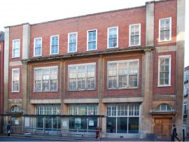

Alteration to Glazing on the West Elevation

The Asset
Built circa 1900.
Architect Leonard Aloysius Stokes.
His aim was to develop a British style of architecture, free from revivals of past styles. The building consequently appears somewhat plain. 3 storeys of red brick with stone dressings in an attenuated Georgian style. Concealed roof. 5 bays wide, the end bays project slightly. To the right is door with cornice and lunette window above. To the left is a window treated in a similar runner. Centre 3 bays divided by chamfered piers supporting cornice at 2nd floor level. Large windows between on each floor, 6 windows on 2nd floor. Single sash windows in breaks on the 3rd floor.

The building is set in the centre of Reading on the main shopping parade. The building is surrounded by modern buildings including department stores, cafes and bars.

Proposed Works
Airsys proposes to remove the gazing to one double window on the ground floor of the west elevation of the building. The glazing will be replaced with an aluminium louvre which will be powder coated white to blend in with the surrounding windows and other louvres on the west elevation. The louvre in needed as part of an ICT cooling design for additional high-speed broadband to be installed in the telephone exchange.

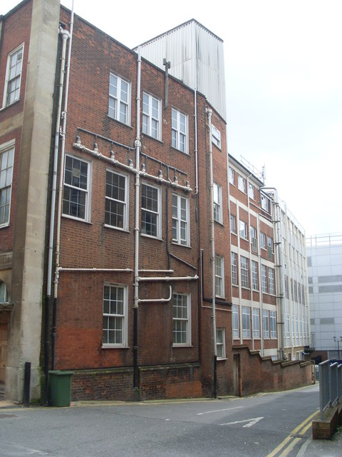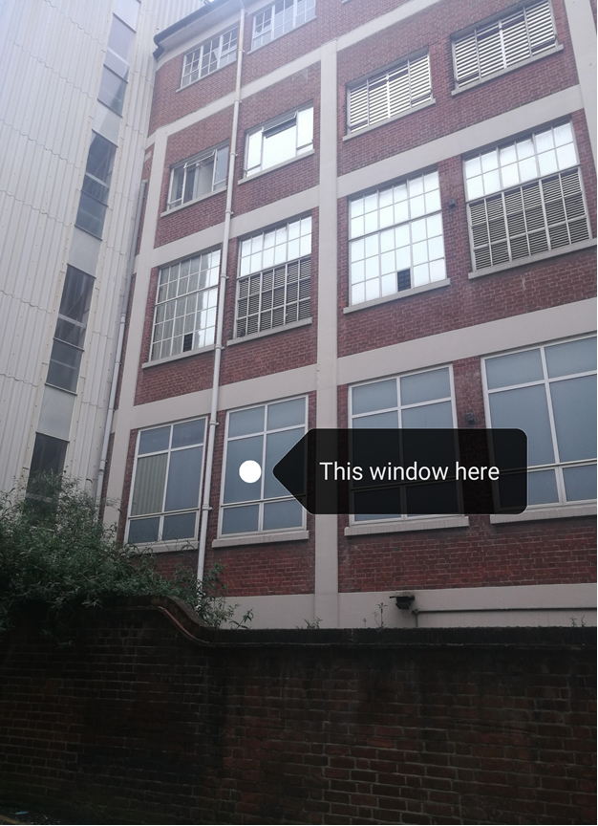

Impact on the Asset
As the proposed work will be taking place on the west elevation of the building well back from the historical front façade I believe the impact on the asset to be minimal. The building already has several louvres installed in the west elevation on several floors. The window to be removed is not of any architectural significance, but the design of the louvre could be modified to just remove the glazing and fit 6 smaller individual louvres into the existing frames. See drawing that accompanies this statement

