DELEGATED APPLICATION REPORT - Application Nos.: 181529/ADV
Target Expiry: 6/2/1019 (Extended)
Address: Wren Kitchens, Unit 1, Imperial Way, Worton Grange
Proposal: Retrospective application for 1 no fascia sign, internally illuminated via LEDs and 3 no. sets of vinyls applied externally to the windows.
Officer: Alison Amoah

Site Description and Surrounding Area:
The application site forms part of the overall mixed use scheme at the former Worton Grange (‘The Gateway’). Wren Kitchens (Unit 1) is located at the north/western corner of the site, with an elevation towards the A33.

Proposal:
- 1 no. fascia sign – ‘The UK’s Biggest Kitchen Showroom’. 21.2m long by 1.5 m high. constructed from aluminium flex face box systems, powder coated corporate Green RAL 6018, housing a tensioned digitally printed PVC skin. Internally illuminated via LEDs.
- 3 no. - Digitally printed vinyls applied externally to glazing (50mm mullions with 15mm returns)

(WREN sign to the left received consent as part of ref:180416)
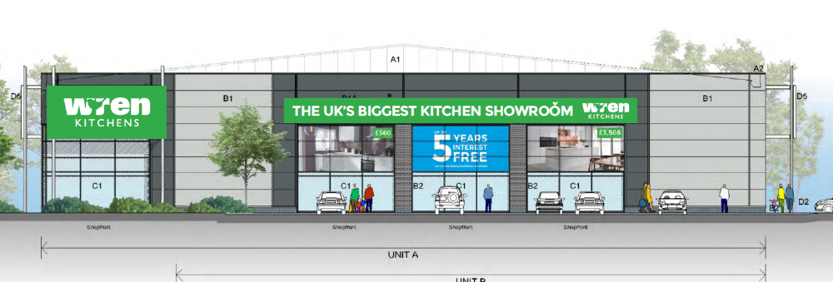

Plans considered: All received 30th August 2018:
- Location Plan
- Proposed Signage [6 sheets], prepared by Sapphire Creative Signmaking

Relevant Planning History:
151944/FUL – A Hybrid application seeking outline planning permission for the development of up to 175 new homes, including affordable housing(with all matters reserved apart from access), and full planning permission for the development of 12 commercial units in flexible use within Classes B1(c),B2 and B8,two car showrooms with MOT and servicing(Sui Generis), three retail warehouse units (Class A1),120 bed hotel (Class C1),pub with restaurant facility (Class A4),coffee shop (Class A1), restaurant (Class A3), and bank (Class A2). New vehicular access from Basingstoke Road and Imperial Way. Bus stop facilities, hard and soft landscaping and other ancillary development (Summarised Description). Permitted 14/ 4/2016.

Some egs of Signs within Worton Grange (‘The Gateway’ site)
171498/ADV - No.8 internally illuminated fascia signs, no.1 internally illuminated
projecting sign, no.1 internally illuminated hoarding sign and no.1 – Consent 20/10/17

180161/ADV - No.22 non-illuminated 'To Let' fascia signs and No.12 non-illuminated number signs – Consent 13/3/18

180262/ADV - No. 1 7m high non-illuminated totem sign – Consent 13/3/18

180416/ADV - Consent to display 8 No. Internally illuminated fascia signs to North East, South East, South West and North West Elevations (Wren Kitchens)– Consent 30/4/18

180776/ADV - Scanlite digital electronic displays to advertise special offers, sales, etc. Full colour, variable text, images (Unit 1 – now Wren) – Consent 26/7/18

181168/ADV – Display of various illuminated and non-illuminated signage (Burger King)– Consent 4/9/18

181563/ADV – (Costa) 17 no. signs, 8 no. illuminated, 9 no. non-illuminated - mix of fascia, pole, directional, parking and height barrier signs – Consent 10/12/18

Consultation Responses: Bewley Homes were consulted. No comments were received.

Natural Environment: As per the comments given for 180776, the proposed elevations don’t correctly indicate the approved tree planting on the A33 frontage. I would request that the applicant confirms their knowledge and acceptance of the approved tree planting on this frontage, which is more than is indicated on the elevation/proposed drawings. I would not wish to see any signs approved on the A33 frontage that resulted in the applicant requesting that the approved trees are not retained or that they are inappropriately pruned. They are of species that will be as taller/taller than the proposed sign height, hence the applicant needs to accept that there will be some degree of visual blocking of the sign from the A33 in the future.

Planning Officer note: The agent confirmed the following: “We accept that there will be some degree of visual blocking of the sign from the A33 in the future. We are still happy to progress with the application.”

Transport: No objection subject to condition on restriction on illumination.

Equality Act 2010:
In determining this application the Council is required to have regard to its obligations under the Equality Act 2010. However, there is no indication or evidence (including from consultation on the application) that the protected groups identified by the Act have or will have different needs, experiences, issues and priorities in relation to this particular planning application. Therefore in terms of the key equalities protected characteristics it is considered there would be no significant adverse impacts as a result of the development.

Relevant Planning Policy and Guidance
Section 38(6) of the Planning and Compulsory Purchase Act 2004 requires that proposals be determined in accordance with the development plan unless material considerations indicate otherwise. Material considerations include relevant policies in the National Planning Policy framework (NPPF) - among them the 'presumption in favour of sustainable development'.

The following local and national planning policy and guidance is relevant to these applications:

Reading Borough Local Development Framework Core Strategy (2008, altered 2015):
CS7 (Design and the Public Realm)

Reading Borough Local Development Framework Sites and Detailed Policies Document (2012, altered 2015):
DM12: Access, Traffic and Highway Related Matters
DM22: Advertisements

Legal context:
Regulation 3 of the Town and Country Planning (Control of Advertisements) (England) Regulations 2007 requires the Local Planning Authority to exercise its powers under these regulations in the interests of amenity and public safety taking into account the provisions of the development plan, so far as they are material; and any other relevant factors. Regulation 3 states that factors relevant to amenity include the general characteristics of the locality, including the presence of any feature of historic, architectural, cultural, or similar interest.

Factors relevant to public safety include highway safety and whether the advert would hinder security or surveillance devices, including speed cameras.

Appraisal:
Main Issues: The main issues are considered to be:
(a) Amenity
- Safety

(a) Amenity
The NPPG (para 132) explains that:
“The quality and character of places can suffer when advertisements are poorly sited and designed. A separate consent process within the planning system controls the display of advertisements, which should be operated in a way which is simple, efficient and effective. Advertisements should be subject to control only in the interests of amenity and public safety, taking account of cumulative impacts.”
Amenity is a matter for interpretation by the local planning authority as it applies in any particular case. In practice, “amenity” is usually understood to mean the effect on visual and aural amenity in the immediate neighbourhood of an advertisement or site for the display of advertisements, where residents or passers-by will be aware of the advertisement.
Policy CS7 states that all development must be of high design quality that maintains and enhances the character and appearance of the area of Reading in which it is located.
Policy DM22 lists a number of criteria to be used to assess if new advertisements will respect the building or structure on which they are located and/or their setting.
Fascia sign 1 consists of 21.2m long by 1.5 m high aluminium flex face box powder coated Green and internally illuminated. It occupies the highest part of the main elevation of the premises and dominates its appearance. Signage already exists on those areas of the new premises which were specifically designed for signage placement and in combination with these and the proposed vinyls fascia sign 1 gives the property a cluttered and unattractive appearance. It therefore does have a harmful impact on the visual amenity of the site and the retail park generally.

The other three proposed signs are vinyls only applied to the windows and as such their visual impact is reduced to acceptable levels and they comply with these relevant policies.

However, for the reasons given, it is considered that facia sign 1 harms the appearance of the building and the wider area and therefore has a detrimental effect on the visual amenity. This retail park is still being occupied by new traders and it is important at this stage to set clear parameters for what signage would be appropriate and where on the building it should be placed to ensure that the design quality and appearance of the retail park is safeguarded to comply with policies CS7 (Design and the Public Realm) and DM22 (Advertisements).

(b) Safety
The proposed signs would be visible by road users, although they would be set well back from the highway. The illuminance level of the fascia sign would not distract drivers so as to have an effect on safety. None of the signs would obscure any existing traffic signs, reduce visibility for road users, or sight lines of cameras. Transport has no objection subject to a luminance condition. With respect to safety the advertisements are therefore considered to accord with Reading Borough Local Development Framework Sites and Detailed Policies Document (2012) DM12: Access, Traffic and Highway-Related Matters and the safety requirements of DM22: Advertisements.

RECOMMENDATION:
The recommendation is that a split decision should be issued to grant the vinyl signs but to refuse fascia sign no.1.

GRANT

Proposed conditions:

- Standard advert conditions
- Approved plans – excluding fascia sign 1

Reason for refusal:
Fascia sign no.1, by virtue of its high level position and size, results in harm to the appearance of the building and the character of the wider area and therefore has a detrimental effect on visual amenity. When seen in the context of approved signage fascia sign no.1 leads to an unattractive and cluttered appearance for the building and this is also harmful to the character and appearance of this retail park contrary to policies CS7 (Design and the Public Realm) and DM22 (Advertisements).

