Arboricultural Method Statement
And Impact Assessment

35a, St Peter’s Avenue,
Caversham,
RG4 7DH.

For:

Mr. and Mrs. Pinchen

Reference AA/AMS+AIA-19.12.18

Atworth Arboriculture Ltd, 189 Purlpit, Atworth, Wiltshire SN12 8HJ.
Vincentcainey@yahoo.co.uk 01225 708508 07970467918

Introduction
- Site: 35a, St Peter’s Avenue

- Client: Mr. and Mrs. Pinchen

2.1 Atworth Arboriculture Ltd was instructed to supply an Arboricultural Method statement and Impact Assessment for the proposed development at the site above.

2.2 Local Planning Authority – Reading Borough Council.

3.0 Proposed development

3.1 The proposed development is to extend the first floor to create an extra bedroom.

4.0 Arboricultural Method Statement Methodology

4.1. The Arboricultural Method Statement provides the means by which areas of construction within or near to the Root Protection Area (RPA) of retained trees can be achieved whilst minimising the potential impact of construction activity.

4.2 This Statement is written assuming any approved Preliminary Management Recommendations to trees have already been carried out.

4.3 The excavation of foundations for any structure on sites where trees are present may result in root damage and removal. Where root loss is likely to occur, it is important that a method of construction that minimises the impact on tree roots is utilised.
4.4 Copies of this document will be available for inspection on site.

5.0 Tree Protection Measures
5.1 Normally it is necessary to install barrier fencing and/or ground protection measures to protect the tree roots during construction.
In this case the tree is surrounded by compacted surfaces of the driveway and parking area (Picture 1) and protection is not necessary.

Picture 1
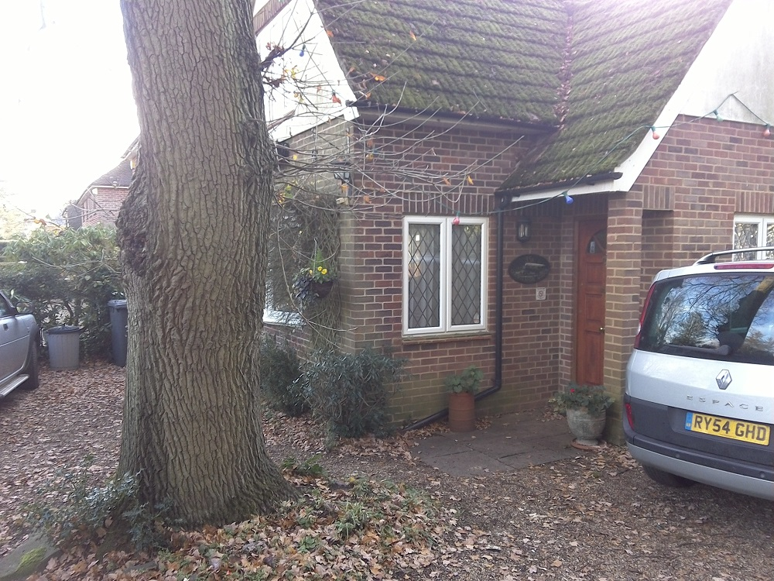

6.0 Works required within the RPA – Mitigation strategy

6.1 All of the proposed work is within the RPA of the tree. A construction method has been designed where the extension is supported by cantilevers off the existing structure and no foundations or ground works are required

Arboricultural Implications Assessment (AIA)

7.0 Above Ground Constraints

7.1 Effects of new buildings on amenity value on or near the site
As the tree is protected by a Tree Preservation Order (TPO), there are limited works that can be carried out on the tree and any work must be approved by the Local Planning Authority. The main limb that was projecting towards the house from the south (Picture 2) has been previously reduced to 0.5m length.
The LPA representative was concerned about the possible damage that would occur should a limb fail and fall towards the house. This would still be the case were the new extension not there. The tree is in good condition and with ongoing monitoring and maintenance, approved by the Local Authority should not pose a threat of damage to the building.

Picture 2
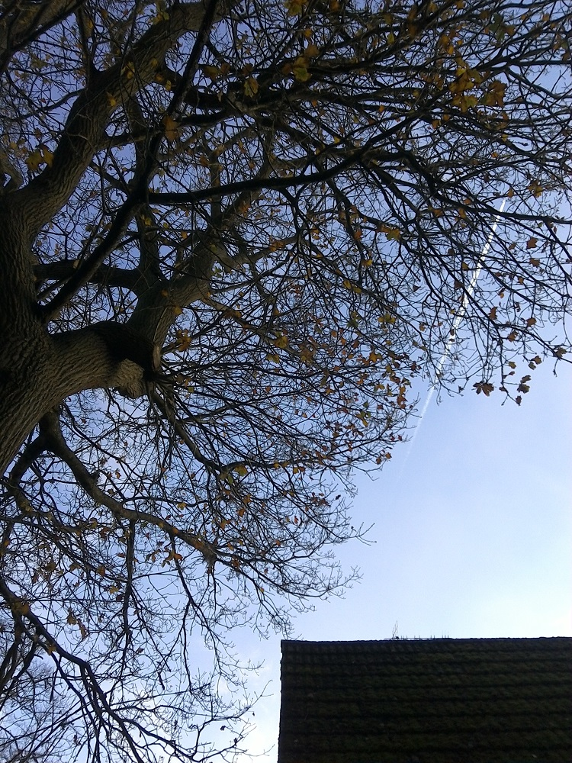

7.2 Pruning and felling works to facilitate development
There is some minor (under 75mm diameter) dead wood over the drive, north east at 11m above ground level.

7.3 Proximity of trees to structures
The building has a generally good relationship with the tree and the addition of the extension will make little difference.

8.0 General Precautions

8.1 It will be the arboriculturist’s duty to monitor site works relating to trees and where necessary take photographs to inform the LPA that the works are taking place in accordance with LPA planning conditions in relation to trees. It remains the responsibility of the LPA to enforce any breach in conditions.

8.2 The storage of site materials, tipping of spoil, rubbish or cement washings, or the lighting of fires is not permitted within the RPA, which is the grey hatched area on the RPA plan, AA/RPA-17.12.18

8.3 Fires on site will be avoided if possible, when they are unavoidable they will not be lit in a position where flames or heat could affect foliage or branches or cause a nuisance to neighbours. The potential size of fire and wind direction should be taken into account when determining its location and it will be attended at all times until extinguished or safe enough to leave.

Vince Cainey BSc, Atworth Arboriculture Ltd

19th December 2018

