DELEGATED APPLICATION REPORT - Application No.: 190413
Address: 689 Oxford Road
Proposal: Change of use from D1 (Day Care Facility for People with Learning Difficulties) at ground floor and C3 flat at first floor, to part ground floor for B1 office and C3 residential for the remainder of the building.
Case officer: Alison Amoah
Target Expiry: 3/6/19 (ext)

Site Description and Surrounding Area:
The application site, is the end of terrace located on the corner of Oxford Road and Grovelands Road. It is a two storey Victorian property with a large hard surfaced yard to the rear, accessed from Grovelands Road. There is an existing gable ended, attached, single storey building accessed from the outside, and adjacent to this a largely glazed entrance structure. There is no boundary to the Oxford Road frontage. There is a brick side boundary to Grovelands Road frontage with double gate access.

The adjacent terrace has a higher building line with accommodation within the roof space.

There is a mix of residential and commercial on Oxford Road, albeit the main Oxford Road commercial centre is further towards Reading. Grovelands Road is wholly residential.

The building is currently vacant, but its most recent permitted use was for D1 non-residential day care (permitted under 99/0580). The officer report for that application refers to the preceding use having been B1 office. Planning history also indicates that there was a shop. The submitted existing floor plans suggest C3 flat at first floor and D1 use at ground floor. Web searches suggest that the property has been used for NHS podiatry services and the estate agent states that its last use was for a nutrition and dietetic centre.

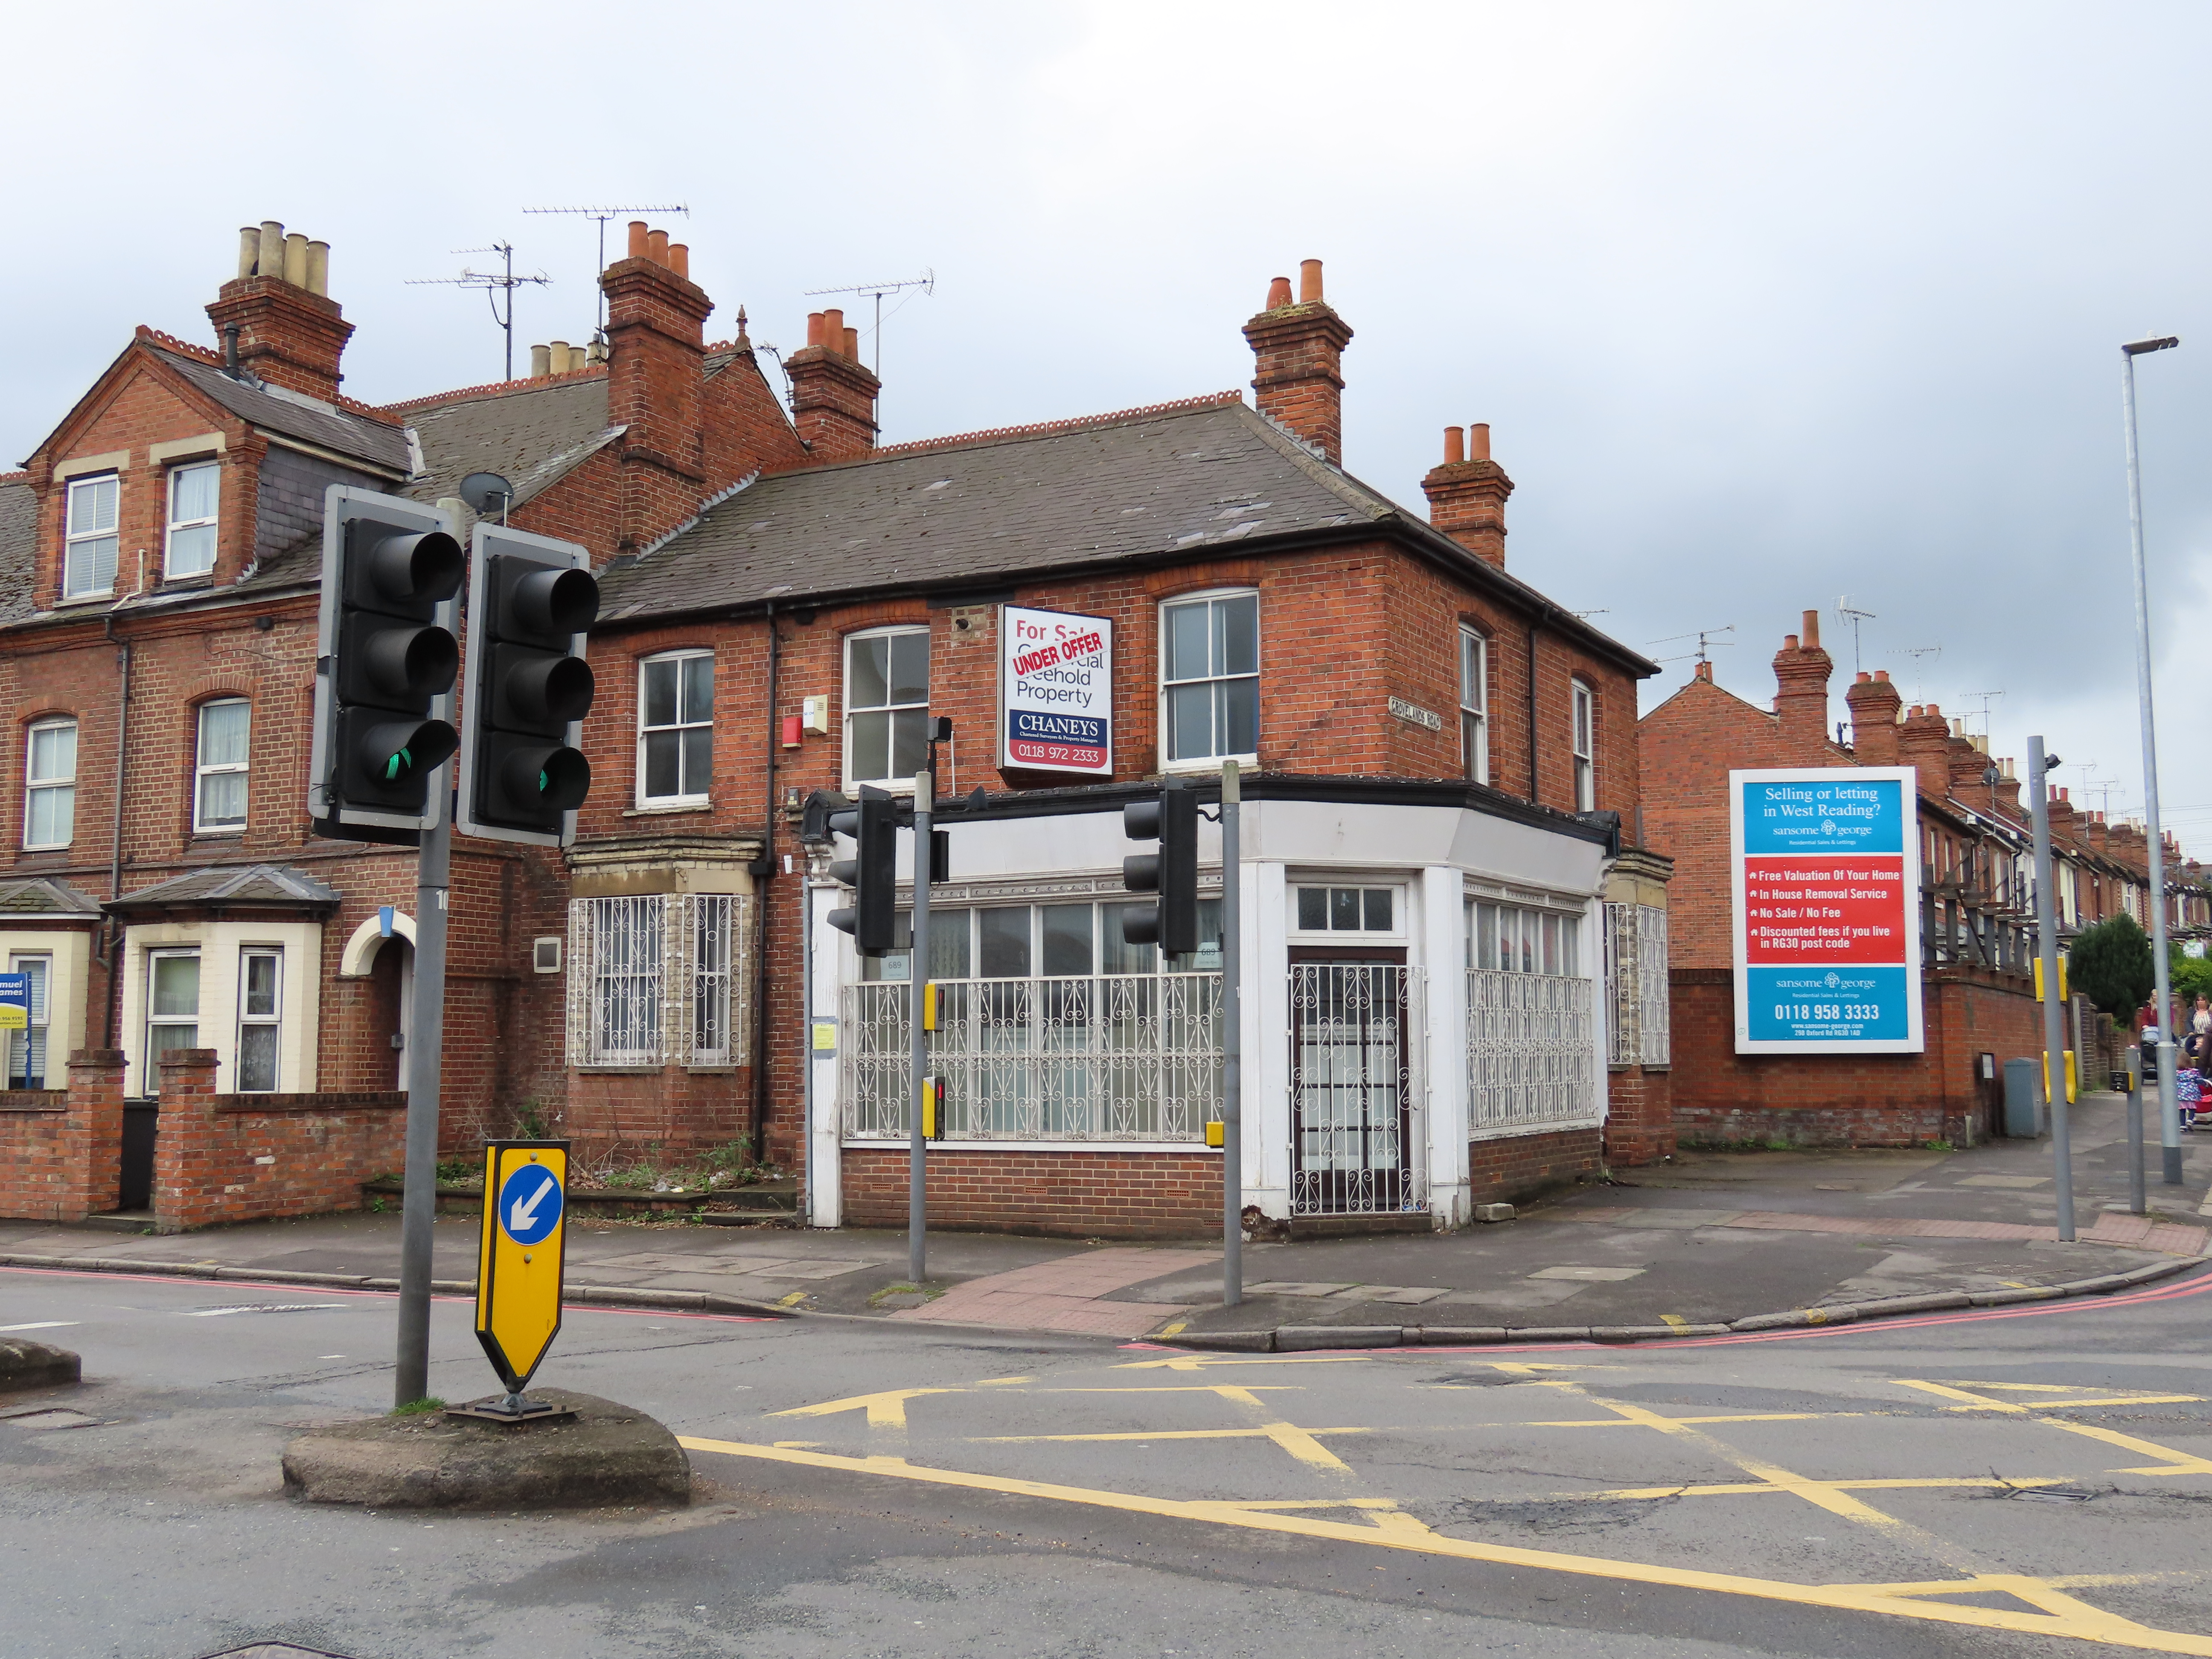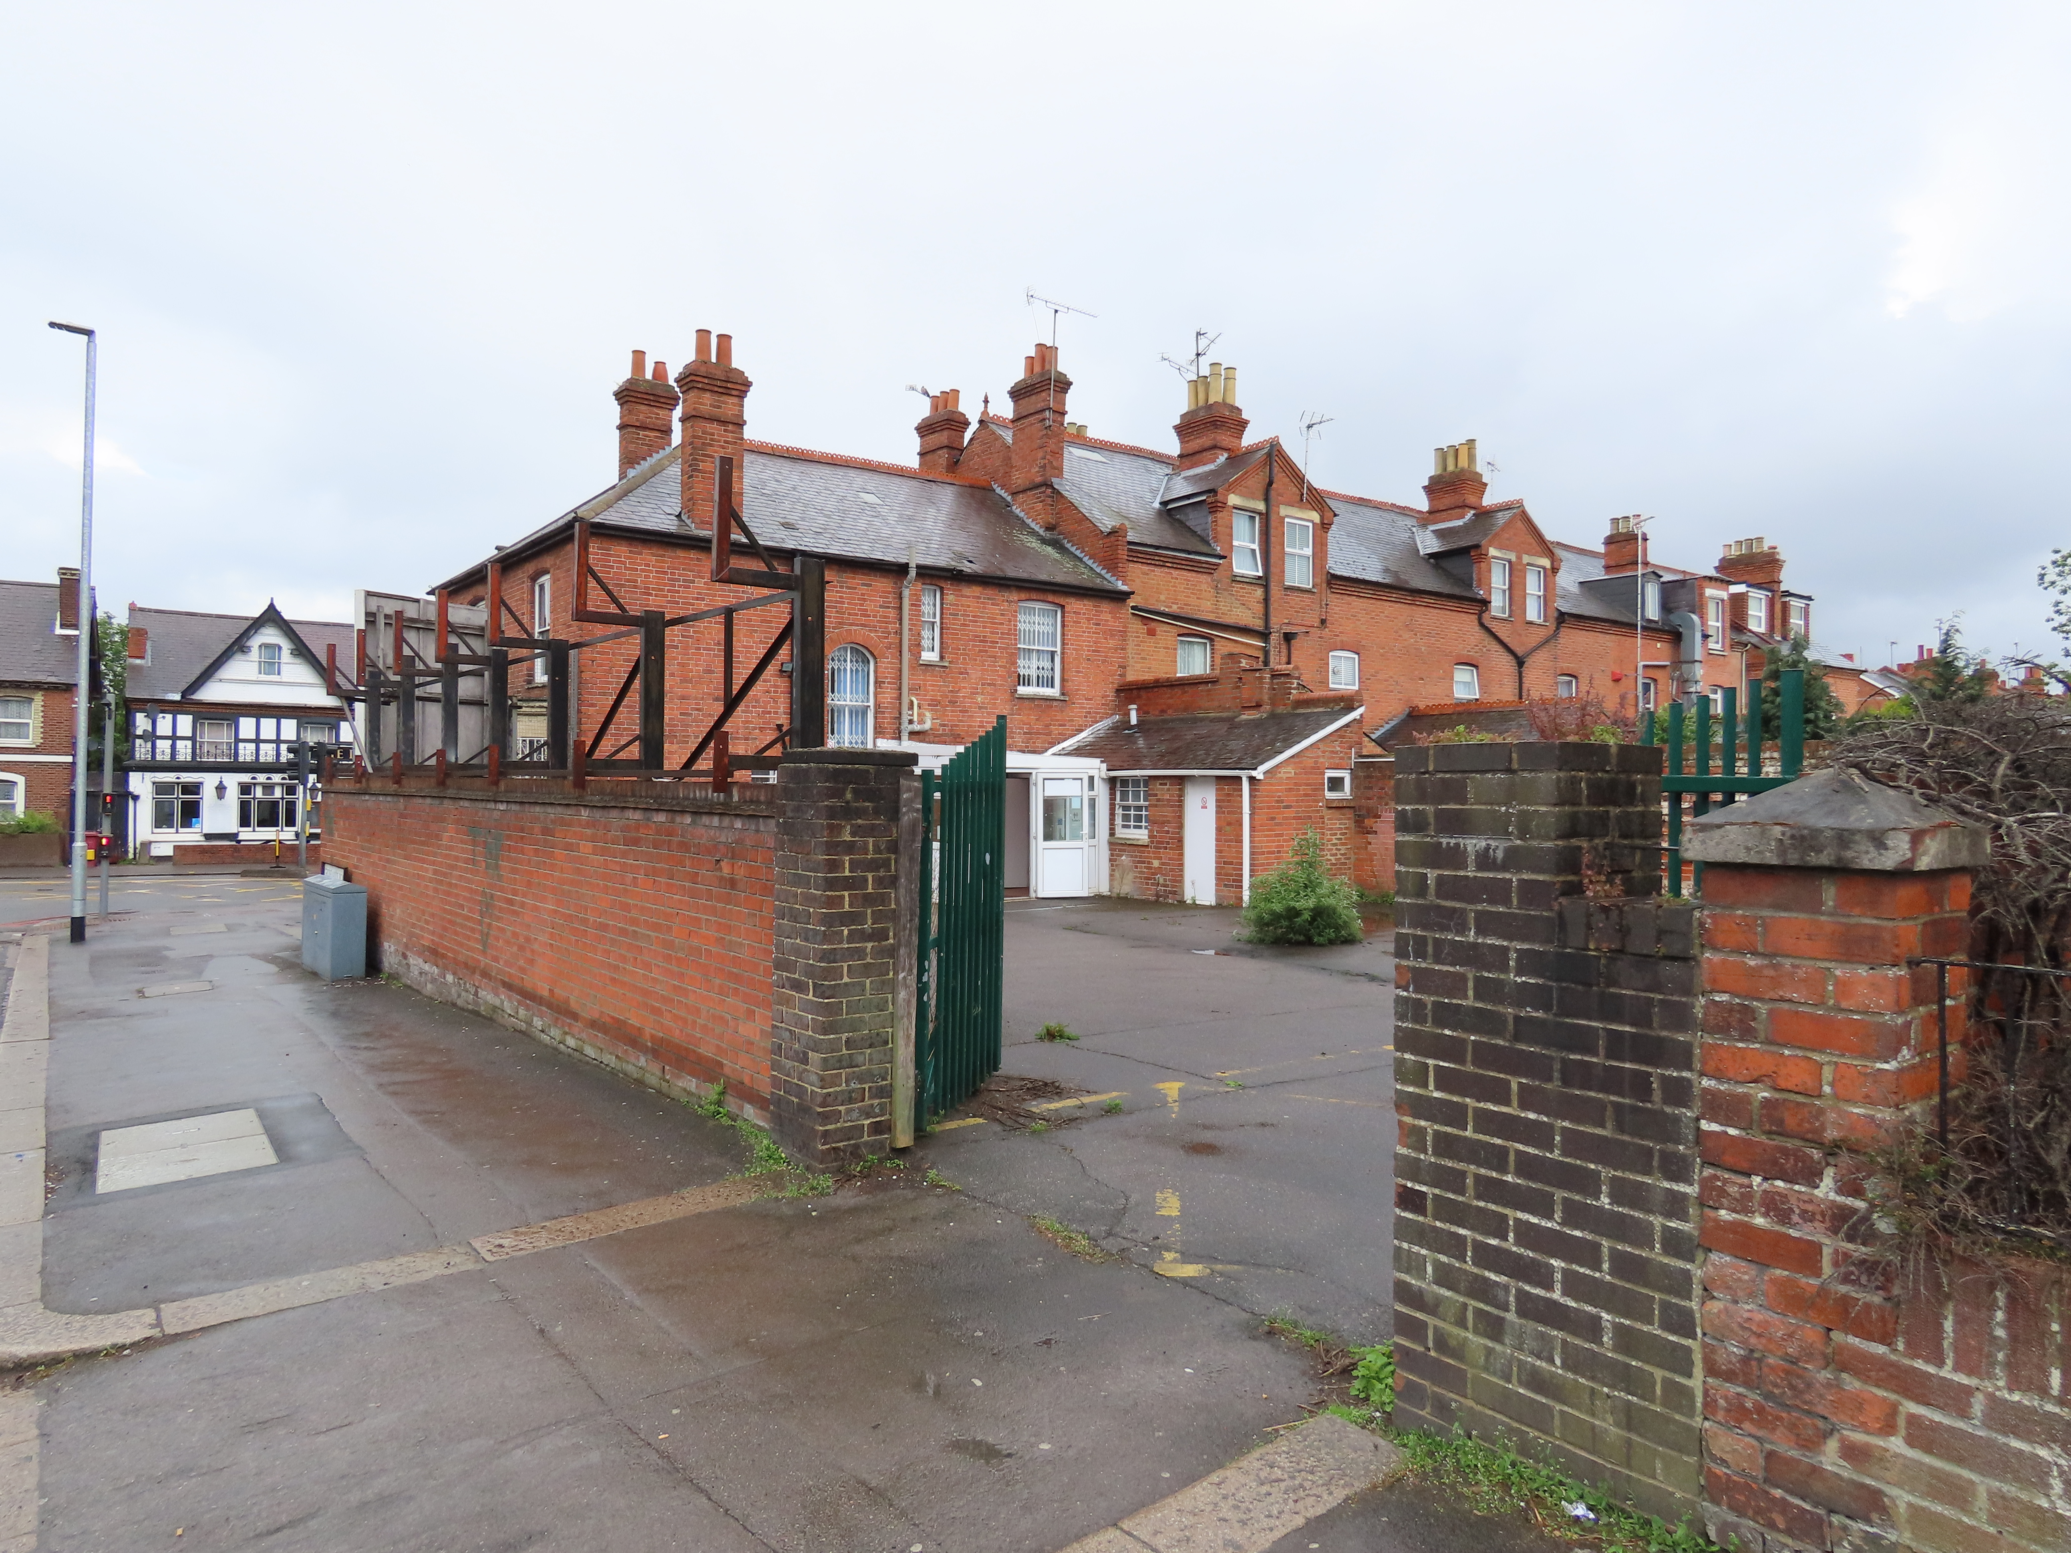

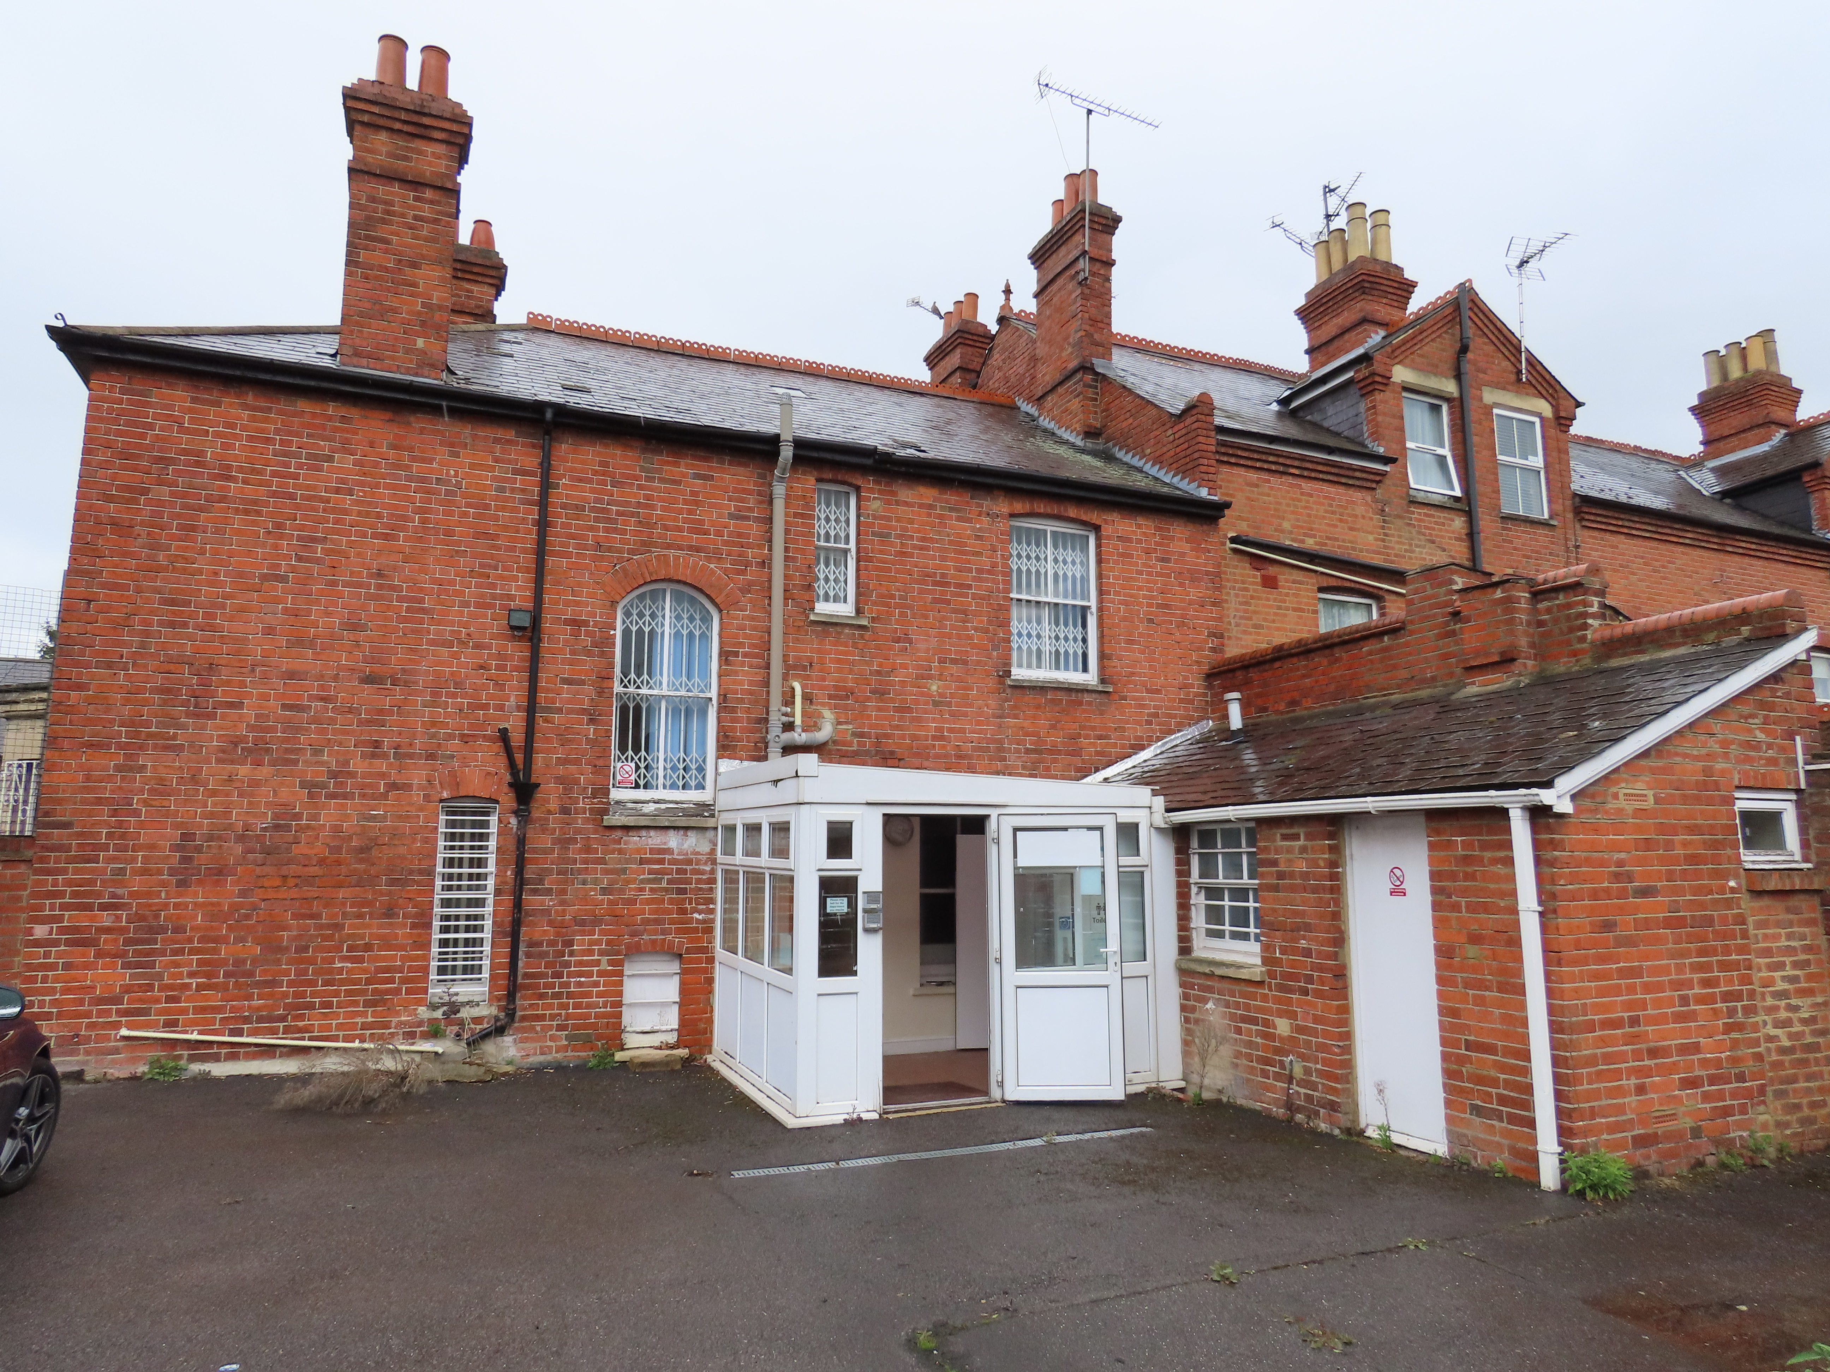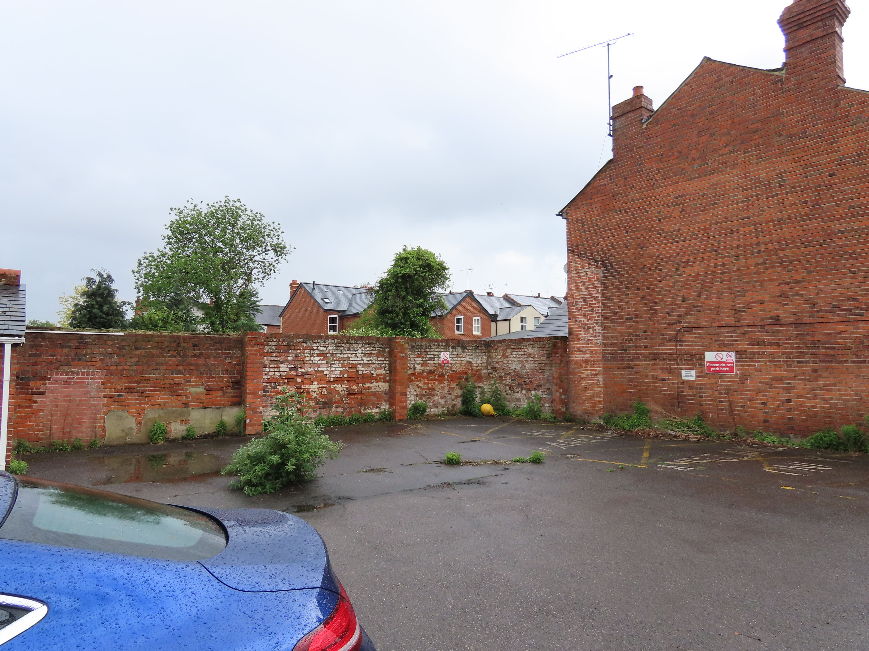

Proposal & Background:
- Change of use from D1 to B1 office for part of ground floor (front glazed corner section) and the remainder for C3 dwelling. The B1 office would be 27.5sqm with independent toilet and kitchen, and would be blocked off from the remainder of the building. Access would be via the corner door to the front. Access to the C3 use would be from Oxford Road.
- Demolition of the existing rear glazed entrance structure and replacement with a flat roofed single storey extension 3.7m deep (increase of 1.2m deep over existing), 3.04m wide, and 3.5m high.
- Rear garden and 3 no. parking spaces.

Materials would be to match existing.

Plans considered: All received 13th March 2019:
- Existing Plans & Elevations – Drawing no: 01
- Proposed Plans & Elevations – Drawing no: 02

Other documents:
Letter from agent Greg Farrell, dated 29th March 2019
Letter from Chaneys Chartered Surveyors, dated 29th March 2019
Chaneys marketing material for the application site

Amended plans received 29th March 2019:
Proposed Plans & Elevations – Drawing no: 02 Rev A
Proposed Plans & Elevations – Drawing no: 02 Rev B

Amended plans received 3rd June 2019:
Proposed Plans & Elevations – Drawing no: 02 Rev E

Relevant Planning History:
TP5964 – Use of first floor as offices and stores – Approved 6/10/1967
77/273 – Shopfront modernisation – Approved 7/4/77
99/0580 - Change of use from Class B1 to Class D1 (Offices to Day Care Facility for People with Learning Difficulties) – Approved 19/11/99 (committee decision)

Consultation Responses: Nos. 687, and 687 (flat) Oxford Road and 1 Grovelands Road were consulted and site notice was displayed. No comments were received.

Environmental Protection and Nuisance: Standing Advice C relates to ‘Small residential developments or conversions – Minor Category 9 dwellings or less – near busy road or near land use of noise/air quality concern’

Noise impact on development - A noise assessment should be submitted in support of applications for new residential proposed in noisy areas.

The noise assessment will be assessed against the recommendations for internal noise levels within dwellings and external noise levels within gardens / balconies in accordance with BS 8233:2014 and WHO guidelines for Community Noise. The report should identify any mitigation measures that are necessary to ensure that the recommended standard is met.

Where appropriate, the noise assessment data should also include noise events (LAMax) and the design should aim to prevent noise levels from noise events exceeding 45dB within bedrooms at night. Noise levels above 45dB are linked with sleep disturbance.

Internal noise criteria (taken from BS8233:2014)
Room | Design criteria | Upper limit
Bedrooms (23:00 to 07:00) | <30dB LAeq,8hour
Living rooms (07:00 – 23:00) | <35dB LAeq,16hour
Gardens & Balconies | <50dB LAeq,T | <55dB LAeq,T

A condition for the submission of a noise assessment is recommended.

Air Quality - Increased exposure - The proposed development is located within an air quality management area that we have identified with monitoring as being a pollution hot-spot (likely to breach the EU limit value for NO2) and introduces new exposure / receptors. An assessment and/or mitigation measures should be provided as part of the application.

The applicant will need to demonstrate sufficient mitigation measures are implemented to protect the residents from the effects of poor air quality.

Where the development involves converting an existing building and allowing a buffer zone is not an option then it may be that other mitigation can be applied. In the first instance this would be to implement measures to reduce the level at the facade of the property by creating a barrier between the property and the carriageway, such as close boarded fencing or planting vegetation.

If this is not possible then locating habitable rooms away from the source of pollution or the use of mechanical ventilation with the inlet on the clean side of the property may be acceptable. This list of potential measures is by no means an exhaustive list.

Mitigation against increased exposure:
- Mechanical ventilation – inlets from the ‘clean’ side of the development, long term maintenance needs to be addressed
- Buffer zones – consider increasing distance of the building façade from very busy roads
- Habitable rooms – consider placing stairwells, corridors and bathrooms on the façade fronting pollution source
- Mixed use – locate any sensitive uses on higher floors, allowing commercial use on lower elevations
- Balconies – consider avoiding use in areas of exceedence, especially on ground and first floor level
- Non-opening front windows – this should only be considered in certain circumstances, needs to be balanced against loss of freedom for future occupants

Reading Borough Council’s Air Quality Policy DM19 requires that developments have regard to the need to improve air quality and reduce the effects of poor air quality through design, mitigation and where required planning obligations to be used to help improve local air quality.

A condition for the submission of an air quality mitigation scheme is recommended.

Transport: This application is for a change of use from D1 to B1 for ground floor office and to C3 residential for the remainder of the building. The B1 use consists of 27.5sqm and the C3 use comprises of an open plan kitchen/ dining room and separate family room on the ground floor and 4- bedrooms on the first floor.

The site is located within Zone 3, Secondary Core Area, of the Council’s adopted Parking Standards and Design SPD. Typically these areas are within 400m of a Reading Buses high frequency ‘Premier Route’, which provides high quality bus routes to and from Reading town centre and other local centre facilities.

In accordance with the adopted SPD, the B1(a) use would be required to provide 1 parking space per 50sqm and the residential use would be required to provide 2 parking spaces.

There is an existing vehicular access into the site off Grovelands Road. The plans (Drawing 02-B) demonstrate that 3 parking spaces can be accommodated within the site which complies with the Council’s parking standards. 2 of these parking spaces should be allocated to the residential dwelling and 1 space for the B1 use.

No information has been provided on cycle storage but to ensure access is provided to alternative modes of transport, some form of cycle storage should be provided for the residential element of development. Therefore, we require additional information to confirm that the cycle parking provision meets the Council’s adopted standards. I am, however, happy for this to be dealt with by way of a condition.

No details regarding the bin storage facility for both the residential and office use has been submitted. However, I am also happy to deal with this by condition.

In view of the above, there are no transport objections subject to conditions DC1 - Vehicle parking space provided in accordance with approved plans, DC5 - Bicycle parking – plans to be approved and bin storage.

Equality Act 2010:
In determining this application the Council is required to have regard to its obligations under the Equality Act 2010. However, there is no indication or evidence (including from consultation on the application) that the protected groups identified by the Act have or will have different needs, experiences, issues and priorities in relation to this particular planning application. Therefore in terms of the key equalities protected characteristics it is considered there would be no significant adverse impacts as a result of the development.

Relevant Planning Policy and Guidance:
Section 38(6) of the Planning and Compulsory Purchase Act 2004 requires that proposals be determined in accordance with the development plan unless material considerations indicate otherwise. Material considerations include relevant policies in the National Planning Policy framework (NPPF) - among them the 'presumption in favour of sustainable development'.

The following local and national planning policy and guidance is relevant to this application:
National Planning Policy Framework
National Planning Guidance

Reading Borough Local Development Framework Core Strategy Document, 2008 (altered 2015).
Policy CS1: Sustainable Construction and Design
Policy CS2: Waste Minimisation
Policy CS3: Social Inclusion and Diversity
Policy CS4: Accessibility and the Intensity of Development
Policy CS7: Design and the Public Realm
Policy CS9: Infrastructure, Services, Resources and Amenities
Policy CS14: Provision of Housing
Policy CS15: Location, Accessibility, Density and Housing Mix
Policy CS18: Residential Conversions
Policy CS23: Sustainable Travel and Travel Plans
Policy CS24: Car/Cycle Parking
Policy CS31: Additional and Existing Community Facilities
Policy CS34: Pollution and Water Resources

Reading Borough Local Development Framework: Sites and Detailed Policies Document (2012, altered 2015)
Policy SD1: Presumption in Favour of Sustainable Development
Policy DM1: Adaption to Climate Change
Policy DM3: Infrastructure
Policy DM4: Safeguarding Amenity
Policy DM8: Residential Conversions
Policy DM10: Private and Communal Outdoor Space
Policy DM12: Access, Traffic and Highway-Related Matters

Supplementary Planning Guidance/Documents
A Design Guide to House Extensions (2003)
Revised Parking Standards and Design (2011)
Revised Sustainable Design and Construction (2011)
Residential Conversions (2013)

APPRAISAL:
Main considerations:
The main issues to be considered are:
- Principle of use
- Amenity of proposed residents and existing residents of nearby properties
- Design of the proposed extension
- Car/ cycle parking
- Environmental matters
- Impact mitigation/ infrastructure contributions

- Principle of use
The key issue is whether the loss of a D1 use is acceptable under Policy CS31, which states that “Proposals involving the redevelopment of existing community facilities for non-community uses will not be permitted, unless it can be clearly demonstrated that there is no longer a need to retain that facility.”

The estate agent, Chaneys, provided a letter (dated 29th March 2019), which sets out the process of marketing which took place from August 2017. Initially it was marketed as a rental property, and the only interest from a D1 user was from a nursery. However, they did not pursue it further because of substantial building works they would have required to make the building suitable. There was no other strong interest from any other parties. The property was vacant for nearly a year and the owner decided to sell it, and marketing commenced in July 2018. It was marketed as a D1 use with the potential for residential or other uses subject to planning permission. There was no interest from any D1/ community users. The applicant came forward seeking to pursue a mixed residential and office use, the latter for his own building company.

It is considered that reasonable efforts have been made to market the property for an ongoing D1 use, however it would appear that the premises does not provide the type of accommodation sought by a range of D1 users and on balance its loss and change of use to residential and office use would be a reasonable approach. This would meet policy requirements of CS14 in providing additional residential accommodation. Indeed the property would have originally been largely in residential use, and the site is located adjacent to a row of existing terraced houses. The proposed C3 use would provide a good sized (158sqm) 4 bedroom family house. The office use at ground floor would provide some commercial use at the ground floor, in a similar vein to its historic use as a shop unit.

The principle of the change of use is therefore acceptable subject to meeting other policy requirements below.

- Amenity of proposed residents and existing residents of nearby properties
With respect to amenity policies DM4 and DM10 of the Sites and Detailed Policies Document are relevant.

Noise – It is likely that with respect to the proposed residential use this would create less noise and disturbance than the previous D1 use. With respect to the proposed office use, the applicant intends to use this for his own business and anticipates limiting this to two days per week. Even if this were used more frequently this would be unlikely to have a significant detrimental effect with respect to noise and disturbance as it is located with its entrance with good separation from the residential use and separated from the remainder of the ground floor by an internal corridor. There would one space

External windows – All habitable rooms do benefit from external windows.

Amenity Space – A rear garden is proposed and would be of a sufficient size to serve the proposed residential use and would be consistent with the overall level of amenity space at existing residential properties adjacent to the site.

Layout/Stacking of Rooms –The layout is relatively traditional with bedrooms at first floor and living accommodation on the ground floor and is therefore considered to be acceptable.

Bin storage – A bin storage area is shown on the plan in the rear garden, which is considered acceptable. A condition is recommended to ensure this is provided and retained.

c) Design of the proposed extension
The proposed rear extension is largely on the footprint of the existing glazed entrance structure. It would have no effect on privacy or overlooking, and would not be visually dominant or overbearing, and would be of an appropriate design, and it is therefore considered that it would accord with policy (DM4, DM9).

d) Car/ cycle parking
Transport has confirmed that the proposed three car parking spaces would meet adopted standards. A condition is recommended which requires the provision and retention of the spaces with one for the office use and two for the residential use.

Cycle storage is shown on the plan within the rear garden and a condition is recommended to ensure this is provided and retained.
e) Environmental matters

The proposed scheme is within an Air Quality Management Area and Policy DM19 requires that developments have regard to the need to improve air quality and reduce the effects of poor air quality through design and mitigation to help to improve local air quality. The EP&N standing advice is that mitigation is required for developments which introduce sensitive receptors (which includes residential) and suggests some examples (as set out above). The proposed site offers limited or no opportunities for mitigation. The proposed layout is likely to be similar to the property’s original residential layout and this combined with the location of existing windows restrict the opportunity to have stairwells and corridors adjacent to the facades facing the roads. The proposed scheme includes reintroducing a front boundary to Oxford Road with planting. This would provide a small barrier between the property and the highway.

In terms of noise it is proposed that windows would be improved and a condition is recommended requiring measures to be implemented prior to occupation.

f) Impact mitigation/ infrastructure contributions
The development would involve the change of use of existing D1 use to residential and office use. The C3 use would be CIL chargeable. An informative is included.

As the conversion involves the provision of 10 or fewer dwellings then no affordable housing contributions are required under Policy DM6.

RECOMMENDATION:

APPROVE

- TL1 – standard time limit
- AP1 – approved plans: Proposed Plans & Elevations – Drawing no: 02 Rev E, received 3rd June 2019
- M1 - Matching materials
- DC1 - Vehicle Parking Spaces
- DC3 - Bicycle parking
- DC6 - Bin storage
- Prior to occupation measures shall be implemented to protect the building from the external noise environment of the area, including improved windows, boundary fence and planting to the front, as shown on the approved plan. The scheme itself shall be designed, specified and constructed so that the sound insulation performance of the structure is such that the indoor ambient noise levels accord with guidance within BS 8233:2014 (Guidance on Sound Insulation and Noise Reduction for Buildings).

Reason: to protect the amenity of future occupants of the proposed development in accordance with Policy DM4.

Informatives:
IF5 - Terms & Conditions
IF6 – Building Control
IF3 - Highways26
I11 - CIL
IF7 - Complaints about construction& demolition noise and dust
IF1- Positive and proactive

