Delegated Application Report - Application No.: 190308
Address: Land off Rushley Way and Whale Avenue, Kennet Island
Proposal: Landscape Improvement Works
Case officer: Alison Amoah
Target Date: 24th April 2019 (extended)

Site Description and Surrounding Area: The site comprises an area to the north of Whale Avenue (in Kennet Island), one of the primary streets within the development, which is adjacent to a community space ‘The Meeting Point’, and an area to the south of the road which is existing public realm.

The site is surrounded by existing residential flats and houses and to the south the Circle Hospital.

There are existing on street parking spaces and a bicycle hub for ‘Readi Bikes’.

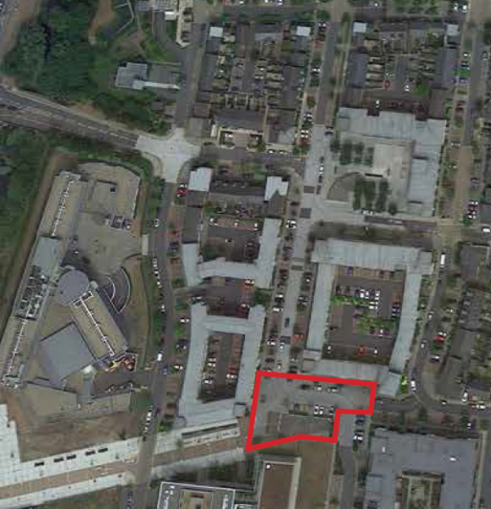

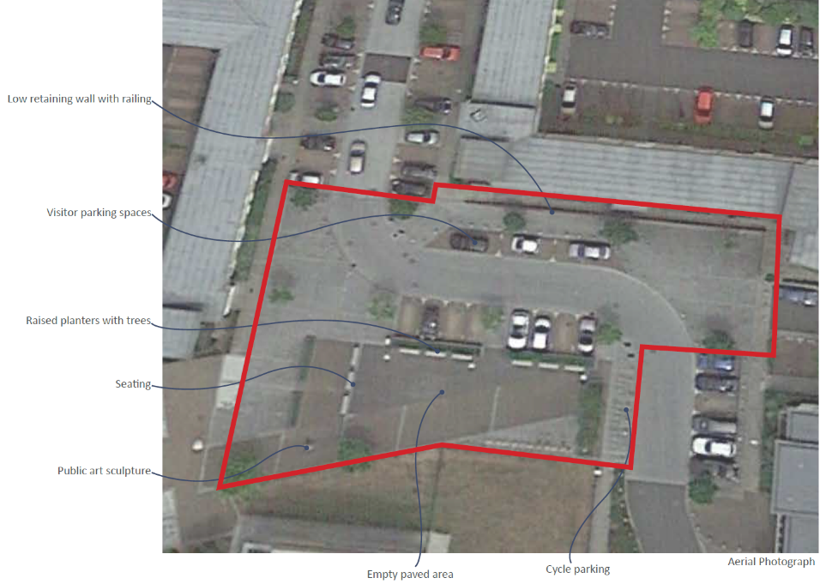
Proposal: The proposal is to create two separate community spaces. To the north of Whale Avenue an open terrace adjacent to the community building. To the south a semi-enclosed space for recreation.

The northern part would be enlarged by relocating the existing visitor parking spaces to the south side of the road. The wall and railings would be replaced with wide steps.

The southern part would include:
- New raised planter
- Some of the existing trees to be replaced with new trees and planted with greater soil volumes
- 2 no. pergolas for shelter
- Soft landscaping area with play features
- Public art relocated with seating around it
- Cycle hire parking re-located to the western side of Whale Avenue

Plans considered: As received 25th February 2019:
- Site Location Plan – Drawing no: 2825-LA-05 Rev P1
- Existing Site Plan – Drawing no: 2825-LA-06 Rev P1
- Planting Plan – Drawing no: 2825-PP-02 Rev P1
- General Arrangements Plan – Drawing no: 2825-LA-07 Rev P1
- Kennet Island – Whale Avenue Enhancements - Landscape Design Report, document reference 2825-RE-03, dated February 2019, prepared by Allen Pyke Associates

Amended received 5th March 2019:
- Existing Site Plan – Drawing no: 2825-LA-06 Rev P2
- Planting Plan – Drawing no: 2825-PP-02 Rev P2
- General Arrangements Plan – Drawing no: 2825-LA-07 Rev P2

Amended received 22nd March 2019:
- General Arrangements Plan – Drawing no: 2825-LA-07 Rev P3

Amended received 12th April 2019:
- General Arrangements Plan – Drawing no: 2825-LA-07 Rev P4
- Planting Plan – Drawing no: 2825-PP-02 Rev P3
- Kennet Island – Whale Avenue Enhancements - Landscape Design Report, document reference 2825-RE-03, dated April 2019, prepared by Allen Pyke Associates

Amended received 18th April 2019:
- Kennet Island – Whale Avenue Enhancements - Landscape Design Report, document reference 2825-RE-03, dated April 2019, prepared by Allen Pyke Associates

Amended received 24th April 2019:
- General Arrangements Plan – Drawing no: 2825-LA-07 Rev P6
- Planting Plan – Drawing no: 2825-PP-02 Rev P4

Relevant Planning History:
Part of the overall Kennet Island Development originally approved under:
05/00548/OUT | Mixed use development comprising up to 1,150 new homes, offices (126,000 sq m), hotel, retail and community uses including cafes, bars, restaurants and health and fitness studios, open space and associated infrastructure including a pedestrian and cycle bridge link across the A33. | Approved subject to s106 (18 September 07).

Consultation Responses: Three site notices were displayed. No comments were received.

Environmental Protection and Nuisance: No objections.

Leisure: We are happy with the proposals and have no objections.

Natural Environment: “Overall, the proposal will be an improvement to the current situation. However, I have a few points that need to be addressed.

With reference to the Landscape Design Report dated February 2019, Existing Site Plan 2825-LA-06 P2, General Arrangements Plan 2825-LA-07 P2 and Planting Plan 2825-PP-02 P2:

There is a significant element missing from the Landscape Design Report and that is an assessment of the existing vegetation / trees. From looking at Google Street View it appears that there is a least one tree which appears to be in poor condition (relative to others) that is proposed to be retained and others that appear to be in good condition that are to be removed and replaced. Clearly, this proposal is an opportunity to replace any trees that are failing to thrive and an assessment of the existing tree condition may help inform a decision of whether to try and incorporate particular trees and identify species that are not as successful as others. This information is required.

The proposal will result in the overall loss in tree number by one, which is not desirable, when it appears there is space within the scheme to accommodate another tree in the southern side.

I note that the existing Birch in the raised planter (south side) is to be replaced with 3 Amelanchier. It would appear from Google Street view that the Birch are struggling, with dieback present. I suspect this will be due more to the inappropriate planter/tree pit design rather than species. This raises the question of how the Amelanchier is going to fare any better when the existing planter is proposed for re-use?

In relation to the tree species used, they are all relatively small, upright form trees which does not fully utilise the canopy spread space available in the southern part at least. I assume they have been proposed for consistency? They are generally bee friendly species/varieties, although I would suggest that Sorbus aucuparia Joseph Rock is substituted with a Sorbus producing red berries which are more attractive to birds.

With regard to the remainder of the Play area, I note the more naturalistic play approach which I would suggest conflicts with the artificial grass proposed. Artificial grass should in any case be discouraged on ecological grounds – GS Ecology has raised concern about its use on other sites.

No details of tree pits have been provided and will be required – differentiating between those in soft landscape areas and those in area landscape areas, the latter requiring underground structural tree pits to ensure adequate soil volume and working around any services present. I assume the location of services has been established prior to proposing new tree locations?

Fuller details of the hard landscape elements will also need to be secured, if you don’t feel it necessary to have them prior to a decision.”

Planning Officer note: The applicant provided further details and amendments summarised as follows (rec 12/4/19):
- Amended Landscape Statement which includes an assessment of the existing vegetation and trees.
- Amelanchier considered to do better than the Birch in the planter, because it has a smaller ultimate size and requires less water than Birch.
- Extra tree in the south grass area.
- Amendment of tree species; and
- Change from artificial grass to real grass.

The applicant also requested that tree pit details be conditioned as they would take some time to prepare and in any case no new trees are proposed in hard landscaping, so a structural cell system should not be necessary. With regard to services they do not anticipate any conflicts however, if required services would be diverted as necessary to facilitate the scheme.

The Natural Environment Officer provided the following further comments:

“I note that the revised Landscape Design Report now includes a section (two pages) on the existing trees. Looking at Google St View, the conditions of the trees from this (dated June 2018 when trees can be seen in leaf, which makes assessment of their condition easier) does not appear to tie up with that indicated in the LDR (page 8).

When compared to each other, i.e. comparing those classified as poor, average or good:
- Trees 1 & 2 are indicated as in ‘average condition’ but google st view indicates good condition, albeit the growth of tree 1 appears to be stunted when compared to 2:
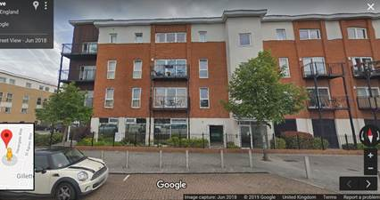

- Trees 4, 5, 7 & 8 are all indicated to be in ‘good condition’ but Google St view indicates 4, 5 & 7 to be only ‘average condition’ at best (5 & 4 in foreground, left; 7 below right – all showing dieback):
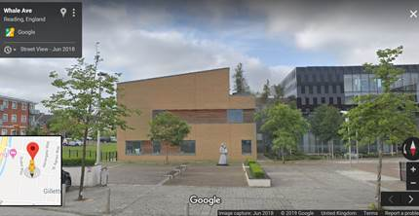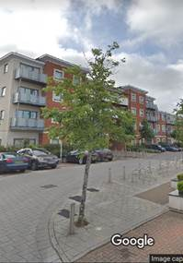

- Trees 9 (two trees) are deemed to be in poor condition but from Google St view would appear to be in average-good condition:
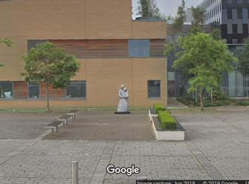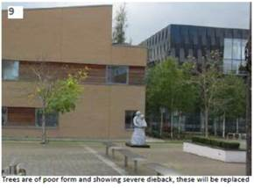
However, I note the photo of trees 9 on page 9 of the LDR (above, right) and assume the LDR photo must have been taken maybe late summer or recently if the trees are in leaf already, i.e. after the Google capture date? - there is an extreme difference in the apparent condition of the trees between the two photos.

Given the above anomalies, it would be useful to seek clarification.

The LDR indicated trees 4,5,7 & 8 are to be retained, however the landscape proposals show tree 5 would have to be removed. If retained, trees 4, 5, 7 & 8 are proposed to be subjected to ‘selective canopy pruning’. It would be useful to know what this is envisaged to be.

It is agreed (from Google St view images) that the removal of trees 3, 6, group 10 is reasonable due to poor condition or dieback.

I note that an additional tree is now proposed such that 10 are to be removed and 10 replaced so tree planting number is now acceptable.

I note the substitution of the previous Sorbus for another as requested. Species are now fine, albeit all narrow so not utilising the space available. As previously stated, I assume this is for consistency.

I note the explanation for the replacement of Birch in the raised planter with Amelanchier due to the restricted rooting environment, Amelanchier being smaller. I would suggest that additional maintenance will be required due to the use of a planter in terms of watering and fertilisation. Maintenance can be conditioned.

I note the inclusion of grass instead of artificial turf, which is a definite improvement to soften the area.

Tree pit details can be conditioned, as suggested, along with services routes.”

Planning Officer note: Further clarification was provided and an amended Landscape Design report (rec 18/4/19), following which the Natural Environment Officer confirmed that subject to the following conditions the scheme is acceptable: hard and soft landscaping, tree pit details, services, landscape maintenance, implementation and replacement planting.

Transport: Original comments were as follows:

- “Visitor parking space No. 3 is not the required width of 2.4m and therefore is not acceptable.
- The cycle hire docking station is to be relocated but the proposed location will obstruct pedestrian movement travelling east to west and therefore is not acceptable.

Revised plans are therefore required to address the above points prior to the determination of the development.”

Planning Officer note: Following the submission of amended plans and further clarification, Transport confirmed that “.. the car parking spaces are deemed acceptable although it is noted that the block paving does indicate a smaller parking space but I am happy to accept it. In terms of the cycle hire location I still think this will restrict pedestrian movement and will also require users to walk into the carriageway to remove a bicycle. I would be happy to accept a planning condition requesting that a revised plan is submitted identifying a relocated position for the cycle hire.”

A condition has been included requiring the submission and approval of a revised location.

Equality Act 2010:
In determining this application the Council is required to have regard to its obligations under the Equality Act 2010. However, there is no indication or evidence (including from consultation on the application) that the protected groups identified by the Act have or will have different needs, experiences, issues and priorities in relation to this particular planning application. Therefore in terms of the key equalities protected characteristics it is considered there would be no significant adverse impacts as a result of the development.

Relevant Planning Policy and Guidance:
Section 38(6) of the Planning and Compulsory Purchase Act 2004 requires that proposals be determined in accordance with the development plan unless material considerations indicate otherwise. Material considerations include relevant policies in the National Planning Policy framework (NPPF) - among them the 'presumption in favour of sustainable development'.

The following local and national planning policy and guidance is relevant to this application:

National Planning Policy Framework
National Planning Guidance

Reading Borough Local Development Framework Core Strategy Document, 2008 (altered 2015).
Policy CS1: Sustainable Construction and Design
Policy CS4: Accessibility and the Intensity of Development
Policy CS7: Design and the Public Realm
Policy CS24: Car/Cycle Parking
Policy CS28: Loss of Open Space
Policy CS29: Provision of Open Space
Policy CS31: Additional and Existing Community Facilities
Policy CS36: Biodiversity and Geology
Policy CS38: Trees, Hedges and Woodland

Reading Borough Local Development Framework: Sites and Detailed Policies Document (2012, altered 2015)
Policy SD1: Presumption in Favour of Sustainable Development
Policy DM4: Safeguarding Amenity
Policy DM10: Private and Communal Outdoor Space
Policy DM12: Access, Traffic and Highway-Related Matters
Policy DM16: Provision of Open Space
Policy DM18: Tree Planting

Supplementary Planning Guidance/Documents
Revised Parking Standards and Design (2011)

Appraisal:
The main issues to be considered are:
- Suitability of open space proposals and community function
- Effect on car/ cycle parking

- Suitability of open space proposals and community function
The existing site comprises a mix of landscaping, parking spaces, and open space adjacent to, and to the south of, the existing community space.

The applicant has advised that the open space here is currently rarely used and the community space, which can be hired out by residents, is not well used. The open space, to the south of Whale Avenue lacks purpose. It contains a large number of benches, but has no clear function. There is public art, but this is poorly sited and does not create a strong focal point. There is limited soft landscape.

This application has been put forward as the compensation scheme for the loss of open space, which would result from the proposal (under ref: 180543) to replace the temporary marketing suite with flats (to the north-west of the site).

The proposed scheme under this application (190308) would, through replacing the railings and wall with wide steps, and relocating parking spaces, enlarge the area adjacent to the community building, and would provide a bigger and more flexible space which could be used for seating, stands etc, so could be used for outdoor gatherings. It is considered that this would create a more active and positve space infront of ‘The Meeting Point’ and by being a more active frontage would contribute positively to the streetscene.

The south area would provide an area of grass, informal play and seating areas and pergolas for shelter. In addition it is proposed to relocate the public art combined with seating to create a greater focal point. It is considered that the overall proposals would enhance the space both in terms of its use, but also its overall appearance.

Although this compensation scheme is not the same type of open space as that which would be lost by the development of the marketing suite for flats, it is considered to meet policy requirements under policy CS28. This Policy allows compensation to include “improvements to recreational facilities on remaining open space…” and in the supporting text states that “appropriate replacement space should be provided where it is easily accessible to the people most affected by the lost space..” and that “compensating improvements could be made to existing open space in the area.”

The proposed open space scheme would enable the improvement of the layout, planting and appearance of an existing area of public realm, and would assist in intensifying the use of the space, consistent with one of the recommendations of the Reading Open Spaces Strategy. In addition it would enable the potential for an improved community space, through the enhancement of its external space, thereby meeting the overall thrust of Policy CS31.

The overall landscaping proposals are considered acceptable by Natural Environment subject to conditions.

Leisure have confirmed acceptance of the overall proposals. A condition is included to ensure that further details of the proposed furniture, play equipment and pergolas (as shown in the Landscape Design Report) is submitted and approved.

- Effect on car/cycle parking
The proposed scheme includes for the relocation of existing visitor parking spaces, to the south of Whale Avenue, which Transport has confirmed is acceptable. With respect to the relocation of the Readibike cycle hire stands a condition is included for the submission and approval of a suitable location. There would be no loss of car or cycle parking spaces and Transport has confirmed that the scheme is acceptable and accords with policies CS23 and CS24.

RECOMMENDATION:

APPROVE

- TL1 – 3 years

- AP1 – Approved Plans:
The development hereby permitted shall be carried out in accordance with the following approved plans:

Received 24th April 2019:
- General Arrangements Plan – Drawing no: 2825-LA-07 Rev P6
- Planting Plan – Drawing no: 2825-PP-02 Rev P4

- DC1 - Vehicle parking space provided in accordance with approved plans
- The existing cycle hire docking station to be retained until the submission to and approval in writing by the Local Planning Authority of its revised location.
- L2a - Submission of hard and soft landscaping details with respect to services, plant establishment details and tree pits.
- L2b – Landscaping implementation
- L3 – Landscaping maintenance
- L5 – Landscape Management Plan details
- Details of the proposed furniture, play equipment and pergolas (as indicated on the approved General Arrangements Plan Drawing no: 2825-LA-07 Rev P6), to be submitted to and approved in writing by the Local Planning Authority and installed in accordance with the approved details and retained thereafter.

Informatives:
- IF5 - Terms and Conditions
- IF3 - Highways
- IF1 - Positive and Proactive

