DELEGATED APPLICATION REPORT - Application Nos.: 181563/ADV
Target Expiry: 10/12/2018
Address: Costa Coffee, Worton Grange
Proposal: 17 no. signs, 8 no. illuminated, 9 no. non-illuminated - mix of fascia, pole, directional, parking and height barrier signs.
Officer: Alison Amoah

Site Description and Surrounding Area:
The application site forms part of the overall mixed use scheme at the former Worton Grange (‘The Gateway’). Costa Coffee (Drive Thru - Unit F) is located at the western side, with an elevation towards the A33.

Proposal:
- 4 no. left directional signs (2xleft; 2x right) – ‘Costa Drive Thru’. 1450mm high (ground to top of sign), max 800m wide. Non-illuminated. Aluminium panel with reflective vinyl details on steel post.
- 3 no. Parking restriction signs – Sign itself 500mm square on post (height of post to be determined on site (as to be fixed on lamp posts). Non-illuminated. Aluminium panels with vinyl details.
- 1 no. Waiting sign – ‘Costa Drive Thru Waiting Bay’. 1450mm high (ground to top of sign) by max 800m wide. Non-illuminated. Aluminium panel with reflective vinyl details on steel post.
- 1 no. Exit post sign – 1450mm high (ground to top of sign) by max 800mm wide. Non-illuminated. Aluminium panel with reflective vinyl details on steel post.
- 2 no. Double sided key seller sign – (image/words of item/s to vary). 925mm from ground to underside of sign. Sign 1278mm high by 934mm wide, i.e. A0 poster frame fitted to light box with internal LED fluorescent tube illumination. Aluminium. Without menu 1200 cdm2 at face; with menu insert 590 cdm2.
- 2 no. Double sided key seller sign – (image/words of item/s to vary). 925mm from ground to underside of sign. Sign 1278mm high by 934mm wide, i.e. A0 poster frame fitted to light box with internal LED fluorescent tube illumination. Aluminium. Without menu 1200 cdm2 at face; with menu insert 590 cdm2
- 1 no. Double menu, double sided sign - (image/words of item/s to vary). 925mm from ground to underside of sign. Sign 1278mm high by 2000mm wide, i.e. A0 poster frame fitted to light box with internal LED fluorescent tube illumination. Aluminium. Without menu 1200 cdm2 at face; with menu insert 590 cdm2.
- 1 no. Double sided pole sign – ‘Costa Drive Thru’. 8000m high by 2000mm wide on 63000mm steel post. Aluminium and internally illuminated 550-600cdm2 at face.
- 1 no. Fascia tray sign – ‘Drive Thru’ 10500mm wide by 1500mm high. Aluminium tray powder coated with letters cut and backed up with opal acrylic. Internally illuminated 500-600 cdm2.
- 1 no. Wall letters – ‘Costa’ – Individual letters 700mm high. Total width 3470mm. 5650mm from underside of sign to ground. Aluminium backed letters with stainless steel rim and illuminated opal perspex letter faces, internally illuminated 550-600 cdm2 at face.
- 1 no. Tray sign – ‘Costa Drive Thru’ -3300mm wide by 1600mm high. Powder coated aluminium tray with stainless steel outline. Letter cut form tray and backed up with opal acrylic. Internally illuminated 550-600 cdm2 at face.
- 1 no. Height barrier sign with A1 poster sign– ‘Costa Drive Thru’ cantilever height barrier. Double sided, crash bollards and lane closed chain. Aluminium box section with cut out text backed up with opal acrylic internally illuminated with LED 550-600cdm2. Internally illuminated A1 poster frame. Overall height 4000mm and 4500mm wide, with sign portion 500mm high
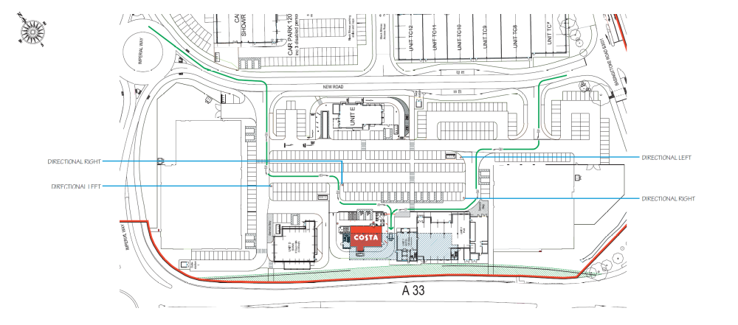

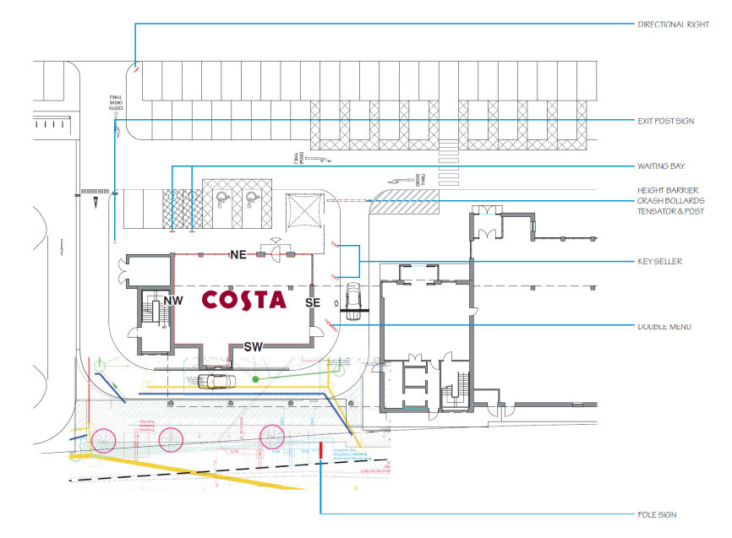

Plans considered: All received 5th September 2018
- Location Plan
- Site Location Plan – Drawing no: 1894-P-20
- Costa Drive Thru Pack Revision 4, prepared by Benson Signs [proposed site plan, elevations & sign details]
- Arboricultural Method Statement and Tree Protection Plan – Document no: 1072687-ARB-D001, Rev A, dated 22nd June 2016, prepared by Mouchel, received 20/11/18 [project wide document]

Relevant Planning History:
151944/FUL – A Hybrid application seeking outline planning permission for the development of up to 175 new homes, including affordable housing(with all matters reserved apart from access), and full planning permission for the development of 12 commercial units in flexible use within Classes B1(c),B2 and B8,two car showrooms with MOT and servicing(Sui Generis), three retail warehouse units (Class A1),120 bed hotel (Class C1),pub with restaurant facility (Class A4),coffee shop (Class A1), restaurant (Class A3), and bank (Class A2). New vehicular access from Basingstoke Road and Imperial Way. Bus stop facilities, hard and soft landscaping and other ancillary development (Summarised Description). Permitted 14/ 4/2016.

Signs within Worton Grange (‘The Gateway’ site)
171498/ADV - No.8 internally illuminated fascia signs, no.1 internally illuminated
projecting sign, no.1 internally illuminated hoarding sign and no.1 – Consent 20/10/17

180161/ADV - No.22 non-illuminated 'To Let' fascia signs and No.12 non-illuminated number signs – Consent 13/3/18

180262/ADV - No. 1 7m high non-illuminated totem sign – Consent 13/3/18

180416/ADV - Consent to display 8 No. Internally illuminated fascia signs to North East, South East, South West and North West Elevations (Wren Kitchens)– Consent 30/4/18

181168/ADV – Display of various illuminated and non-illuminated signage (Burger King)– Consent 4/9/18

Consultation Responses: Bewley Homes were consulted. No comments were received.

Natural Environment: Directional Left sign at the front of Unit F Vs tree (T5): With reference to drawing 24721 showing the location of the proposed sign and to Landscape Proposals Plan Relevant Part 3 P001-1110 Rev 04 (approved under 170024):

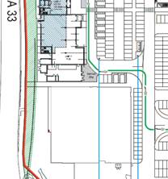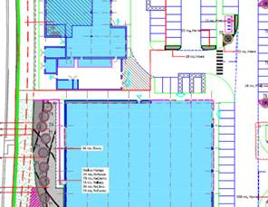

I note that the sign is proposed at 1450mm high. The tree size (Pyrus - 16/18cm girth and min 4.5m high) should have a clear stem above the height of the sign, i.e. the lowest branches should be above this. In that respect, it may be acceptable. However, further information is required to confirm acceptability:
- What underground foundation is required for the sign?
- Is the tree already in place and if so, how will it be protected during the installation of the sign?
- How far apart (given the limited soft landscape bed) does the applicant envisage the tree & sign being?

Directional Right sign at the front of Unit F Vs tree (T9): With reference to drawing 24721 showing the location of the proposed sign and to Landscape Proposals Plan Relevant Part 4 P001-1300 Rev 04 (approved under 170398)

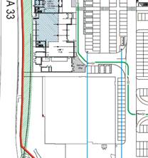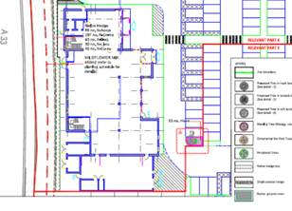

Similarly, there is potential conflict here. The tree in this case (Acer) is smaller at planting, specified at 12-14cm girth, min 3.5m high. It may have a sufficiently high enough lower crown to be above the sign, however it appears that the position of the tree and sign present a conflict. Further comment is required, addressing the same points as above.

Pole sign on the A33 frontage
The pole sign on the A33 frontage does not conflict with approved tree planting, however I assume the applicant is satisfied that it is not being shown in the MRT zone. The approved landscape drawing (left below) has the extent of land required for the MRT shown by a broken red line, which appears to be where the sign is located.

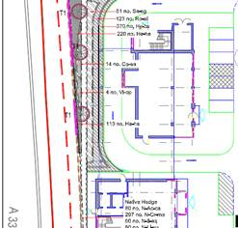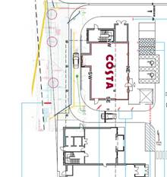

The remainder of the signs directly around the Costa building pose no conflicts.

Planning Officer note: The agent provided further details of underground foundations, an AMS and Tree Protection Report, and confirmation of the land required for MRT not conflicting with the proposed pole sign on A33 frontage. Natural Environment confirmed that all f this was acceptable.

Transport: No objection subject to condition on restriction on illumination.

Equality Act 2010:
In determining this application the Council is required to have regard to its obligations under the Equality Act 2010. However, there is no indication or evidence (including from consultation on the application) that the protected groups identified by the Act have or will have different needs, experiences, issues and priorities in relation to this particular planning application. Therefore in terms of the key equalities protected characteristics it is considered there would be no significant adverse impacts as a result of the development.

Relevant Planning Policy and Guidance
Section 38(6) of the Planning and Compulsory Purchase Act 2004 requires that proposals be determined in accordance with the development plan unless material considerations indicate otherwise. Material considerations include relevant policies in the National Planning Policy framework (NPPF) - among them the 'presumption in favour of sustainable development'.

The following local and national planning policy and guidance is relevant to these applications:

Reading Borough Local Development Framework Core Strategy (2008, altered 2015):
CS7 (Design and the Public Realm)

Reading Borough Local Development Framework Sites and Detailed Policies Document (2012, altered 2015):
DM4: Safeguarding Amenity
DM12: Access, Traffic and Highway-Related Matters
DM22: Advertisements

Legal context:
Regulation 3 of the Town and Country Planning (Control of Advertisements) (England) Regulations 2007 requires the Local Planning Authority to exercise its powers under these regulations in the interests of amenity and public safety taking into account the provisions of the development plan, so far as they are material; and any other relevant factors. Regulation 3 states that factors relevant to amenity include the general characteristics of the locality, including the presence of any feature of historic, architectural, cultural, or similar interest.

Factors relevant to public safety include highway safety and whether the advert would hinder security or surveillance devices, including speed cameras.

Appraisal:
Main Issues: The main issues are considered to be:
(a) Amenity
- Safety

(a) Amenity
Of the signs proposed to be internally illuminated, these would be up to a maximum lux level of 600 cd/m2. The majority of these are set back from the highway and many would only be visible form within the development. The proposed pole sign, between the building and A33, although 8m high, is consistent in scale with other similar signs within and around this overall development (e.g. 181168). A condition is recommended to limit the maximum lux per sign to 600 cd/m2, aprt form the fascia tray sign, which is to be a maximum of 300 cd/m2.

It is considered that the material, colour and luminance of the various signs are appropriate to the building and immediate area and reflect the nature of the development. It is not considered that there would be harm to the appearance of the building or the wider area and therefore there would be no detrimental effects on visual amenity.

On the above basis, the proposed signs are considered to comply with Reading Borough Local Development Framework Core Strategy (2008) and CS7 (Design and the Public Realm), and Reading Borough Local Development Framework Sites and Detailed Policies Document (2012) DM4: Amenity and DM22: Advertisements.

(b) Safety
The majority of the proposed signs would be visible by road users, in particular the pole sign, although the majority would be set well back from the highway. The illuminance level of the signs would not distract drivers so as to have an effect on safety. None of the signs would obscure any existing traffic signs, reduce visibility for road users, or sight lines of cameras. Transport has no objection subject to a luminance condition. The advertisements are therefore considered to accord with Reading Borough Local Development Framework Sites and Detailed Policies Document (2012) DM12: Access, Traffic and Highway-Related Matters and DM22 (Advertisements).

RECOMMENDATION:

GRANT

Proposed conditions:

- Standard advert conditions
- Approved plans
- Maximum luminance should not exceed 600 cd/m2 for the following signs – double sided key seller sign, double sided menu sign, double sided pole sign, fascia tray sign, wall letters, tray sign, and height barrier sign including A1 Poster Frame. Maximum luminance should not exceed 300 cd/m2 for the following sign – Fascia tray sign.

Reason: To avoid glare, which could lead to danger to highway users and/or in the interests of amenity in accordance with Core Strategy Policy CS20 and Sites and Detailed Policies Document Policy DM12.

Informatives:
- The applicant should ensure that there is suitable tree protection, when signs are installed, which complies with BS 5837: 2012. The detail is set out in section 6.2, i.e. install suitable barriers (e.g. Heras) around the trees whilst work is taking place and Appendix 2 of the Arboricultural Method Statement and Tree Protection Plan – Document no: 1072687-ARB-D001, Rev A, dated 22nd June 2016, prepared by Mouchel, received 20/11/18 [project wide document].
- With regard to sign foundations these should be installed no closer than 2 metres to the root-ball of the trees or 2.5 metres where possible, with an allowance of 350mm of topsoil above the foundations to enable the reinstatement of the ground-cover shrubs where the signs are located.

