

07 February 2019
Heritage Comments
D6 Freestanding Advertising Display at Queen Victoria Street Reading

1.0 Introduction
  - This document and the comments contained therein have been prepared in order to support the application for advertisement consent for two freestanding advertising units within the centre of Reading. The advertisements in question comprise two displays forming part of a modern freestanding unit. Each display is equal in area to a “six sheet” advertisement, an industry term that denotes the historic multiples of posting bills that make up the total display area. The advertising structures for Queen Victoria Street are two of 15 proposed locations for the same type and size of display. The proposals primarily engage the provisions of the 2007 Advertisement Regulations, however, in the case of the Queen Victoria Street, the assessment of amenity impact must be viewed beyond the general due to the proximity to heritage assets.

  - The proposals are advertisements as defined in the Town and Country Planning Act 1990 and require express consent under the provisions of the Regulations. The Regulations provide the method of control and sets down the criteria to be applied for advertising proposals, which are the interests of visual amenity and public safety. In the case of Queen Victoria Street, the proposal is for two freestanding units positioned at northern and southern ends of the Street. The detail plans of the unit are contained within the application documents submitted for the consideration of the Council under the following references:

18/1966 outside No 31 Queen Victoria Street and
18/1967 outside No 2 Queen Victoria Street

2.0 Listing Detail
2.1 Nos 1-31, 2-32 Queen Victoria Street together with Nos 24-28 and 35-38 Broad Street and Nos 148,149 & 150, Friar Street form part of a group listing within the retail centre of Reading. The official Listing entry, as amended, reads as follows;

Date of First Listing 14th December 1978

Details In the entry for

BROAD STREET (north side) Nos 24,26 and 28 and Nos 35, 36 and 37
FRIAR STREET (South Side) Nos 148, 149 and 150
BROAD STREET (North Side) Nos 24 to 28 (consec) and Nos 35 to 38 (consec)
QUEEN VICTORIA STREET Nos 1 to 31 (odd) Nos 2 to 32 (even)
------------------------------------
A circa 1894 commercial street with returns to Broad and Friar Streets. Probably by Joseph Morris. Dutch gabled free Baroque style. 3 1/2 storeys, yellow brick and terracotta with dividing Ionic pilasters. Dentil cornice. Pilasters to dormers, broken pediments above. An elongated pattern of shallow bays to 1st and 2nd floors 4:2:1:1:1:1:3. Mullion and transom window to bays, sashes with architraves (and pediments on 1st floor) to rest. Modern shopfronts, retaining cornice to fascia and scroll brackets to pilasters, only one shop retains pre-war shopfront. Large returns to Broad Street. The return to east (No 28 Broad Street) supported by No 26 (dated 1894, grey brick with red terracotta dressings) and by No 24 (an early C20 Bank with -large shaped pediment doorway on corner to Cross Street; red brick with stone dressings and stone fret patterns to gables).
Listing NGR: SU7152673571

Legacy

The contents of this record have been generated from a legacy data system.
Legacy System number: 39134

Legal

This building is listed under the Planning (Listed Buildings and Conservation Areas) Act 1990 as amended for its special architectural or historic interest

End of official listing

3.0 Proposed Development
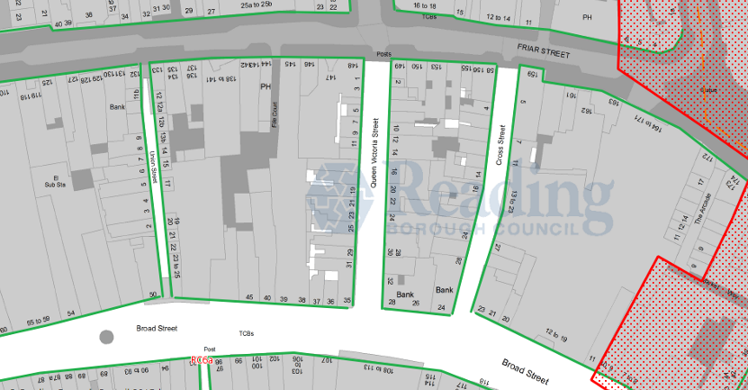
3.1 The application sites, bookend Queen Victoria Street, a main north/south thoroughfare connecting Friar and Broad Street, shown in the below extract from the Council Proposals Map. The green outline denotes active frontages and the red outline indicates the boundary of a conservation area.

3.2 The proposals for Reading Town Centre include the replacement and upgrade of five existing bus shelter sites and the installation of 10 Council Information Panels (CIPs). The replacement of the existing and installation of the new freestanding displays will be undertaken in one process using the same form and design of structure. The advertising displays will remain in the traditional 6 sheet format; a portrait display that is often found within commercial centres either attached to other items of street furniture or freestanding units. Each unit will be double sided and capable of showing commercial and community messages, together with area specific promotions run by retailers within the town centre. The unit technology is an LCD screen, whereby the image on show can be changed remotely and thus avoid the need to manually change the printed advertisements every two weeks. This technology removes the entire printing and recycling process by using more efficient methods, by eliminating waste in the process, and provide a sustainable method of roadside display.

3.3 The upgrade and use of LCD technology is part of a wider programme of improvement and investment across the company’s advertising estate. Through the use of high-resolution lighting, the LCD screens maintains an ultra HD resolution which is not subject to the wear and tear associated with traditional poster formats. The unit comprises a freestanding slim steel unit containing the LCD display panels, each of which provide a screen size of 2m² (portrait). The LCD screens show illuminated advertisements; however, the luminance level for the screens are limited to 600Cdm², the recommended maximum of the Institute of Lighting Professionals (ILP). Up to that maximum level, the unit includes a light sensor to measure the ambient brightness and dimmers to control to adjust to lighting conditions. The levels are reduced to 250Cdm² between dusk and 06:00 hours. The exterior of the unit is powder coated in black to maintain its look throughout the lifetime of the display.

4.0 Heritage Comments
4.1 The current applications for the 15 locations have been subject to internal consultation and heritage related concerns have been raised in respect of the two locations at either end of Queen Victoria Street. The comments for both locations are the same and articulated as follows;

“The High Definition electronic advertising panels within Queen Victoria Street would primarily affect the settings of Grade II Listed Nos. 1-15 Queen Victoria Street. These Listed Buildings within Queen Victoria Street represent some of the finest in the town centre and form a main thoroughfare into the town centre. The approach from Reading station into the town centre along Station Road is considered to be particularly important to Reading and the significance of its historic environment and to visitors from the station. Currently there have been a number of inappropriate adverts to shop fronts along Queen Victoria Street which planning officers are resisting in an effort to improve their overall appearance and appropriateness to the Listed Buildings. The installation of visually intrusive High Definition electronic advertising boards within this location by the Council would negate those long-term efforts.

Conclusions
Due to the materials, size and resulting glare, the proposed adverts are considered to be visually intrusive and would detract from the settings of the Queen Victoria Street Listed Buildings and harm their significance. Due to the incongruity of the adverts within the streetscene and their potential disturbance to the harmony and prominence of the Listed Buildings, the proposed adverts are not considered to be consistent with their location as required by Policy DM22 and are considered to have a harmful impact on the significance of the Listed Buildings contrary to the NPPF and policy DM22 and requirements of the Planning (Listed Buildings and Conservation Areas) Act 1990. “

4.2 The above comments indicate that the concerns are threefold and relate to; the size of the unit; the material used; and on the perception that the displays are likely to cause glare. For these reasons it is believed that the advertisements would be visually intrusive in the centre and detract from the setting of the Listed Buildings on Queen Victoria Street. Each of these points will be discussed in turn in section 7.0 below, suffice it to say the applicant does not accept that view nor that the introduction of two units for the entire length of Queen Victoria Street would have an overbearing or intrusive effect on the street or the buildings setting. The applications give rise to the general considerations outlined in 1.2 and applicable to all advertising proposals, however for the purpose of this report we are only concerned with the heritage matters and in the assessment of impact the proposal would have on the significance of the heritage asset. For this reason, it is informative to understand the basis of assessment of development close to heritage assets as expressed in national guidance, which is summarised below.

- Legislative and Policy Framework
Planning (Listed Buildings and Conservation Areas) Act 1990
  - Section 66 of the Act establishes a general duty for a planning authority, in considering whether to grant consent for a development which affects a listed building, to have special regard to the desirability of preserving a listed building or its setting or any features of special architectural or historical interest which it possesses. A building is listed by virtue of its special architectural or historical interest (Section 1(1)).
  - Section 72 of the Act establishes a duty in the exercise of any function under the Act to pay special attention to the desirability of preserving or enhancing the character or appearance of a conservation area. A conservation area is an area of local interest designated principally by the Local Planning Authority.
National Planning Policy Framework
  - Section 12 of the National Planning Policy Framework (NPPF) deals with the consideration of cultural heritage assets and sets out the importance of being able to assess the impact of a development on the significance of heritage assets. Significance is defined in Annex 2 as the value of an asset because of its heritage interest. This interest may be archaeological, architectural, artistic or historic and can extend to its setting. The setting of a heritage asset is defined in Annex 2 as the surroundings in which a heritage asset is experienced. Its extent is not fixed and may change as the asset and its surroundings evolve. A designated heritage asset is recognised by the NPPF to be a World Heritage Site, Scheduled Monument, Listed Building, Protected Wreck Site, Registered Park and Garden, Registered Battlefield or Conservation Area designated under the relevant legislation. The framework recognises that a balance needs to be struck between the preservation of the significance of a heritage asset and delivering public benefit. Regarding designated assets, paragraph 132 states that the more important the asset, the greater the weight should be on its conservation. Distinction is drawn between those assets of highest significance and those of a lesser significance.
  - The NPPF identifies harm as being either substantial or less than substantial. Where a proposal would lead to substantial harm to significance consent should be refused unless the harm or loss is necessary to achieve substantial public benefit that outweighs that harm. In cases where less than substantial harm to the significance of a designated asset is anticipated, paragraph 134 requires that this harm should be weighed against the public benefits of the proposal.
GPA2: Managing Significance in Decision Taking in the Historic Environment

  - This document provides advice on how decision-taking in the historic environment should be undertaken, emphasising that the importance of identifying, and understanding the significance of, any affected heritage asset and the contribution of their settings towards their significance. The advice reiterates that heritage assets may be affected by direct physical change or by change in their setting. The document sets out the recommended steps for assessing significance and the impact of development proposals upon it, including examining the asset and its setting and analysing local policies and information sources.
GPA3: The Setting of Heritage Assets
  - This advice note focuses on the management of change within the setting of heritage assets. This document is an update to guidance previously published by Historic England (The Setting of Heritage Assets 2011) to ensure that it is fully NPPF compliant and is intended to assist historic environment practitioners in approaching and implementing national policy and guidance. The guidance is, a continuation of the approach advocated by the 2011 document, and there is now a clear continuation in the way in which setting is identified, and its assessment is intended to be approached, across the NPPF, PPG and Historic England’s own guidance. Setting is defined as ‘the surroundings in which a heritage asset is experienced. Its extent is not fixed and may change as the asset and its surroundings evolve’. Setting is also described as being a separate term to curtilage, character and context. The guidance emphasises that setting is not a heritage asset, nor a heritage designation and that its importance lies in what it contributes to the significance of the heritage asset. It also states that elements of setting may make a positive, negative or neutral contribution to the significance of the heritage asset.
  - While setting is largely experienced in visual terms (with views being an important consideration in any assessment of the contribution that setting makes to the significance of an asset), setting can also be heavily impacted upon by other environmental factors including noise, vibration and odour. Further, setting may also incorporate perceptual and associational attributes (including designed or incidental historic relationships) pertaining to the asset’s surroundings.
  - Practical and proportionate decision making is advocated within guidance with regards to the management of proposed development and the setting of heritage assets. It is stated that the protection of the setting of a heritage asset need not prevent change, and that settings may change without the generation of harm to significance; changes within the setting of a heritage asset may have positive, negative or neutral effects. It is stated that the contribution made to the significance of heritage assets by their settings will vary depending on the nature of the heritage asset and its setting and that different heritage assets may have different abilities to accommodate change within their settings without harming the significance of the asset and therefore setting should be assessed on a case-by-case basis.

- Impact Assessment
  - It is accepted that the application sites adjoin a listed building, or rather listed buildings that together form a grouping covering three retail streets within the town centre. The freestanding units will not be affixed to any building but be positioned within an expansive paved area, which itself is a modern intervention into the street. The group listing is of Grade II significance and from the detail of the listing description accepts that the upper floors of the 3 ½ storey buildings are the most valued aspect of the whole. It is also recognised, even at the time of listing in the late 1970’s, that the ground floor street level frontages are modern in design with only one having existed pre WWII.
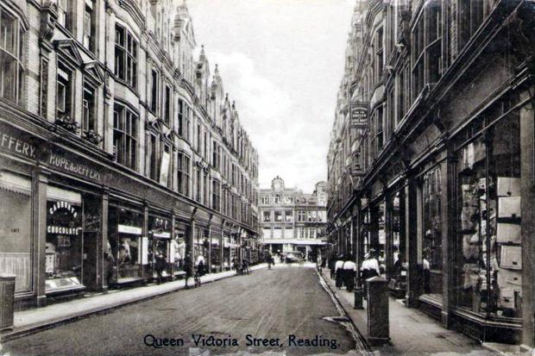
Early 20th Century view of the Street
  - It is perhaps not surprising that the street level presentation of the buildings has changed over the years and will, given the commercial nature of the centre, continue to change and evolve to meet the needs of retailers. Such alterations must of course reflect the setting of the building but it is considered that the previous and future changes make the street view of the listing building less significant in heritage terms than the unaltered upper floors. It is within the street level environment of the town centre that the new display units will stand, within the visual context of the busy and vibrant shop frontages.
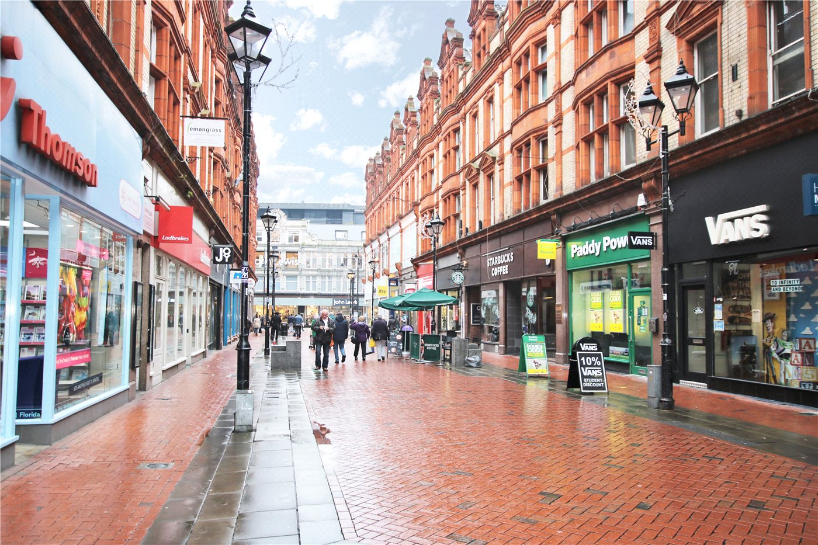
View of the street today
  - Queen Victoria Street, together with Broad Street and Friar Street fall within the core retail centre and are recognised as key active frontages within the town centre. The appearance and design of the frontages reflect the nature of that designation. The streets are fully paved such that the full width of the street is dedicated to pedestrian flow. The materials used are modern red brick in a herring bone pattern with sandstone features. The materials used in the shop fronts are typically bright, vivid and glazed, and illuminated from within when dark. In the case of Queen Victoria Street, the street is very wide with a gap of over 11m between shopfronts with each proposed unit being a distance no less than 1.9m from a building façade.
  - It is the street that provides the setting for the buildings and as mentioned in guidance, “setting” is not itself a heritage asset, nor a heritage designation, but its value lies in the contribution it makes to the significance of the heritage asset. It is further noted that setting is an element that may change over time without harm to significance. Such changes in setting may have positive, negative or neutral effects on a listing building and this approach is suggested in light of common situations, such as in Queen Victoria Street, where the visual context necessary changes and reflects the evolving nature of the retail sector, without such changes debasing the importance of the heritage asset.
  - Both locations share that common context, which is of a busy retail setting with active commercial frontages that include shops, cafes and office buildings. Within the main retail core of any town centre there is an expectation, even within historic settings, of seeing vibrant and lit advertising imagery on shopfront facades, fascia’s, window displays and freestanding items of street furniture.
  - Modern retailing now often includes dynamic shop frontage displays and interactive technology in order to remain relevant to the 21st century shopper. The role of guidance is not to curtail such change but encourage sensitive interventions that support the vitality of the town centre whilst respecting the areas character and heritage. Modern interventions within historic environments, such as rail and retail settings, do no harm the value and fabric of the building that contains them.
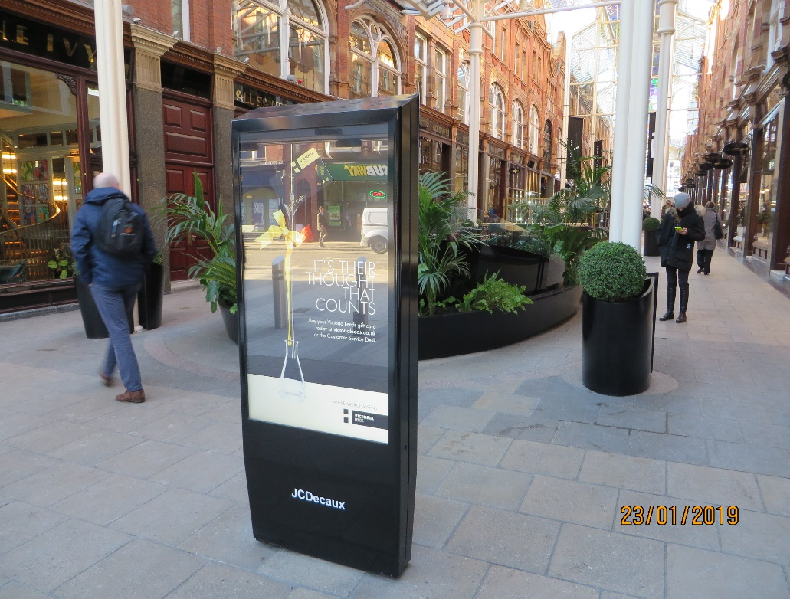
Modern LCD display at Victoria Gate Leeds and below in St Pancras Station
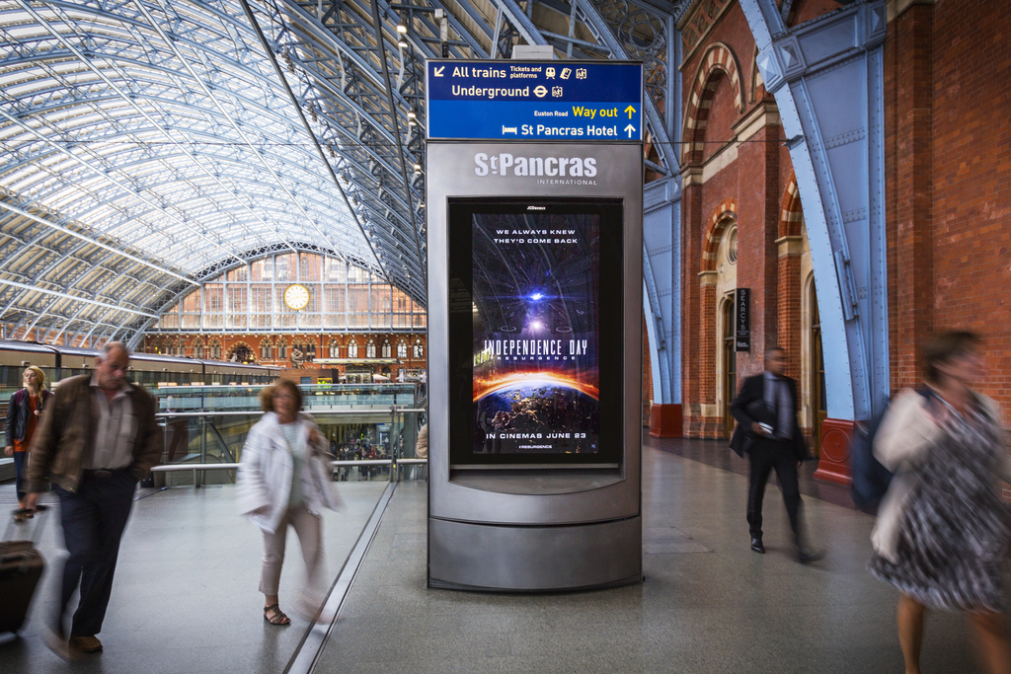
  - Both above images illustrate how modern and old can coexist and complement each other without harming the character of the former. The use of the best quality sustainable materials and simple designs using a neutral palette can ensure a seamless conjoining of the two distinctly different built forms. In the case of the proposals for the two sites on Queen Victoria Street the addition of the units to the street would not overwhelm or appear alien to the street context and retail frontages. The character, the look and architecture at street level is very different to the upper floors of the building and yet neither visual jar with each other. Therefore, the impact on setting, a setting which is already heavily influenced by the more modern additions and to the street, will be negligible.
  - In response to the key points raise in the heritage comments relating to advert size, the materials and lighting levels, the following response are;
Size – The advert panel is a standard six sheet display which is commonly found within pedestrianised location because it is of a human scale without being dominate. The overall height of the unit is less than 2.9m to fit beneath the canopy of a bus shelter and significantly less than the height of shop fronts along the street. The shop fronts are characterised by deep fascias above a shop display and entrance of 3m in height. The display panels would remain subordinate in this context.
Materials – The display unit has been designed to appear simple in form and neutral in colour so as not to have an overt influence or command of the view. The unit clearly represents a modern intervention to the street but will be one of several interventions that mark the continual evolution and transformation of the retail presence in the centre. The shop fronts that provide the immediate backdrop for the displays are also modern alterations with many using the same materials and colour palette as the units being proposed. The overall look and design of the units is modern, clean and utilises durable, contemporary materials which complement rather than conflict with the surroundings.
Glare - The suggestion that he advertisement are likely to cause glare is unfounded and not credible. The quality of the images being displayed is an important element of the proposal and the company purchases the best in class HD units to ensure the lighting levels are effectively controlled and the image quality remains crisp. As mentioned in 3.3 above, the luminance levels for the screens, which is the SI unit of measurement, is tightly controlled to avoid over exposure and glare. The applicant will follow the advice of the ILP and reduce the luminance levels at night time to ensure the output of the screens is enough to be visible but not overwhelm. If necessary, the lighting levels can be set by condition and monitored post install to confirm compliance.
7.0 Conclusion

7.1 The LCD screens are considered appropriate and complementary to the commercial character of the town centre and it is within such locations that this type of small scale advertising unit works best. The commercial messages displayed on the screens contribute and support the shoppers experience, being capable of showing localized information and promotions that reinforces the town centre retailing function and encourages consumer spending. Within Queen Victoria Street, where the character is unique and distinctive, the street level activity is as vibrant and active as the rest of the town centre. However, in recognition of this character, only two units are proposed on a frontage of over 130m so as not to dominate views or clutter the street. The proposed work is an entirely reversible intervention and can be removed without lasting harm to the area and is limited to five years’ consent. Overall the proposal is considered to have a neutral impact on the area that will not undermine the integrity of the heritage asset.

7.2 The proposed development will not have a harmful effect on the setting of the listed buildings within the street. The visual association of the displays is more closely aligned to the active and constantly changing street frontages and shop entrances rather than the upper floors of the buildings. Within the context of the street, the advertisements represent relatively minor intervention that will have a visually neutral effect upon the character and appearance of the heritage assets.

Town and Country Planning (Control of Advertisements) (England) Regulations 2007

