Information panel on the life of William Marshal, Earl of Pembroke, who died in Caversham on 14 May 1219

Heritage Statement
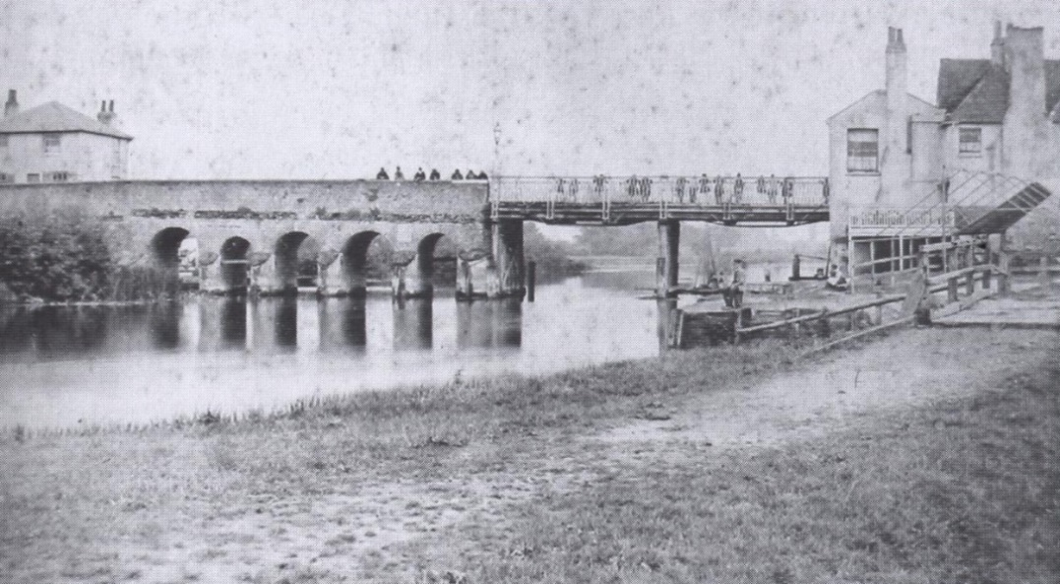
The first reference to a bridge at Caversham is dated 1231. Chapels at each end of the bridge were stopping points for pilgrims and travellers, and alms contributed to the upkeep of the bridge. When the chapels were destroyed during the Reformation, revenue for the upkeep ceased and there were disputes over the responsibility for repair. Queen Elizabeth I donated 50 oak trees to aid repairs.

Images over the centuries show the bridge constructed in two sections. During the Civil War, the Parliamentarians took down the Reading end of the bridge and created a form of draw bridge.
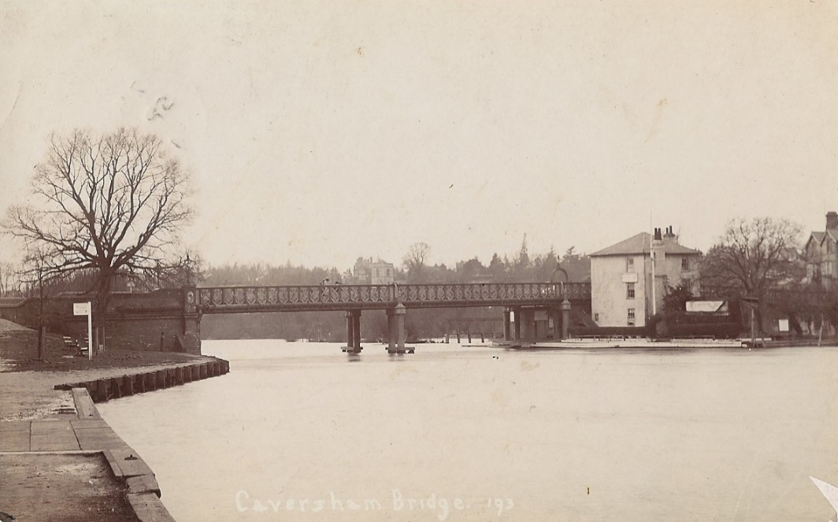
By 1846, the bridge was deemed beyond economic repair. A new iron bridge was completed in 1869.

By the time of the boundary change in 1911, the iron bridge was already inadequate. Reading Corporation undertook to replace or widen the bridge. Plans were drawn up for a new bridge but halted by WWI. Work was completed in 1926 and the opening ceremony performed by the Prince of Wales.
The bridge is constructed of concrete and stone with some Art Deco detailing. It incorporates purpose-designed viewing places on the central buttress. It is an interesting structure and the Panel for Historical Engineering Works of the Institution of Civil Engineers has included it in their lists which record and promote historical structures. Eight bronze lampstands mounted on the stone parapets were manufactured by the nationally important Bromsgrove Guild of Applied Arts.
In 2018, the St Peter’s Conservation Area was extended to include the bridge. Views of the bridge and from the bridge are important characteristics of the Conservation Area.

Relevance of William Marshal to Caversham Bridge
With the first written reference to a bridge at Caversham in 1231, it is generally assumed Marshal was at least partly responsible for its construction, perhaps in conjunction with the Abbot of Reading. Marshal’s lands included the Manor of Caversham. During the final weeks of his life, he and his family resided in Caversham. The young King Henry III and the Court were at Reading Abbey but visited Marshal in Caversham. The Abbot of Reading visited to give Marshal absolution, and it is clear that crossing the Thames between Reading and Caversham was an important issue.
From the Eastern viewing platform, you can look along the Thames towards the site of the early Manor House where Marshal died and across the Thames to Reading Abbey where his body lay in state.

The aim of the William Marshal information panel
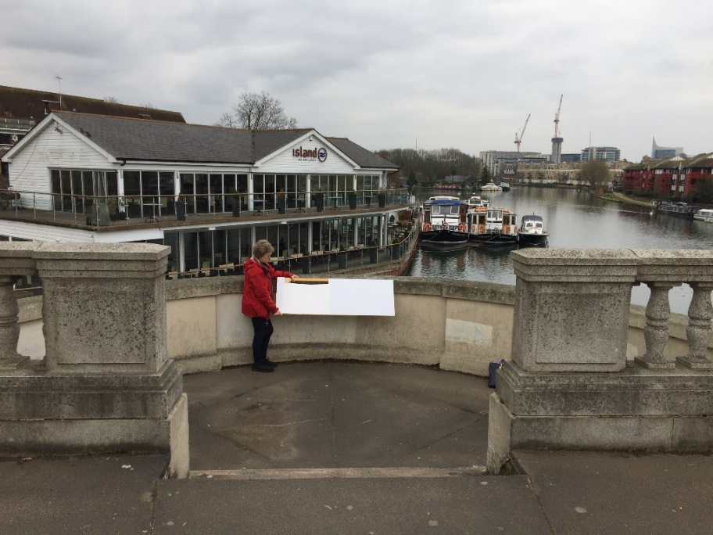

The evolving design for the panel will illustrate Marshal as an illustrious knight and later as an important statesman who is believed to have changed the course of English history. It will include a time line over a period of 100 years and will explain Marshal’s importance nationally and locally. The images and text are intended to attract people of all ages and contribute to a sense of local heritage and history. The size of the panel has been set to allow that information to be set out clearly, attractively and legibly.
It will serve as a focal point for local visits and tourism and a base for heritage trails. It will add to the interest of the Eastern Viewing point but will not be visible from outside the bridge.

Helen Lambert
CADRA Chair

28 April 2019

