DELEGATED APPLICATION REPORT Target Expiry: 1/2/2019 (ext)

Application No.: 181807
Address: 198 Shinfield Road & 198A Shinfield Road (proposal does not affect this property)
Proposal: Internal alterations to 198A Shinfield Road to provide a bathroom, and reduction of floorspace resulting from extension to 198 Shinfield Road for the provision of a toilet at ground floor. Proposed front porch and single storey rear extensions to 198 Shinfield Road.
Case officer: Alison Amoah

Site Description and Surrounding Area:
The property is a semi-detached house which comprises a 3 bed house at ground and first floor, and a studio (198A Shinfield Road), which forms part of the original ground floor of no.198 Shinfield Road. There is an existing flat roofed single storey extension, to the boundary with no. 196, with a maximum depth of 4m (staggered original rear boundary). It is a wholly residential area with the same design of houses in semis and terraces along this segment of Shinfield Road, with limited changes to the original front elevations. This pair of semis, is set further back from Shinfield Road than the adjacent terrace of 4 (nos. 200-206).

The subdivision of the house into a 3 bed dwelling and 1 bed [actually a studio] was granted under CLE in 2004 (04/00084/CLE).

Proposal: (amended) Demolish the existing extension (kitchen) and erect a single storey rear extension to create kitchen and study/bedroom. Maximum 4 metre depth (from original rear of house) at 3.3m wide, increasing to 4.18m wide (because of the original staggered rear boundary). Then stepped in from the boundary with no. 196 by 1.5 m and extending a further 2.5m. Two windows and a door are proposed to the rear, with 2 no. proposed roof lights over the proposed kitchen. A proposed side facing window (towards no. 200). Maximum height of the slightly pitched roof would be 3m. This would be 2.2m to the boundary with no. 200, i.e. extending no further towards the boundary than the existing house.

Also proposed is a front porch projecting in front of the existing original porch space (the latter having a front building line in line with the original front projecting gable, i.e. originally it created an l-shaped front building line) with pitched/hipped roof, measuring 1.3m deep, by 2.9m wide and 3.3m max height. A small obscure glazed side facing window is proposed to both sides as a means to increase light into the space and the lounge. The front window serving the lounge would be wider to maximise daylight/sunlight entering.

Internal alterations to the studio (198A) to provide a bathroom, and some reduction in floorspace to enable the provision of a bathroom at ground floor for 198 Shinfield Road.

Materials would be to match existing.

Plans considered: As received 18th October 2018:
Site Plan - Drawing no: SR198:012
Ground Plan – Existing & Proposed [labelled as Existing] – Drawing no: SR198:13
Existing Elevations – Drawing no: SR198:15
Site and Block Plans – Drawing no: SR198:011
Proposed Elevations – Drawing no: SR198:16

Amended Plans received 11th January 2018:
Ground Plan – Existing & Proposed [labelled as Existing] – Drawing no: SR198:13 Rev C
Proposed Elevations – Drawing no: SR198:16 Rev B

Amended plans received 20/1/19:
Site and Block Plans - Drawing no: SR198:011 Rev A
Site Plan - Drawing no: SR198:012 Rev A
Ground Plan – Existing & Proposed [labelled as Existing] – Drawing no: SR198:13 Rev D
Existing Elevations – Drawing no: SR198:15 Rev A
Proposed Elevations – Drawing no: SR198:16 Rev C

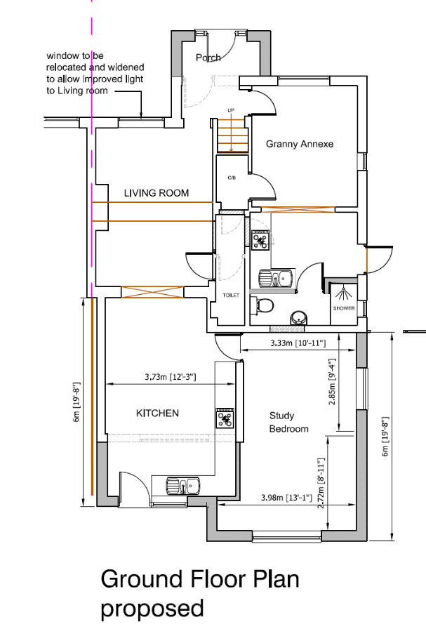

Relevant Planning History:
94/00658 (940678) – Single storey rear extension – Approved 3/10/94
95/00146 (9500206) – Single storey rear extension – Approved 5/5/95

03/00708 (031075) – Two storey side and single storey rear extension to form 2 apartments 1x1 bed 1x 3 bed refused 19/8/03
03//01029 (030040) – Two storey side and single storey rear extension (granny annex) – refused 30/10/03.

It should be noted that the report for this stated “as established on the site visit [and in other reports]…198 Shinfield Road appears to be currently in use as two separate residential units. These uses are a ground and first floor family house and a separate ground floor flat. This use does not have planning permission and the property is subject to ongoing enforcement action. Given the fact that the property is already in use as two separate dwellings, together with the scale of the proposed extension and the internal layout, it is likely that that the purpose of the proposed extension is to maintain and enhance this use, rather than to be ancillary to the existing house”

04/00084/CLE (040265) – Conversion of property into 2 residential units. The use has been ongoing since May 1997 – Granted 26/3/04.

181648 - Rear extension measuring 6.0m in depth, with a maximum height of 3.10m, and 2.95m in height to eaves level. Notification of the construction of an extension under class A Part 1 of Schedule 2 of the Town and Country Planning (General Permitted Development) (England) Order 2015 – withdrawn 15/10/18

Consultation Responses: Nos. 196 & 200 Shinfield Road and 9 Linden Road were consulted. No comments were received.

Equality Act 2010:
In determining this application the Council is required to have regard to its obligations under the Equality Act 2010. However, there is no indication or evidence (including from consultation on the application) that the protected groups identified by the Act have or will have different needs, experiences, issues and priorities in relation to this particular planning application. Therefore in terms of the key equalities protected characteristics it is considered there would be no significant adverse impacts as a result of the development.

Relevant Planning Policy and Guidance
Section 38(6) of the Planning and Compulsory Purchase Act 2004 requires that proposals be determined in accordance with the development plan unless material considerations indicate otherwise. Material considerations include relevant policies in the National Planning Policy framework (NPPF) - among them the 'presumption in favour of sustainable development'.

The following local and national planning policy and guidance is relevant to this application:

Reading Borough Local Development Framework Core Strategy (2008, altered 2015)
CS7: Design and the Public Realm

Sites and Detailed Policies Document (2012, altered 2015)
DM9: House Extensions and Ancillary Accommodation;
DM4: Safeguarding Amenity

Supplementary Planning Guidance:
A Design Guide to House Extensions (2003)

Appraisal Checklist:
DM9 states: An extension to a house will be acceptable where it:

- Respects the character of the house in terms of scale, location, materials and design;

To assess this, the following has been considered – would the proposal:

- Detract from the appearance of the original building through the use of ill-matching materials and by not fitting in with the design, scale and proportions of the original building; No – although relatively large in footprint as a single storey rear extension the proposal is considered acceptable and there are other egs in this location. A porch of similar dimensions would have been possible under permitted development, and the stagger in the building line with no. 200 further forward reduces the impact of a forward projection.

- Reduce the amount of usable amenity space for the property to an unacceptable degree; No

- Require the loss of trees in the garden or put significant trees at risk; No

- Respects the character and pattern of neighbouring properties and the street as a whole in terms of scale, location, materials and design, and any important existing building line; Respects neighbour’s amenities and does not present a large blank façade to public areas.

To assess this, the following has been considered – would the proposal:

- Significantly reduce the amount of daylight and sunlight enjoyed by neighbouring properties; No

- Invade the privacy of neighbouring properties through overlooking from windows or balconies; No – the side facing windows of the porch are to provide additional daylight/ sunlight into the lounge. These are proposed to be obscured glazed and condition is recommended. The rear extension has a proposed side facing window. This is not considered to be significantly different to the original side facing glazed door.

- Detract from the character of neighbouring properties through siting, excessive bulk, ill-matching materials or inconsistent design; No – the amended scheme pulls the extension off the boundary by 1.5m beyond 4m depth, which is considered sufficient to reduce the overall bulk on the boundary to no. 196.

- Detract from the appearance of the street or area by using ill-matched materials, glazing and detailing; No

DM4 states: Development will not cause a significant detrimental impact to the living environment of existing or new residential properties, in terms of:
• Privacy and overlooking; NO (see above)
• Access to sunlight and daylight; NO (see above)
• Visual dominance and overbearing effects of a development; NO (see above)
• Noise and disturbance; NO
• Artificial lighting; NO
• Vibration; NO
• Dust and fumes; NO
• Smell; or NO
• Crime and safety. NO

RECOMMENDATION

APPROVE subject to conditions and informatives.

Proposed Conditions:

- Standard Time limit TL1
- The development hereby permitted shall be carried out in accordance with the following approved plans as received 20th January 2019:
Site and Block Plans - Drawing no: SR198:011 Rev A
Site Plan - Drawing no: SR198:012 Rev A
Ground Plan – Existing & Proposed [labelled as Existing] – Drawing no: SR198:13 Rev D
Proposed Elevations – Drawing no: SR198:16 Rev C
- Matching materials
- Porch windows to be obscure glazed

Informatives:

Terms and conditions
Building regulations
Encroachment
Complaints re noise during construction
Use of extension for 198 only and 198A to be retained as studio. Any change of use of 198A to be part of the main dwelling (198) would require planning permission.
Positive and proactive

