DELEGATED APPLICATION REPORT

Application No. 170909/FUL
Address: Land at 177 Upper Woodcote Road, Reading
Proposal: Application for removal or variation of a condition following grant of planning permission. (170909)
Case officer: Brian Conlon

SITE DESCRIPTION

The application site relates to land at 177 Upper Woodcote Road, located on the western side of Upper Woodcote Road. The site is currently vacant except for an outbuilding and vegetable garden. The surrounding area is characterised by low density residential development consisting predominantly of large detached dwellings set within generous plots with dwelling scales ranging from bungalows to two-storey dwellings. Along this part of Upper Woodcote Road two-storey dwellings are predominant (including a number of replacement dwellings). The site is within an Air Quality Management Area.

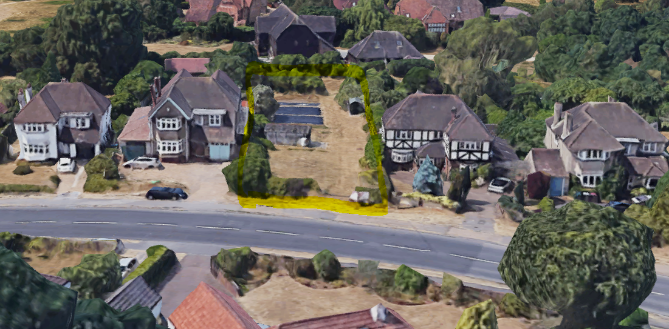
Google maps (2019)

PROPOSED DEVELOPMENT

This application seeks the removal or variation of a condition following previous grant of planning permission reference 170909. The original consent saw permission granted for the erection of a two storey dwelling (4 bed) with integral garage, a new access and landscaping.

Specifically, this current application seeks to vary condition 2. This condition reads as follows:

“The development hereby permitted shall be carried out in accordance with the
following approved plans:

Drawing No: Block Plan Proposed 17055 – PP0011
Drawing No: Floor Plans Proposed 17055 – PP1030
Drawing No: Elevations Proposed 17055 – PE1010 Received 5th June 2017
Drawing No: Site Plan and Elevations as Proposed 17055 – PP0010 Rev A Received 10th
August 2017
Drawing No: Location Plan 17055 – L01 – B Received 6th September 2017

REASON: because permission is granted in respect of the development as detailed in
the approved plans only”

The revised plans consist of a remodelled and enlarged dwelling from that approved under the previous permission. The changes consisted primarily of additional living accommodation above the garage at two storeys, a continuation of the roof, enlarged first floor and ground floor elements to the rear and a remodelling of the house with additional glazing. To the front driveway, a revised layout and landscaping scheme has been proposed. The resultant dwelling would contain 6 bedrooms.

Given concerns expressed by Officers during the application process as to the proposed scale and lack of soft landscaping, amended plans were successfully negotiated consisting of the following changes:

- Relocation of the north elevation single-storey rear projection to the south elevation, reducing the overall level of flank wall when viewed from No.179 Upper Woodcote Rd;
- Articulation in the southern flank walk elevation to add definition;
- Removal of the electric gate, softening of the front landscape by following the approved scheme with the two trees incorporated;
- The permeable area is reduced in size and boundaries now replaced with hedging instead of fencing.
- Minor internal alternations for practicality.

All adjoining neighbours were notified of the above amendments through updated neighbour notification letters.

RELEVANT PLANNING HISTORY

170909 - Erection of two-storey dwelling with integral garage (APPROVED) Jan 2018

CONSULTATIONS

Natural Environment – Revisions requested to the proposed landscaping and boundary treatment to soften the frontage of the proposed dwelling. (Amended plans received addressing this point).

Transport – No comments received. (170909 - No objections to previous access with visibility splays subject to conditions)

Archaeology Officer: No objection subject to the requirements of condition 9 of permission 170909 being maintained.

Ecology Consultant – No objection.

All adjoining neighbours were consulted by letter twice and a Site notice was displayed at the site for the requisite period. 4 letters of objection were received. The issues raised are summarised as follows:

- Ground floor windows are above fence line of No. 175;
- Reassurance that the single-storey rear elevation will never be developed up to two-storey;
- Overshadowing that may be caused towards No. 179 and resultant loss of light;
- Massing of the house which is going to overshadow the neighbouring houses;
- Proximity to the road and highway safety implications;
- Plot is quite narrow and as such a site would be better suited to a chalet bungalow.

EQUALITY ACT 2010:

In determining this application the Council is required to have regard to its obligations under the Equality Act 2010. However, there is no indication or evidence (including from consultation on the application) that the protected groups identified by the Act have or will have different needs, experiences, issues and priorities in relation to this particular planning application. Therefore in terms of the key equalities protected characteristics it is considered there would be no significant adverse impacts as a result of the development.

LEGAL AND PLANNING POLICY CONTEXT

Section 38(6) of the Planning and Compulsory Purchase Act 2004 requires that proposals be determined in accordance with the development plan unless material considerations indicate otherwise. Material considerations include relevant policies in the National Planning Policy framework (NPPF) - among them the 'presumption in favour of sustainable development'. S73 Variation applications allow a minor material alterations to planning permissions.

APPRAISAL

The main issues to be considered are:

- Principle of Development
- Character of the Area
- Amenity
- Ecology and landscaping
- Parking, access and refuse storage
- Affordable Housing and CIL

Principle of development

This application is made under Section 73 of the Town and Country Planning Act 1990 to vary a condition imposed upon a decision already granted planning permission by the Local Planning Authority. Section 73 of the Act instructs the Local Planning Authority to consider the variation to, or relief of conditions that are applied for, stating that "if they [the LPA] decide that planning permission should be granted subject to conditions differing from those subject to which the previous permission was granted….they shall grant permission accordingly" (s.73(1)(a)).

As such, the Local Planning Authority can grant permission unconditionally or subject to different conditions, or alternatively refuse the application if it is deemed that the original condition(s) should remain in place.

Any decision made under this application would not revoke the original development; however, the grant of a planning permission under Section 73 would essentially provide a new planning permission that would be implemented instead of the original permission. It is therefore necessary to reconsider the overall development proposal against the development plan. In this instance the proposal seeks to vary the approved plans contained under condition 2 of permission 170909.

Since the grant of the permission on in Jan 2018 there has been no change to national planning policy as contained within the NPPF or Adopted Local Plan relevant to this site. The grant of planning permission for Application 170909 was determined to accord with the principles set out in these documents for the principle of a new dwelling in this location. The principle of development therefore remains acceptable and the solely the variation of Condition 2 will be assessed against the requirements of the Local Plan, the NPPF and any other material planning considerations.

Character of the Area

Policy CS7 of the Core Strategy states that, development must be of a high design quality that maintains and enhances the character and appearance of the area in Reading in which it is located.

The revised plans sees the dwelling sited in the same location as that of the approved dwelling, between both adjoining neighbours in a conventional side to side relationship. This effectively provides a continuation of the existing gently curving building line along this part of Upper Woodcote Road.

The scale of the dwelling has increased with the notable addition of living accommodation above the garage and extended roofline. The overall ridge height of the dwelling does not exceed that of the southern neighbour, whilst it would be marginally taller than its northern neighbour. Whilst generous, the overall scale and massing of the house is not considered to appear incongruous or disproportionate in comparison to either neighbouring property, or out of keeping with the prevailing character of dwellings found along the road. When viewed either way along the Upper Woodcote Road, it is recognised that the vast majority of the roof form and depth of this revised proposal would be effectively screened behind the principal elevations and overall mass of either neighbouring property, thereby effectively reducing any harmful prominence in the street.

Whilst the overall footprint remains large, side accesses are retained to the back garden and the overall plot remains of a sufficient size in order to comfortably accommodate a dwelling of this scale without appearing to overdeveloping the plot and allows for suitable gapping.

The character of the surrounding properties in Upper Woodcote Road consists mostly of large, two storey detached houses with pitched roofs and the range of materials consisting mostly of red brick and/or white render. The revised design is a more contemporary design approach through additional glazing and a central glazed atrium/gable feature serving landing and entrance hall. To the rear elevation a substantial single storey element provides generous natural light, with access to the rear. Two-storey protruding gable sections contain living accommodation at ground floor. In this regard, the overall design is not considered to result in any material harm on the character or appearance of the area.

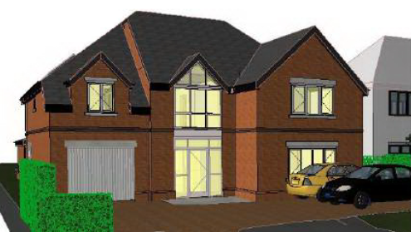
PL-09 Rev A

To ensure suitable quality of materials it is considered reasonable and appropriate to secure a schedule of the proposed materials by way of a suitable worded condition. The proposal thereby accords with the Reading Borough Local Development Framework Core Strategy (2008) and Sites and Detailed Policies Document (2012).

Amenity

The only neighbouring properties likely to be directly affected by the revised proposal remain Nos. 175 and 179 Upper Woodcote Road, located to the south and north of the site respectively. Both these neighbouring properties made representations to the original and amended plans received. Each adjoining property will dealt with in turn.

Firstly, in relation to No.175 to the south of the site, the occupants have requested that all facing windows be obscure glass. There are both windows at ground floor and first floor and also skylights within the roof. The objectors have expressed concern that ground floor windows are above their fence line in the submitted drawings. The occupants of No.175 also request reassurance that the single-storey rear elevation will never be developed up to two storey.

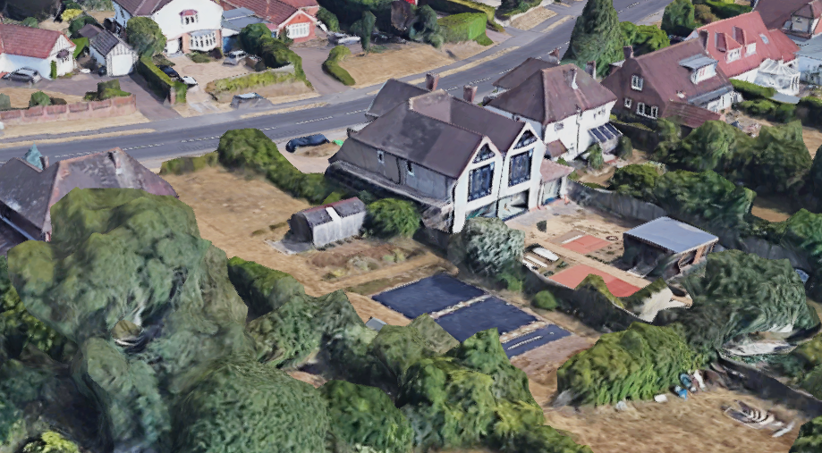
Aerial view towards No. 175 (Google maps 2019)

The three ground floor windows on the southern elevation of the proposed new dwelling would serve a utility room and family room. No.175 has three ground floor side windows itself serving rooms below a substantial newly-constructed full width two-storey rear extension. Between both plots stands a 1.8m high close boarded fence. A minimum height of 1.7m is considered sufficient to prevent any views from an adult standing at finished floor level within a room. Notwithstanding the fact that both properties would enjoy a conventional side to side relationship where such windows on side elevations are not uncommon, details of existing and proposed ground levels and internal finished floor levels were secure as part of this application. These show that the existing close boarded fencing is sufficient to prevent any direct overlooking into either ground floor room when in use. However, in order to prevent any further perceived loss of privacy, full details of means of enclosure will be secure via a landscaping condition. At first floor level three skylights are set into the roof slope, whilst a single high level window serves a bathroom. The three skylights do not allow any overlooking and the bathroom window can be conditioned to be obscure glazed.

With regard to loss of light and overbearing, the revised dwelling would continue to maintain a 45 degree clearance to the nearest habitable room window from 175 Upper Woodcote Road. Given this, and the distance of 1m to the common boundary and approximately 2.5m to the main flank wall of No.175 itself, the proposal is not considered to result in any material loss of light or overbearing impact to the occupiers of this property.

In relation to No.179 to the north, the occupants of this property have expressed their concern relating to overshadowing that may be caused towards their property and resultant loss of light. The rear elevation of the new dwelling would extend further into the rear garden than that of No.179, thereby replicating the staggered arrangement of houses along upper Woodcote Road.

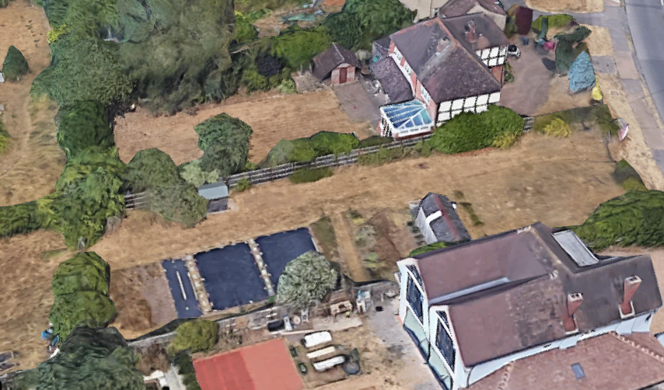
Aerial view towards No. 179 (Google maps 2019)

The proposed first floor element closest to 179 would also maintain a 45 degree clearance to the nearest habitable window on their rear elevation. In addition the roof would be hipped in order to minimise any impact. The deeper first-floor elements of the proposal are now designed so as to be staggered away from the northern boundary with this neighbour. In conjunction with the generous rear garden available to occupants of 179, no significant level of overbearing and/or loss of light will occur. The occupants of 179 will continue to enjoy late afternoon sunshine to their rear patio area, incidentally located to the northern side of the garden, furthest away from the new development and behind an existing conservatory.

Like approved permission 170909, two first-floor bathroom windows continue to be proposed on the flank elevation facing No.179. Equally an obscure glazing condition will ensure no material loss of privacy for either occupant.

In direct response to concerns over subsequent extensions and alterations to what is already a substantial detached property, it continues to be necessary and reasonable in this specific circumstance to remove permitted development rights under Classes A (extensions and alterations), B (roof additions) and D (porches). In addition, a further condition is required in respect of protecting the amenity of neighbours during the construction period. A construction method statement will therefore be secured via condition and is required from a highway safety perspective too. As such in overall terms, considering all nearby residential occupiers, no significantly harmful amenity impacts would occur, subject to conditions.

Therefore, in summary, based on the individual site circumstances, the relationship between the proposal and existing neighbours to the north and south, the proposal is considered to maintain the current levels of privacy, adequately prevent any harmful levels of overbearing and/or loss of light, and not allow any views into either plot which would not ordinarily be gained in such conventional side-to-side relationship. Therefore the scheme continues to accord with Policies DM4, DM9 and DM11.

Ecology and landscaping

The site does not contain any trees worthy of a Tree Preservation Order; however, the site is on a main route and/out of Reading, identified as a ‘treed corridor’ in the Council’s Tree Strategy. Revised plans were received showing 2 new trees retained on the road frontage to replace the existing substandard Prunus (Purple Plum) and also showing enhanced soft landscaping indicated within the forecourt area which is appropriate.

Parking, access and refuse storage

In accordance with the Council’s adopted Parking Standards and Design SPD, the development would be required to provide a parking provision of 2 off road parking spaces. Similar to the approved scheme, the site plan illustrates that an integral garage is to be provided, dimensions of which are slightly below standard. However, in addition to the integral garage, two off-road parking spaces are proposed as well as a manoeuvring space which will allow egress from the site in forward gear, therefore parking remains acceptable.

A new access point continues to be proposed to the south of the existing dropped kerb, indicating required visibility splays. The existing dropped kerb will also be required to be reinstated in line with the footway. An informative will be attached stating that the applicant must obtain a licence from the Council's Highways section before any works are carried-out on any footway, carriageway, verge, or other land forming part of the public highway to agree the access construction details.

Waste and recycling storage will be provided to the southern boundary and collection will be at the roadside as is for other residents of the road. Bin storage should comply with Manual for Streets and British Standard 5906: 2005 for Waste Management in Buildings to avoid the stationing of service vehicles on the carriageway for excessive periods. Therefore no objections are raised with regard to parking, access or refuse storage subject to relevant conditions and informatives in accordance with policies CS23, CS24 and DM12 of Sites and Detailed Policies Document (2012) (Revised 2015).

Construction

It is considered necessary and relevant to reinstate conditions managing hours of construction and the prevention of waste being burned. However, based upon the site’s specific location, its scale, and the lack of any parking restrictions along this section of Upper Woodcote Road, a Construction Method Statement for a scheme of this scale is largely unenforceable and would not meet the identified tests of the Government’s Planning Practice Guidance for the imposition of planning conditions. Equally, noise and dust controls are dealt with via a restriction on the hours of construction and through separate Environmental Health legislation, so too is any damage or obstruction to a public highway.

Affordable Housing and CIL

A contribution towards off-site affordable housing provision was secured under application 170909 through a Section 106 agreement to the sum of £50,000 which was secured. This requirement remains as part of this application and is covered with an indexation requirement of the previous legal agreement to cover any subsequent Section 73 permissions granted. The proposal would be a Community Infrastructure Levy (CIL) liable development. The applicant has provided the appropriate CIL Additional Information Form. An informative would be attached to the decision notice to advise the applicant of their responsibilities in this respect.

CONCLUSION

This Section 73 application to vary the approved plans condition (Condition 2) of permission 170909 has been considered against the above relevant planning policies and the extant permission. With regard to all matters raised, it is recommended permission be granted for the variation of condition 2 of permission 170909 subject to the attachment of all remaining and relevant conditions and informatives.

RECOMMENDATION
GRANT subject to conditions

CONDITIONS

Time limit S73
Approved plans
Materials schedule (AGL)
Landscaping small scale (PTO)
Vehicle and cycle parking in accordance
Refuse in accordance
Stopped up access
Access in accordance
Archaeological work in accordance
Hours of construction
No waste burned
Removal of PD rights +S
Obscure glazing

Informatives

