Heritage Impact Statement
Flat 9, 28 London, Reading, Berkshire, RG1 5AG
Relating to the Proposal for a Fireplace Installation
This statement has been prepared to support the application to reinstate a fireplace to an existing chimney breast within Flat 9, 28 London Road, Reading. Flat 9 is located on the third floor, 28 located leftmost within the central block. This application succeeds works completed in 2018 by Thomas Homes through which the entirety of the building block formally known as Portland Place but now referred to as St David’s Hall and two adjacent buildings (referred to as St Laurence’s Hall No. 16-22 and St Mary’s Hall No. 32-40) were restored and repurposed to contain 53 separate dwellings, planning application no. 150730.
The heritage interest of St David’s Hall and therefore Flat 9, 28 London Road, are formally recognised by its Historic England listing at Grade II* defining it as a “particularly important building of more than special interest” together with the building's inclusion in the Kendrick Conservation Area (KCA). The attributions mainly derive from its standing as a period regency building and the fact the terrace frontage was designed “as one”. It is, therefore, is said to make a positive contribution to the townscape of London Road (Picture 4). St David’s Hall together with nearby Albion terrace, The Great Hall and War Memorial Clock Tower are all noted as ‘Focal Buildings’ and fall within ‘Important Views’ on the KCA Townscape Appraisal Map (picture 3)³.
A full conversation appraisal and heritage impact assessment was completed in March 2015 by Dr Nicholas Doggett and David Bevan, Asset Heritage Consulting of Oxford¹, ahead of renovations completed by Thomas Homes. The report details a complete historical background of St David’s Hall and the heritage of the building within the surrounding area. It is arguable wheatear the single design of the front facade gives it more architectural interest than terraces either side (both currently designated Grade II) which were created by addition, particularly St Marys Hall No. 32-40, known to have been built earlier. Doggett and Bevan go further and argue that St David’s Hall does not contain sufficient inherent architectural and historic interest to justify its Grade II* status and rather is more consistent within a grade II designation. Regardless, it is a building that is emblematic of its period and all efforts should be made to preserve its originality and heritage as an authentic regency building.
The building was originally conceived and built as one following the design of the local architect and speculative developer Richard Billing II and is believed to have been built around the 1830s. Map evidence confirms that the terrace was constructed after 1813 and before 1853 (Pictures 1&2). The university leased Nos. 24-30 from Alfred Palmer, proprietor of the Huntley & Palmers biscuits, in 1922 and was given the freehold (still retained) in 1936 following his death. Form this time until works by Thomas homes St David’s Hall was used to house university departments and student halls of residence. Over this time extensive changes were made to the internal structure of the building as a result of its various different university uses. In the 1990s consents were given for student bedrooms, bathrooms, communal lounges etc to form “halls of residence for the college”. Because of this and other alterations through time many original features and other historic fabric have been lost. Most significantly none of the “32 original fireplaces and fire surrounds”¹ have been retained within St David’s Hall, one original cooking range remains on the basement level. It is clear the removal and loss of these fireplaces has had a negative impact on the heritage off the building, moreover, the general lack of maintenance and subsequent dereliction between 2004-2018 ultimately lead to the buildings listing in 2012 to the Heritage at Risk Register (Picture 3) despite efforts by the university to repair the external envelope and contain an outbreak of dry rot.
Extensive work completed between 2015-18 by Thomas Homes did much to restore St David’s Hall including key architectural elements such as the Soanian dished / “saucer-doomed” ceiling to the entrance of No.28 & No.24 of a style popularised by architect Sir John Soane. In St Laurence’s Hall and St Mary’s Hall some of the original fireplaces were retained and sympathetically restored, where this was not possible however fireplaces were simply blocked off. The chimney chambers were fashioned in the core masonry of the structure and hence have remained relatively unscathed from alteration. The chimney breast can be seen visibly within the building’s interior pronounced from the retaining walls. Pictures No. 9-13 show the varied and poor condition of fireplaces prior to restoration in 2015 within St Laurence’s Hall and St Mary’s Hall. The surrounds vary in levels of decoration with both wood and marble surrounds seen together with traditional grated or arched cast iron burners. All original fireplaces are cited as important parts of the respective building’s heritage and are highly typical of designs from the Regency period.
The building is two deep and characteristic of the first part of the 18th century. Reflecting many of the prevailing social and design hierarchies. The third floor more traditionally would have comprised of servant or infant accommodation with north facing rooms (facing London Road) generally having a higher status than those facing south. Plans from JPPC Chartered Town Planners, April 2015 (Picture 14) further details the locations of retained original fireplaces across the ground floor of No. 14-40 London Road, the report shows no fireplaces were retained on the ground floor of St David’s Hall. The ground and first floors being of higher importance, containing more formal rooms and therefore most likely to contain more elaborate and decorated feature fireplaces.
St David’s Hall features two central chimney stacks arranged to divide the 4 original dwellings dividing No. 24 & 26 and No. 28 & 30, these stacks are still outwardly visible both internally as protruding chimney breasts (Picture 4) as well as external stacks dominating the roofscape (Picture 5). Each stack contains 17 pots (Picture 6), totalling 34 across the building. Hence it is reasonable to assume that fireplaces would have originally existed front and back as the primary source of heating on each of the 4 floors (32 fireplaces total) with cooking ranges located on the basement levels. This number is consistent with the number cited in Heritage Consultings’ March 2015 Report.
In conclusion, St David’s Hall is an authentic Regency building that would once have relied upon numerous fireplaces as its primary heating mechanism. The number of chimney stacks and number of original fireplaces sited in the 2015 Asset Heritage Consulting Conservation Appraisal & Heritage Impact Assessment points to the fact that the third floor (and therefore flat 9) would originally have had 2 fireplaces, one in the front room (north facing) and one in the back room (south facing). This application serves to reinstate one of these fireplaces in the original location it is presumed to have been, directly connecting to the chimney chambers. Every attempt will be made to ensure a faithful to period replacement which would be sympathetic to the buildings’ original heritage. This replacement will consider examples seen in pictures 9-13 and more generally influenced by authentic designs and building materials of the Regency period.
The current use of the room is as a sitting room, open plan kitchen and living space, the portions of the room are centred around a blank chimney breast directing attention to an empty space. The installation serves to complete the rooms original proportions. Modern alternatives of a lighter composition or via more temporary installation methods have been considered prior to this the rooms original proportions. Modern alternatives of a lighter composition or via more temporary installation methods have been considered prior to this application, while some of these solutions might fall outside the requirements for listed building consent they are generally of lower quality and not authentic to the Regency period. Such an installation would not be in keeping with the character of the building. The overall impact of the proposal is seen to be positive and it seeks to faithfully reinstate a time lost original feature.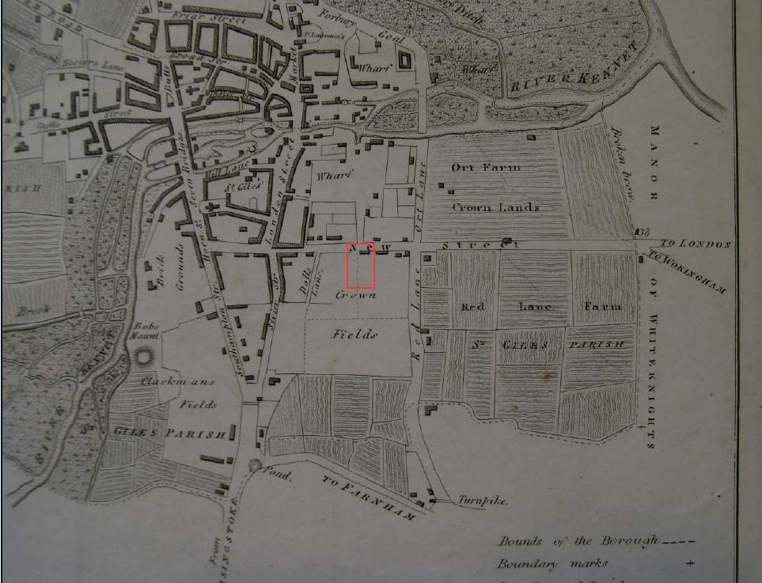
Picture 1. 1813 John Man’s Plan of the Borough of Reading
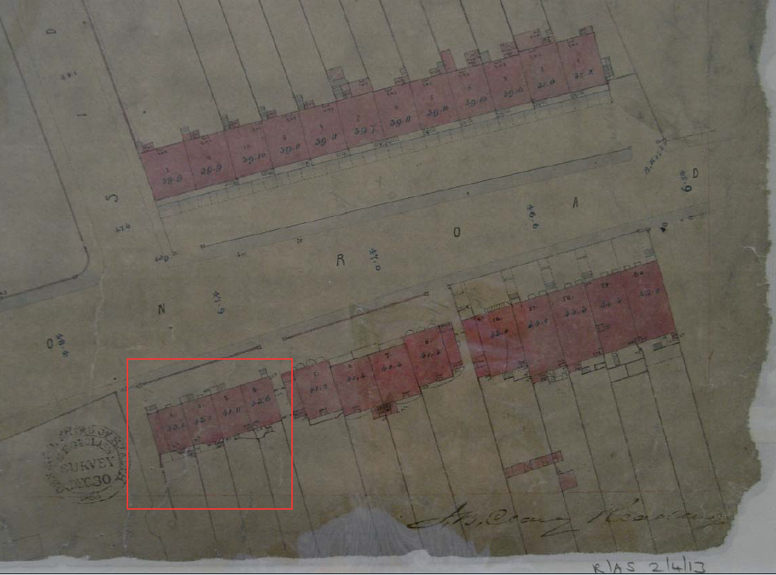
Picture 2. 1853 Board of Health Plan of Reading
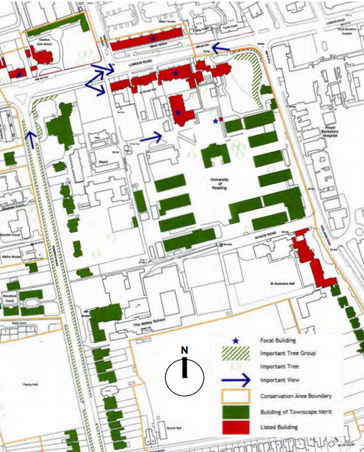
Picture 3. Kendrick Conservation Area Townscape Appraisal Map. July 2005.
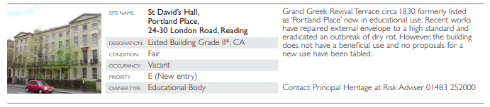
Picture 4. Heritage at Risk Register, South East 2012.
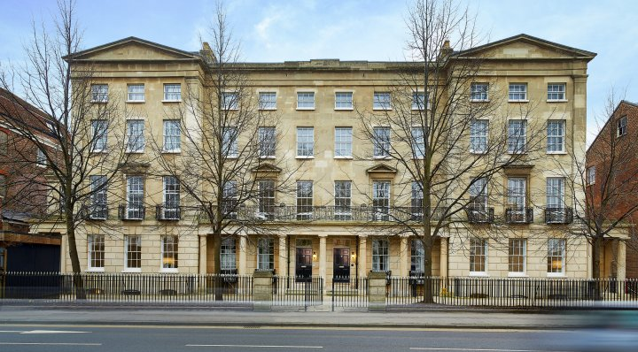
Picture 5. St David’s Hall front facade, south facing from London Road (2018).
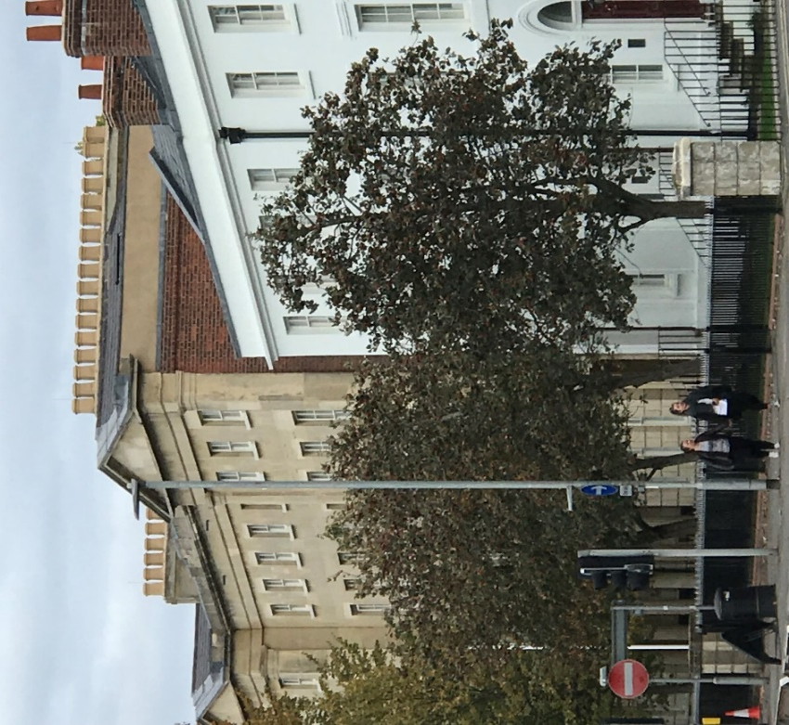
Picture 6. South East view of front facade from London Road, chimney stacks visible (2018).
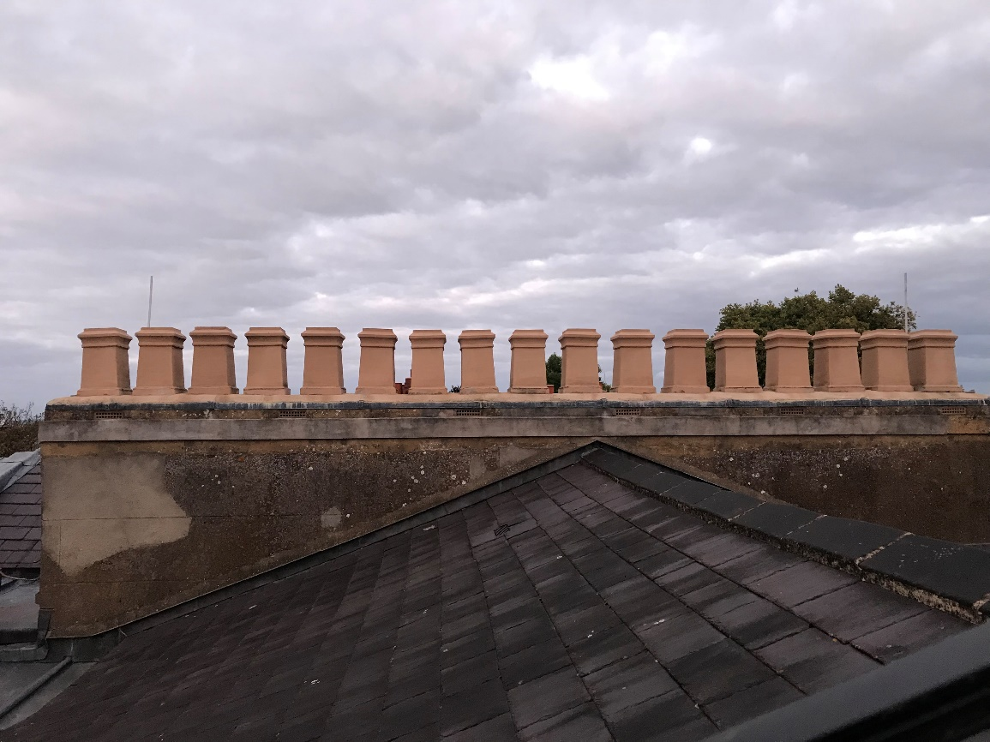
Picture 7. Eastwards view of chimney stacks from rooftop, 17 pots visible (2018).
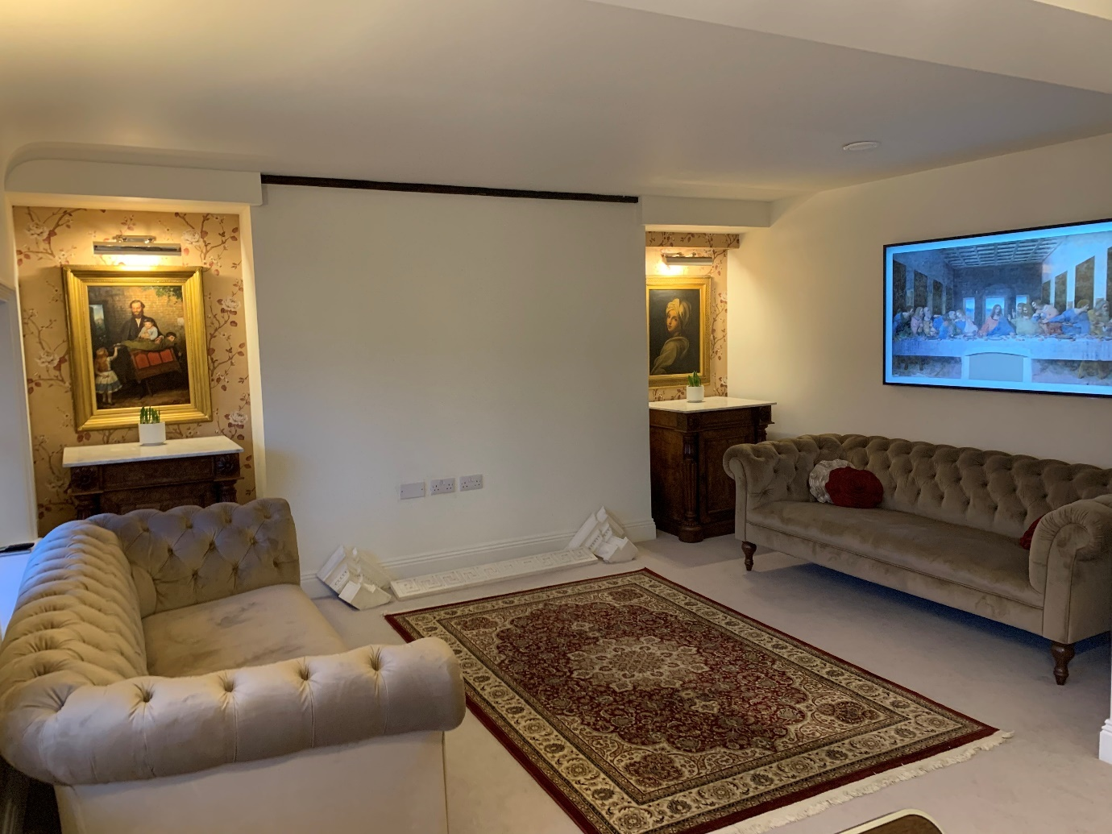
Picture 8. The Proposed location, North facing room located on the third floor (flat 9) 28 London Road. Chimney beast dominant within room and aligned with the east chimney stack.
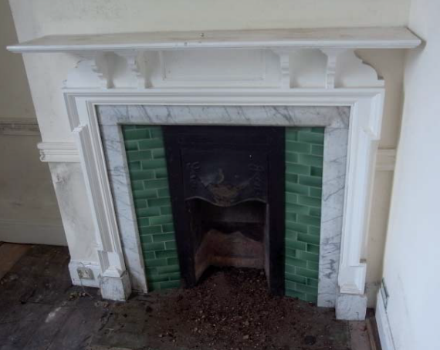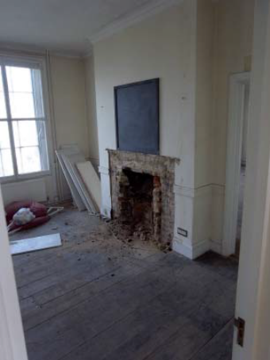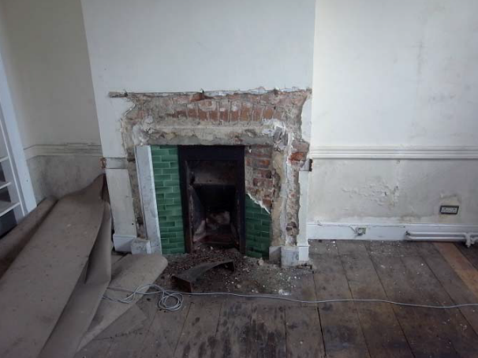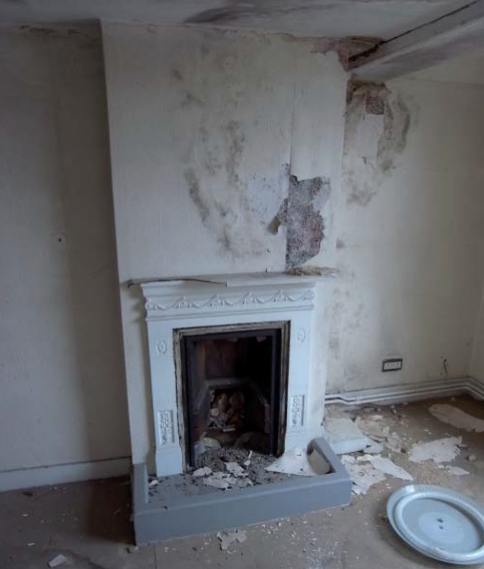
Pictures 9-11. Fireplaces within St Lawrence Hall No.16-22 London Road prior to restoration in 2015.
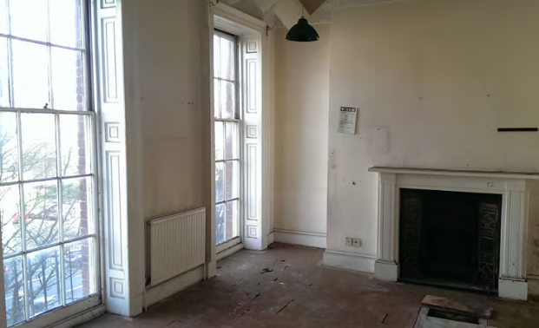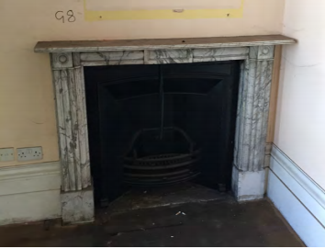
Picture 12-13. Fireplace in St Mary’s Hall No.32-40 London Road prior to restoration in 2015

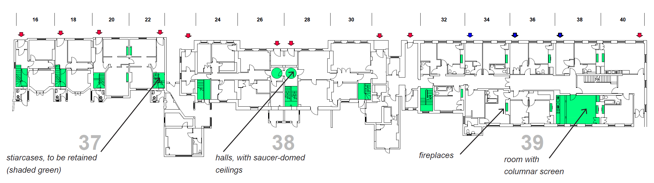
Picture 14. JPPC Chartered Town Planners (April 2015) ground floor plans across No. 16-40 London Road. Retained original fireplaces and other significant architectural features highlighted in green.

References
[1] Asset Heritage Consulting (March 2015). Conservation Appraisal & Heritage Impact Assessment in respect of Conversion of Nos. 16 to 40 London Road, Reading, Berkshire, RG1 5AQ - Document A & C
[2] JPPC Chartered Town Planners (April 2015). Proposed conversation and alteration of existing buildings to residential Use (53 dwellings) together with car and cycle parking, landscaping, bin stores
[3] Reading Borough Council (July 2005) Kendrick Conservation Area Character Appraisal
[4] Woodfield Brady Architects (March 2015). Conversation of 16-40 London Road, Reading to Residential use.
[5] Reading Borough Council (March 2007) Eldon Square Conservation Area Appraisal
[6] Historic England (December 1978) IoE Number 39014
[7] Ditchfiled and Page (1923). The Victoria History of the County of Berkshire

Previous Granted Permissions
App. No.: | 150730 | Site Address: | University Of Reading London Road  Reading  RG1 5AQ
Description: | Proposed conversion and alteration of existing buildings to residential use (53 dwellings) together with car and cycle parking, landscaping and bin stores.
Received Date: | 27/04/2015 01:00:00 | Decision Sent Date: | 09/10/2015
 |  | Decision Date: | 09/10/2015

App. No.: | 121002 | Site Address: | 24 London Road  Reading
Description: | Holly 4132 Removal (Fell to ground level) because of close proximity to building and to aid the proposed renovation of the roof and external structure
Received Date: | 08/02/2012 | Decision Sent Date: | 23/02/2012
 |  | Decision Date: | 23/02/2012

App. No.: | 960895 | Site Address: | 24 London Road  Reading
Description: | Reconstruction of original stone pier.
Received Date: | 15/07/1996 01:00:00 | Decision Sent Date: | 04/09/1996
 |  | Decision Date: | 04/09/1996

App. No.: | 940055 | Site Address: | 24 London Road  Reading
Description: | Ground floor extension to link offices.
Received Date: | 23/09/1994 01:00:00 | Decision Sent Date: | 07/04/1995
 |  | Decision Date: | 07/04/1995

App. No.: | 940056 | Site Address: | 24 London Road  Reading
Description: | Form 2 new openings in external walls and provide single storey extension to link offices. Install internal partition.
Received Date: | 23/09/1994 01:00:00 | Decision Sent Date: | 07/04/1995
 |  | Decision Date: | 07/04/1995

App. No.: | 920337 | Site Address: | 24 London Road  Reading
Description: | New arrowhead railings and gates to front boundary of property with new stone piers.
Received Date: | 27/07/1992 01:00:00 | Decision Sent Date: | 04/11/1992
 |  | Decision Date: | 04/11/1992

App. No.: | 920919 | Site Address: | 24 London Road  Reading
Description: | Erection of new gates, railings and stone piers within the curtilage of a listed building.
Received Date: | 27/07/1992 01:00:00 | Decision Sent Date: | 04/11/1992
 |  | Decision Date: | 04/11/1992

App. No.: | 920614 | Site Address: | 24 London Road  Reading
Description: | Opening of 5'0 arched gateway in unlisted wall adjacent to listed buildings and erection of ceremonial gates.
Received Date: | 04/06/1992 01:00:00 | Decision Sent Date: | 03/07/1992
 |  | Decision Date: | 03/07/1992

App. No.: | 920152 | Site Address: | 24 London Road  Reading
Description: | Refurbishment and change of use to form two further study bedrooms with associated bathrooms in addition to listed building consent 91/0290/LB
Received Date: | 25/02/1992 | Decision Sent Date: | 03/03/1993
 |  | Decision Date: | 03/03/1993

App. No.: | 920684 | Site Address: | 24 London Road  Reading
Description: | Refurbishment and change of use of listed building to form two further study bedrooms with associated bathrooms in addition to planning permission 91/0291/FD.
Received Date: | 24/02/1992 | Decision Sent Date: | 01/03/1993
 |  | Decision Date: | 01/03/1993

App. No.: | 910809 | Site Address: | 24 London Road  Reading
Description: | Refurbishment and change of use to provide study bedrooms with associated bathrooms and shower rooms plus social rooms communal lounge & dining areas. To form hall of residence for College
Received Date: | 20/03/1991 | Decision Sent Date: | 09/07/1991
 |  | Decision Date: | 09/07/1991

App. No.: | 910810 | Site Address: | 24 London Road  Reading
Description: | Refurbishment and change of use of listed building to form study. Bedrooms with associated bathrooms, shower rooms and social rooms Common lounge and dining area and a wardens bed-sit
Received Date: | 20/03/1991 | Decision Sent Date: | 09/07/1991
 |  | Decision Date: | 09/07/1991

