Design and Access Statement
Flat 9, 28 London, Reading, Berkshire, RG1 5AG
Relating to the Proposal for a Fireplace Installation
This application seeks listing building consent to reinstate one of thirty-two original fireplaces which have all since been removed from St David’s Hall. The works proposed will seek to ensure a faithful to period replacement fireplace which would be sympathetic to the buildings’ original heritage. They are intended to be minimally invasive and localised to the chimney breast and flue within North-facing room of Flat 9, 28 London Road (Picture 7). Flat 9 is located on the third floor, 28 located leftmost within the central block. St David’s Hall is a Grade II* listed building, the historical significance of the building in the context of this application has been reviewed in the Heritage Statement submitted with this application. No original fireplaces remain in the building and consequently, all chimney breasts have been sealed off.
Many of the partition and interior walls, including the application chimney breast have been clad in drywall following recent refurbishment in 2018 It is therefore difficult to assess the condition of structures directly behind these walls until works have commenced. The breast is aligned with the buildings east chimney stack, it is expected that the drywall covers the a masonry chimney chamber (seen exposed in the attic space above – Picture 7), the opening for the original fireplace was likely filled in with brickwork during the 20th century when open fires were no longer required to heat the building. In order to install the fireplace this cavity will need to be excavated It should be noted that this work is not expected to affect or significantly alter any original parts of masonry. The cavity will accommodate a period cast iron register grate, the exhaust of which will be aligned within the original chimney flue.
Material will be removed with great care and only as much as is required to accommodate the register will be cleared. A traditional slate hearth will be set within the cavity using a quick setting cement based tiling adhesive forming a structural base for the fireplace. The cavity will subsequently be resealed with around the aperture of the fireplaces cast iron register grate, depending on the height of this opening compared the original cavity it may be necessary to install a masonry lintel to support the blockwork above the opening. Brickwork to be set/pointed with traditional lime mortar.
The proposed fire surround (Pictures 1-2) is constructed of solid carved marble featuring a meander motif / Greek check pattern and ionic columns believed to be consistent with the Regency Greek revival style of the building. Original fireplaces are known to remain in the adjacent buildings, St Lawrence Hall No.16-22 & St Mary’s Hall No.32-40 London Road (off the same period as St David’s Hall) and feature marble surrounds of similar construction.
The marble surround has been professionally restored (Pictures. 4-5). Restores comments:
“In my opinion, I would say it's a very good bespoke replica for a Georgian estate house copied from an original or part of an original that was beyond restoration, taking note of the high quality I would say it's been made by the Chesney bespoke team circa 1990s. These are high end, top quality facsimiles I suspect it is one that was damaged prior to installation so was rejected, the starting cost for these is £10,000 + vat upwards so are expected to be perfect.”
Mark Swan, Sussex Fireplace restoration
Chesney’s of London being an established vendor known for high-quality period and replica fireplaces.
The marble surround will be secured by metal pegs, mounts, copper wire or metal threads placed into parts channels within the interior structure of the surround and affixed to the wall. It may be necessary to strengthen areas of the drywall structure with additional wood joists which would ensure minimal damage to the original masonry chimney breast. Where this is not possible given a need for further structural support mounts will be secured directly into load-bearing masonry or further blockwork added to build out the structure within the drywall. The surround will be set in place using traditional bonding materials (plaster of Paris / Gypsum plaster). Each bond should have continuous contact along its full joint and is bonded to the masonry / re-enforced joist along the back edge.
A Cast iron register grate is yet to be sourced, picture 3 shows an example design that will fill the interior opening of the surround and act as the fire housing. It is intended that the cast Iron burner will be styled in an authentic period design sympathetic to the buildings’ original heritage. Examples from St Laurence’s Hall and St Mary’s Hall will be referenced to ensure that materials used are authentic to the period. The internal aperture of the marble surround is quite large, so this may necessary to install traditional slate slips around the grate.
Once the cavity for the register grate has been made and assuming the original chimney flue is found to be in a good condition with no obstructions a chimney survey will be conducted to determine which of the 17 chimney pots the flue is routed to. Following the result of this survey and providing the removal of the chimney cap applied to the interior of the chimney pot at roof level will result in no damage to the original structures it will be removed to allow for operational use of the fireplace. The flue should be tested and certificated by a suitably qualified NACS registered chimney sweep, to the standard required for solid fuel usage. If undue force is required for removal of any caps, obstructions or the flue is otherwise seen be unusable the fireplace will be installed but serve as a purely decorative feature and all caps or seals will then remain in situ.
Electrical outlets are currently positioned in the application breast assuming the chimney flue is connected to allow for an operational solid fuel fire wiring will be drawn out from the drywall and terminated. If it is not possible to establish an operational solid fuel fire this wiring will be retained and relocated to an appropriate location.

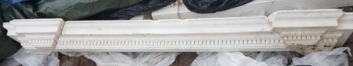
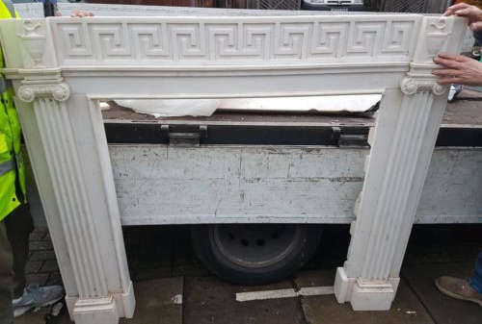

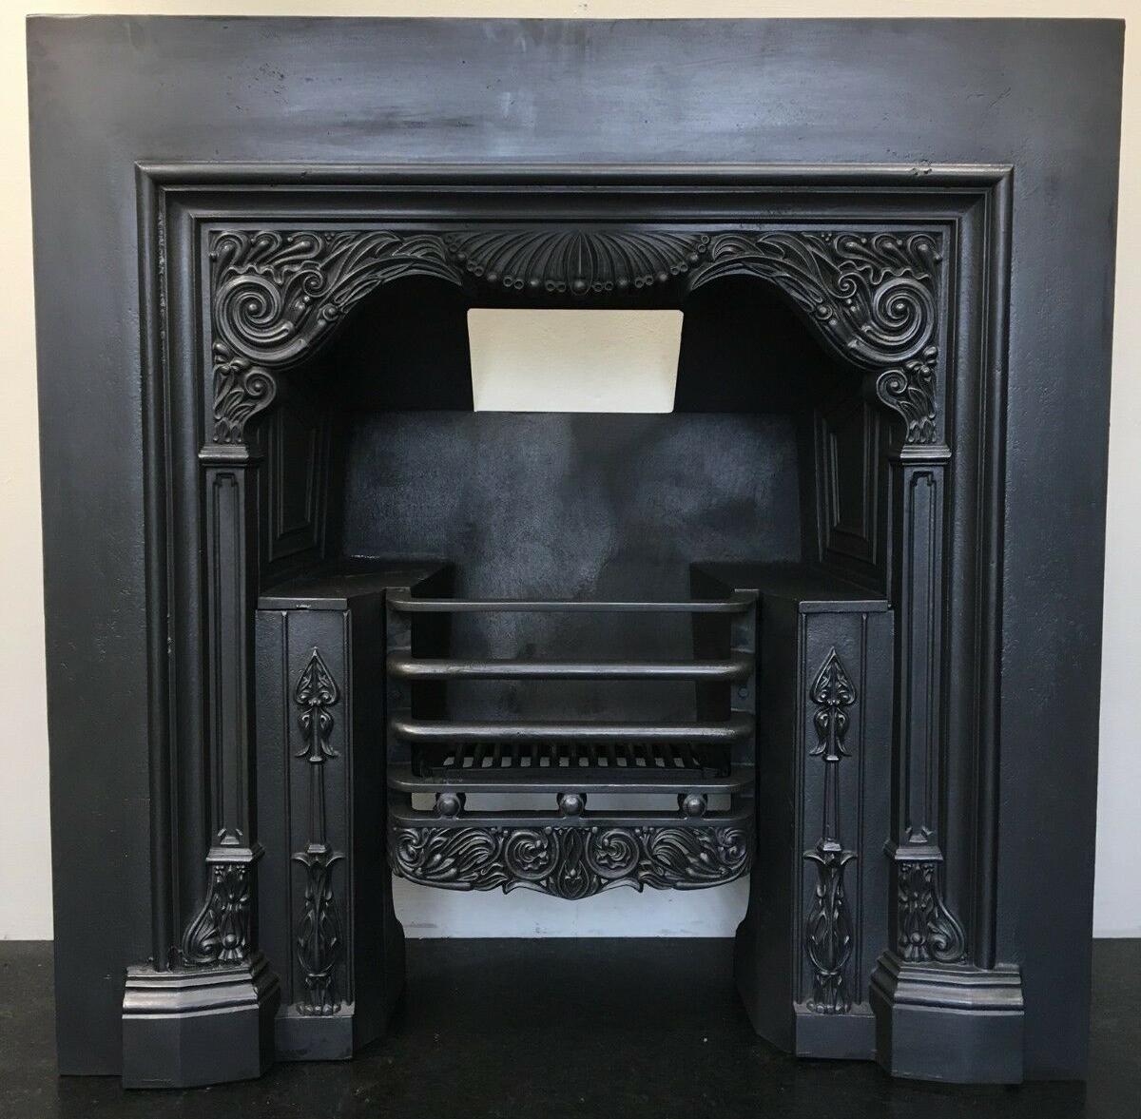
Pictures 1-2. The proposed marble fire surround and mantle.

Picture 3. An example of a cast iron register grate.
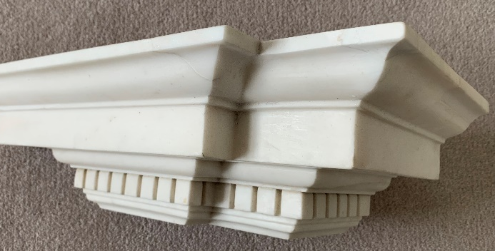
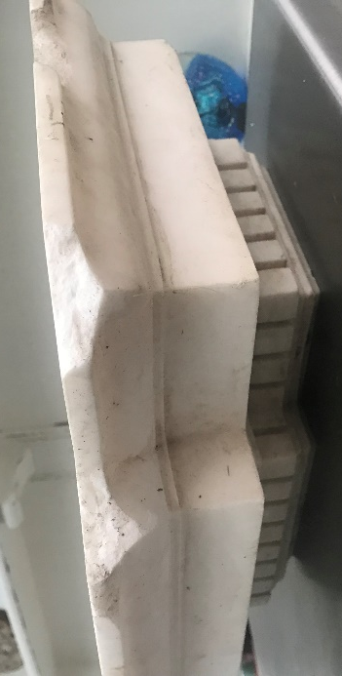
Pictures 4-5. Restoration works to sections of the mantle completed to the mantel by Sussex Fireplace Restoration.
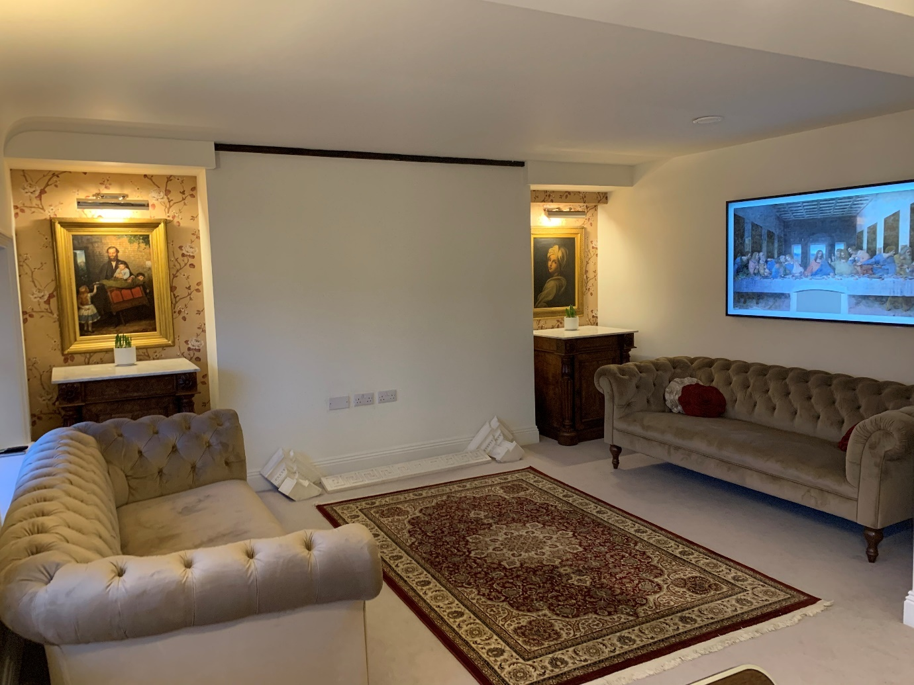
Picture 6. The Proposed location, North facing room located on the third floor (flat 9) 28 London Road. Chimney beast dominant within room and aligned with the east chimney stack. Parts of the mantle shown in front of the chimney breast.

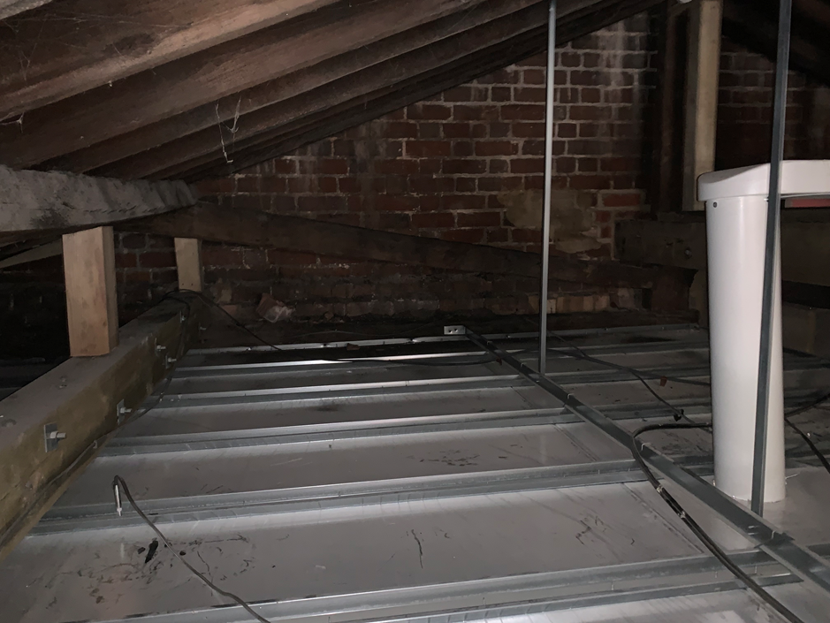
Picture 7. The exposed partition / chimney camber seen in attic space. (Directly above Picture 6)
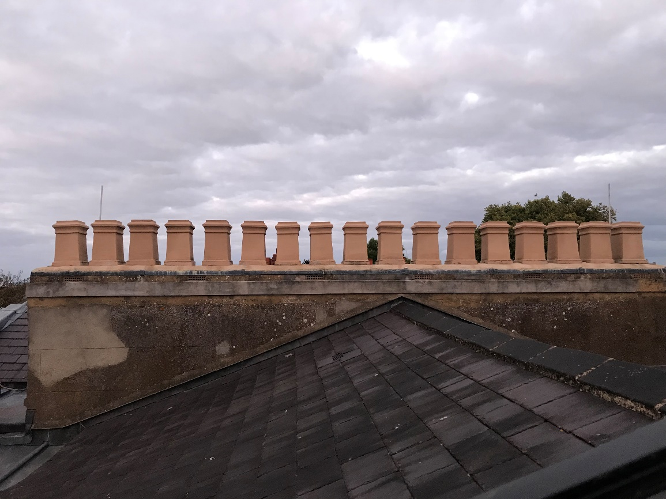
Picture 8. Eastwards view of chimney stacks from rooftop, 17 pots visible. (Directly above Picture 7)
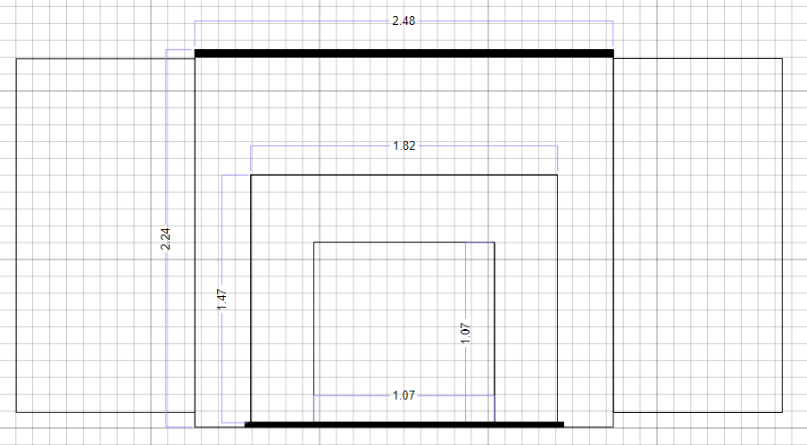
Picture 9. Scale drawing of proposed fire surround within the application chimney breast, dimensions listed in metres. Ceiling Beam and slate hearth shaded black.
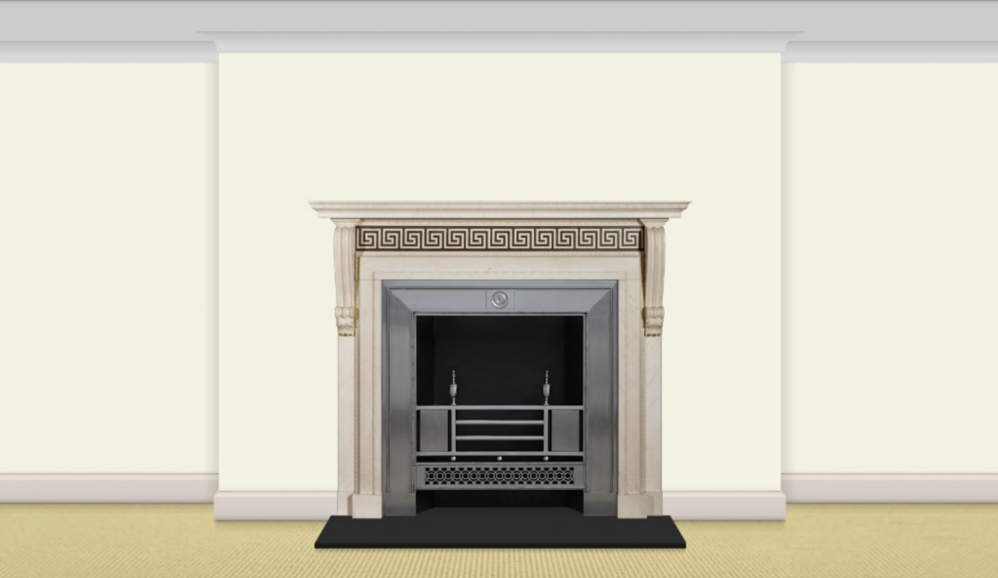
Picture 10. Visualisation showing approximate proportions of proposed fire surround within the application chimney breast. Fire surround and grate shown only for visualisation and differ from the design of the proposed insert and grate.

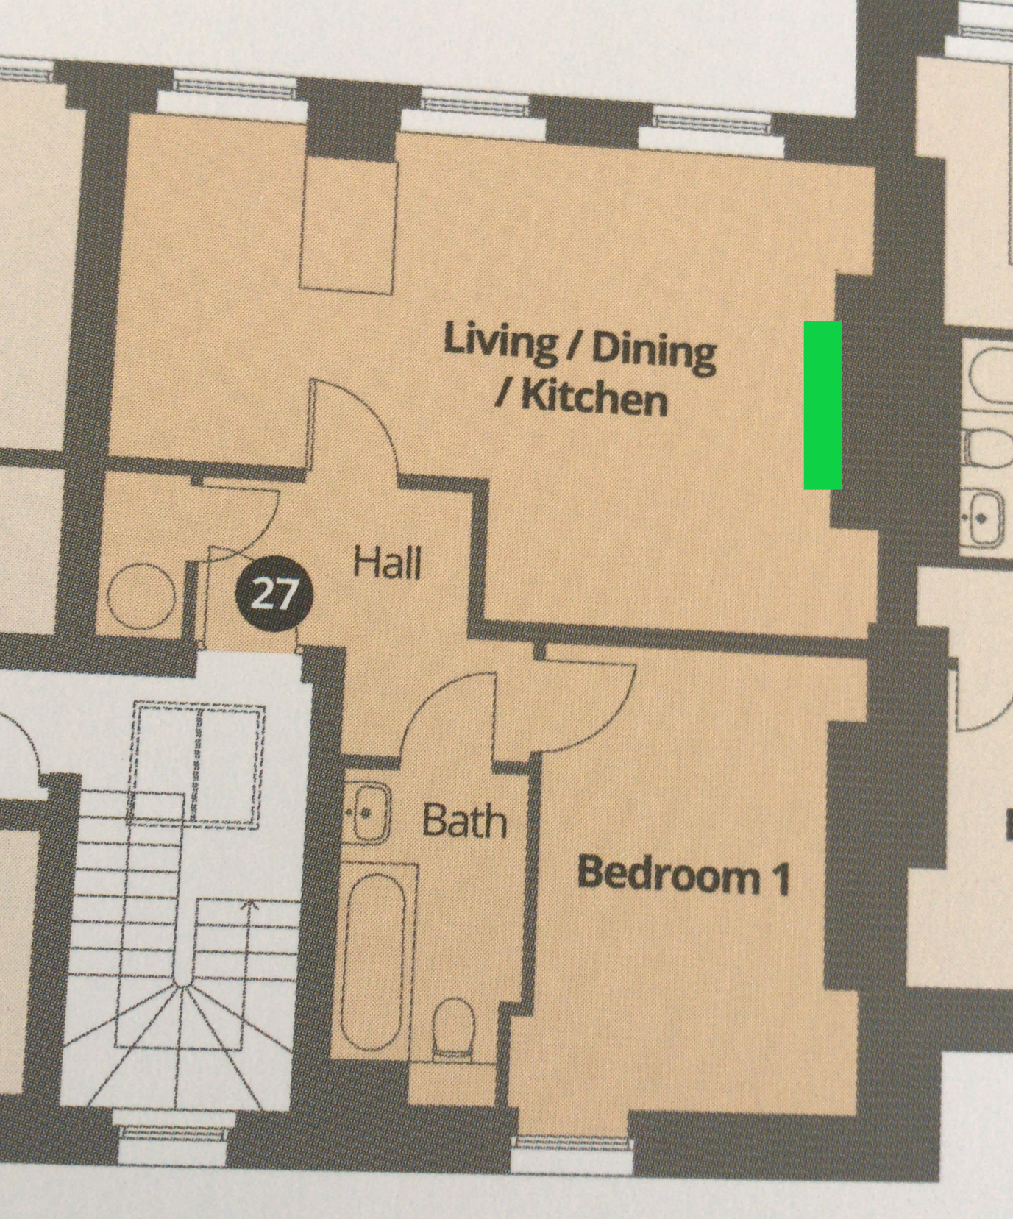
Picture 11. Floorplan of flat 9, 28 London road (previously listed as “plot 27”). The Proposed fireplace location highlighted in green, north facing room chimney breast.

