Delegated Application Report Target Date: 8/10/19 (extended)

Address: Green Park Village
Application No: 190109/NMA
Proposal: Non-Material Amendment to application 170096 - changes to site layout east of Urban House (plots 467 & 468, and parking/landscaped area)
Case Officer: Alison Amoah

Proposal: Non material changes relating to Phase 3B2 of Green Park Village as follows:
- changes to the site layout east of the Urban House (plots 467 & 468), and the parking/landscaped area within this area

The reason for the proposed changes, as set out by the applicant, is as a result of development of the technical design.
Original Plan approved under 170096/REM | Proposed Amended Plan under 190109/NMA
Site Layout Plan – Drawing No: PL-P3B2-002 Rev P11, received 18th May 2017 | Site Layout Plan – Drawing no: PL-P3B2-002 Rev P12, received 24th January 2019
Phase 3B Streetscene Elevations A-E– Drawing no: PL-P3B-004 Rev P2, received 24th May 2017 | Phase 3B Streetscene Elevations A-E – Drawing no: PL-P3B-004 Rev P3, received 24th January 2019
House Type D1 Plans & Elevations Hardie Plank– Drawing no: PL-P3B2-010 Rev P3, received 24th May 2017 | House Type D1 Plans & Elevations Hardie Plank– Drawing no: PL-P3B2-010 Rev P4, received 24th January 2019
Detailed Soft Landscape General Arrangement Plan (sheet 1 of 4)– Drawing no: D2307 L.340 Rev D, received 24th May 2017 | Detailed Soft Landscape General Arrangement Plan (sheet 1 of 4)– Drawing no: D2307 L.340 Rev G, received 23rd September 2019
Planting Schedule and Specification – Drawing no: D2307 L.344 Rev B, received 24th May 2019 | Planting Schedule and Specification – Drawing no: D2307 L.344 Rev G, received 23rd September 2019

Objections Received (Summary):
Applications under S96A are not applications for planning permission, so are not covered by the publicity requirements as set out in the DMPO. However, Transport and Natural Environment were consulted.

Transport –There are no transport objections as the revised site layout retains the required level of parking.

Natural Environment - I note the change in layout from that below left to that below right, around plots 467 & 468:

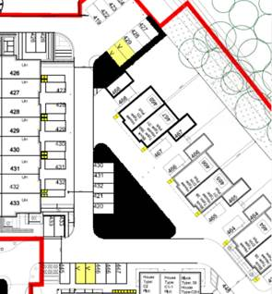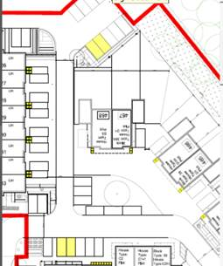

The approved landscape layout, as show on drawing Detailed Soft Landscape General Arrangement Plan (sheet 1 of 4)– Drawing no: D2307 L.340 Rev D (approved under 170096/REM), includes the following in the area in question:

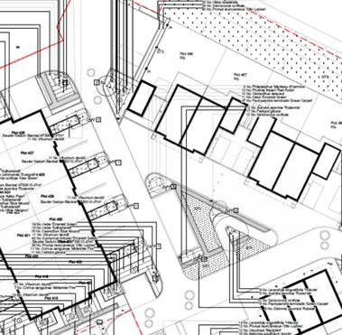

This included 4 trees; those being 3 upright Hornbeam and 1 Liquidambar in the amenity space in front of the properties. It would appear that the change will result in the reduction of tree number but it would be useful to know at this point what the impact on the landscaping will be. In any case the landscaping will have to be formally amended – can this be done via this current application? If so, details prior to a decision are requested.

The small, corner landscape bed north/rear of plots 467 & 468 (adjacent to the parking spaces) appears to be reduced in size but by an insignificant amount.

Planning Officer note: The agent provided amended soft landscape and planting plans, which Natural Environment confirmed were acceptable.

Relevant Planning History:
10/01461/OUT (102172) – A planning application for mixed-use development comprising: Phase 1 (submitted in full with no matters reserved and as defined in area on Plan Ref. PL-P1-001) for the construction of housing (Class C3), local retail (Use Classes A1, A2, A3, A4, A5), management suite, village hall, engineering and infrastructure works including reconfiguration of the lake, lakeside access, car parking, pedestrian and cycle routes, services & infrastructure, landscaping and other associated works; and Subsequent phases (submitted in outline with all matters reserved except for details of the main access proposals) for the construction of housing (Class C3), extra care housing with ancillary community uses (Class C2), offices (Class B1), one-form entry primary school Class (Class D1), health surgery (Class D1), Nursery (Class D1), sports pitches, children's play facilities, engineering and infrastructure works including reconfiguration of the lake and vehicular access, lakeside access, car parking, pedestrian and cycle routes, services & infrastructure, landscaping and other associated works – Approved 1/7/11
170096/REM - Application for approval of reserved matters following outline approval for Phase 3B 2 (10/01461/OUT)– Approved 9/6/17

Appraisal:
- The proposed changes are minor in nature and would not have a significant impact on the amenity of future residents of the scheme and would have no effect on the level of parking. The changes are considered acceptable within the context of the overall original approved scheme under 10/01461/OUT (102172), as amended by 172236, and the reserved matters permission (170096).
- As the original outline permission (10/01461/OUT) and the reserved matters application, to which this NMA relates (170096) were major applications delegated authority was sought and confirmed by councillors.

Conclusion:
The changes as proposed are considered to be acceptable non-material alterations to the approved scheme.

Recommendation:
Approve non-material amendment subject to conditions. Although Section 96(A) of the Act does not allow for the original decision to be re-issued, it does allow the modification of, or imposition of, conditions. In this respect it is considered appropriate to impose an additional condition:

Condition
The plans hereby approved by this Non-Material Amendment (under Section 96A of the Town and Country Planning Act 1990) are as follows:

• Site Layout Plan – Drawing no: PL-P3B2-002 Rev P12, received 24th January 2019
• Phase 3B Streetscene Elevations A-E – Drawing no: PL-P3B-004 Rev P3, received 24th January 2019
• House Type D1 Plans & Elevations Hardie Plank– Drawing no: PL-P3B2-010 Rev P4, received 24th January 2019
• Detailed Soft Landscape General Arrangement Plan (sheet 1 of 4)– Drawing no: D2307 L.340 Rev G, received 23rd September 2019
• Planting Schedule and Specification – Drawing no: D2307 L.344 Rev G, received 23rd September 2019

Reason: to clarify which plans are approved by this Non-Material Amendment.

INFORMATIVES
- This notice relates only to the changes to the plans as approved under condition 1 of the reserved matters permission 170096 (pursuant to condition 2 of permission 10/01461/OUT). It shall only be read in the context of the substantive planning permission granted under reference number 10/01461/OUT (102172), as amended by 172236 and is bound by all the conditions and obligations attached to that permission. That permission still stands and this notice (and any other notices issued under section 96a for this development) should be read together.
2. In reaching this decision, the local planning authority is satisfied that the changes proposed by this application do not constitute a material change to the approved planning permission.

