FILE NOTE

PROJECT NO.: 1976
PROJECT NAME: 153 HEMDEAN ROAD, READING, RG4 7QU
SUBJECT: Planning Condition Material Schedule Rev C
DATE: 07 October 2019
AUTHOR: MC
ACG REF: 1976_401_191007_Material Schedule C

No. | Type | Specification | Material Sample Photographs | Material Sample Precedent | Location/Type
01 | Brickwork | Supplier: Bespoke Brick Company  Product Type: Brick  Product Reference/Finish: Cinder Coal White  Mortar Colour: White | 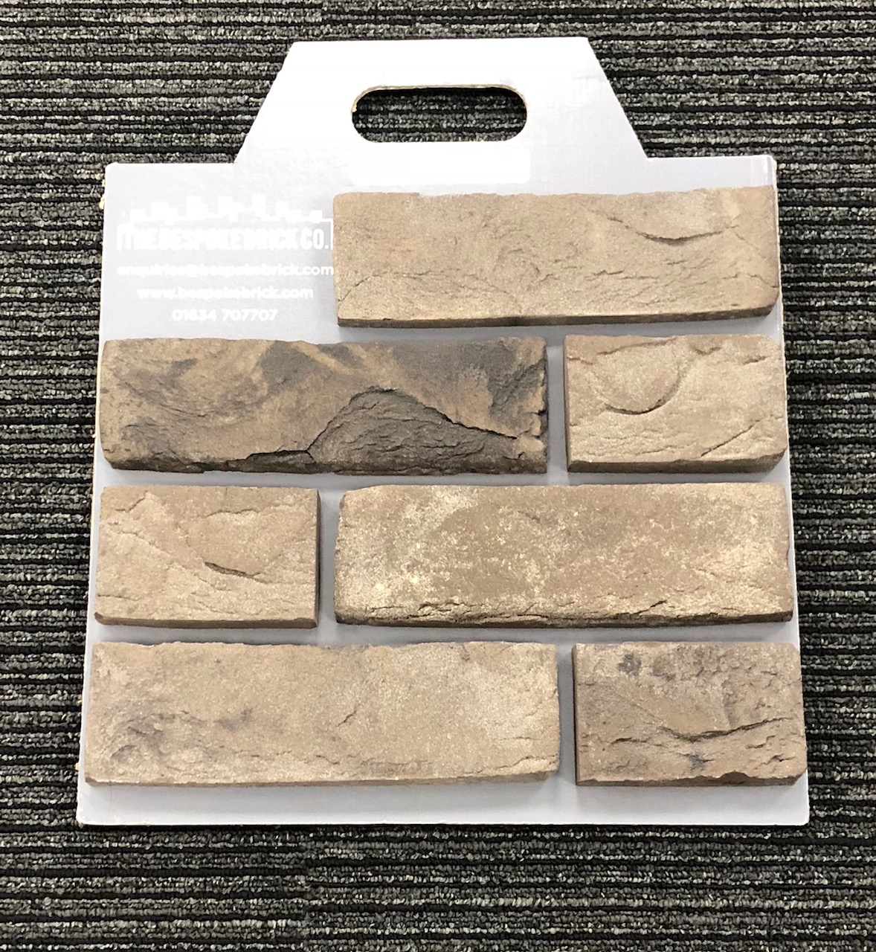 |  | External Walls
02 | Render | Supplier: Sto Ltd  Product Type: StoTherm Classsic  Product Reference/Finish: White |  |  | External Walls
03 | Slate Roofing | Supplier: Marley Eternit  Product Type: Roofing Slates  Format: 600mm (H) x 300mm (W)  Product Reference/Finish: Thrutone Fibre Cement Slates – Blue/Black |  | 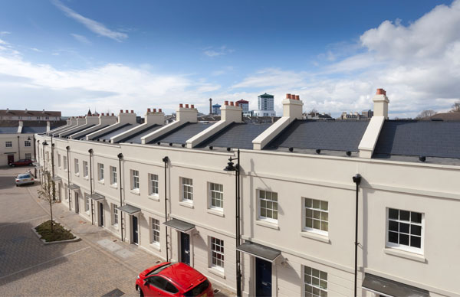 | Roofs
04 | Windows | Supplier: IdealCombi  Product Type: Futura+ 53mm inward opening range for tilt and turn. Fixed Panes same range  Composite Windows  Product Reference/Finish: Anodised HAI Horsens B1 | 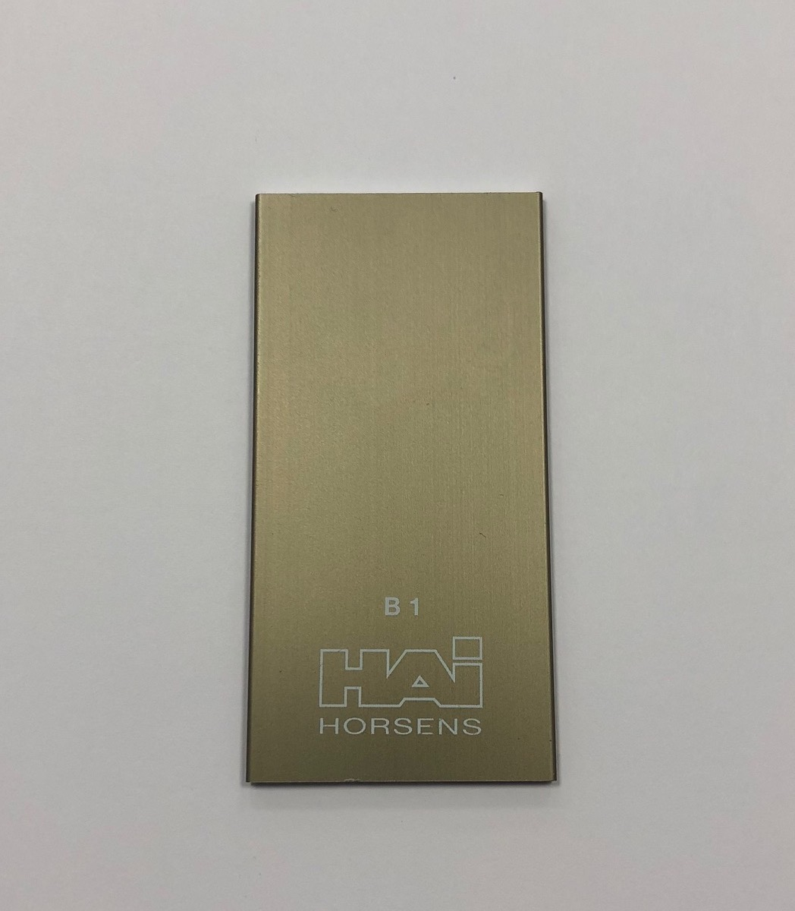 | 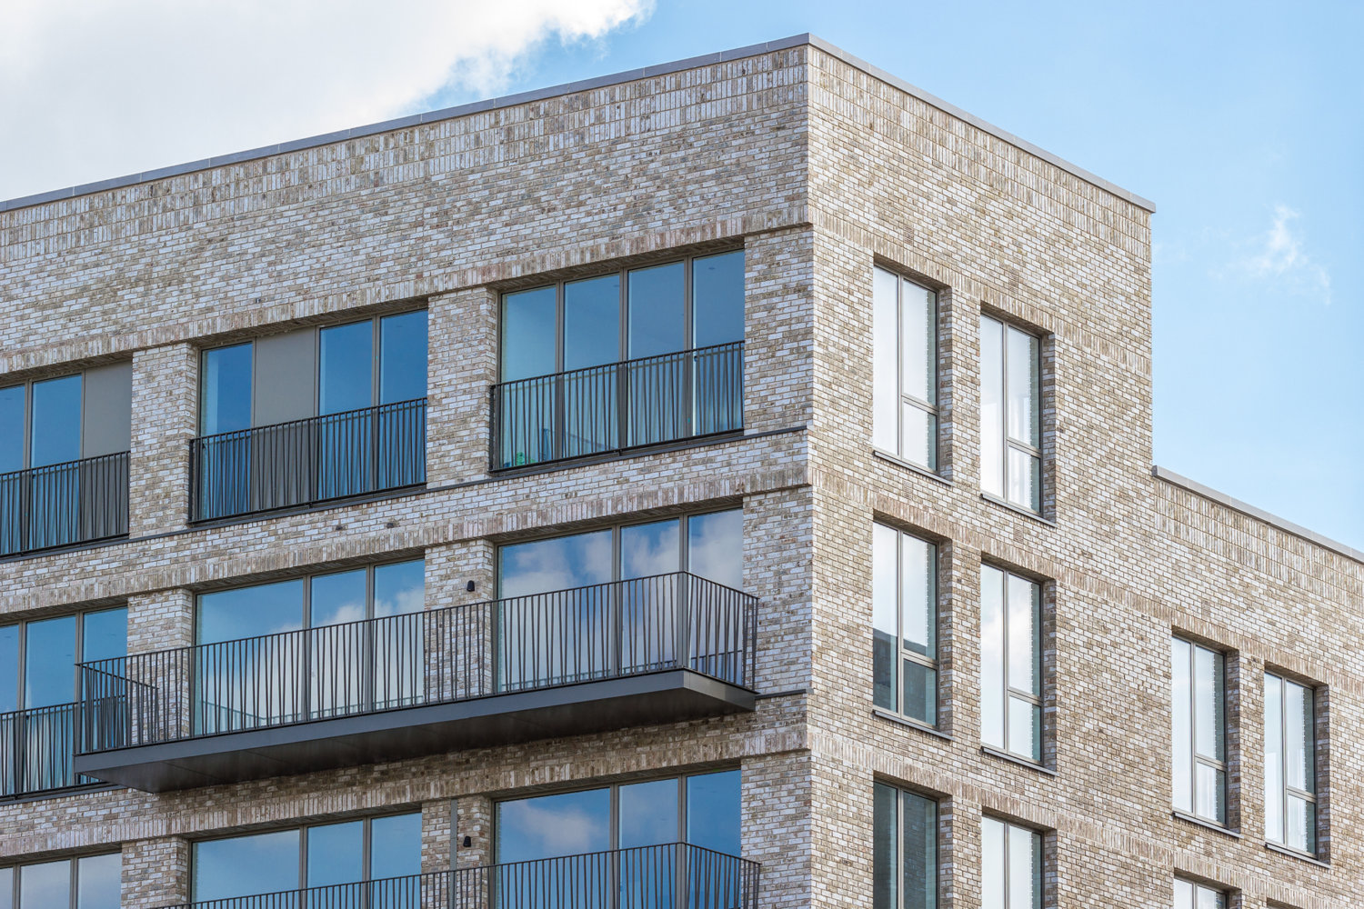 | External Windows
05 | Sliding Doors | Supplier: Keller  Product Type: Minimal Windows  Thermally Broken Aluminium Windows  Product Reference/Finish: Anodised HAI Horsens B1 | 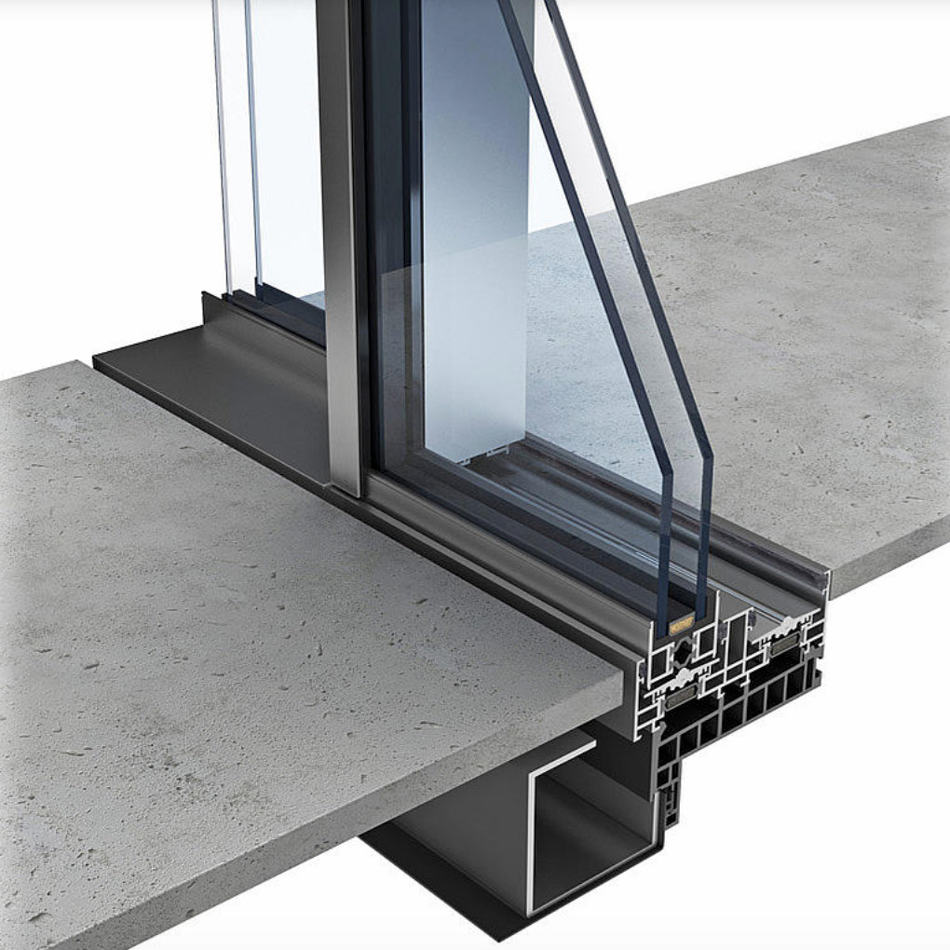 | 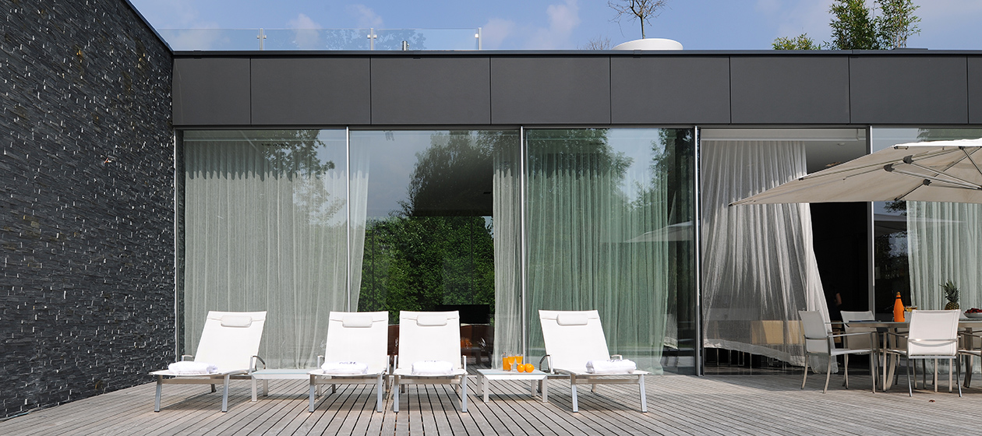 | External Walls – to Balcony Areas
06 | Chain Link Fencing | Chain Link PVC Coated (green) galvanised core  https://www.jacksons-fencing.co.uk/fencing/roll/chain-link-family-pvc | Proprietary | Proprietary | Boundary fences to reinforce existing hedging, set 150mm above prevailing ground levels

