http://www.asgardsss.co.uk/cycle-maintenance-shed

Bike Storage X 6 - Police Approved

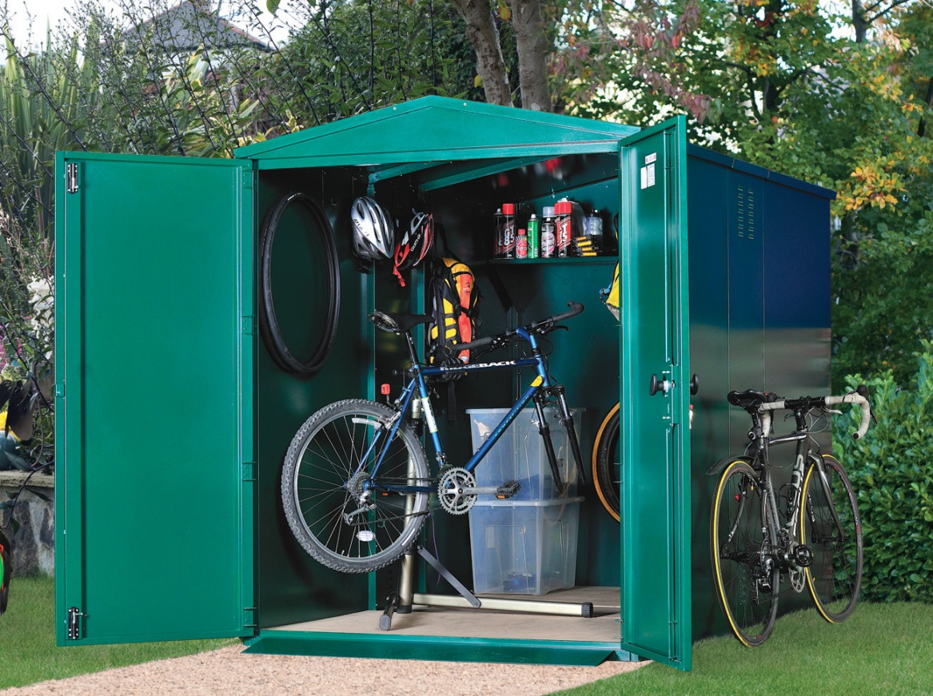
OR
http://www.asgardsss.co.uk/bike-cycle-storage/bike-locker-vertical

Bike Locker - Vertical
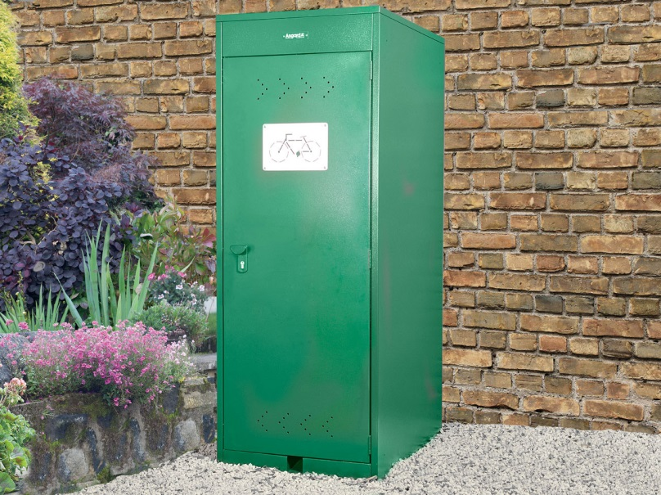

https://wienerberger.co.uk/en/product-search/pagus-grey/black

Pagus Grey/Black
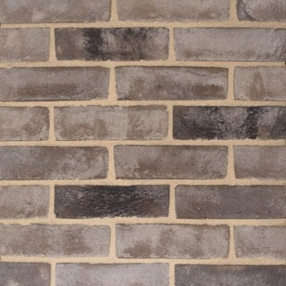

https://wienerberger.co.uk/en/product-search/pagus-grey

Pagus Grey
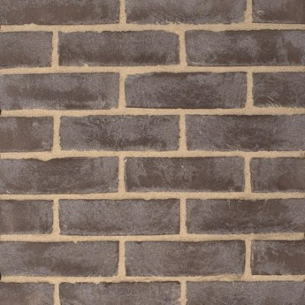

https://wienerberger.co.uk/en/product-search/renaissance-multi?wb_condition=ProductType:1366306088345

Renaissance Multi

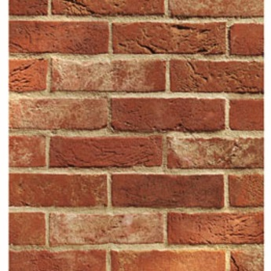

https://idealcombi.com/commercial/products/futura-plus/ (Examples only….. Colours to be decided)
With Futura+, Idealcombi launched the second generation of composite windows already back in 2010.
Moving on from wood/wood, alu/wood and the traditional composite windows these innovative Idealcombi window systems use PUR as thermal break to reach outstanding energy performance for a slim profile window.
The use of PUR allows for strong and slim designs with outward opening Futura+ windows and inward opening Futura+i windows to be matched in the same screens, with the same slim 53 mm aluminium sightlines.
With further updates made in 2017, Idealcombi Futura+ is now one of the most energy efficient, sleek and contemporary design windows on the market. And they’re all Danish design windows manufactured to a high quality standard.
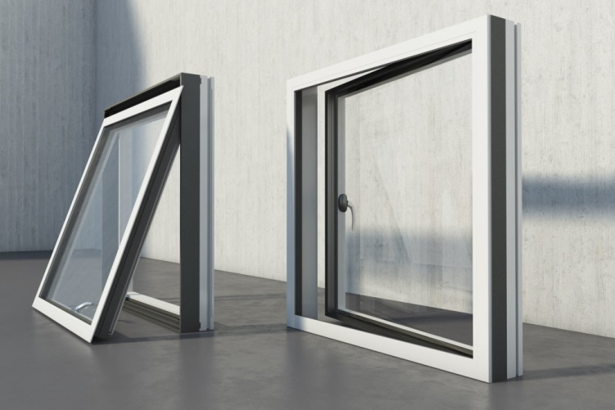
https://idealcombi.com/doors/front-doors/
