Application No: 190363
Address: Travis Perkins, Acre Road, Reading, RG2 0SA
Proposal: Regularise external storage heights within the building yard, as wellas alter and add parking bays.
Case Officer: Brian Conlon
Site Description and Surrounding Area
The application relates to an existing Travis Perkins builders merchants located to off Acre Road within the defined Core Employment Area, south of Reading. The site is rectangular and 0.63ha in size. The site was granted consent under 151635 for change of use to a
builders merchant (sui generis).
The site has direct access onto Acre Road with a service and material storage yard occupying the central part of the site and a trade counter, office and storage building occupying the southern part of the site. The surrounding area comprises of commercial and industrial uses.
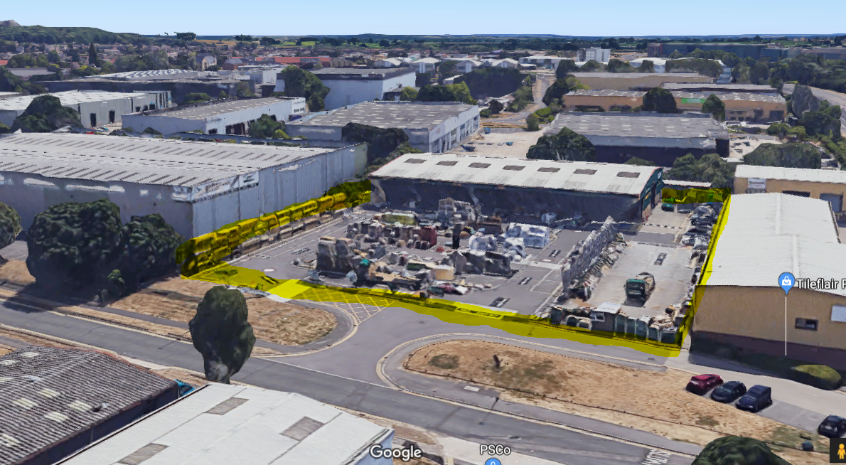
Upon conducting the application site visit, materials were observed being stored at approximately 5m in height to the perimeter of the yard and at a range heights (2-4m) to the centre of the yard where racking did not exist.

Proposal
This application seek consent to regularise external storage heights within the central builders yard as the site operator (Travis Perkins) has identified a health and safety issues with the existing storage racking. At present, existing storage is indicated as up to 3.5m to the perimeter of the site and up to 5.5m to the centre of the site. The proposed storage is to be increased up to 5.5m on the perimeter of the site (as observed on site) and 8.5m in the centre of the site.
The proposal also involves creating 4 additional parking bays at the north of the site for staff parking, as well as altering the parking next to the trade counter to cater for large good vehicles (vans).

Plans Considered
Original plans received on the 4 March 2019:
KNS-1148-101
KNS-1148-102 (Existing)
KNS-1148-103 (Proposed)

Relevant Planning History
Application Number: 93/00596/FD
Erection of new warehouse & offices including vehicle parking.
Decision: Permitted on 23 September, 1993

Application Number: 151635
External alterations to existing warehouse (Class B8) and part change of use to a
builders? merchant (sui generis) for display, sale and storage of building, timber and
plumbing supplies, plant and tool hire including outside display and storage, revised
access, car parking and servicing arrangements, and associated works.
Decision: Permitted on 30 November, 2015

Consultation Responses
RBC Transport – No objection subject to conditions.
Neighbouring commercial premises consulted and no responses received.

Equality Act 2010
In determining this application, the Council is required to have regard to its obligations under the Equality Act 2010. However, there is no indication or evidence (including from consultation on the application) that the protected groups identified by the Act have or will have different needs, experiences, issues and priorities in relation to this particular planning application. Therefore in terms of the key equalities protected characteristics it is considered there would be no significant adverse impacts as a result of the development.

Relevant Planning Policy and Guidance
The following local and national planning policy and guidance is relevant to this application:
National Planning Policy Framework (NPPF) (Feb 2019)

Section 2 - Achieving sustainable development
Section 4 - Decision-making
Section 6 - Building a strong, competitive economy
Section 12 - Achieving well-designed places
Section 14 - Meeting the challenge of climate change, flooding and coastal change

Reading Borough Local Development Framework Core Strategy (2008, altered 2015)

CS1: Sustainable Construction and Design
CS7: Design and the Public Realm
CS10: Location of Employment Development
CS24: Car/Cycle Parking
CS35: Flooding

Sites and Detailed Policies Document (2012, altered 2015)

SD1: Presumption in favour of sustainable development
DM1: Adaptation to climate change
DM12: Access, traffic and highway-related matters
SA12: Core employment areas

Emerging Local Plan - Submission Draft Reading Borough Local Plan (March 2018)

Reading’s Draft Local Plan has been subject to Examination by the Secretary of State and is likely to be adopted in 2019 at which point the policies will fully apply. http://www.reading.gov.uk/newlocalplan

Supplementary Planning Guidance

Revised Parking Standards and Design (2011)
Revised Sustainable Design and Construction (2011)

Other material guidance and legislation

National Planning Practice Guidance
Department for Transport Manual for Streets
Department for Transport Manual for Streets 2

Appraisal

Principle of development
The site is located within a defined Core Employment Area, South of Basingstoke Road as outlined in Policy SA12c of the Sites and Detailed Policies Document (2012). Policies CS10, CS11 and CS12 of the Core Strategy seek to ensure a ‘flexible and responsive supply of employment land’ in Reading.
The proposal seeks to alter the external storage heights of building materials and supplies on what is recognised as an existing employment site. The proposal would not result in any change of use or any material change in the intensity of the use currently occurring (builders merchants). The proposal would allow the operator to increase on site storage and comply with relevant health and safety requirements (which fall outside of the planning system). A specifically worded planning condition is appropriate to ensure external storage is undertaken in accordance with the submitted plan. Therefore the proposal is considered acceptable in principle.

Design and impact on the character of the surrounding area
Immediately adjacent to the east and west of the site are two very large commercial buildings, one occupied by Horseman Coaches and the other ‘Mayfield Trading Estate’ occupied by Tileflair and Johnsons Decorating Centre. These buildings are in excess of current storage heights observed and effectively prevent any views into the site other than from Acre Road to the north.
Materials stored at the increased storage height would be visible from Acre Road but be consistent in appearance with current external storage to the perimeter of the site. Any views into the site from Acre Road are not of high amenity value and to view external storage of such material on racking when approaching a building merchant in reasonably expected. As such, the proposal would accord with Policy CS7 of the Core Strategy.

Impact on neighbours
There are no residential dwellings within proximity to this commercial unit and none which would be affected by any changes to the height of external storage. The nature of the surrounding area is almost entirely commercial/industrial and as such the increase in external storage up to 8.5m in the centre of the site is considered to be acceptable in terms of its impact on neighbouring commercial uses. The proposal therefore complies with the aims of Policy DM4 of the Sites and Detailed Policies Document.

Transport issues
The proposal will result in a net increase in 4 parking spaces. The proposed location of these staff spaces are within the applicant’s control and do not impact on the public highway. In view of this, there are no transport objections in respect of this application subject to a recommended condition requiring vehicle parking space provided in accordance with approved plans prior to first use. As the site is already in operation and the proposed external storage heights not reliant upon the creation of four new parking spaces, such a condition is not considered to meet the 6 tests of the Planning practice Guidance (2019), and therefore not required.
Flooding
The site lies within Flood Zone 2. However, the proposals do not result in any increase in floor space area and area of hardscaping. As such the proposals are not considered to increase the risk of flooding onsite and offsite.

Conclusion
The proposal has been assessed and found to be acceptable as it complies with the identified policy and guidelines.
RECOMMENDATION
GRANT

