DELEGATED APPLICATION REPORT - Application No.: 190738/FUL & 190739/ADV
Address: Caversham Baptist Church, Prospect Street
Proposal:

190738/FUL - New external ramp and stairs, external changes to doors and side ramp balustrade and new notice board.

190739/ADV:
New & replacement signage.

Case officer: Alison Amoah
Target Expiry: 14/8/2019 (ext)

Site Description and Surrounding Area:
The application site is a Grade II listed church with frontages to Prospect Street and South Street, prominently sited within the centre of Caversham.

The main pedestrian entrance is via a set of steps from South Street, through solid timber doors. There is also access from a rear door (from the car park), which includes a ramp, and a further external door, which opens onto Prospect Street. There is an existing sign board to the left of the main doors on South Street and existing signage attached to the building.

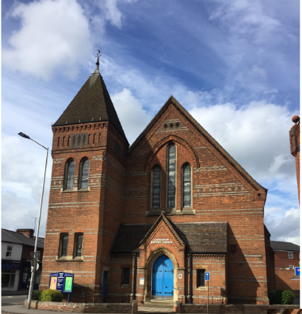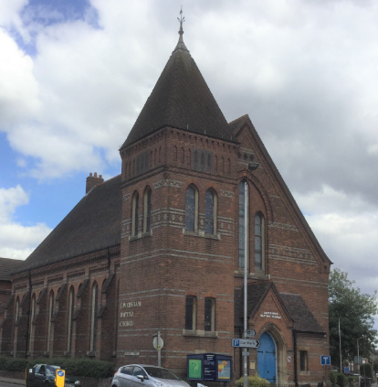

Proposal:
This application is a resubmission following the withdrawal of the previous applications (180629/FUL and 180630/ADV). Following the withdrawal of those applications the applicant has secured approval for the works to the Listed Building. As the Caversham Baptist Church is a Place of Worship it is subject to the Ecclesiastical Exemption under the Planning (Listed Buildings and Conservation Areas) Act 1990. Therefore the works to the listed building are authorised by the Listed Building Advisory Committee of the Baptist Union of Great Britain and the Baptist Union of Wales. The Certificate of Authorisation dated 29 March 2019 is attached at Appendix 1 and identifies the works approved and the relevant conditions.

The submission to the Council is therefore concerned with planning and advertisement consent and the proposed scheme for the external works including the signage (in italic) includes the following elements:

South front (South Street)
- New ramp and stairs with low brick walls, chamfered stone capping and stainless steel and glass balustrade (SWR Balustrade frameless glass channel system and wall mounted balustrade). Handrail – 50mm round section metal handrail.
- Build-up of levels in front of the main church door to enable level access from the top of the ramp. Paving – Indian Sandstone.
- New set of steps parallel to the ramp (between the ramp and the front of the church).
- Glazed front door of polished oak with etched glass infills incorporating the existing hinges. The existing doors will be conserved. The Design and Access Statement details the method for storage.
- Replacement ground mounted notice board of 2.4m above ground, 1.29m high x 2.59m wide with 2 no. A1 poster sections to be lit from the top and inside. Constructed of Metal post and frame supporting a timber board and doors. Please note the applicant has confirmed that details of lighting are yet to be determined.
- Replacement new church logo signage above the main door – individual blue glass letters - “Caversham” – 150mm high; “Baptist Church” - 115m high. Height to bottom of lettering – 3.28m from street paving level.
- Planting.
- Elevations also show: ventilation panel using modified heater flue; and boiler flue - 600m above main church roof

West side (Prospect Street)
- Remove existing noticeboard and repair and repoint brickwork.
- Door to be replaced with matching design from oak, and existing to be reused internally.
- New church logo sign – 3.58m above the pavement at 0.9 x 0.9m. “Caversham” – 85mm high; “Baptist Church” – 65mm high. Glass.
- New A2 poster size noticeboard – aluminium frame, polycarbonate acrylic cover. 0.6m wide by 0.8m high. 1.5m above pavement.
- Replacement new church logo signage on the side of the tower – 1.5w by 0.65m high, 3.67m above pavement. “Caversham” – 170mm high; “Baptist Church” – 130mm high; “Sharing the heart of Jesus, in the heart of Caversham” - 40mm. Glass.
- Elevation also shows: infill brick for unused flue; painting of two window frames; gas meter vents – 2 no. cast iron airbricks; gas pipe duct outlet – cast iron airbrick; flue for heating modified for ventilation, 3 no; boiler flue 400mm above roof in black, matte metal; first floor extraction terminus to tile vent.

North side
- 5 no. rooflights.
- Elevation also shows: 2 no. boiler flues in matte black metal; soil vent pipe to tile vent; and WC extraction to tile vent.

East side (car park)
- Side of tower door to be replaced in oak to match existing. Existing to be re-used internally.
- Existing ramp – glass and steel balustrade to match the proposed front ramp.
- Elevation also shows: 6 no. modified heater flues for ventilation using cast iron airbricks; cold water storage tank overflow to wall; and boiler flue 400mm above roof in black matte metal.

Plans considered: Received 7th May 2019 unless otherwise stated:
- Existing Plans and Elevations – Drawing no: 1872/S01 Rev B
- Existing Doors and Joinery – Drawing no: 1972/S02 Rev B
- Location Plan – Drawing no: 1972/P-01
- Proposed Site Plan - Drawing no: 1972/P02 Rev G, received 7th August 2019
- Proposed First Floor and Roof Plan – Drawing no: 1972/P03 Rev D
- Proposed Services Ground Floor Plan – Drawing no: 1972/P12 Rev B
- Proposed Services First Floor Plan – Drawing no: 1972/P13 Rev B
- Proposed Services First Floor Plan – Drawing no: 1972/P14 Rev B
- Proposed Details – 3 [section] – Drawing no: 1972/P10 Rev C
- Proposed Elevations and Details 1 – Frontage South Street– Drawing no: 1972/P04 Rev G, received 7th August 2019
- Proposed Elevations and Details 2– Drawing no: 1972/P05 Rev G, received 7th August 2019
- Proposed Elevations and Details 3 – Car Park– Drawing no: 1972/P06 Rev G, received 7th August 2019

Other documents:
- Design and Access Statement, dated April 2019, document ref: 1972 Rev 2, prepared by DLK Architects, received 7th May 2019
- Heritage Statement, dated April 2019, document ref: 1972 Rev 2, prepared by DLK Architects, received 7th May 2019

Discussion with the agent:
The Officer raised a number of questions following initial assessment of the submitted plans and in light of the previous withdrawn scheme. Officers had concerns with the previous scheme, summarised as follows:
- Objection to the loss of the main front doors and specific reference to the importance of the hinges.
- Fussy and cluttered ramp/ railings added to by the numbers of sets of steps as well as the ramp.
- Location of front notice board compared to the existing.
- Use of LEDs for signage and the size of signage.
- Lack of landscaping.

Officer question 1: What is the reason that the side door access with its existing ramp could not be enhanced thereby removing the need to undertake such significant changes to the front? Is it because this would require other changes to the external and internal fabric, which are considered more detrimental compared to what is proposed?

Agent response: One of the underpinning principles of the Disabled Discrimination Act is to create equal access for all, ie. to avoid disabled people having to use a ‘back entrance’, while the able bodied use a front entrance. In addition the church wish to promote the principle of access for all at their main entrance and in the course of this the building will appear more open and welcoming; in this day and age, this is increasingly important for churches. On a practical note, the space inside the rear entrance is extremely limited if you consider suggesting that this is considered for wheelchair users. Also these people, if attending a meeting in the main worship area would enter that room at the front which would be unfortunate; they need to have the same access availability as the able-bodied.
Officer question 2: Why is the former proposed suggestion by my colleague Natalie Weeks to retain the front doors, but have inset glazed doors, so that there would be visibility when the existing doors are open, but could be closed when not in use, not something you could achieve? Her comments were “Whilst the church enjoys Ecclesiastical Exemption, the council’s conservation consultant is concerned regarding the loss of the front oak doors. Whilst being sympathetic to attempts to make the building more visually accessible, the loss of the existing front doors would harm the Listed Building’s character. A preferable solution could be the retention of the existing doors behind inset glass doors, with the oak doors opened to provide visibility during services etc. and then closed behind when not in use”?
Agent response: The reason for proposed glazed front doors is to create a sense of openness to the community outside, when the building is out of use. The doors are heavy solid doors which act as a barrier at the main entrance and the building appears mysteriously closed. The configuration proposed allows for some simple lighting from the inside to be discreetly visible from the outside at these times; the scheme is designed to promote a sense of welcoming openness. The psychology of an open and glazed entrance is well known in breaking down barriers to those outside and inviting entrance into a building by opening a view in; this is as important when the building is unoccupied.

Officer question 3: Do you have confirmation that the ramp size, gradient etc is fully DDA compliant?, as I note issues were raised previously by the Access Officer in this regard and CADRA noted similar with respect to proximity of ramp to the pavement and the road. I have taken note of the comment in the supporting statement that the layout is really the only option that would be possible.

Agent response: Yes we believe that the ramp is DDA compliant, designed to the correct width and gradient within the space available within the site.
Officer question 4: Why is the secondary set of steps, accessed from Prospect Street required, when there are the central steps from South Street?

Agent response: The steps are a client requirement. They give ease of access between the main entrance doors and the door into the tower. The tower floor is lower than the foyer. To ease internal access between the foyer and the tower stair, one option was to raise the tower floor to the same level as the foyer but this would have involved also raising the height of the external tower door which is something that we wanted to avoid with reference to the listed status and details and so the external steps have enabled us to avoid this.

Relevant Planning History:
93/00578/ADV (930729) – Replacement Sign – Refused 20/9/93

93/00579/ADV (930730) – Freestanding Noticeboard – Approved 22/10/93

180629/FUL - At Front of building - New Ramp and Stair construction with Metal Railings, New Glazed Front Door, New Notice Board, New Signage above the Main Entrance and new door. Prospect Street - Relocating the Roundabout Traffic Sign from a Post mounted Sign to a Wall mounted Sign. New Signage at Tower and Side Entrance, New Notice Board. At East Elevation - New Railing to Existing Ramp, Railing design to match proposed front railing – Withdrawn 4/7/18

180630/ADV - 6No Sign At Front of building - New Signage above the Main Entrance and Replace Notice Board (Size 3.36 sqm) – Advertisement benefiting from deemed consent Class 6. At Prospect Street - New Sign at Tower and New Signage above Side Entrance. Relocating the Roundabout Traffic Sign from a Post mounted Sign to a Wall mounted Sign - Advertisements which are excluded from direct control Class 7. Replace Side Notice Board (Size 0.845 sqm) - Advertisement benefiting from deemed consent Class 2(C).Withdrawn 4/7/18

Consultation Responses: Nos. 1, 2, 2A, 4-16 (even Prospect Street), 2 South Street, 46, 47, 48, 51-55, 54, 59, 61-63 Church Street, 1-9 Archway House, Gosbrook Road, 2-6 (even) Gosbrook Road were consulted and a site notice was displayed. Three letters of support were received summarised as follows:

- Proposals will make it easier to access the building from the front for the elderly and disabled community of Caversham but it will also enhance the look of it with its central visibility in the village.
- A more modern inclusion to the classic building shows that there is still life in the area and it's not dwindling in people, and is in fitting with the modernisation of the nearby shops. Showing it's heritage and original structure, but with a new lease of life to show relevance.
- As well as being an important and historical building of significant architectural heritage, the building is still very much an operational facility that serves the community throughout the week. The accessibility improvements are most welcome; the clever use of space and materials create a contemporary enhancement to the frontage whilst honouring its heritage. Another welcome improvement is the new glass-paned front doors and through-view, creating a more welcoming approach - again without damaging the architectural heritage. Reusing the hinges from the current doors demonstrates a sensitive attention to detail. The combination of external and internal changes ensures the building will provide a valuable and much needed community resource in the centre of Caversham, well into the 21st Century.

Caversham Globe and Reading Conservation Area Advisory Committee (CAAC) were consulted, but no comments have been received to date.

CADRA: CADRA expressed concern about the earlier application and has since had direct correspondence with the Church. The Baptist Church is both an important listed building and an important focal centre for Caversham.

It is our view that the ramp, railing and balustrade should be as simple and uncluttered as possible so as not to detract from the important listed building. We welcome the additional planting to the entrance frontage, the reuse of the original strap work hinges on the main door and note that the original Waterhouse door is to be long term stored. The signage on the tower and above the side door now looks more discrete and we understand it is no longer LED lit. The illuminated traffic sign remaining where it is in the road is preferable to it being bolted to the tower, although we recognise there is no ideal solution for this sign.

We raised with the Church the potential risk of a wheelchair descending the ramp and running on to the road. We understand that this is addressed by the curve of the ramp and the gentle slope.

RBC Access Officer: I would hope that the gradient of the ramp would be as gentle as possible, and preferably at 1:15. This might, together with the curve of the ramp, allay fears of people ending up in the road.

I cannot easily see both the handrails on the ramp, but I would hope that they would comply with Part M of the Building Regulations.

I am unclear as to whether or not there is a requirement for any tactile paving at the top and bottom of the steps, but as the steps are existing, this MAY not be needed. It would be useful to get clarification of this.

It is a shame that the steps and ramp are so close together, but I expect that this cannot be avoided. At least the ramp should be at a gentle gradient.

I don’t have access to BS 8300-1:2018, but I’m sure that it would be useful to look at the relevant sections. I don’t know who here would have access to it, if anyone.

I have concerns about whether some disabled people would be able to easily see what was on the new noticeboard – I think that BS8300 might be useful here, too.

Conservation Consultant: The Caversham Baptist Church is a Place of Worship and is therefore subject to the Ecclesiastical Exemption under the Planning (Listed Buildings and Conservation Areas) Act 1990.

The proposals to the front elevation from the proposed ramp would represent a significant change to the appearance of the church by raising the ground level and obscuring the existing front doorway stone steps. Although this can be partly justified in terms of provision of disabled access to the church, the use of appropriate materials is required to ensure a sympathetic structure.

There are also some concerns regarding the harm to the principal elevation from the replacement of the main front doors with new doors with glazed insets. The retention of the existing hinges will help to preserve some of the character of the entrance.

The additional and replacement noticeboards, consisting of a front noticeboard and a side noticeboard, are not considered to be harmful in themselves.

Conclusions
On balance, though there would be some harm from the loss of stone steps, the loss of the main front door and the addition of the ramp, the proposals would help retain the church in its original, sustainable function which is consistent with its long-term conservation. There are, therefore, no objections in principal to the proposed works but it is recommended that the following conditions are attached to consent – time, submission of further materials details, and works to match existing.

Natural Environment: The addition of planting is positive. Clearly, sufficient space needs to be afforded for the planting beds within the hard landscape design (I note the shrub outside the door is in a pot). I think it is acceptable subject to the following conditions –L2a Landscaping – When details need to be submitted for approval; L2b Landscaping implementation; and L3 Standard Landscaping Maintenance.

Equality Act 2010:
In determining this application the Council is required to have regard to its obligations under the Equality Act 2010. The proposal includes a new access ramp, which is DDA compliant and therefore should have a positive effect with respect to the protected groups identified by the Act. Therefore in terms of the key equalities protected characteristics it is considered there would be no significant adverse impacts as a result of the development.

Relevant Planning Policy and Guidance:
Section 38(6) of the Planning and Compulsory Purchase Act 2004 requires that proposals be determined in accordance with the development plan unless material considerations indicate otherwise. Material considerations include relevant policies in the National Planning Policy framework (NPPF) - among them the 'presumption in favour of sustainable development'.

The following local and national planning policy and guidance is relevant to this application:
National Planning Policy Framework 2019
National Planning Guidance

Reading Borough Local Development Framework Core Strategy Document, 2008 (altered 2015).
Policy CS1: Sustainable Construction and Design
Policy CS2: Waste Minimisation
Policy CS3: Social Inclusion and Diversity
Policy CS4: Accessibility and the Intensity of Development
Policy CS7: Design and the Public Realm
Policy CS31: Additional and Existing Community Facilities
Policy CS33: Protection and Enhancement of the Historic Environment
Reading Borough Local Development Framework: Sites and Detailed Policies Document (2012, altered 2015)
Policy SD1: Presumption in Favour of Sustainable Development

APPRAISAL:

190738/FUL
Main considerations:
The main issues to be considered are:
- Design and Impact on Heritage Asset
- Landscaping

- Design and Impact on Heritage Asset
Reading Borough Council Core Strategy CS33: Protection and Enhancement of the Historic Environment requires historic features (which includes listed buildings) to be protected and where appropriate enhanced. And states that “Planning permission will only be granted where development has no adverse impact on historic assets and their settings. All proposals will be expected to protect and where appropriate enhance the character and appearance of the area in which they are located and for the purpose of ensuring that work is appropriate to the special architectural or historic interest of the listed building.”

Policy CS7: Design and the Public Realm also requires that “All development must be of high design quality that maintains and enhances the character and appearance of the area of Reading in which it is located.” This includes protecting and enhancing the historic environment of the Borough.

The NPPF para 193 and 196 state:

“193. When considering the impact of a proposed development on the significance of a designated heritage asset, great weight should be given to the asset’s conservation (and the more important the asset, the greater the weight should be). This is irrespective of whether any potential harm amounts to substantial harm, total loss or less than substantial harm to its significance.

196. Where a development proposal will lead to less than substantial harm to the significance of a designated heritage asset, this harm should be weighed against the public benefits of the proposal including, where appropriate, securing its optimum viable use.

The most significant proposals are to the front of the church (South Street elevation) which include a ramp and new stairs would represent a significant change to the appearance of the church, through the raising of the ground level and loss of the existing front doorway stone steps. However, what is presented is considered an improvement on the withdrawn scheme, in that it is a less obtrusive design using simple glass and metal balustrades. This has gone some way to reducing the clutter that was evident in the withdrawn scheme. Although officers considered the secondary steps, running parallel to the ramp, to be unnecessary, the agent has provided a reasoned argument (as above under ‘Discussion with the Agent’) for their inclusion, which seeks to minimise further changes to the listed building structure itself. The proposals also include for the replacement of the main front with new polished oak to match the existing doors, with etched glass insets. The Conservation Consultant identifies that that there would be some harm from this, but that the retention of the existing decorative hinges will help to preserve some of the character of the entrance. It is also proposed to store the original doors within the church building in accordance with the Baptist Union Listed Building Advisory Committee conditions.
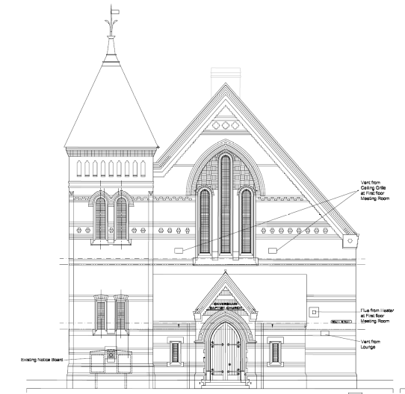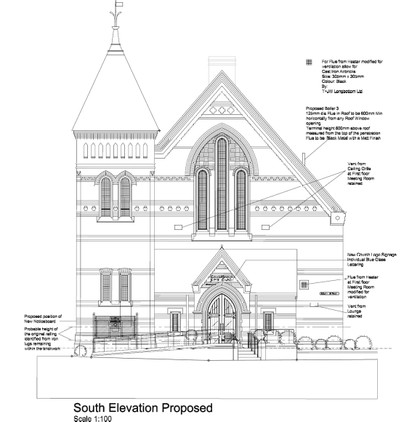

Existing Southern Elevation Proposed Southern Elevation

The DAS sets out how the applicant has examined a number of options to improve the building in order to enhance the service to the community around the church. Further to community consultation the feedback was that the building was not welcoming and offered poor accessibility. With that in mind they sought to develop a scheme, which provided proper access to the building, in accordance with current building regulations and to create a feeling of openness by introducing glazing to improve sight lines into the building and to make it more welcoming.

Any harm to the appearance has to be weighed against the improvements in access which would be achieved. These would meet underlining principles of the Disability Discrimination Act in creating equal access for all, and would meet NPPF policy (para 8) in terms of achieving sustainable development through meeting the social objective:

“ to support strong, vibrant and healthy communities, ……by fostering a well-designed and safe built environment, with accessible services ..”

and Para 127 (section 12 – Achieving Well-Designed Places) which states:

“Planning policies and decisions should ensure that developments: ……………
c) are sympathetic to local character and history, including the surrounding built environment and landscape setting, while not preventing or discouraging appropriate innovation or change
f) create places that are safe, inclusive and accessible….and support communities’ health, social and cultural well-being….”

Although the Conservation consultant concludes that there would be some harm to the heritage asset from the proposals there is recognition that it would help to retain the church in its original function, which is consistent with its long term conservation. This accords with national policy which allows for harm to be weighed against the public benefits of the proposal, and would enable an improved community facility, through improved access, to be achieved, in line with Policy CS31.

The proposed scheme also includes for one new sign, on the Prospect Street frontage and some replacement signage to the side of the tower, above the main doors and the floor mounted sign new/ replacement signage, which would be similar or smaller in scale than the existing and in the same location. It is considered that the proposed signs individually and cumulatively are of modest scale that will not result in substantial harm to the listed
building or to the appearance or setting of the listed building.

New external doors to match existing are proposed with the reuse of the original doors inside the church. The scheme also includes for, some replacement and additional roof lights, as well as more minor elements such as new vent grilles and flues. None of these elements are considered to be harmful to the listed building.

It is proposed to use matching/ sympathetic material and conditions are recommended for the submission and approval of further details. This would align with conditions attached to the Listed Building Consent by the Baptist Union which, in respect of external works, include the requirements for further details to be submitted and approved for the signage, in terms of backing material, lettering and method of fixing, the facing and paving materials of the ramps, details of the rooflights and the ventilation grilles in the walls.
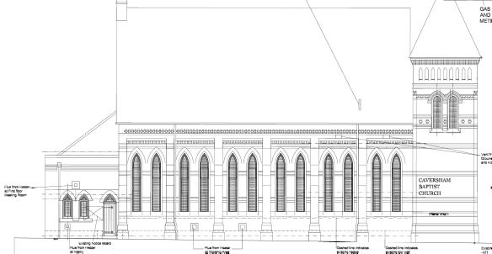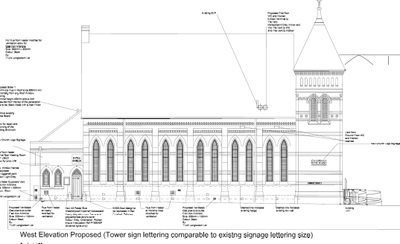
Existing Western Elevation (Prospect Street) Proposed Western Elevation
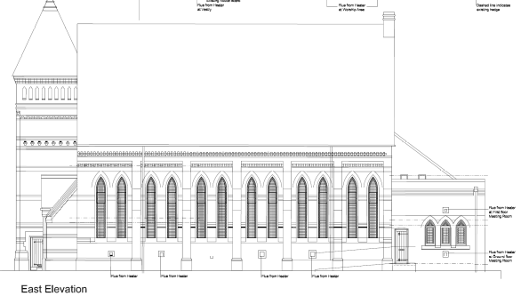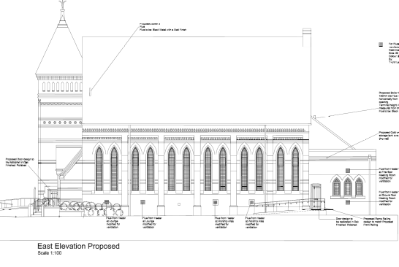
Existing Eastern Elevation (from car park) Proposed Eastern Elevation
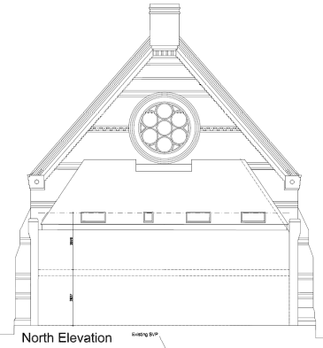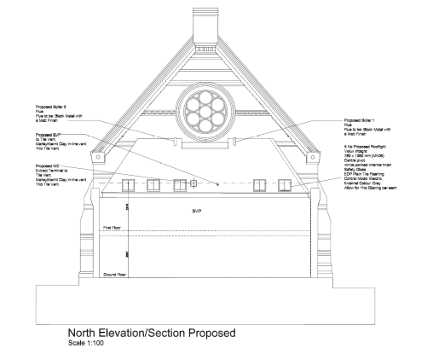
Existing North Elevation Proposed North Elevation

c) Landscaping
The proposal includes for the retention and some new landscaping to the frontage (South Street) and to Prospect Street, which the Natural Environment Officer has confirmed is acceptable subject to conditions.

RECOMMENDATION:

APPROVE

- TL1 – standard time limit
- AP1 – approved plans -
Received 7th May 2019 unless otherwise stated:
Existing Doors and Joinery – Drawing no: 1972/S02 Rev B [with respect to matching the existing door design]
Proposed Site Plan - Drawing no: 1972/P02 Rev G, received 7th August 2019
Proposed First Floor and Roof Plan – Drawing no: 1972/P03 Rev D [with respect to external works]
Proposed Services Ground Floor Plan – Drawing no: 1972/P12 Rev B [with respect to external works]
Proposed Services First Floor Plan – Drawing no: 1972/P13 Rev B [with respect to external works]
Proposed Services Roof Plan – Drawing no: 1972/P14 Rev B
Proposed Elevations and Details 1 – Frontage South Street– Drawing no: 1972/P04 Rev G, received 7th August 2019
Proposed Elevations and Details 2– Drawing no: 1972/P05 Rev G, received 7th August 2019
Proposed Elevations and Details 3 – Car Park– Drawing no: 1972/P06 Rev G, received 7th August 2019
- The following, shall be submitted to and approved in writing by the Local Planning Authority before the relevant part of the work is begun:

a) Samples of all facing brick materials stone which demonstrates the type, colour and texture of the materials for the new access ramp;

a) Samples of all facing stone materials which demonstrates the type, colour and texture of the materials for the new access ramp;

The relevant part of the works shall not be carried out other than in accordance with the details thus approved.

Reason: In order to safeguard the special architectural and historic interest of the building in accordance with the Core Strategy Policy CS33 and the NPPF.

- All new works, and works of making good to the retained fabric, unless approved otherwise in writing by the local planning authority, shall be finished to match existing, original or adjacent work (as deemed appropriate by the local planning authority) with regard to the methods used and to materials, colours, textures and profiles.

Reason: In order to safeguard the special architectural and historic interest of the Listed Building in accordance with the requirements of policy

- Pre-commencement
L2a Landscaping – When details need to be submitted for approval

- L2b Landscaping implementation
- L3 Standard Landscaping Maintenance
- Pre-commencement
Prior to the commencement of development full sectional details, to show existing levels and the proposed ‘build up’ to the front of the southern entrance (South Street), to accommodate the proposed ramp and two sets of steps, to be submitted to and approved by the Local Planning Authority. Thereafter, the proposed scheme is to be implemented in accordance with the approved details.

Reason: To safeguard the special architectural and historic interest of the Listed Building in accordance with the requirements of Adopted Core Strategy Policy CS33 and the NPPF.

Informatives:
IF5 - Terms & Conditions
IF6 – Building Control
IF3 - Highways26
IF2 - Pre-commencement
IF7 - Complaints about construction& demolition noise and dust
This permission needs to be read alongside the advertisement consent 190739 and the listed building consent as granted by the Listed Buildings Advisory Committee of the Baptist Union of Great Britain and the Baptist Union of Wales, issued on 29th March 2019, and all work undertaken in accordance with all relevant conditions.
IF1- Positive and proactive

190739/ADV
Main considerations:
The main issues to be considered are:
- Amenity
- Public Safety

- Amenity
The NPPG provides clarification as to the exact context amenity should be considered (in short, it includes aural and visual amenity and factors relevant to amenity include the general characteristics of the locality, including the presence of any feature of historic, architectural, cultural or similar interest). Furthermore, at the local level, policies CS7 and DM22 require that development be compatible with the character and appearance of the surrounding environment in order to maintain the visual amenities of the area.

The proposed signs are largely replacing existing signs albeit with some adjustments in size and positioning. In comparison to the withdrawn scheme the proposed is considered an improvement because LED surround have been removed and some of the signs are smaller.

Illumination is proposed for the main noticeboard to the front, labelled on the elevation as to be from above and within, but no further details have been provided. A condition is, therefore recommended which requires the submission and approval of such details.

They are not considered to detract from the appearance of the listed building, and external advertising is present in the immediate vicinity of the listed building and therefore the proposal is considered acceptable in relation to the surrounding context.
- Public Safety
It is not considered that the proposed signage would have a detrimental effect to public safety.

RECOMMENDATION:
APPROVE

- TL1 – standard time limit
- AP1 – approved plans -
Received 7th August 2019:
Proposed Site Plan - Drawing no: 1972/P02 Rev G, received 7th August 2019
Proposed Elevations and Details 1 – Frontage South Street– Drawing no: 1972/P04 Rev G
Proposed Elevations and Details 2– Drawing no: 1972/P05 Rev G
Proposed Elevations and Details 3 – Car Park– Drawing no: 1972/P06 Rev G
- Prior to the installation details of the proposed illumination for the free-standing noticeboard to the South Street frontage are to be submitted to and approved by the Local Planning Authority and thereafter installed in accordance with the approved details.
Reason: to ensure that it enhances the visual local environment and safeguards the special architectural and historic interest of the Listed Building in accordance with the requirements of Adopted Core Strategy Policy CS7, and CS33 and the NPPF.

Informatives:
IF5 - Terms & Conditions
This consent needs to be read alongside the full planning permission 190738 and the listed building consent as granted by the Listed Buildings Advisory Committee of the Baptist Union of Great Britain and the Baptist Union of Wales, issued on 29th March 2019, and all work undertaken in accordance with all relevant conditions.
IF1- Positive and proactive

Appendix 1 – Listed Building Consent
