Delegated Application Report Target Date: 28/10/19
Address: Land to the rear of 112-126 Southampton Street
Application No: 191322/CLE
Proposal: Compliance with Condition 1 of planning permission 150517/FUL
Case Officer: Tom Hughes
Site Description
The application site comprises land to the rear of 112-126 Southampton Street. The pre-existing use of the site was for the garaging of vehicles and hardstanding. At the time of the application, the garages had been demolished.
Description of Use or Development
A Lawful Development Certificate for an existing development is sought to confirm compliance with Condition 1 of planning permission 150517/FUL. Condition 1 of planning permission 150517/FUL states: “The development to which this permission relates must be begun not later than three years beginning with the date on which the permission was granted. Reason: to prevent an accumulation of unimplemented planning permissions, and in accordance with Section 91 of the Town & Country Planning Act 1990 as amended by the Planning and Compulsory Purchase Act 2004”.
Relevant Planning History
060277/FUL – Demolition of existing garages and erection of 6x1 bed flats – Withdrawn 06/12/06
061419/FUL – Demolition of existing garages and erection of 6x1 bed flats – Refused 20/06/07
110906/FUL – Erection of 5 dwellings at the rear of the property – Refused 13/03/12
121102/PRE – Erection of 4 dwellings – Observations sent 18/04/12
120891/FUL – Erection of 2x1 bed dwellings and 2x2 bed dwellings – Refused 26/09/12 – Appeal dismissed 02/07/13
121818/FUL – Erection of 2x1 bed dwellings and 2x2 bed dwellings – Withdrawn 04/02/14
150517/FUL – Demolition of existing garages and erection of 3 x 3 dwellings – Permitted 19/04/17
170053/ADV – Display of non-illuminated advertisement hoarding to front of property – Refused 14/03/17
190124/APC – Approval of details reserved by condition – Application returned 22/05/19
191619/FUL – Temporary consent for 3 years for commercial parking area for cars – to be determined
Relevant Planning Policy and Guidance
Section 10 of the Planning and Compensation Act 1991 established a procedure that enables anyone who wishes to do so, to apply to the local planning authority to determine whether a proposed use or operation, or an existing operational development or an existing use of land, or any other matter constituting a failure to comply with any condition or limitation subject to which planning permission has been granted, is lawful, and is so, be granted a certificate to that effect.
A Lawful Development Certificate is a legal document stating the lawfulness of past, present or future development. If granted by the local planning authority, the certificate means that enforcement action cannot be carried out to the development referred to in the certificate. However, the certificate will not protect from enforcement action by the planning authority if the specified use or development is then changed ‘materially’ without a planning application for it.
The certificate is not planning permission. The planning merits of use, operation or activity in the application are not relevant. The issue of a certificate depends entirely on factual evidence about the history and planning status of the building or other land and the interpretation of any relevant planning law or judicial authority. The responsibility is on the applicant to provide evidence to support the application.
The NPPG states that ‘The applicant is responsible for providing sufficient information to support an application. In the case of applications for existing use (section 191 of the Town and Country Planning Act 1990), if a local planning authority has no evidence itself, nor any from others, to contradict or otherwise make the applicants version of events less than probable, there is no good reason to refuse the application, provided the applicants evidence alone is sufficiently precise and unambiguous to justify the grant of a certificate on the balance of probability’.
Consultations
Planning Enforcement
Provided confirmation that the demolition has taken place, and that the land is now in use as a car park. Enforcement investigation ref: E19127 established that an unauthorised change of use to a car park had occurred. The garages were demolished, and this was considered sufficient to constitute the permission implemented. It was advised that the owner was not in a position to proceed with the development, so he has created a commercial car park for which he hopes to gain temporary planning permission.
Infrastructure Monitoring Officer
Provided confirmation that the owner has assumed liability and acknowledged receipt of a Commencement Notice on 15/10/18.
Planning Solicitor
Confirmed agreement with the officer recommendation.
Submitted Evidence
The agent supplied the following, received on 12/08/19:
Drawing No: 8565-PL-01 Rev. A – Site Location
Site Photographs
Invoice from Turner Bros Demolition Ltd, dated 02/11/18
Letter from Reading Borough Council, dated 15/10/18, acknowledging receipt of a Commencement Notice
Analysis of Evidence
The agent has submitted an Application for a Lawful Development Certificate for an existing development, to establish compliance that the development approved under planning permission 150517/FUL has commenced.
The agent has supplied evidence showing that demolition has occurred on site, sufficient to corroborate the evidence of the Local Planning Authority that the development has commenced.
Having regard to the foregoing, it is considered on the balance of probability, the development approved under planning permission 150517/FUL has commenced. In the circumstance, it is considered appropriate to grant a Certificate of Lawfulness to that effect.
Recommendation
Grant Certificate
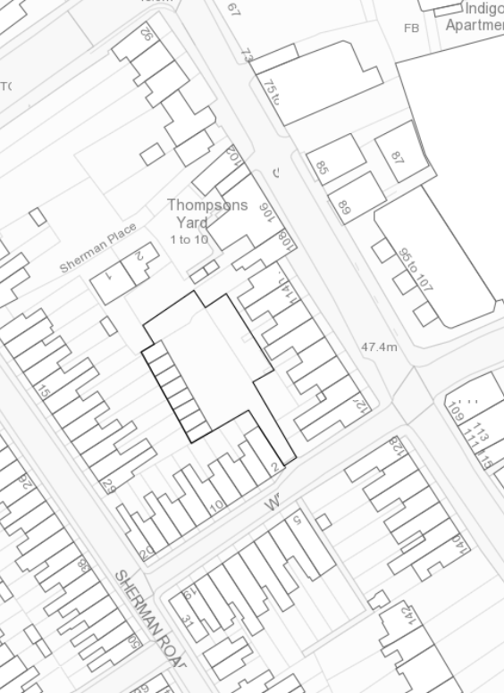
‘The Attached Plan’

