Delegated Application Report Target Date: 20/09/19
Address: 6 Basingstoke Road
Application No: 191066/CLE
Proposal: Use as two self-contained flats (Class C3)
Case Officer: Tom Hughes
Site Description
The application site is a three storey mid-terraced property. The surrounding area is predominantly residential.
Description of Use or Development
A Lawful Development Certificate for an existing use is sought for the use of 6 Basingstoke Road as two self-contained flats. The relevant time period is 26/07/15 – 26/07/19.
Relevant Planning History
None.
Relevant Planning Policy and Guidance
Section 10 of the Planning and Compensation Act 1991 established a procedure that enables anyone who wishes to do so, to apply to the local planning authority to determine whether a proposed use or operation, or an existing operational development or an existing use of land, or any other matter constituting a failure to comply with any condition or limitation subject to which planning permission has been granted, is lawful, and is so, be granted a certificate to that effect.
A Lawful Development Certificate is a legal document stating the lawfulness of past, present or future development. If granted by the local planning authority, the certificate means that enforcement action cannot be carried out to the development referred to in the certificate. However, the certificate will not protect from enforcement action by the planning authority if the specified use or development is then changed ‘materially’ without a planning application for it.
The certificate is not planning permission. The planning merits of use, operation or activity in the application are not relevant. The issue of a certificate depends entirely on factual evidence about the history and planning status of the building or other land and the interpretation of any relevant planning law or judicial authority. The responsibility is on the applicant to provide evidence to support the application.
The NPPG states that ‘The applicant is responsible for providing sufficient information to support an application. In the case of applications for existing use (section 191 of the Town and Country Planning Act 1990), if a local planning authority has no evidence itself, nor any from others, to contradict or otherwise make the applicants version of events less than probable, there is no good reason to refuse the application, provided the applicants evidence alone is sufficiently precise and unambiguous to justify the grant of a certificate on the balance of probability’.
Consultations
Planning Enforcement
No previous dealings with the property.
Council Tax
Records show 6 Basingstoke Road as two separate flats, banded separately for council tax purposes since 01/04/97.
Legal
The Council’s Planning Solicitor confirmed agreement with the Officer recommendation in an email dated 05/11/19.
Submitted Evidence
The agent supplied the following, received on 03/07/19:
Planning Statement
Site Location
Drawing No: 03 – Existing Site Plan
Drawing No: 01 – Existing Floor and Roof Plans
Drawing No: 02 – Existing Elevations
Letter from Haslams estate agents, dated 21/01/09, regarding the sale or letting of two flats at 6 Basingstoke Road
List of deposits – ground floor flat, dated 23/08/09 - 31/07/18
List of deposits – first floor flat, dated 29/02/08 - 25/07/18
Quinquennial inspection report, dated October 2018, by W M Graham Associates, regarding two flats at Basingstoke Road
Invoices from Demir Build, dated 21/11/18, 13/12/18, 08/01/19, 07/02/19, 07/03/19 and 14/03/19, regarding renovation works to two flats at 6 Basingstoke Road
Tenancy agreement, dated 15/07/16 – 31/07/17, at 6a Basingstoke Road (ground floor flat)
Tenancy agreement, dated 01/08/17 – 31/07/18, at 6a Basingstoke Road (ground floor flat)
Tenancy agreement, dated 28/05/19 – 27/05/20, at 6a Basingstoke Road (ground floor flat)
Tenancy agreement, dated 26/09/15 – 25/09/16, at 6b Basingstoke Road (top floor flat)
Tenancy agreement, dated 26/09/16 – 25/07/18, at 6b Basingstoke Road (top floor flat)
Tenancy agreement, dated 01/06/19 – 31/05/20, at 6b Basingstoke Road (top floor flat)
Invoices from Stately Construction Ltd, dated 25/04/19, 18/03/19 and 18/04/19, regarding renovation works to two flats at 6 Basingstoke Road
Statutory Declaration from applicant, dated 20/06/19, regarding the following:
- 6a and 6b Basingstoke Road have both in use as rental flats for in excess of 10 years in a continuous and uninterrupted fashion
- 6a and 6b Basingstoke Road were renovated between November 2018 and May 2019
Analysis of Evidence
The agent has submitted an Application for a Lawful Development Certificate for an existing use, to establish that the use of 6 Basingstoke Road as two self-contained flats has been ongoing for more than four years.
The relevant time period is 26/07/15 – 26/07/19.
The agent has supplied evidence dating to 2009 showing the use of the property as two self-contained flats. The Local Planning Authority has evidence of its own to show that the use of the property as two self-contained flats has been ongoing since 1997. Tenancy agreements, building inspections and renovation invoices supplied are sufficient to corroborate the information contained within the Statutory Declaration, that the property has been used as two self-contained flats for more than four years. Officers are also satisfied that the vacancy of the flats between late-2018 and May 2019 was for renovations of the property.
Having regard to the foregoing, it is considered on the balance of probability, the property known as 6 Basingstoke Road, Reading, RG2 0EL has been in use as two self-contained flats for a period in excess of four years. In the circumstance, it is considered appropriate to grant a Certificate of Lawfulness to that effect.
Recommendation
Grant Certificate
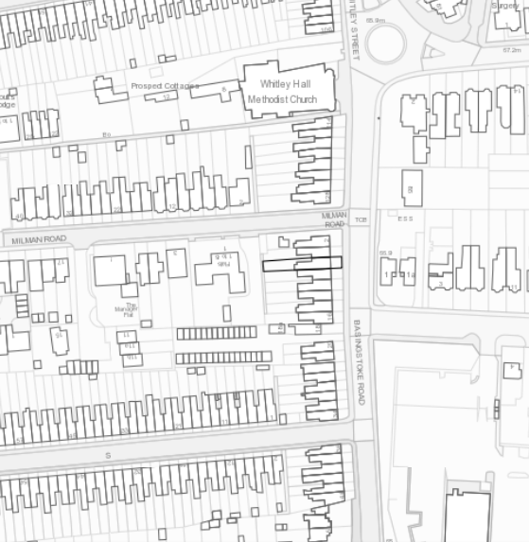
Site Location

