Heritage Statement on Listed Building
Application 19/1174 26-28 Southampton Street, Reading
Oxford Archaeology, August 2019

Reading Borough Council Application 19/1174
26-28 Southampton Street Reading RG1 2QL
Proposal: Erection of two storey rear extension to form additional living area and bathroom.
General
This note has been prepared by Oxford Archaeology further to the Heritage Statement of the Historic Environment Consultancy supplied with the application.
Location of the site
The site lies on the west side of Southampton Street, just south of the A329 flyover, and comprises two listed buildings No. 26 and No. 28 Southampton Street. These do not fall in any conservation area, though the Grade II listed St Giles’ church across the road lies within the Market Place/London Street Conservation Area. The adjacent property on the south, the former Red Lion public house at Nos 34 to 38 Southampton Street has a Certificate of Immunity from listing was issued by the Secretary of State (for the period 28 Jan 2019 to 27 Jan 2024).
The proposal is to convert the existing office premises in Nos 26 to 28 to domestic use, with two flats in No. 26, and No. 28 as a separate residence with a new rear wing.
Historical background
The Southampton Road (formerly called Horn Street at the north end) was one of the principal suburban roads from Reading, extending southwards from the River Kennet in St Giles’ Parish and leading towards Winchester and Southampton. The parish church dates from at least the 12th century, and the suburb was well-established in the medieval period and is shown fully built up on Speed’s map of Reading (1610). Some of the land in the suburb was used for market gardens and orchards, and these properties may have been associated with an orchard area to the rear.
The two properties were listed in 1978 with a somewhat misleading description. No. 26 was described as being of 19th-century date, and No. 28 as 20th-century (see Appendix). The history of these properties has not been investigated further, but they have no doubt been divided and separated at various times as separate cottages and a single premises.
Historic building fabric
The northern part (No. 26), listed as C19, probably dates from the late 18th century, with a mansard roof and carefully patterned brickwork on the rear wall with red bricks and flared headers. Nothing internally appears to be of earlier date, and it may retain some original casement windows.
The central part (here called No. 26a), listed as C19, is actually a late medieval timber-framed structure probably dating from the mid to late 15th century. There is a substantial survival of original medieval timber framing, mostly exposed on the first floor, including the cross frame on the north and south sides with arch braces and a window with diamond profile mullions in the front wall. The ground floor room has a fine ceiling with chamfered and stopped common joists with housed shoulders and diminished haunch joints to the principal beam. This detail dates the building to the 1440s or later. There is no reason to suppose that any of the frame is older than this floor (or that the floor has been inserted), and that raises the question of whether this was part of a larger building, perhaps with an open hall to the rear, or further elements to either side.
At a much later date the ground floor rooms of 26 and 26A were given dado panelling, probably in the mid-19th century, when a double-door opening was made between them. A carpenter’s graffito observed on the wall near the double door suggests that this work was undertaken in or after the mid-19th century, and as the door architrave matches that of the some of the windows they may have been replaced at the same time. There are also some 18th-century elements, like the fielded and panelled door in No. 26, while variations in the dado panelling suggests that it has been altered or added to in the 19th or 20th century.
The staircase rising on the east front within 26A is another modern addition, cutting across the ground-floor window, truncating the medieval floor joists, and necessitating a redecoration of the interior.
The southern part (No. 28) is listed as C20, and oral history relates how it was made in the early years of the 20th century by the owner, who carefully created a replica historic doorway, external framing and beamed ceiling on the interior. This was all well-crafted and is attractive in appearance, but immediately betrays its date by the incorrect use of adze marks to give an antique appearance in a manner never found in authentic historic carpentry.
The brick outer walls of 26A and 28 are of various dates, presumably 18th of 20th century, and there is no reason to suppose that any part of No. 28 is older than the early 20th century in its brickwork, windows or fittings. The roof of the whole property is covered with traditional clay tiles, in need of some localised repair.
Historic significance
Medieval timber frame buildings are always of significance and here of some rarity as a survival in Reading, although not noticed at the time of listing. The recognition of the importance of No. 26A as another example fully warrants its Grade II listing (but no more than that). No 26 is of modest interest as a minor example of the late 18th century suburban townhouse. No. 28 might have been listed for its group value with the other two parts of the building, but was apparently listed in its own right as a 20th-century replica, and is a not unpleasing example of that.
Historic setting
This row of buildings contribute positively to the historic townscape of Southampton Street, and together with the former Red Lion contribute peripherally to the conservation area at St Giles’ Church in views along the street from the south. Views from the north are compromised by the A329 flyover bridge and roundabout which lie a short distance way. Removal of the neighbouring buildings for the roundabout have opened a view through the courtyard which was not available before then, and this includes the spire of St Giles’ church seen over the top of the former Red Lion.
The impact of the current proposals
The current proposals to convert the buildings from office use to domestic accommodation is a welcome use of the historic buildings. The necessary repairs and minor alterations required to put the building in a good state will be beneficial where carried out in a manner sympathetic to the listed building and in accordance with the listed building consent.
Division of the building will probably be returning it to an earlier state before the three elements had been run together as a single property. The principal innovation will be the addition of a rear wing to No. 28, in approximately the same location as one shown on C19 OS maps (see Fig. 1 below). This will do no harm to what is apparently an early 20th-century building, with no fittings (e.g windows) in the west wall whose removal or relocation will be of any particular consequence.
The new wing will have no impact on the character or significance of the listed buildings, being built in materials sympathetic to the brickwork of Nos 26 and 28, and in the case of No. 28 being on the approximate site of an earlier rear extension.
The new rear wing will be subservient to the main structure of No. 28, and the spire of St Giles’ Church will be just as visible as it is now from the public space outside the property. There will be no impact on views from the street as the new wing will not generally be seen behind the mass of the Red Lion premises. The proposed development will not have any impact at all on the character and appearance of the nearby Conservation Area.

Conclusions
Despite the variety and complexity of various responses to this application, there are some fairly clear issues:
- The listed buildings at 26 – 28 Southampton Street are of various dates from the 15th to the 20th century.
- Although not recognised in the listing, part of No. 26 is of exceptional interest as a surviving medieval building, while No. 28 is a curiosity as a well-executed pastiche dating from the early 20th century.
- The buildings have undergone considerable changes, not least in being united and separated at different times, and altered in the 20th century for office purposes.
- The proposal for return to domestic use is likely to be beneficial and is to be welcomed.
- The proposed addition to No. 28 will be wholly in keeping with the materials, scale and character of the listed buildings.
- The new building will not harm the setting of the Grade II buildings in any way and will not detract from the character of the nearby conservation area.

Julian Munby
Head of Buildings Archaeology
Oxford Archaeology
August 2019

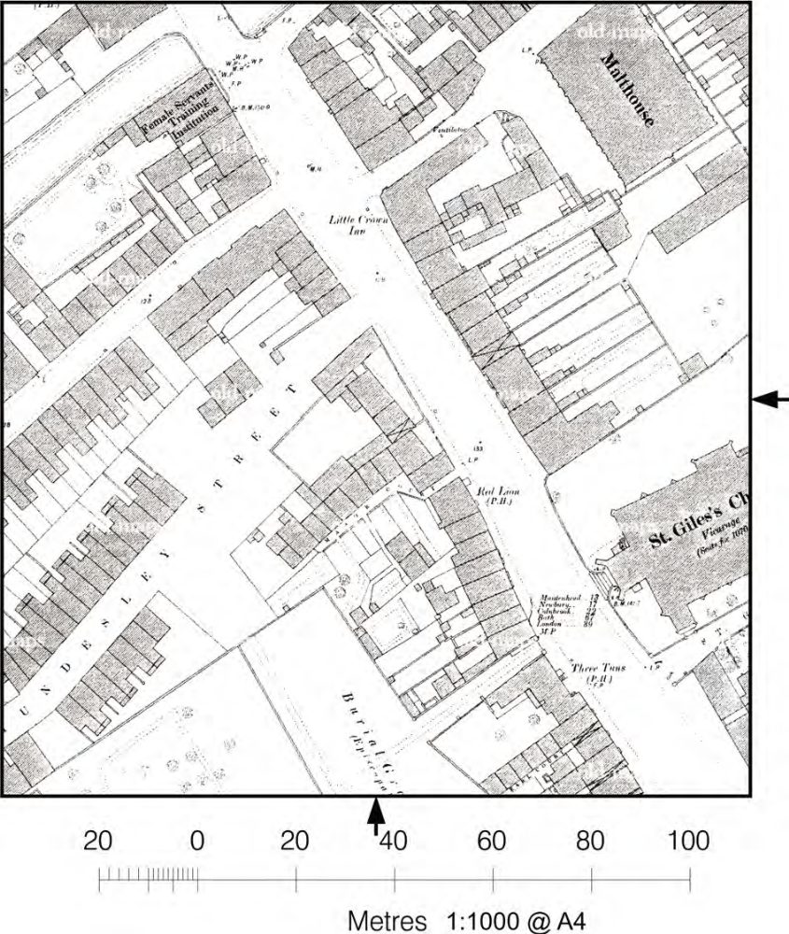

Figure 1: Extract from the OS 1:500 town plan of Reading, 1879, showing the north end of Southampton Street

Appendix: Statutory List Entries

Statutory Address: 26, SOUTHAMPTON STREET, READING

Listed Building: Grade II
List Entry Number: 1113582
Date first listed: 14-Dec-1978
District: Reading (Unitary Authority)
National Grid Reference: SU 71574 72973
SOUTHAMPTON STREET 1. 5128 (West side) No 26 SU 7172 NE 4/231 II 2. Early C19. 2 1/2 storeys altered. Grey brick headers with red brick dressings and quoins. Cogged eaves cornice to tiled roof. Right hand part of house original with 1 window, tripartite casement, segment headed on Ground floor and mansard roof with end chimney and dormer. Left hand part may be a C20 rebuild with slight break: 1 range of windows, 3 light casement on ground floor and a 5 light, probably reused, oak mullion casement on 1st floor; also parapet with cogged cope, no attic. To left it is treated like No 28. The garden railings are cast iron arrow head with patterned bars to gate.
Listing NGR: SU7157172975
Legacy System number: 39175
Legacy System: LBS

Statutory Address: 28, SOUTHAMPTON STREET, READING

Listed Building: Grade II
List Entry Number: 1113583
Date first listed: 14-Dec-1978
District: Reading (Unitary Authority)
National Grid Reference: SU 71578 72966
SOUTHAMPTON STREET 1. 5128 (West Side) No 28 SU 7172 NE 4/574 II 2. Apparently C17 in fact an early C20 replica, timber framed and jettied brick infill, herring-bone below left hand 1st floor windows. Tiled roof with end chimneys. Jetty beams stop chamfered Right hand bay breaks forward slightly with 1 range of 2 light casements. Left hand bay has 3 close-set casements on 1st floor and shop window on ground floor, door panelled and stained to appear early C17.
Listing NGR: SU7157172975
Legacy System number: 39176
Legacy System: LBS

Oxford Archaeology

OA (formerly the Oxford Archaeological Unit) was established in 1973 and has grown to be one of the largest archaeological practices in Europe, employing c.250 people including field archaeologists, heritage management, industrial, historic buildings and finds specialists, and a team of illustrators and computing and survey personnel. Oxford Archaeology has offices in Lancaster (Oxford Archaeology North), Cambridge (Oxford Archaeology East) and Oxford (Oxford Archaeology South).

OA offers a comprehensive range of archaeological and historical services including strategic policy advice, heritage management services, historic landscape assessment, desk-based appraisal, documentary research, field evaluation and survey, and full-scale excavation, building surveys, industrial archaeology and publication.

OA works on projects throughout the UK and abroad, recently completing extensive and complex projects in France, Ireland and Turkey with further work carried out in both Montserrat and St Lucia (West Indies), Greece, Albania, India, Libya, Oman, and China.

OA has long experience of environmental assessment, conservation and planning advice on a number of major and minor projects across England involving the protection, management and presentation of major national monuments, and World Heritage Sites.

Julian Munby BA, FSA

JM (a graduate of the Institute of Archaeology, London) is Head of Buildings Archaeology Department at OA, with over 40 years’ experience of historic buildings and heritage matters. He has extensive knowledge of the survey and publication of buildings and landscapes, ranging from the medieval period to the 19th century. He has worked at OA on heritage aspects of the assessment of High Speed Railways and other major infrastructure schemes, and has been involved in desktop studies on development impact studies for historic buildings and landscapes in the context of Environmental Assessment.

JM Has directed work for the National Trust on several properties including Osterley House and Chastleton, for the Historic Royal Palaces at Kensington Palace and the Tower of London, for English Heritage at Kenwood and Witley Court, and has surveyed monuments in Scotland, Ireland and the West Indies

JM has worked on Conservation Plans for the Tower of London, for English Heritage, at Audley End House and Osborne, on Framlingham and Orford castles, and at Portchester, Deal and Dover castles; for Lincolnshire County Council at Gainsborough Old Hall, and for the National Trust at Tyntesfield, Tattershall Castle and Knole; and for the Heritage Council Ireland on Kilkenny City Walls, and Athlone, Newtown Jerpoint, Carlingford and Fethard Town Walls. Most recently he has worked on Conservation Plans for Leeds Castle (Kent), Knole, and Dover Castle.

JM regularly gives advice on planning issues concerning historic buildings, sites and monuments, with regard to changes in the fabric and setting. He has appeared as an effective expert witness at Public Inquiries on a broad range of planning concerns.

Described for convenience in this report as No. 26 at the north end and 26A in the centre, with No. 28 at the south end
The statutory listers might have noted the medieval timber window in the front wall, and with access to the rear could have seen the one surviving external post, but otherwise the age of the building is not immediately apparent externally

