DELEGATED APPLICATION REPORT - Application No.: 190570
Address: 13 Yelverton Road
Proposal: Retrospective single storey rear extension
Case officer: Alison Amoah
Target Date: 28/6/2019 (Ext)

Site Description and Surrounding Area:
The application site is a terraced house with an existing 4.6m deep, 3m high and 5.1m wide single storey rear extension and flat roofed rear dormer. No. 17 Yelverton Road has a very similar ground floor rear extension, albeit 4m in depth, which was approved under the HPA 161798.

There is a good sized rear garden remaining.

Proposal:
Retrospective proposal for a flat roofed single storey rear extension, dimensions as above, with one roof lantern, rear window and door. This follows an enforcement investigation and a recommendation to submit a retrospective application.

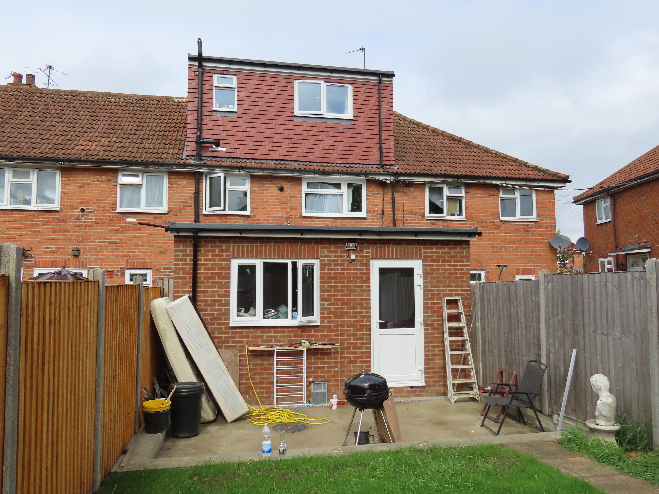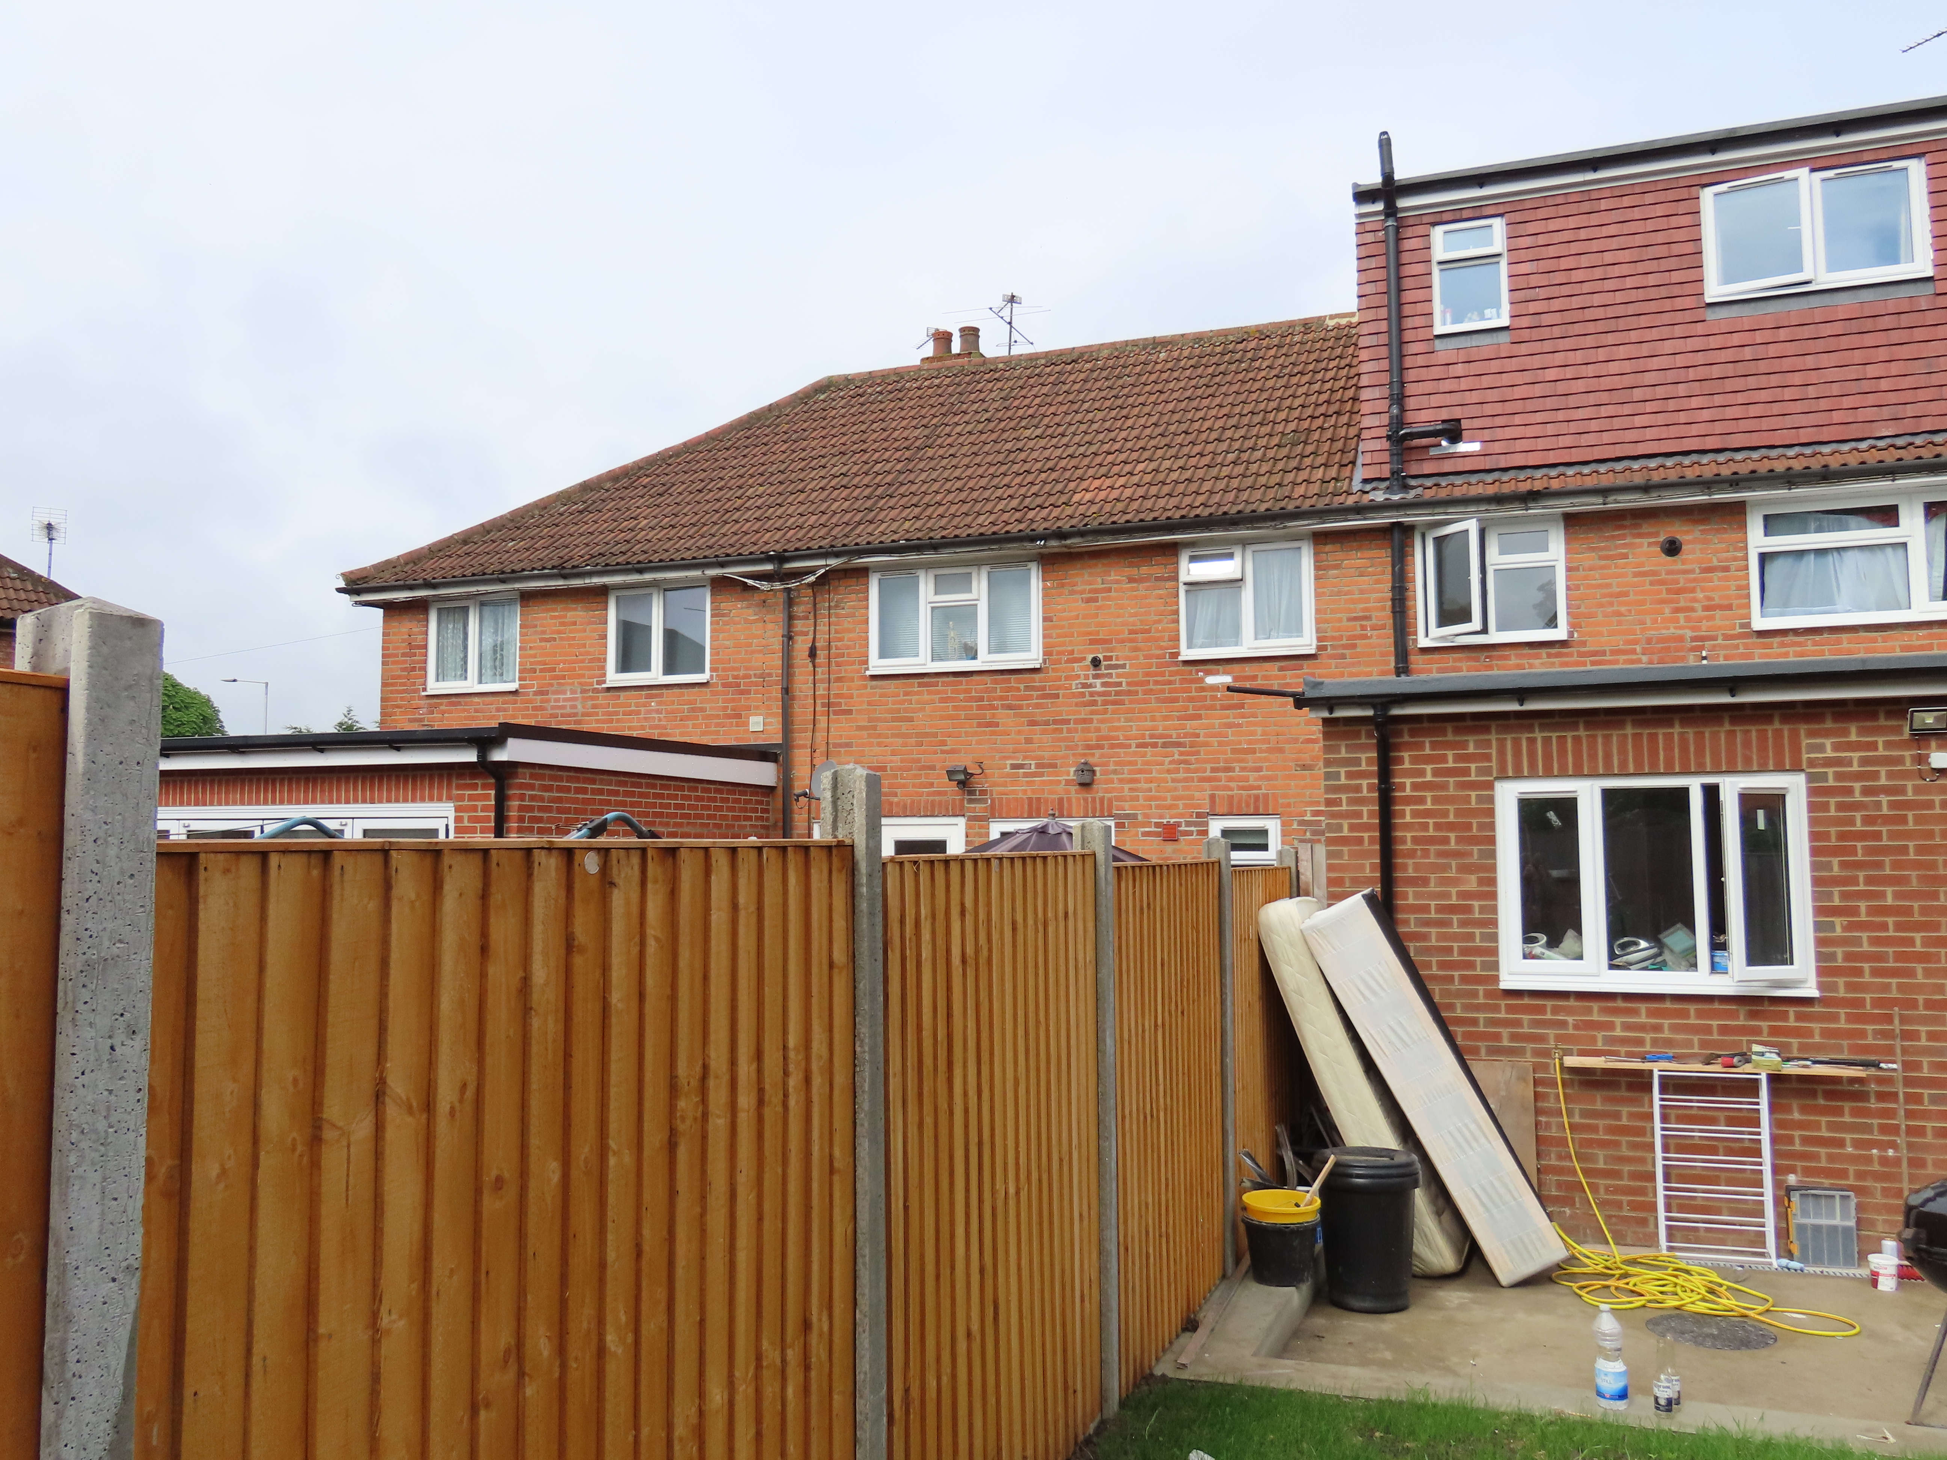
As built View towards no. 17

Plans considered: Received 10th April 2019:
Site Plan, Block Plan, Location Plan – Drawing no: 190307-1
Floor Plan and Elevations – Drawing no: 190307-2

Amended Plan received 17th July 2019:
Floor Plan and Elevations – Drawing no: 190307-2 Rev B

Relevant Planning History:
17 Yelverton Road - 161798/HPA - Rear extension measuring 4m in depth, with a maximum height of 3.14m, and 2.6m in height to eaves level. Notification of the construction of an extension under class A Part 1 of schedule 2 of the Town and Country Planning (General Permitted Development) (England) Order 2015 – Prior Approval not required 1/11/2016

Consultation Responses: Nos. 11 & 15 Yelverton Road, and 35 Buckland Road were consulted. The following objection was received:

“Planning should have been applied for prior to work commencing and kept within the accepted regulations. The rear extension work has been going on since December and is now completed. When someone came around from the council they said the measurements they were doing and have gone beyond that. All over Christmas they were building, drilling rex. Causing damage in both gardens creating big holes and damaging patios and fencing which has to be made safe for the animals. With having an extension on the other side of our property we are now blocked in on either side.”

Equality Act 2010:
In determining this application the Council is required to have regard to its obligations under the Equality Act 2010. However, there is no indication or evidence (including from consultation on the application) that the protected groups identified by the Act have or will have different needs, experiences, issues and priorities in relation to this particular planning application. Therefore in terms of the key equalities protected characteristics it is considered there would be no significant adverse impacts as a result of the development.

Relevant Planning Policy and Guidance
Section 38(6) of the Planning and Compulsory Purchase Act 2004 requires that proposals be determined in accordance with the development plan unless material considerations indicate otherwise. Material considerations include relevant policies in the National Planning Policy framework (NPPF) - among them the 'presumption in favour of sustainable development'.

The following local and national planning policy and guidance is relevant to this application:
Reading Borough Local Development Framework Core Strategy (2008, altered 2015)
CS7: Design and the Public Realm
CS36: Biodiversity and Geology
CS38: Trees, Hedges and Woodland

Sites and Detailed Policies Document (2012, altered 2015)
DM4: Safeguarding Amenity
DM9: House Extensions and Ancillary Accommodation

Supplementary Planning Guidance/ Documents:
A Design Guide to House Extensions (2003)

Appraisal Checklist:
DM9 states: An extension to a house will be acceptable where it:

- Respects the character of the house in terms of scale, location, materials and design;

To assess this, the following has been considered – would the proposal:

- Detract from the appearance of the original building through the use of ill-matching materials and by not fitting in with the design, scale and proportions of the original building; No – the extension is considered to be of an appropriate, scale, design and has been built in suitable materials.
- Reduce the amount of usable amenity space for the property to an unacceptable degree; No.
- Require the loss of trees in the garden or put significant trees at risk; No

Respects the character and pattern of neighbouring properties and the street as a whole in terms of scale, location, materials and design, and any important existing building line; Respects neighbour’s amenities and does not present a large blank façade to public areas.

To assess this, the following has been considered – would the proposal:

- Significantly reduce the amount of daylight and sunlight enjoyed by neighbouring properties; No – No. 15 Yelverton, who objected to the proposal and refer in the main to construction issues, also refer to being ‘blocked in’ with developments both sides. Although it is true that there are extensions both sides, in terms of the impact on daylight and sunlight the application scheme is not considered to cause significant harm both because the extension is north of the application site, but also because the rear room is believed (based on looking at floor plans for other applications on Yelverton Road) to be a kitchen, and therefore not a habitable room. The main ground floor living accommodation is to the front of the property.

In terms of no.11 there is likely to be some shadowing from the extension, but as with no. 15 the rear room is believed to be a kitchen and therefore, a non-habitable room. It is considered that the effect in this regard would not be significantly greater than the effect which would have resulted from a permitted development extension of 3 metres.

- Invade the privacy of neighbouring properties through overlooking from windows or balconies; No

- Detract from the character of neighbouring properties through siting, excessive bulk,
ill-matching materials or inconsistent design; No – Although the application scheme is larger than what would have been possible under permitted development, i.e. 3m deep, a judgement has to be made as to whether the increased depth creates significant additional detriment with respect to character and appearance. The Council’s Design Guide identifies that the acceptability of a rear extension “will be derived from the particular circumstances of the application site. For example do neighbouring properties have extensions”. In this instance there is an existing, very similar, extension at no. 17 of 4m depth (approved under the prior approval process). It is considered that a rear extension, which has an additional depth of 0.6m over and above that example, does not cause significant further detriment to the character of neighbouring properties.

DM4: Safeguarding Amenity states an extension to a house will be acceptable where it will not cause a significant detrimental impact to the living environment of existing or new residential properties.

To assess this, the following has been considered – would the proposal cause a significant detrimental impact to the living environment of existing or new residential properties in terms of:
- Privacy and overlooking; No
- Access to sunlight and daylight; No – see above
- Visual dominance and overbearing effects of a development; No – see above
- Noise and disturbance; No
- Artificial lighting; No
- Vibration; No
- Dust and fumes; No
- Smell; No
- Crime and safety; No

RECOMMENDATION:

APPROVE
1) AP1 - Approved plans
Informatives:
IF5 - T&Cs
IF1 - Positive and proactive

