PLANNING, DESIGN & ACCESS STATEMENT
PROPOSED NEW DEVELOPMENT AT:-
4A & 5 WOODS ROAD, CAVERSHAM, READING,
BERKS. RG4 6NA. FOR MR & MRS JOHN BROWN

Date 29/9/2019

Contents

- Introduction

- Site Context

- Planning History

- Proposal

- Sustainable Development / Materials

- Flood risk

- Affordable Housing

- Heads of Terms

- Energy efficiency

- Landscaping

- Planning Policy

- Design considerations

- Conclusions

- Appendices
1. Introduction

1.1 This Planning, Design & access statement has been produced to support a planning application seeking the demolition of existing dwelling at No5 Woods Rd. A new access will be provided to serve two new detached dwellings indicated as Plots #2 &3; Plot #2 will have an attached garage, Plot #3 will have a detached Garage.
The existing dwelling at No 4A (indicated as Plot #1) will be retained.

1.2 The site for No 4A & 5 has been owned by Mr and Mrs John Brown for many years, they have legally separated the ownership of the land such that the area indicated as plot #2 is now owned by their son Mr Jack Brown.

1.3 Mr & Mrs John Brown plan to sell the retained dwelling No 4A. They will live in the new detached property indicated as Plot #3. They are looking to claim ‘self build’ exemption from CIL on this property, as will Mr Jack Brown on the construction of the house he will reside in (plot #2).

1.4 As a ‘self build’ exemption will be claimed there will be no commitment to CIL on the new properties referred to as Plots #2 & 3

2. Site Context

2.1 The application site is located to the north of Reading.

2.2 The site (total No4A & No5) occupies of plot size of 1821sqM.

2.3 The surrounding area has a mix of residential Dwellings.

2.4 The curtilage of the property is well defined and enclosed on four sides with a mix of hedgerow & 1.8 Metre high close board fencing.

2.5 The gardens of Nos 5A – 8 Woods Rd have already been developed.

3. Planning History

This application is a re-submission following the refusal of the recent application No 181573 and the subsequent appeal.

There are 3 other recent applications showing on Reading BC website for No 4A (140311, 991565, 9000490); There is one application for No 5 (890046).

4. Proposal

4.1 The proposal is to demolish the existing dwelling at No 5 Woods Rd, this will allow for a new access with pavement & landscaping to 2no Detached dwellings at the rear of the site

4.2 The 2no Detached dwellings, indicated as Plots # 2 &3, at the rear of the site are on similar building lines of the already developed garden at No5A.

4.3 A Detached Garage will be erected to serve Plot #3. Plot #2 will have an attached Garage.

4.4 The existing Garage for the dwelling No 4A (indicated as Plot #1), will be now be retained, the new length of the rear garden of 4a will be in excess of 11.5 Metres.

4.5 Plots #2 & 3 will have a 2.4M sq x 2.5M max height shed for storage.

5. Sustainable Development / Materials

5.1 The National Planning policy Framework is at the forefront of driving sustainable developments. It states that there should be ‘an automatic presumption in favour of sustainable developments’.

5.2 The proposed will be built from sustainable materials sourced locally where possible.
6. Flood risk.

Applications are mindful to the risks of flooding. The application site is not at risk of flooding.
Environment Agency flood map:

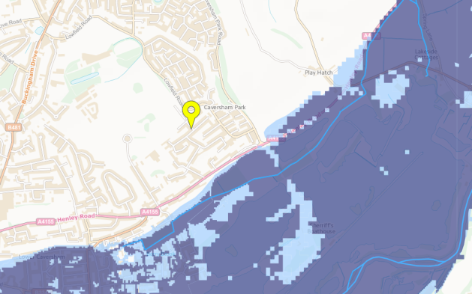

7 Affordable Housing

The current site will consist of 1no retained 4 bedroomed detached dwelling, market value circa £575000; There will 2no 4 bedroomed detached dwellings of an estimated market value of £475000.

8 Heads of Terms – S106 Legal agreement

8.1 The applicant, Mr John Brown owns the land within the red line as marked on the Location / Site Plan.

8.2 A copy of the Land title deed will be presented on request.

8.3 Details of the applicants Solicitor can be provided on request.
8.4 The applicant agrees to pay reasonable legal costs in respect of the Section 106 agreement.

9 Energy Efficiency

As a minor development there is no requirement for an Energy efficiency statement, however the new dwellings will be constructed to current Building regulations and be subject to an appropriate SAP analysis.

10 Landscaping

10.1 Principles will be adopted so as to protect existing wildlife, with an emphasis on retaining native plants & trees where possible.

10.2 Landscaped Finished Ground levels and means of enclosure will be as existing.

10.3 Parking and circulation areas, bin store and new site entrance are illustrated on the Block Plan.

10.4 Drainage of foul and surface water will be provided later, if these items could be conditioned if approval is given to the application.

10.5 Provision in boundary treatments can be provided so that the natural wildlife can traverse the site.

11 Planning Policy

11.1 The Local Plan policies pertinent for the site are:
a) G2 – Protection and enhancement of the environment;
b) G5 – Previously developed land
c) C4 – Detrimental landscaping
d) C6 – Biodiversity
e) D1 – Good design
f) D2 – sufficient parking including cycles.
g) H4 – provision of housing in built up areas.
h) C57 – Design and the public realm.
i) DM11 – Development of Private Residential Gardens.
j) DM4 – Safeguarding amenity.
k) DM10 – Private & Communal outdoor space.
l) CS38 – Trees, Hedges & Woodlands.
m) CS20 – Implementation of the Reading Transport Strategy.
n) CS36 – Biodiversity and Geology.
o) CS9 – Infrastructure, Services, Resources & Amenities.
p) DM3 – Infrastructure Planning.

12 Design Considerations:

12.1 The proposal will use sustainable materials sourced locally and will be constructed from selected brickwork & roof coverings to be agreed with the LPA.

12.2 The dwellings will be constructed to current building regulations and will be finished to the highest standards.

12.3 Residential dwellings in the area offer a mix of style, materials and type.

12.4 The bulk, scale and amenity space for the retained and new dwellings is in keeping with the surrounding area.

12.5 The site is located within zone 3 Reading BC revised parking standards and as required 2no Parking bays are provided for each dwelling with adequate space to manoeuvre within the site.

12.6 We are seeking to address the issues raised in the refusal Notice to application No 181573:-
12.6a - A new access is proposed via the space created by the demolition of No 5 Woods Rd, to serve the 2 new dwellings at the rear of the site. This access will be 5 Meters wide with a pedestrian pavement to one side. The access will be lined with soft landscaping. NB No 5 Woods Rd will not be replaced with dwelling previously indicated as Plot #5
12.6b – One of the previously proposed dwellings (indicated as Plot #4) has been removed from this application, this, with the exclusion of plot #5, will negate the criticism of over development.
12.6c – The design of the new access road to serve the 2 new dwellings would allow, with the agreement of Mr & Mrs Brown, the further development of the ‘wider area’.
12.6d – The amenity space to the proposed Plot #2 is considerably improved.
12.6e – The new plot #2 will be constructed outside of the RPA of the protected tree TPO 13/18 (indicated as T4 in aboricultural report).
12.6f – The loss of Trees, indicated as T8, T10 & T11 and also the Hedgerows, indicated H4 & H5, can be mitigated by the new planting as indicated adjacent to the new access road, an AMS can be provided in due course to substantiate this. It is suggested in the aboricultural report this could be a condition of planning approval.
12.6g – The proposal of the new access road will allow for the entry to site of service vehicles, although a bin store has been shown at the entrance of the site for each of the new properties, adequate space is available for a refuse truck to enter and manoeuvre within the site.
12.6h – Visibilty splays have been indicated on the Block Plan.
12.6i – A pavement is proposed for pedestrian visitors to the 2 new dwellings.
12.6j – Every effort will be made to protect the bio diversity of the site during construction, natural habitats will be retained where possible

13 Conclusion:

It is our opinion that the proposal will provide well balanced family homes in keeping with recent development of the area. It will provide one additional family home on an already developed site while allowing good amenity space to the scale and density in excess of other properties recently developed in the neighbourhood.

We would request increased dialogue with Reading BC planning on this application, in particular if additional information or agreement is required.

Mr and Mrs Brown are trying to give their son an opportunity to enter the property ladder, addressing a far reaching social issue, particularly with costs in the Reading area. With the loss of the previous Plot #4, they are not able to assist their Daughter at this time. Although this is not a planning issue, it is hoped that the merits of this application are appreciated.

The Professional costs in making an application of this type are significant with the Topographical survey & Aboricultural report provided with this application. We request that the Biodiversity / Bat report and the Legal agreement, requested within the refusal notice of application 181573, be provided once this application has been discussed and any further concerns have been raised by RBC planning.

14 Appendices:

14.1 Additional specialist reports can be provided on request
from Reading Borough Council Planning department.
14.2 No 5 Woods Road – to be demolished – looking north west
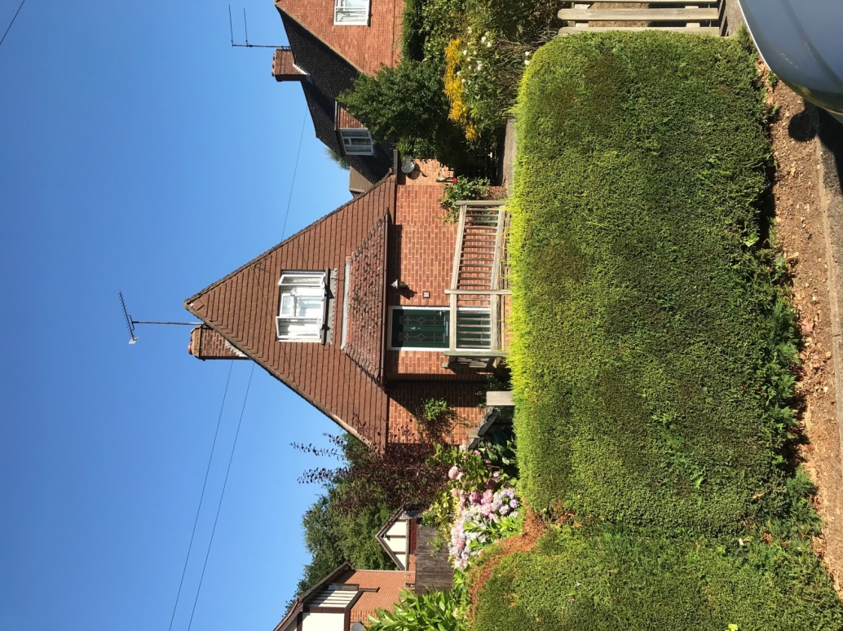
14.3 No 4A Woods Road – to be retained
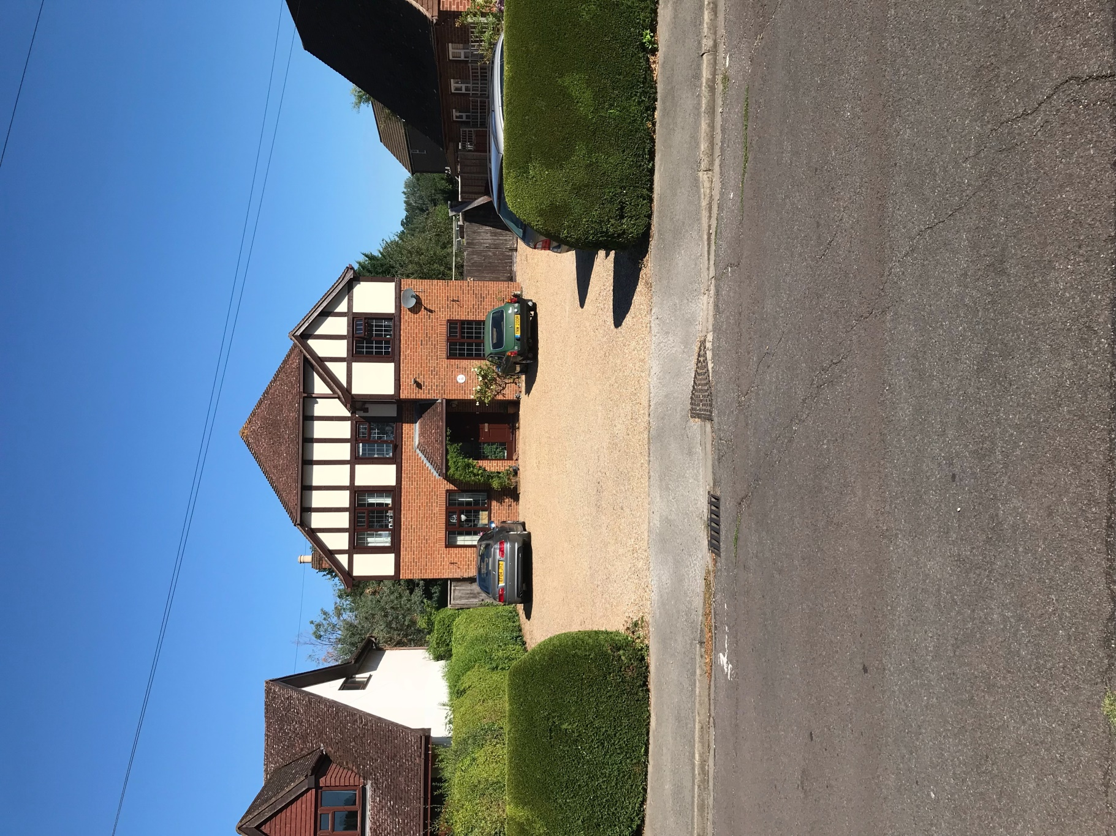

14.4 Front Elevation No 5 & 4A Woods Road – looking north west
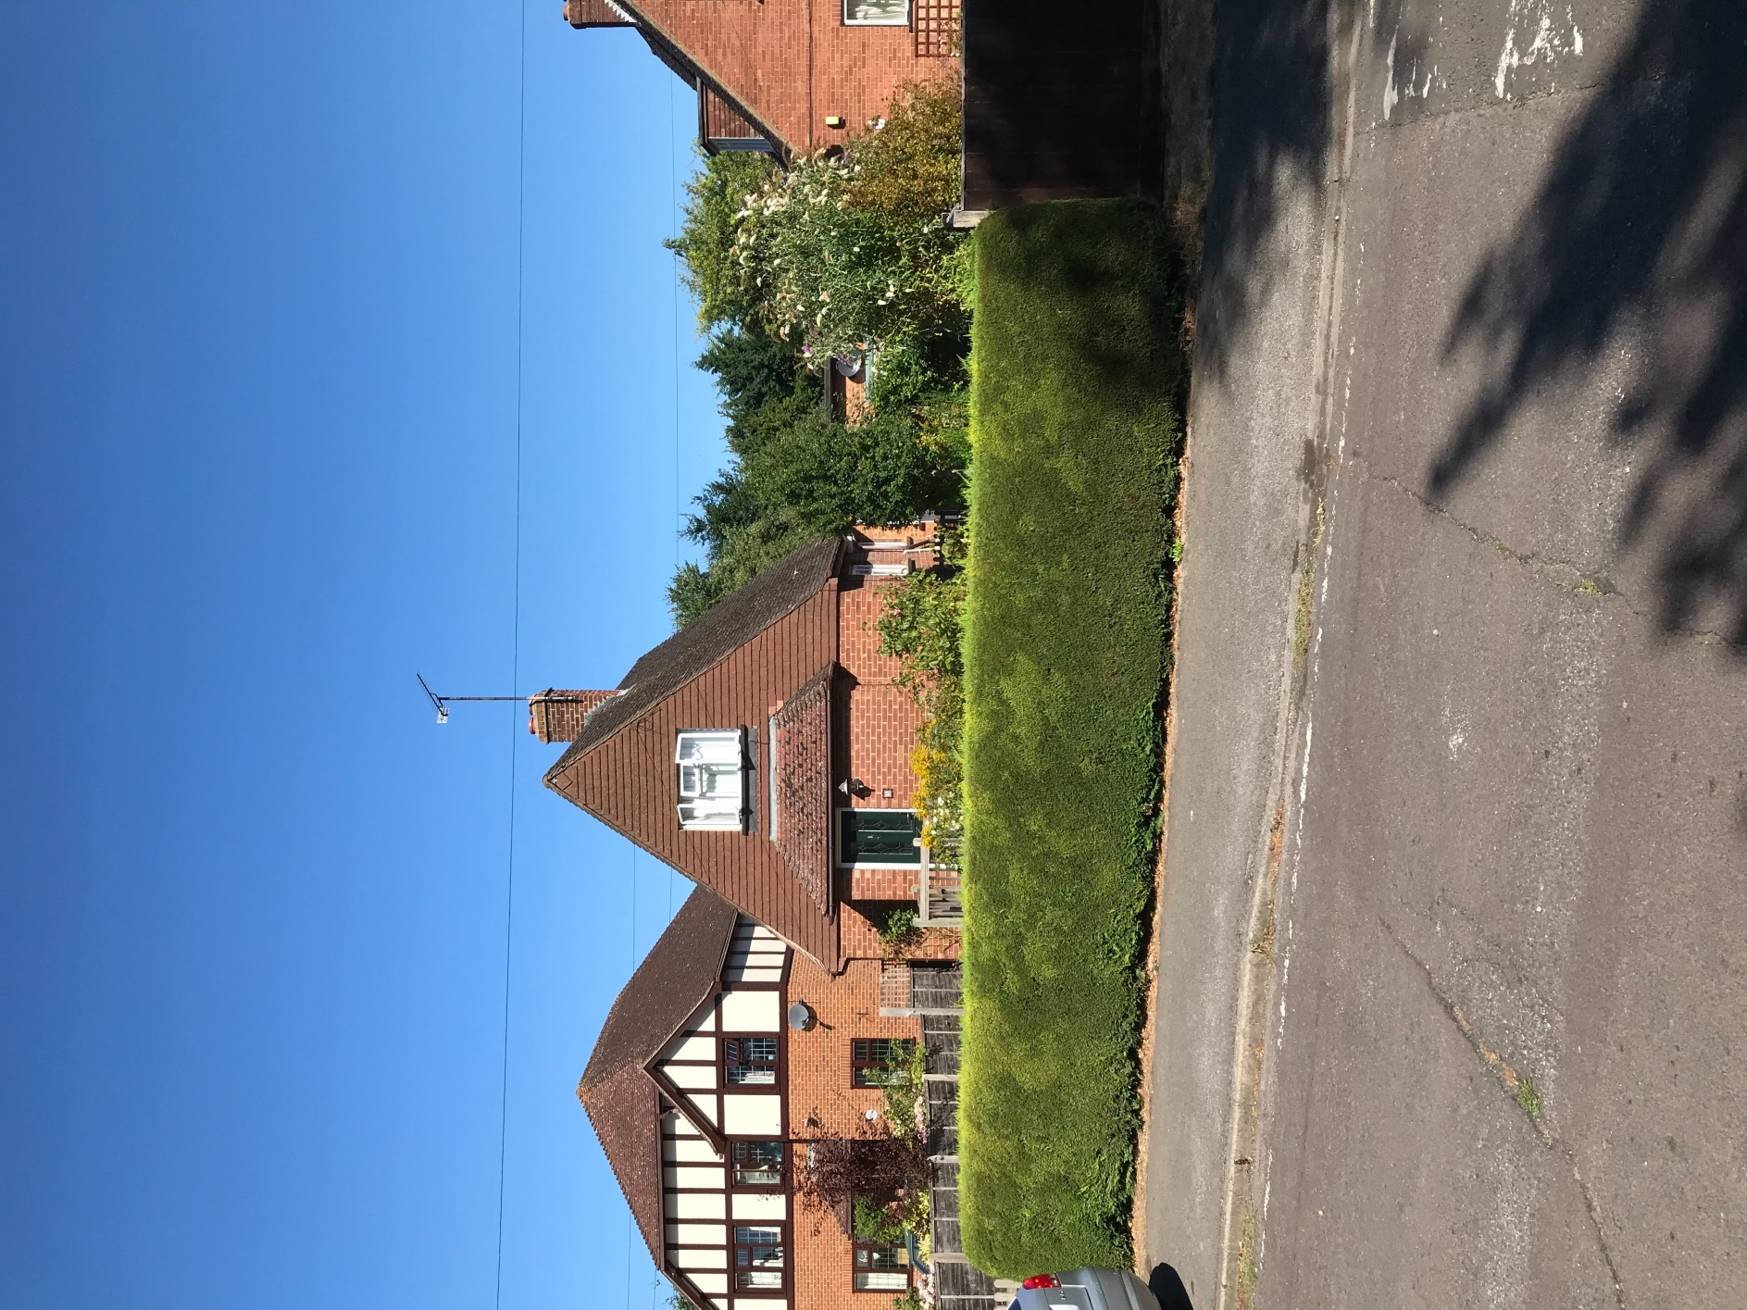

14.5 Rear of No 5 & No 4A Woods Road – Looking south east
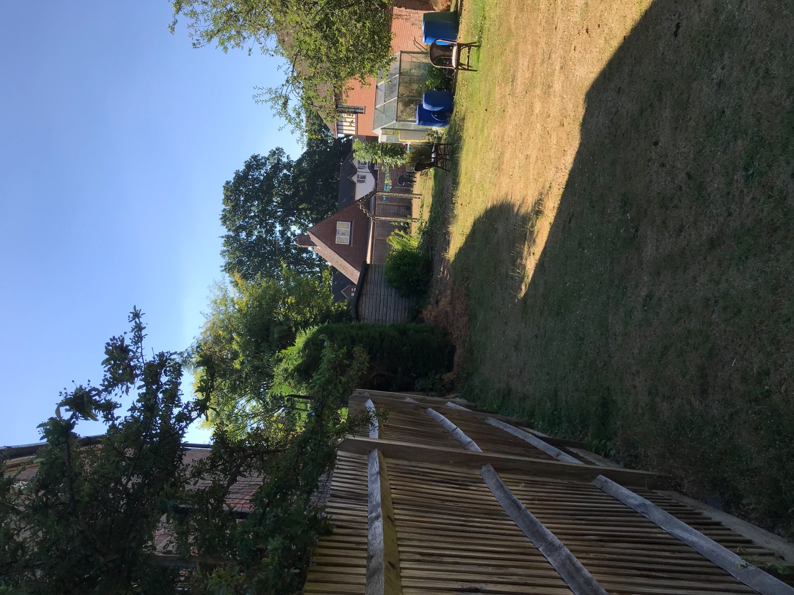

14.6 Rear of No 4A Woods Rd – Looking south east
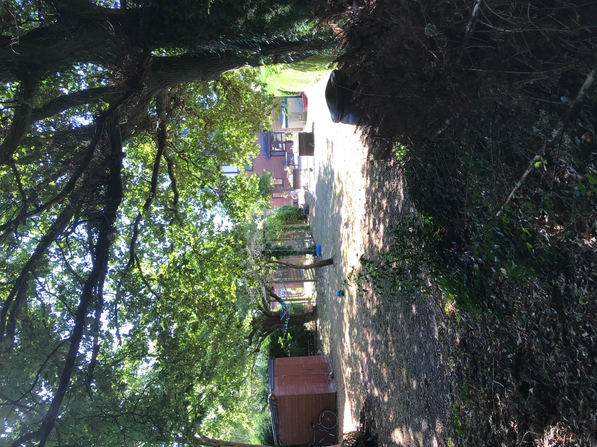

14.7 View looking east – recently developed garden of No 5A Woods Road
