Delegated Application Report Target Date: 07/10/19
Address: 29 Edinburgh Road
Application No: 191331/CLP
Proposal: Loft conversion with provision of rear box dormer and roof lights, and installation of window
Case Officer: Tom Hughes
Introduction and Proposal
The application site is a two storey mid-terraced dwelling. The surrounding area is predominantly residential.
The proposal is for a loft conversion with the provision of a rear box dormer and roof lights. The dormer would extend across the full width of the rearward roof slope, projecting to a maximum depth of 3.8m with a maximum height of 2.5m. The dormer would be set down from the existing ridgeline and set back from the existing eaves. A window would be located to the rear elevation. Materials have been selected to match those of the existing dwelling. Two roof lights would be located to the forward roof slope. An additional window would be located to the rear elevation at the first floor.
Plans Submitted
The applicant supplied the following, received on 14/08/19:
Drawing No: MURPHY-0619-06 Rev. B – Site Location and Block Plan
Drawing No: MURPHY-0619-04 – Existing Floor Plans and Elevations
Drawing No: MURPHY-0619-02 Rev. B – Proposed First Floor Plan
Drawing No: MURPHY-0619-01 Rev. B – Proposed Second Floor Plan
Drawing No: MURPHY-0619-03 Rev. B – Proposed Elevations
Drawing No: MURPHY-0619-05 Rev. B – Proposed Section
Relevant Planning History
191024/HOU – Single storey rear extension – Permitted 21/08/19
Summary of Consultations
No consultations were undertaken as it is not required for an application of this type.
Relevant Planning Policy and Guidance
National Planning Practice Guidance
The Town and Country Planning (General Permitted Development) (England) Order 2015 (GPDO)
Permitted development rights for householders – Technical Guidance April 2017
Assessment
A Certificate of Lawfulness for a proposed development has been submitted as the applicant considers the proposal falls within the permitted development rights of the property.
The proposed loft conversion with the provision of a rear box dormer and roof lights, and the installation of a window must be assessed to ensure that it complies with the conditions of Classes A, B and C, Part 1, Schedule 2 of the Town and Country Planning (General Permitted Development) (England) Order 2015, which relate to ‘enlargement, improvement or other alteration of a dwellinghouse’, ‘additions etc to the roof of a dwellinghouse’ and ‘other alterations to the roof of a dwellinghouse’.
The relevant conditions of the GPDO for a loft conversion with the provision of a rear box dormer and roof lights, and the installation of a window, which is not listed or in a conservation area, are as follows:
Installation of a window
A.1 Development is not permitted by Class A if:
A.1 (a) permission to use the dwellinghouse as a dwellinghouse has been granted only by virtue of Class M, N, P or Q of Part 3 of this Schedule (changes of use); complies
A.1 (b) as a result of the works, the total area of ground covered by buildings within the curtilage of the dwellinghouse (other than the original dwellinghouse) would exceed 50% of the total area of the curtilage (excluding the ground area of the original dwellinghouse); complies
A.1 (c) the height of the part of the dwellinghouse enlarged, improved or altered would exceed the height of the highest part of the roof of the existing dwellinghouse; complies
A.1 (d) the height of the eaves of the part of the dwellinghouse enlarged, improved or altered would exceed the height of the eaves of the existing dwellinghouse; complies
A.1 (e) the enlarged part of the dwellinghouse would extend beyond a wall which (i) forms the principle elevation of the original dwellinghouse; complies or (ii) fronts a highway and forms a side elevation of the original dwellinghouse; complies
A.1 (f) subject to paragraph (g), the enlarged part of the dwellinghouse would have a single storey and – (i) extend beyond the rear wall of the original dwellinghouse by more than 4 metres in the case of a detached dwellinghouse, or 3 metres in the case of any other dwellinghouse, complies or (ii) exceed 4 metres in height; complies
A.1 (g) until 30th May 2019, for a dwellinghouse not on article 2(3) land nor on a site of special scientific interest, the enlarged part of the dwellinghouse would have a single storey and – (i) extend beyond the rear wall of the original dwellinghouse by more than 8 metres in the case of a detached dwellinghouse, or 6 metres in the case of any other dwellinghouse, complies or (ii) exceed 4 metres in height; complies
A.1 (h) the enlarged part of the dwellinghouse would have more than a single storey and – (i) extend beyond the rear wall of the original dwellinghouse by more than 3 metres, complies or (ii) be within 7 metres of any boundary of the curtilage of the dwellinghouse opposite the rear wall of the dwellinghouse; complies
A.1 (i) the enlarged part of the dwellinghouse would be within 2 metres of the boundary of the curtilage of the dwellinghouse, and the height of the eaves of the enlarged part would exceed 3 metres; complies
A.1 (j) the enlarged part of the dwellinghouse would extend beyond a wall forming a side elevation of the original dwellinghouse, and would – (i) exceed 4 metres in height, complies (ii) have more than a single storey, complies or (iii) have a width greater than half the width of the original dwellinghouse; complies
A.1 (ja) any total enlargement (being the enlarged part together with any existing enlargement of the original dwellinghouse to which it will be joined) exceeds or would exceed the limits set out in sub-paragraphs (e) to (j);
A.1 (k) it would consist of or include – (i) the construction or provision of a verandah, balcony or raised platform, complies (ii) the installation, alteration or replacement of a microwave antenna, complies (iii) the installation, alteration or replacement of a chimney, flue or soil and vent pipe, complies or (iv) an alteration to any part of the roof of the dwellinghouse. complies
A.2 In the case of a dwellinghouse on article 2(3) land, development is not permitted by Class A if:
A.2 (a) it would consist of or include the cladding of any part of the exterior of the dwellinghouse with stone, artificial stone, pebble dash, render, timber, plastic or tiles; n/a
A.2 (b) the enlarged part of the dwellinghouse would extend beyond a wall forming a side elevation of the original dwellinghouse; n/a
A.2 (c) the enlarged part of the dwellinghouse would have more than a single storey and extend beyond the rear wall of the original dwellinghouse; n/a
A.2 (d) any total enlargement (being the enlarged part together with any existing enlargement of the original dwellinghouse to which it will be joined) exceeds or would exceed the limits set out in sub-paragraphs (b) and (c). n/a
Conditions
Development is permitted by Class A subject to the following conditions:
A.3 (a) the materials used in any exterior work (other than materials used in the construction of a conservatory) must be of a similar appearance to those used in the construction of the exterior of the dwellinghouse; complies
A.3 (b) any upper-floor window located in a wall or roof slope forming a side elevation of the dwellinghouse must be (i) obscure-glazed, n/a and (ii) non-opening unless the parts of the window which can be opened are more than 1.7 metres above the floor of the room in which the window is installed; n/a and
A.3 (c) where the enlarged part of the dwellinghouse has more than a single storey, or forms an upper storey on an existing enlargement of the original dwellinghouse, the roof pitch of the enlarged part must, so far as practicable, be the same as the roof pitch of the original dwellinghouse. n/a
Rear box dormer
B.1 Development is not permitted by Class B if:
B.1 (a) permission to use the dwellinghouse as a dwellinghouse has been granted only by virtue of Class M, N, P or Q of Part 3 of this Schedule (changes of use); complies
B.1 (b) any part of the dwellinghouse would, as a result of the works, exceed the height of the highest part of the existing roof; complies
B.1 (c) any part of the dwellinghouse would, as a result of the works, extend beyond the plane of any existing roof slope which forms the principal elevation of the dwellinghouse and fronts a highway; complies
B.1 (d) the cubic content of the resulting roof space would exceed the cubic content of the original roof space by more than (i) 40 cubic metres in the case of a terrace house, complies or (ii) 50 cubic metres in any other case; n/a
B.1 (e) it would consist of or include (i) the construction or provision of a veranda, balcony or raised platform, complies or (ii) the installation, alteration or replacement of a chimney, flue or soil and vent pipe; complies or
B.1 (f) the dwellinghouse is on article 2(3) land. complies
Conditions
B.2 Development is permitted by Class B subject to the following conditions:
B.2 (a) the materials used in any exterior work must be of a similar appearance to those used in the construction of the exterior of the existing dwellinghouse; complies
B.2 (b) the enlargement must be constructed so that (i) other than in the case of a hip-to-gable enlargement or an enlargement which joins the original roof to the roof of a rear or side extension (aa) the eaves of the original roof are maintained or reinstated; complies and (bb) the edge of the enlargement closest to the eaves of the original roof is, so far as practicable, not less than 0.2 metres from the eaves, measured along the roof slope from the outside edge of the eaves; complies and (ii) other than in the case of an enlargement which joins the original roof to the roof of a rear or side extension, no part of the enlargement extends beyond the outside face of any external wall of the original dwellinghouse; complies and
B.2 (c) any window inserted on a wall or roof slope forming a side elevation of the dwellinghouse must be (i) obscure-glazed, complies and (ii) non-opening unless the parts of the window which can be opened are more than 1.7 metres above the floor of the room in which the window is installed. complies
Interpretation of Class B
B.3 For the purposes of Class B, “resulting roof space” means the roof space as enlarged, taking into account any enlargement to the original roof space, whether permitted by this Class or not.
B.4 For the purposes of paragraph B.2(b)(ii), roof tiles, guttering, fascias, barge boards, and other minor roof details overhanging the external wall of the original dwellinghouse are not to be considered part of the enlargement.
Roof lights
C.1 Development is not permitted by Class C if:
C.1 (a) permission to use the dwellinghouse as a dwellinghouse has been granted only by virtue of Class M, N, P or Q of Part 3 of this Schedule (changes of use); complies
C.1 (b) the alteration would protrude more than 0.15 metres beyond the plane of the slope of the original roof when measured from the perpendicular with the external surface of the original roof; complies
C.1 (c) it would result in the highest part of the alteration being higher than the highest part of the original roof; complies or
C.1 (d) it would consist of or include (i) the installation, alteration, or replacement of a chimney, flue or soil and vent pipe, complies or (ii) the installation, alteration or replacement of solar photovoltaics or solar thermal equipment. complies
Conditions
C.2 Development is permitted by Class C subject to the condition that any window located on a roof slope forming a side elevation of the dwellinghouse must be:
C.2 (a) obscure-glazed; complies and
C.2 (b) non-opening unless the parts of the window which can be opened are more than 1.7 metres above the floor of the room in which the window is installed. complies
Recommendation
The proposal has been assessed against the Town and Country Planning Act 1990 (as amended) and Classes A, B and Class C, Part 1, Schedule 2 of the Town and Country Planning (General Permitted Development) (England) Order 2015.
It can be confirmed that the proposed operation would be lawful for planning purposes on the basis of the drawings received on 14/08/19:
Drawing No: MURPHY-0619-02 Rev. B – Proposed First Floor Plan
Drawing No: MURPHY-0619-01 Rev. B – Proposed Second Floor Plan
Drawing No: MURPHY-0619-03 Rev. B – Proposed Elevations
Sufficient evidence has been provided to demonstrate that a Certificate of Lawfulness should be granted for the proposed loft conversion with the provision of a rear box dormer and roof lights, and the installation of a window.
Informatives
Building Regulations
Encroachment and Party Wall Act
Construction and Demolition
Bats
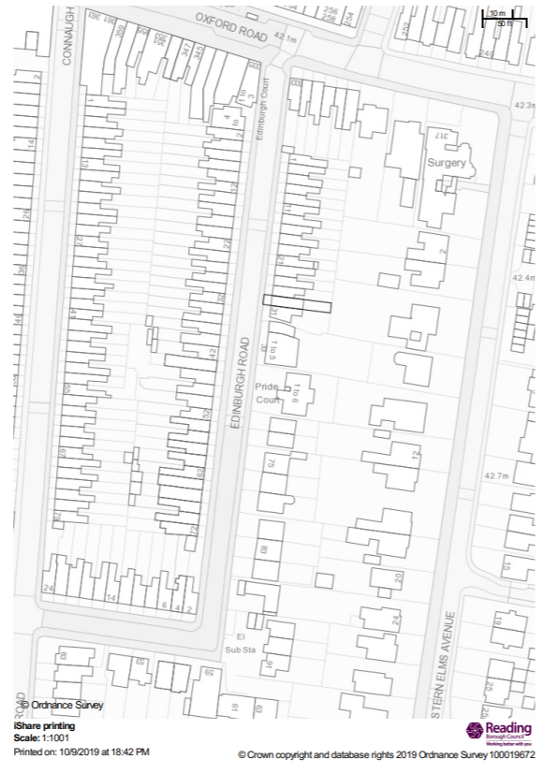
Site Location

