Delegated Application Report Target Date: 29/11/19
Address: 51 Erleigh Road
Application No: 191474/CLE
Proposal: Use of ground, first and second floors as a 5 person HMO (Class C4)
Case Officer: Tom Hughes
Site Description
51 Erleigh Road is a four storey mid-terraced property, located within an Article 4 area controlling the change of use from a Class C3 dwelling to a Class C4 HMO. The basement is in lawful use as a self-contained flat. The surrounding area is predominantly residential.
Description of Use or Development
A Lawful Development Certificate for an existing use is sought for the use of 51 Erleigh Road as a 5 person HMO (Class C4). This application relates to the ground, first and second floors only. The relevant time period is 04/10/09 to 04/10/19.
Relevant Planning History
171276/CLE – Use of basement as self-contained flat – Permitted 25/10/17
Relevant Planning Policy and Guidance
Section 10 of the Planning and Compensation Act 1991 established a procedure that enables anyone who wishes to do so, to apply to the local planning authority to determine whether a proposed use or operation, or an existing operational development or an existing use of land, or any other matter constituting a failure to comply with any condition or limitation subject to which planning permission has been granted, is lawful, and is so, be granted a certificate to that effect.
A Lawful Development Certificate is a legal document stating the lawfulness of past, present or future development. If granted by the local planning authority, the certificate means that enforcement action cannot be carried out to the development referred to in the certificate. However, the certificate will not protect from enforcement action by the planning authority if the specified use or development is then changed ‘materially’ without a planning application for it.
The certificate is not planning permission. The planning merits of use, operation or activity in the application are not relevant. The issue of a certificate depends entirely on factual evidence about the history and planning status of the building or other land and the interpretation of any relevant planning law or judicial authority. The responsibility is on the applicant to provide evidence to support the application.
The NPPG states that ‘The applicant is responsible for providing sufficient information to support an application. In the case of applications for existing use (section 191 of the Town and Country Planning Act 1990), if a local planning authority has no evidence itself, nor any from others, to contradict or otherwise make the applicants version of events less than probable, there is no good reason to refuse the application, provided the applicants evidence alone is sufficiently precise and unambiguous to justify the grant of a certificate on the balance of probability’.
Consultations
Council Tax
Records show two separate dwellings at this address. The basement flat has been banded for Council Tax purposes since 01/07.03, and the main house has been banded since at least 01/04/97. The band on the main house was reduced on 01/07/03 when the basement was banded separately. The property is not classed as an HMO for Council Tax purposes, as the tenants are liable as all named on the same tenancy agreement.
Electoral Roll
Between 2005 and 2019, the number of residents of 51 Erleigh Road on the Electoral Roll varied between 0 and 5.
Legal
Confirmation that sufficient evidence had been supplied was provided by the Council’s Planning Solicitor on 21/01/20. It was reiterated that the certificate should limit the use to a five person HMO.
Submitted Evidence
The agent supplied the following, received on 11/09/19:
Site Location
Drawing No: PL-07 – Proposed Ground Floor Plan
Drawing No: PL-08 – Proposed First Floor Plan
Drawing No: PL-09 – Proposed Second Floor Plan
Energy Performance Certificate, dated 20/08/09
Landlord Gas Safety Certificate, dated 07/08/18
Landlord Gas Safety Certificate, dated 06/08/19
Electrical Installation Report, dated 24/02/17
Tenancy Agreement – 01/07/19 to 30/06/20
HMO Licence – 13/11/17 to 12/11/22
Subsequently the agent supplied the following, received on 28/11/19:
Tenancy Agreement – 01/07/09 to 30/06/10
Tenancy Agreement – 01/07/10 to 30/06/11
Tenancy Agreement – 01/07/11 to 30/06/12
Tenancy Agreement – 01/07/12 to 30/06/13
Tenancy Agreement – 01/07/13 to 30/06/14
Tenancy Agreement – 01/07/14 to 30/06/15
Tenancy Agreement – 01/07/15 to 30/06/16
Subsequently the agent supplied the following, received on 19/12/19:
Tenancy Agreement – 01/07/16 to 30/06/17
Tenancy Agreement – 01/07/17 to 30/06/18
Tenancy Agreement – 01/07/18 to 30/06/19
Analysis of Evidence
The agent has submitted an Application for a Lawful Development Certificate for an existing use, to establish that the use of the ground, first and second floors of 51 Erleigh Road as a 5 person HMO has been on-going for more than ten years.
The relevant time period is 04/10/09 to 04/10/19.
The agent has supplied evidence dating to 2009 showing the use the ground, first and second floors of 51 Erleigh Road as a 5 person HMO. The Local Planning Authority has evidence of its own to show that the use of the property as a five person HMO has been ongoing since 2003. Tenancy Agreements, the HMO Licence and utilities reports and certificates are sufficient to corroborate the assertion that the ground, first and second floors of the property have been used as a 5 person HMO for more than 10 years.
Having regard to the foregoing, it is considered on the balance of probability, the ground, first and second floors of the property known as 51 Erleigh Road, Reading, RG1 5NB have been in use as a 5 person HMO for a period in excess of ten years. In the circumstance, it is considered appropriate to grant a Certificate of Lawfulness to that effect.
Recommendation
Grant Certificate
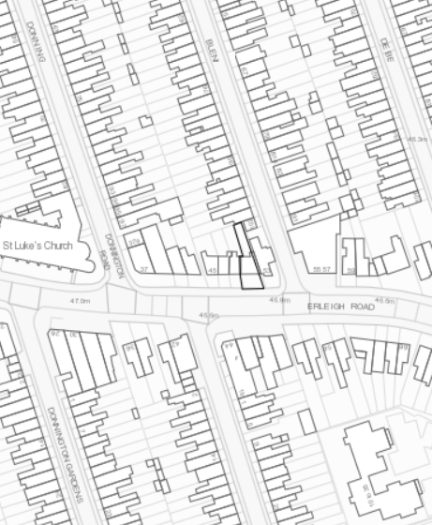
Site Location

