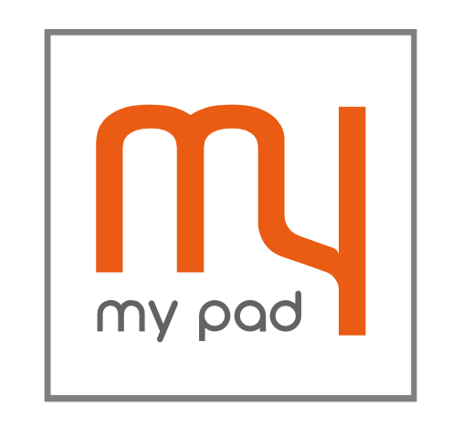
Sheraton Park, Durham Student Management Accommodation
Plan

Welcome to my pad Co-Living Accommodation

We are my pad, a brand that has been managing luxury student accommodation and is now expanding into the exciting new co-living sector.
We are part of an established lettings and management operation that has been looking after property on the South Coast for the past 20 years.

Our values
Transparency and openness, Teamwork and collaboration
Mutual respect and integrity, Equality and fairness
Ensuring excellent service, Working ethically and sustainably

The key to our success is centred on providing the best experience for our residents. my pad offers self-contained studio apartments with luxury fittings providing the feel of living in a boutique hotel with the comforts of home. All my pad buildings are situated in select locations, offering the convenience of city centre living whilst being comfortable, safe and secure. All our buildings have CCTV, video phone entry and secure key card entry systems. my pad brings a wealth of experience in the student accommodation sector, already delivering high quality services with proven expertise in 100 student units for Southampton.

Our aim is for residents to feel that they are safe, comfortable and content at their property, and we are therefore more than happy to incorporate measures to reinforce this goal, such as: inductions and excellent staff in order to enhance the residents’ experience. We are know the intricacies of managing open market along with student accommodation and intend to keep expanding on this knowledge.

Our aim is to ensure that we build a community at the new development which will develop a reputation underpinning the demand for the accommodation by being a place where residents want to live and spend time, with first class facilities, in a friendly atmosphere.

This building has been designed specifically to appeal to residents who are looking for private accommodation in a secure communal development. The majority of the residents are expected to be young workers. However we will not discriminate due to ethnic background, gender, age, religious belief or sexual orientation with regard to new residents; they will be acceptable so long as they are legally permitted to reside in the UK and pass normal AST referencing checks.

We recognise that the development adjoins a settled residential community and we understand the need for on-going dialogue and communication during the construction and operational phases. We will be central to the success of the interface with the community and control of issues such as noise and parking. We will ensure that all potential impacts on the community are dealt with promptly including the timely removal of waste and repairs so that the development always looks in optimum condition. We plan to be at the heart of the community and will encourage and maintain our values.
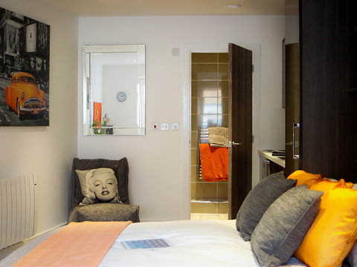
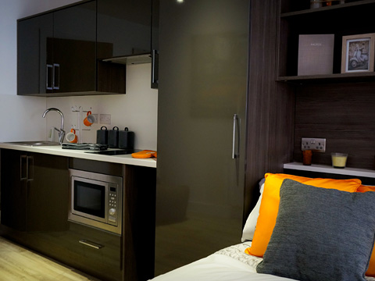

THE CO-LIVING EXPERIENCE
Co-living is a new form of development intended to provide a combination of quality private living space in a development with communal aspects that will promote interaction between residents to overcome the loneliness and stress that is often experienced by people when they are starting work in a new busy city environment.

To this end each of the proposed buildings has a communal lounge near the access door and we intend to invite applications to become the residents’ ambassador who will provide a point of contact for new residents and who will be the person who can help with social events.

Current Portfolio

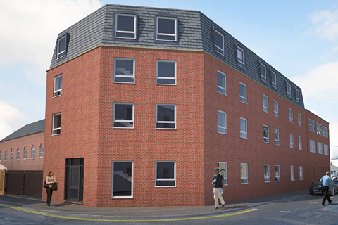
Fairchild House,
21 Southampton Street,
Southampton,
SO15 2ED

45 Student units.

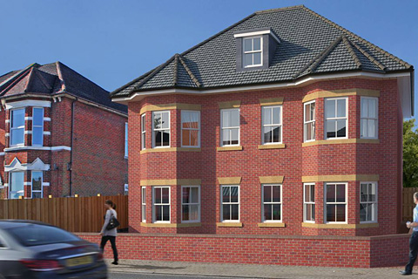

Mayfield House, 51 High Road, Southampton, SO16 2AG

18 Student units.

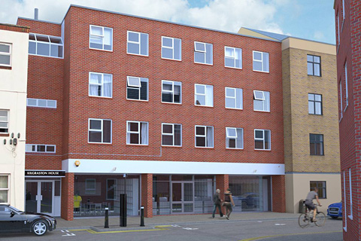

Andromeda House, Flat 1-37,
18 Southampton Street,
Southampton,
SO15 2EG

37 Student Units

Accreditation
Founded by two ex-university residents, we at my pad understand the needs of our tenants, and we place them at the heart of everything we do. As a growing force in the industry, we pride ourselves in offering expert facilities management. We offer bundled or individual services such as cleaning, security and maintenance to suit the needs of our clients. We are backed by numerous accreditation organisations including:
- Property Redress Scheme (PRS)
- NICEIC
- Data Protection
- Housing Hand
- Tenancy Deposit Scheme (TDS)
- Gas Safe Certificate

The Site

The site is located in the heart of Reading. It is approximately 0.5 miles from the city centre, 1 mile from Reading Station and 2.4 miles from the Green Park Business Park. It is well served by local bus routes. The site is located in a residential area which is defined by terraced housing and flatted developments. The Woodley Arms is circulated by an access road which links to Charndon Close. The south, east and west boundary of the site front onto this access road and serves the Woodley Arms car park to the south of the pub building.

The subject site is currently occupied by the Woodley Arms public house which was last in use in 2012. The main built form of the building is of two storey height with a red brick appearance. There is a contrasting lighter brick form to the rear and side of the building with a flat roofed element. The building is in a dilapidated and derelict condition and has been for a considerable period of time.

Planning permission has already been obtained demolish the existing building will be demolished and replace it with a purpose built student accommodation facility providing 38 self-contained studios, amenity space, parking and landscaping. The current proposal is to stick closely to the approved design with two separate buildings but change the occupation from students to co-living.

Vehicular access and parking

There will be 10 associated parking spaces which include one disabled space and one designated space for staff and contractors.

Staff and Services parking
The car park will be secured to prevent unauthorised parking and this will allow for a single car park space for use by our staff and contractors attending the property to undertake cleaning, maintenance and landscaping

Resident Move In and Move Out
Unlike student accommodation there are no particular issues surrounding the moving in or our processes. Residents who have secured a place at the property will be met at the property when they move in to provide an introduction to their accommodation.

When they move out tenants will be expected to manage their own departure and the property will then be inspected to manage the return of the deposit and to ensure the property needs no work prior to the next letting. In all instances the unit will be professionally cleaned between each tenancy.

Tenancy Management

The site will be managed by my pad’s property manager who will be in the main office from Monday to Friday 9.00am to 5.30pm supported by locally based maintenance and cleaning staff.
Outside of office hours, residents will be provided with an emergency contact number which will be manned 24 hours a day. In addition to this, my pad will install CCTV cameras on the outside of the building as well as in the corridors, laundry rooms, communal rooms, cycle store and bin store. An escalation procedure will be put in place to deal with any serious incidents.

Tenancy Agreement
Upon arrival, all residents will be presented with a briefing pack that sets out their obligations in terms of social responsibility to their adjacent and wider neighbours. Each resident will sign up to an Assured Shorthold Tenancy Agreement which binds them to rules and codes of conduct during their stay at one of our buildings. Where residents breach the agreement, there will be escalating levels of enforcement which will include deductions from their deposits, written and final warnings leading ultimately to eviction in the unlikely event of repeated and/or serious breach of the Agreement.

Security
The management team will respond to any noise and antisocial behaviour by residents during daytime weekdays and will be on call for serious incidents. CCTV cameras in and around the building will be channelled back to the main office to allow monitoring of incidents and potential incidents. There will be an electronic access system to prevent unauthorised access.

Inspection
To maintain a good quality living and working environment for all residents, communal areas of the building including entry hall, corridors, laundry rooms, communal rooms, amenity space, cycle store, bin store and all entry and exit points, will be inspected and cleaned regularly by a team of directly employed cleaning staff. This provides a further effective method for monitoring the welfare and behaviour of the residents. At the end of every tenancy the rooms will be inspected, repaired and deep cleaned in readiness for the next student occupier.

Landscape
The external amenity area and the landscaping around the new buildings will be regularly maintained by letting a contract to a local landscape contractor.

Repairs
We have regular inspections to ensure the premises are of excellent standard. The my pad team carry out all of the day to day to repairs and regular testing of the fire alarms. We are backed up by specialist subcontractors for gas, electrical testing, water treatment risk assessment, fire extinguisher and fire alarm maintenance.

Noise and anti-social behaviour
The continual support from the my pad staff and the procedures set in place will enable the local residents to always have a point on contact should there be any problems relating to noise or anti-social behaviour. This means complaints can be dealt with quickly. We have taken the initiative to:
- Hold induction talks for all the tenants on arrival
- We will communicate with the local residents and make this process easy (either with the staff on site or the helpline telephone number which will be provided)
- We will enforce the full terms of the tenancy agreement.

Neighbourhood and community
The team will actively seek to engage with the local tenants, residents and community organisations. In addition to working closely with local people, the team will hold a meeting with the local residents and groups to discuss and address any issues. Contact details will be provided for future use. The amenity area will be subject to a curfew from 10:30pm until 7.00am. This will be monitored with CCTV recording which will be supervised at the main office. We operate a deposit and guarantor policy which will provide further security relating to resident behaviour.

Tenancy enforcement
It is our interests to ensure the scheme maintains an excellent reputation in order to guarantee good demand and high levels of occupancy. The tenants will be monitored by a number of means including:
- Complaints from other residents
- Supervision from the staff
- CCTV
- Complaints from residents
The tenancy agreement covers the disciplinary procedures we use which includes verbal, written and formal written warnings. Therefore, if tenants fail to follow the rules and regulations, we will put our disciplinary procedure into action. In exceptional circumstances, where behaviour is unacceptable or persistent, they will be evicted.

Electronic access control
The building will feature an electronic access control system. Residents will be issued with personal key cards when they first arrive at the building, which are individually registered to the resident and are strictly controlled. In the event of a key card being lost or stolen, the system will cancel the original card and a new one will be issued to the resident.

Waste management
Waste generated at the site will be contained in euro bins in an enclosed area outside of the building. We also provide every room with a general waste bin and a recycling bin to encourage separation of waste.

Health and Safety
An external health and safety consultancy will undertake risk assessments of the completed development, as required, in the following areas:
- Fire Risk Assessment
- Control of Substances Hazardous to Health (COSHH) and Portable Appliance Testing (PAT)
- Legionellosis (water) Risk Assessment
- Gas Safety Certificate
Comprehensive reports will be commissioned annually and will always be kept up to date. The initial assessments will be undertaken towards the end of the construction phase. And will enable all required safety measures to be put in place prior to the first resident move in period.

Cycle store
The Woodley Arms development will be cycle friendly. A bike store will be provided to house resident’s bicycles. This will be located within the amenity area with a secure entry system. We shall also provide tools such as tyre pumps and spare chain links to ensure our tenants are prepared for the worst.

BREEAM certified
Our aim with The Woodley Arms development is to be as eco-friendly and sustainable as possible. BREEAM is a company which assesses and evaluates the procurement, design, construction and operation of a development against targets that are based on performance benchmarks. It measures sustainable value in a series of categories ranging from energy to ecology. Within every category, developments score points for achieving targets, and their final total determines their rating. We will use a BREEAM assessor to assist us in achieving our aim.

