DELEGATED APPLICATION REPORT - Application No.: 171087
Address: 2-4 Wilson Road
Proposal: Construction of a two storey 2 bedroom dwelling house and 3 x one bedroom flats with associated gardens and car parking.
Case officer: Alison Amoah
Target Expiry: 13th June 2019 (ext)

Site Description and Surrounding Area:
The application site is currently a vacant plot, hardstanding, on the western side of Wilson Road, a residential street (on right in the picture below), formerly used for parking for Grovelands Church for up to ca 20 cars, the latter on the corner of Wilson Road and Oxford Road.

Adjacent to the plot to the south is a row of traditional terraces and on the opposite side of the road a recent infill development, formerly Elgee Plastics, now a small row of terraced houses with parking to the front. The site is bounded by houses to the north and south and east and Brock Barracks to the west.

This site has a gated vehicular entrance with a footway crossover on Wilson Road. This road is one-way and is subject to 20mph speed limit. There are on-street parking time limited bays and it is a parking permit area.

The site is in an Air Quality Management Area.

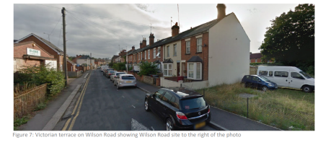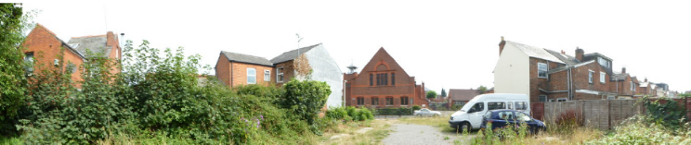

Proposal: The amended proposal comprises the following: 1 no. 2 bedroom terraced house and 3 no. 1 bedroom flats, the latter within what appears as a terraced house, 4 no. car parking spaces and rear amenity space.

The proposed floor spaces are:
Unit 1 - 2 bed house – 87sqm
Unit 2 – 1 bed flat – 51sqm
Unit 3 – 1 bed flat – 51sqm
Unit 4 – 1 bed flat – 51sqm

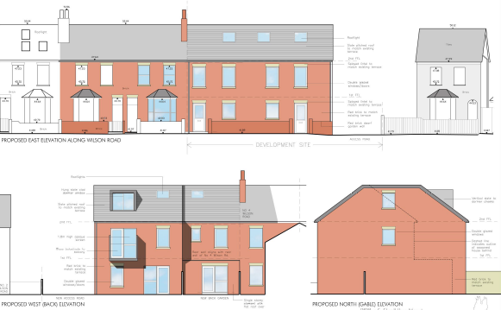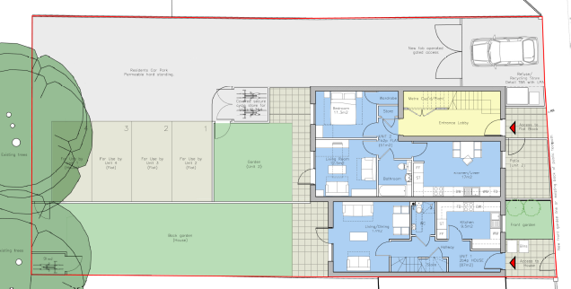

The materials proposed are to match existing, i.e. red clay facing brick and slate roof.

Discussion with the agent:
Originally the proposed scheme was submitted alongside an application to develop community and residential units within a new building at the site of Grovelands Church on Oxford Road (re: 171086). The Wilson Road site was intended to be the surrogate affordable housing site for the Oxford Road site and provide some of the parking provision for it.

Following the refusal of 171086 and the refusal of the subsequent application 180555 the applicant decided to pursue this application as a stand-alone housing site with no relationship to the Oxford Road site. Therefore some of the original comments from consultees were revised (see below).

In terms of the design of the proposed units, amendments were sought by the officer with respect to the alignment of windows and doors, an increase in front window sizes and position, removal of first floor rear element, adjacent to no. 4 Wilson Road, moving of the first floor rear balcony towards the corner of the building and the dormer at second floor, to improve overlooking/ perception of overlooking.

Plans considered: As received 4th July 2017:
- Location Plan – Drawing no: 100
- Site Block Plan - Drawing no: 101
- Existing Elevations & Site Plan Survey - Drawing no: 130
- Site & Ground Floor Plan – Drawing no: 150
- First Floor plan – Drawing no: 151
- Second Floor/Roof Plan – Drawing no: 152
- Proposed Elevations – Drawing no: 160

Other Documents:
- Affordable Housing Statement, prepared by CPL Chartered Architects
- Air Quality Assessment, project number: P2894.3.1, dated 22nd June 2017, prepared by agb environmental
- Arboricultural Report [including Tree Survey, Arboricultural Impact Assessment and Tree Protection Specification], ref: SA/1335/17, dated 22nd June 2017, prepared by Sylvan Arb
- Phase I Geoenvironmental Desk Study Report, report no: 16:06:004, dated June 2017, prepared by Listers Geo
- Planning Statement, dated June 2017, prepared by CPL Chartered Architects
- Transport Statement, ref: TR8170569/MB/DW/002, Issue 1: 20th June 2017, prepared by Glanville

Planning officer note: Following consultation responses and discussions with the applicant/agent the following amended plans were received:

Amended received on 1st September 2017:
- Arboricultural Report [including Tree Survey, Arboricultural Impact Assessment and Tree Protection Specification], ref: SA/1335/17/A, dated 31st August 2017, prepared by Sylvan Arb, received 1st September 2017

Amended received on 13th November 2017:
- Site & Ground Floor Plan – Drawing no: 150 Rev A
- Site Block Plan - Drawing no: 101 Rev A
- First Floor plan – Drawing no: 151 Rev A
- Second Floor/Roof Plan – Drawing no: 152 Rev A
- Proposed Elevations – Drawing no: 160 Rev A

Amended received on 17th January 2018:
- Site & Ground Floor Plan – Drawing no: 150 Rev B rec 17/1/18

Other Documents:
- Proposed Residential Development, Reading Community Church: Oxford Road & Wilson Road Sites transport Statement Addendum, ref: TR8170569/MB/DW/004 1/2 Issue 1: 16 January 2018, prepared by Glanville

Amended received 22nd January 2018:
- Site & Ground Floor Plan – Drawing no: 150 Rev C
- Proposed Elevations – Drawing no: 160 Rev B

Amended other document received 1st February 2018:
- Proposed Residential Development, Reading Community Church: Oxford Road & Wilson Road Sites transport Statement Addendum, ref: TR8170569/MB/DW/006 1/2 Issue 2: 1 February 2018, prepared by Glanville

Amended received 10th August 2018:
- Site & Ground Floor Plan – Drawing no: 150 Rev D
- First Floor plan – Drawing no: 151 Rev B
- Second Floor/Roof Plan – Drawing no: 152 Rev B
- Proposed Elevations – Drawing no: 160 Rev C

Other Documents:
- Planning Statement, Revision A – August 2018, prepared by CPL Chartered Architects

Other Document received 9th October 2018:
- Transport Statement, ref: TR8170569/PW/LR/007, Issue 2: 31st August 2018, prepared by Glanville
- Site & Ground Floor Plan – Drawing no: 150 Rev D

Amended received 1st April 2019:
- Site & Ground Floor Plan – Drawing no: 150 Rev E
- Transport Statement Addendum Note, April 2019, prepared by CPL Chartered Architects

Amended received 22nd May 2019:
- Site & Ground Floor Plan – Drawing no: 150 Rev F

Amended received 10th June 2019:
- First Floor plan – Drawing no: 151 Rev C

Relevant Planning History:
12/01577/FUL (121716) - Demolition of the existing church buildings, construction of a new 3 storey church building to accommodate worship/meeting rooms, offices, café and 2 retail outlets. Attached residential accommodation comprising 1x 1 bed and 1x 2 bed and 1x studio flat (Resubmission of 11/01189/FUL) – Approved 8/4/13

This permission was subject to a S106 legal agreement, which included parking provision on the Wilson Road site.

Consultation Responses:
Consultation on the original submission was undertaken with nos: 2-8 (even) Wilson Road, 553A and 555 Oxford Road, and owners of 1A Wilson Road. One letter of support and 2 no. objections were received as follows (one further letter of objection. Although labelled with this planning reference appears to relate to the refused 171086):

Support:
- This site has been rather an eyesore for many years, since the small hall which used to be on the site was removed. It is often overgrown and would be much better used to provide houses which are much needed in RBC area, especially if the houses are affordable for young families etc.

Objections:
- Traffic impacts/ parking pressures

- The proposed scheme would prevent the owners of 4 Wilson Road from accessing the external face of their house. Since owning the property a crack to the wall has required repair.
Planning Officer note: The proposal would mean that there would no longer be a gable wall to maintain. This is a Party Wall matter and would be dealt with by the standard procedures under the Party Wall Etc Act, which are separate to planning.

- An upstairs bathroom at no. 4 has an extractor which vents out the external side wall. This would be blocked by the development and would be a substantial loss of amenity.
Planning Officer note: The vent could be diverted to a roof terminal or the back wall of the property. This would mean that any future maintenance would be on no. 4s land rather than adjacent land. Works to the party wall are a Party Wall matter and would be dealt with by the standard procedures under the Party Wall Etc Act.

- Out of keeping with the appearance and design of other properties on Wilson Road and would extend further back than the neighbouring properties. Residents of no. 4 will be faced with a 2 storey wall less than 2 m away. This will create a narrow and shadowed alleyway. There will be loss of light to the kitchen and dining room.

- Egs of new development which have left gaps on both sides of the development and does not encroach on neighbouring properties.

- The proposed housing mix is out of character with the rest of the road.

It should be noted that a community consultation event was held by the applicant at 553 Oxford Road on 18th July 2018 (following refusal of the original application on Oxford Road - 171086, which had been submitted the same time as this application). This included designs for Oxford Road and Wilson Road. All neighbours that had objected to the 2017 applications (171086 – Oxford Road, and 171087 – this application) were invited to the event, along with neighbours in surrouding streets, local councilors and Reading Civic Society.

No further comments were received on this application following this consulation event and amended plans (with changes as described under the Section ‘Discussion with the agent’ above) were not reconsulted on.

Ward Cllr comments:
- We also have a concern that the parking at the rear of the housing at 2 - 4 Wilson Road includes a space right against the back garden of no 6 Wilson Road which will detract from the use of that garden.
- While affordable housing is something we expect to see, we would query the need for 1 bed flats above family housing especially as the adjacent proposal is for a family house. In an area where terrace housing is being converted to HMOs we would argue that two family homes are preferable.
- We are also concerned that the top flat appears to have just a window in the roof.

Design Review Panel: The following are comments were made prior to the de-coupling of the application site from the Oxford Road site.

“The secondary site [Wilson Road]) which is seen to provide 100% social housing is somewhat of an oddity and seems to be wholly driven by parking and overspill parking from the larger neighbouring site. The panel welcomes the approach of the applicant in providing proper homes for the social housing aspect of the proposal and this typology should be followed through to the other parts of the site to enable the site to sit better contextually. The panel is sure the council would much rather have 3 (potentially 3 bed) houses rather than the current mix of a 2 bed house, 2bed apartments and 1 bed apartment, this approach should be discussed with the council’s housing officer. Again further talks with the council’s transport officer should help with the viability of the above.

A potential fix for the site could be sought by following the design approach found at 65-79 Elm Park Road Reading RG30 2TP - where the continuation of the terrace is carried through whilst allowing access to parking at the rear via a 3m width one way access road in a classic ‘yard terrace’ approach which is also found at 49-51 George Street, Reading.”

Ecology: No objections

Environmental Protection & Nuisance: Air Quality - The air quality assessment submitted with the application shows that pollution levels near to the development will be below national objective levels, therefore no mitigation has been recommended.

Contaminated land – high risk sites - A phase I assessment submitted with the application recommends that a phase II intrusive site investigation is carried out due to the potential for contaminated land to be present at the site. Conditions are recommended in order to ensure that these works are carried out.

Construction and demolition phases - We have concerns about potential noise, dust and bonfires associated with the construction (and demolition) of the proposed development and possible adverse impact on nearby residents (and businesses). Fires during construction and demolition can impact on air quality and cause harm to residential amenity. Burning of waste on site could be considered to be harmful to the aims of environmental sustainability. The following conditions are recommended: CMS (including noise and dust), construction hours and no bonfires

Natural Environment :The applicant has submitted a comprehensive arboricultural report which details the means of protecting two Sycamore trees at the rear of the site which have been given a BS:5837 category ‘B’ rating. The trees are multi-stem specimens and have some amenity value being visible as a backdrop in wider views from the Oxford Road.

I am satisfied from the arboricultural information provided that the works can be completed without harm to the trees provided the methodology is followed. However, I would like the method statement to include a minimum level of arboricultural supervision on the date when the existing hardcore / concrete is pulled back and the geotextile surface laid. In addition, I would want the LA to be given a minimum of five days’ notice of this date and be advised when the work has been complete so that a tree officer can review operations.
Once the report has been amended to include this information then I would have no objections to the application.

Please list the approved arboricultural data / report as an approved document of the formal planning consent and include a landscaping condition if planning permission is granted.

Planning Officer note: An amended arboricultural report, which included amendments in Section 10 and Appendix C, was received 1st September 2018, which Natural Environment confirmed was acceptable.

Transport: Transport provided 3 sets of comments, the final comments were received subsequent to the applicant’s decision to de-couple this application from the Oxford Road site. These comments are set out below:

“The proposed development consists of the construction of a 2 bedroom dwelling house and 3 x one bedroom flats.

This application site is currently used as parking for the church that is located opposite the site and as a result would be lost. This application only deals with the merits of this proposal and any loss of car parking would be addressed as part of a future application.

The site is located within close proximity to the A329 Oxford Road that accommodates local amenities and high frequency public transport that travels to and from the town centre area.

Vehicular access to the site is to be gained via an existing dropped crossing and this is deemed acceptable. The access is 4.1m in width and therefore can accommodate two-way traffic and is therefore acceptable.

A gate is proposed and is set back 4.8m from the back of the footway. This is below the required 5m but has been deemed acceptable as this would allow a car to wait off the highway while the gate is opened. Further clarity would however be required as to how the gate is to be operated i.e. is it a manual gate or automated.

In accordance with the Councils parking standards a provision of 4 spaces would be required and the proposal complies with is provision. The spaces are to the correct dimensions and are provided with adequate manoeuvrability space.

The development site is located in an area designated as a Residents Parking Permit Area. Under the Borough’s current parking standards, this proposal would generate additional pressure for parking in the area. Therefore there should be an assumption that any future occupants of the flats will not be issued with resident parking permits.

Cycle storage facilities have been provided for the proposed units and this complies with standards. However, I do have some concern over the location of the cycle store for units 2,3 and 4 given that it is located within a concealed corner of the car park and this may discourage the use of cycling as an alternative mode of transport. A revised drawing should therefore be submitted illustrating a revised location, although I would be happy for this to be dealt with by way of a condition.

Refuse collection / storage are located within the required distance in accordance with National Standards.

In principle there are no transport objections to the development subject to the following conditions: DC1 - Vehicle parking space provided in accordance with approved plans, DC3 - Bicycle parking space provided in accordance with approved plans, DC5 - Bicycle parking – plans to be approved, DC7 & DC8 - Parking permits 1 and informatives regarding highways damage (IF3) and parking permits.

Planning Officer note: Transport confirmed acceptance of further amended plans which stated that fob entry would be required for the gates and cycle storage for units 2,3 & 4 were moved closer to the building, to the rear of the amenity space serving the ground floor flat.

Equality Act 2010:
In determining this application the Council is required to have regard to its obligations under the Equality Act 2010. However, there is no indication or evidence (including from consultation on the application) that the protected groups identified by the Act have or will have different needs, experiences, issues and priorities in relation to this particular planning application. Therefore in terms of the key equalities protected characteristics it is considered there would be no significant adverse impacts as a result of the development.

Relevant Planning Policy and Guidance:
Section 38(6) of the Planning and Compulsory Purchase Act 2004 requires that proposals be determined in accordance with the development plan unless material considerations indicate otherwise. Material considerations include relevant policies in the National Planning Policy framework (NPPF) - among them the 'presumption in favour of sustainable development'.

The following local and national planning policy and guidance is relevant to this application:
National Planning Policy Framework
National Planning Guidance

Reading Borough Local Development Framework Core Strategy Document, 2008 (altered 2015).
Policy CS1: Sustainable Construction and Design
Policy CS3: Social Inclusion and Diversity
Policy CS4: Accessibility and the Intensity of Development
Policy CS7: Design and the Public Realm
Policy CS9: Infrastructure, Services, Resources and Amenities
Policy CS14: Provision of Housing
Policy CS15: Location, Accessibility, Density and Housing Mix
Policy CS20: Implementation of Reading Transport Strategy
Policy CS23: Sustainable Travel and Travel Plans
Policy CS24: Car/Cycle Parking
Policy CS34: Pollution and Water Resources
CS38: Trees, Hedges and Woodland

Reading Borough Local Development Framework: Sites and Detailed Policies Document (2012, altered 2015)
Policy SD1: Presumption in Favour of Sustainable Development
Policy DM1: Adaption to Climate Change
Policy DM3: Infrastructure
Policy DM4: Safeguarding Amenity
Policy DM6: Affordable Housing
Policy DM10: Private and Communal Outdoor Space
Policy DM12: Access, Traffic and Highway-Related Matters
Policy DM19: Air Quality

Supplementary Planning Guidance/Documents
Revised Parking Standards and Design (2011)
Revised Sustainable Design and Construction (2011)

Technical Housing Standards – Nationally Described Space Standards, DCLG, March 2015
APPRAISAL:

Main considerations:
The main issues to be considered are:
- Principle of Residential Development
- Design/ Scale/Density
- Layout/Mix/ Size of Units
- Amenity of Proposed Residents and Existing Residents of Nearby Properties
- Environmental Matters
- Car/ Cycle Parking and Bin Storage
- Landscaping
- Impact Mitigation/ Infrastructure Contributions

- Principle of Residential Development
The site is a brownfield site and the development for housing would be acceptable in principle on this accessible site, which would represent a sustainable development, subject to meeting other policy considerations. This would specifically accord with paragraph 11 of NPPF, and policies SD1, and CS14.

- Design/ Scale/ Density
The design was reviewed by the Design Review Panel on 24th October 2017 along with that of the Oxford Road site (171086) which at the time was linked to this site. The majority of the response related to the Oxford Road site. With respect to Wilson Road, however, there was a suggestion that the terrace could be continued whilst allowing for access to the parking at the rear via a 3m wide one way access road in a classic ‘yard terrace’, and providing more houses than flats.

To achieve compliance with Lifetime - Homes standards the width of two terraced buildings is considered to be the maximum achievable on this site. Additionally, from a Transport perspective retaining sufficient width for two-way car movement would be preferable on this busy street and it would be important to provide sufficient parking where there is pressure for on-street parking at present. The layout also enables more effective provision of amenity space.

Using the site for a mix of a house and flats is considered to make more efficient use of the site.

Officers had requested a number of amendments to the originally proposed scheme as follows:

- Windows - to match with the existing adjoining terrace as well as removal of the patio doors. Amendments were made as shown below (right), which the agent explained were as closely aligned as possible in the context of modern accessibility standards, which place requirements on the design in terms of floor levels, stair design, and window sill heights. This amendment was considered acceptable.
- Bay windows – Officers expressed a preference for bay windows to the front, but the agent explained that the proposed living rooms are to the rear in order to make use of passive solar gain.
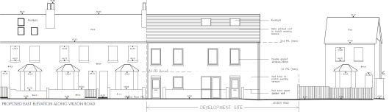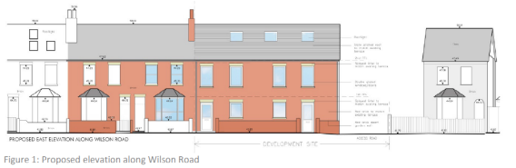
Original Amended

- Balconies and rear dormers – The first floor balcony and dormer windows were moved closer to the corner of the building
- Two storey rear depth – This was reduced adjacent to no.4 Wilson Road.

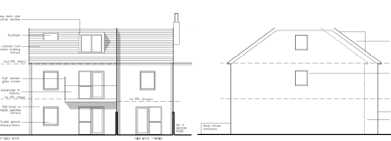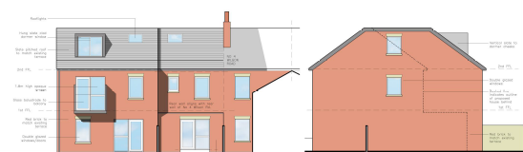
Original Amended

The proposed building would be an extension to the existing Victorian terrace and it is considered that the scale of the new buildings, proportions of the elevations, fenestration details and proposed materials would relate to and complement the existing housing.

It is considered that the proposals would be acceptable in their scale, appearance and design and would therefore be in accordance with Policy CS7 of the Core Strategy and the principles of high quality design set out in the NPPF.

Policy CS15: Location, Accessibility, Density and Housing Mix, identifies indicative density for town centres as 70 and over dwellings per ha, and 40-75 dwellings per hectare for urban sites (Areas that are generally denser than more suburban areas and comprise a mix of residential and employment areas). The proposed site is on the edge of the town centre and equates to ca 83 dwellings per hectare. Although higher than the adjoining density of terrace houses, it is considered that there is a mix of densities in this location and would be acceptable; making efficient use of this accessible site.

- Layout/ Mix/ Size of Units
Policy CS15 requires that “Developments should provide an appropriate range of housing opportunities in terms of a mix of housing types, sizes and tenures, in accordance with the findings of a housing market assessment.” And states that “while a high proportion of future needs is for the accommodation for small households, development should include the provision for family accommodation.” The proposed mix of a two bedroom house and 3 no. 1 bed flats would therefore be acceptable.

The Technical Housing Standards (DCLG, 2015) includes recommended internal floor spaces for 1 bed flats for 2 persons – 50sqm, for 2 bed houses for 4 persons – 79Sqm. All the units (sizes above) exceed these.

The internal layout of the flats part of the development, although not ideal in terms of stacking would not provide sufficient harm to refuse the scheme on this basis.

- Amenity of proposed residents and existing residents of nearby properties
Policies DM4, and DM10 of the Sites and Detailed Policies Document are specifically relevant. DM4 requires that “Development will not cause a significant detrimental impact to the living environment of existing or new residential properties, in terms of: Privacy and overlooking; Access to sunlight and daylight; Visual dominance and overbearing effects of a development; Noise and disturbance; Artificial lighting; Vibration; Dust and fumes; Smell; or Crime and safety.

There would be rear facing windows, which would allow overlooking of existing rear gardens, but this arrangement would be no different to that which exists between existing houses at present. The amended scheme includes a revised location of the second floor dormer and first floor balcony further towards the corner of the proposed buildings and opaque glazing is proposed for the balcony sides.

The proposed dwellings would be to the north of the existing terrace and the depth of the two storey element has been reduced closest to no. 4 Wilson Road. The ground floor projection is 3 m depth and 2.6m high and it is considered that this would have limited impact on the rear facing window of no.4 with respect to daylight and sunlight.

It is not considered that the proposed buildings would be overbearing or visually dominant.

In terms of noise and disturbance between proposed units there would be a requirement to meeting sound insulation standards under building regulations requirements.

On balance the proposals are considered to meet the requirements of Policy DM4.

Policy DM10 provides guidance that amenity space should be 25sqm per flat, although there is also an acceptance that this could be provided for by balconies. The scheme provides for a garden for the ground floor flat, a garden for the house, and a balcony for the first floor flat. Although the second floor flat has no private amenity space there are public parks in walking distance, e.g. Kensington Park.

- Environmental Matters
Air Quality: The site is located within the Air Quality Management Area, which requires that developments should have regard to the need to improve air quality and reduce the effects of poor air quality. For sensitive uses (including residential) mitigation measures should be detailed. The air quality assessment submitted with the application, however, shows that pollution levels near to the development will be below national objective levels, therefore no mitigation has been recommended.

Sustainable Design and Construction: Living spaces have been located on the west facing façade so as to maximise solar gain and reduce energy consumption for heating.

It is anticipated that a permeable surface will be used for the hard surfacing. A condition is included for further details.

The Planning Statement identifies that the design has employed a fabric first approach, which would achieve sustainable building based on good thermal performance of walls, floors, roofs and glazing, which coupled with good levels of air tightness, would ensure that the development minimises carbon emissions.

It is proposed to use permeable paving/tarmac and a condition is included for the submission and approval of hard and soft landscaping.

Contamination: A desk study has established that potential contaminants might be present within the soils and possible groundwater beneath the site. The report therefore recommends that a Phase II ground investigation works are undertaken to identify any soil or groundwater contamination and if necessary identify appropriate remedial measures. Environmental Protection and Nuisance therefore recommend conditions in this regard.

f) Car/cycle parking and bin storage
The amended plans included parking provision for 1 space per dwelling and sufficient cycle storage spaces, which comply with the Council’s standards. Transport has confirmed that these are acceptable, subject to a number of conditions.

The proposed refuse storage area is located close to the road frontage accessible from the side access and for ease of collection. A condition is included for the submission and approval of suitable bin storage enclosure.

The proposed scheme therefore complies with policy CS24.

g) Landscape
There are two large sycamore trees adjacent to the western boundary. A tree survey and impact assessment have been carried out and demonstrate measures to ensure that trees would not be harmed during development. The original Arboricultural Report was amended following the above comments from Natural Environment and the officer confirmed that the works could be completed without harm to the trees provided the methodology were followed. A landscaping condition is included and the report included as one of the approved documents.

The proposed front garden would include a low brick wall and there would be new gate serving the access to the parking.

Subject to the conditions the proposed scheme is considered to accord with policy CS38.

h) Impact mitigation/ infrastructure contributions
The development would involve the creation of additional C3 residential floorspace, which would be liable for CIL at the rate of £148.24per sqm (2019 rate). CIL does not form part of the determination, but an informative is included regarding the CIL process following determination.

Policy DM6 of the Sites and Detailed Policies Document - Affordable Housing states that “on sites of 1 – 4 dwellings, a financial contribution will be made that will enable the equivalent of 10% of the housing to be provided as affordable housing elsewhere in the Borough”.

The Applicant submitted a viability assessment, and further to assessment and negotiation by the Council’s Valuer a figure of £30,000 was agreed with the Applicant as an acceptable level of contribution.

RECOMMENDATION:

APPROVE
- TL1 – standard 3 year time limit
- AP1 – Approved plans -

- Site & Ground Floor Plan – Drawing no: 150 rev F, received 22nd May 2019
- First Floor Plan – Drawing no: 151 Rev C, received 10th June 2019
- Second Floor/Roof Plan – Drawing no: 152 Rev B, received 10th August 2018
- Proposed Elevations – Drawing no: 160 Rev C, received 10th August 2018
- Arboricultural Report [including Tree Survey, Arboricultural Impact Assessment and Tree Protection Specification], ref: SA/1335/17/A, dated 31st August 2017, prepared by Sylvan Arb, received 1st September 2017

- M1 – matching materials
- DC1 - Vehicle parking space provided in accordance with approved plans
- DC3 - Bicycle parking space provided in accordance with approved plans
- DC6 - Bin storage – details to be provided and approved, implemented and retained.
- DC7 – Parking permits
- DC8 - Parking permits
- C2 – CMS
- Hours of noisy construction
- CO7 - Control of Noise and Dust during construction
- CO8 - No bonfires
- CO3 - Contamination – site characterisation
- CO4 - Submission of remediation scheme
- CO5 - Implementation of remediation scheme
- CO6 - Reporting of unexpected contamination
- L2a – Hard and Soft landscaping submission and approval, with hard landscaping to be designed using SUDS principles.
- L2B – Implementation of approved landscaping
- PD1 – no permitted development extensions
- PD2 – no permitted development windows or dormer windows
- PD5 – no use of roof

Informatives:

IF5 - Terms and Conditions
IF - Building Control
IF8 - Encroachment
IF3 – Highways
I13 - Parking Permits
IF4 - S106
I11 - CIL
IF2 - Pre-commencement conditions
Conditions 19, 20 and 21 do not relate to the proposed flats as these do not have the same permitted development rights as houses.
IF1 - Positive & Proactive

