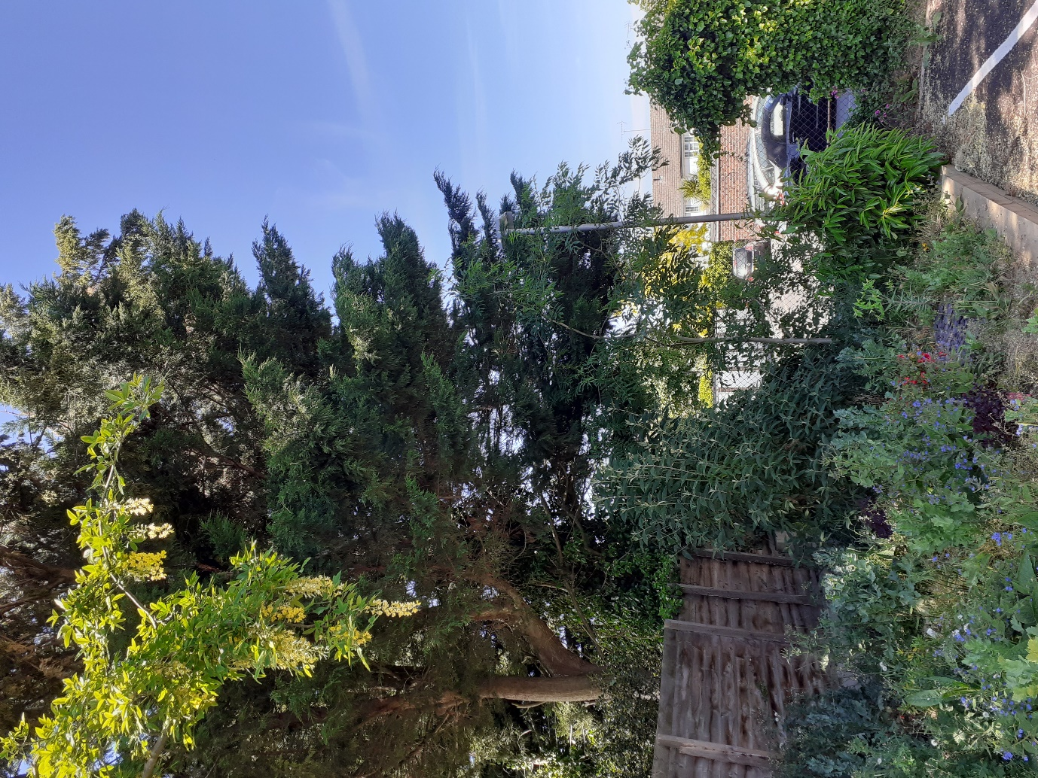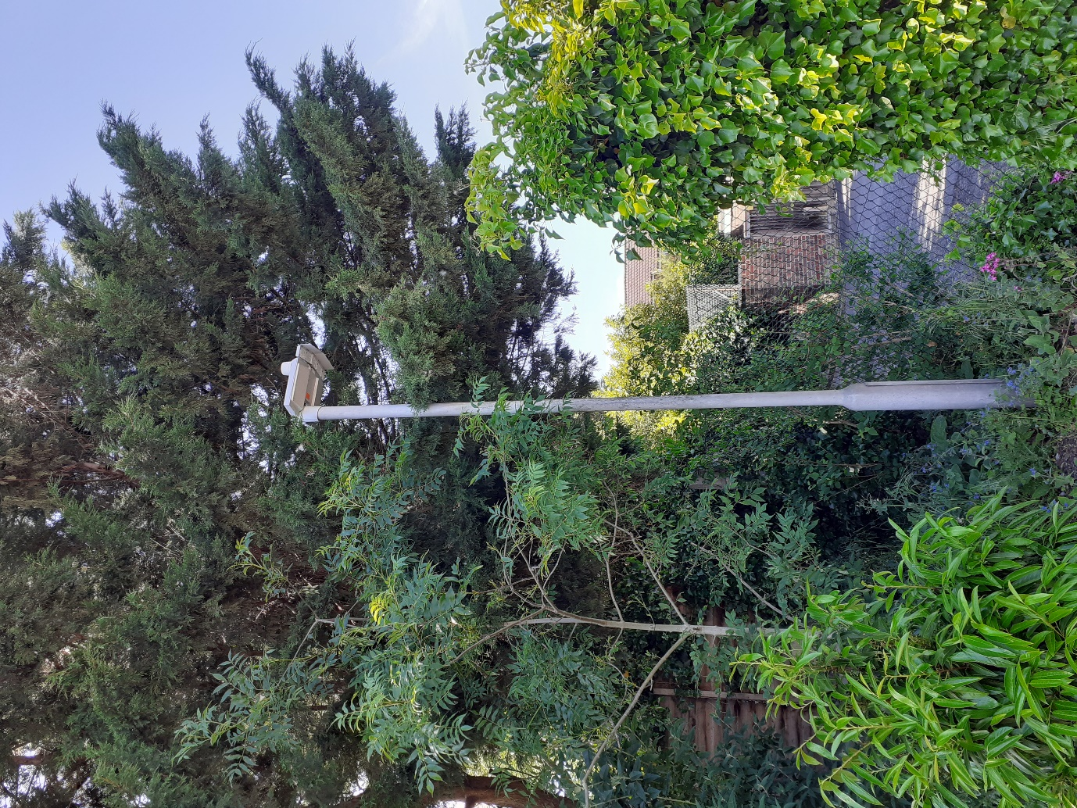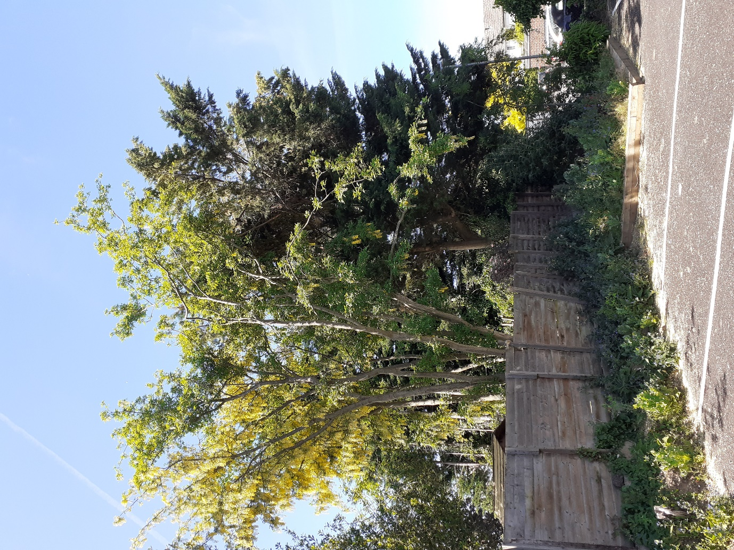
Cypress in Linden Mews - Remove low section back to boundary or main stem
Remove secondary branch back to main stem
Remove entire stem

Progress Theatre – Cypress and Laburnum overhanging from Linden Mews
200696/TCA

