DELEGATED APPLICATION REPORT - Application No.: 191226/HOU
Address: 2 Fontwell Drive
Proposal: Two storey side extension
Officer: Alison Amoah
Target Expiry: 8/11/19 (Ext)

Site Description and Surrounding Area:
The application site is a semi-detached house at the start of Fontwell Drive within a wholly residential area. The plot was recently divided and a new house (40A Hogarth Avenue) built on part of the application site’s garden.

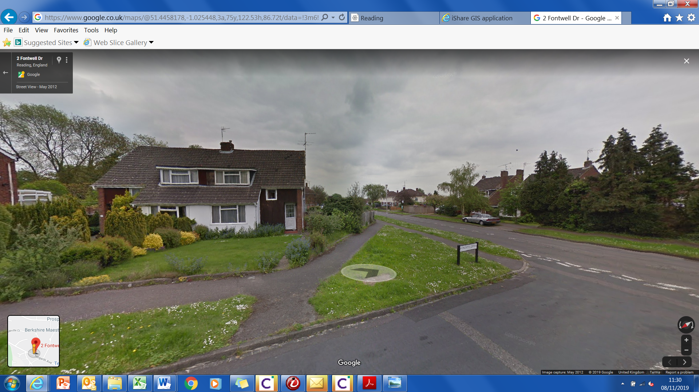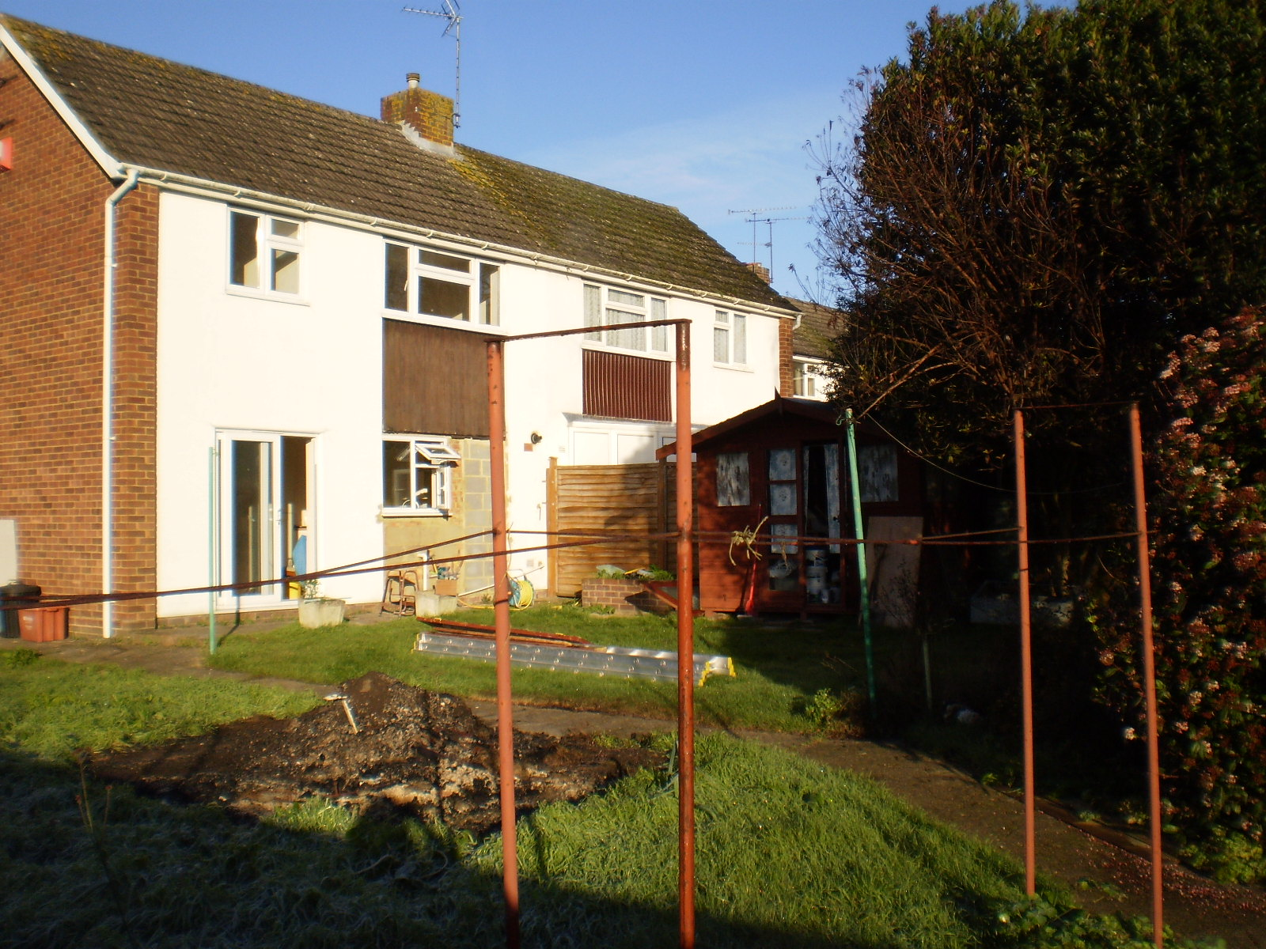

Proposal:
A amended scheme comprises a two storey pitched roof side extension of 3.6m wide, set back and set down from the host dwelling with front facing ground floor window, and two velux windows; two ground floor side facing windows, and first floor rear window and ground floor door and window.

The materials would be to match existing.

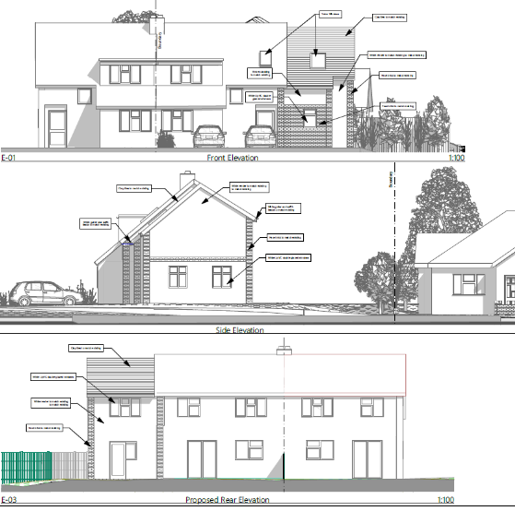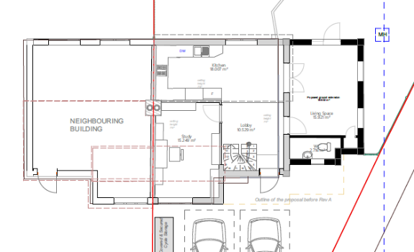

Discussions with the Agent: The original submission included a front facing dormer window, infill front extension in line with existing building line and no set back of the side extension (see extracts below) These elements were considered to be unacceptable with respect to the character and appearance of the host dwelling and the surrounding area.
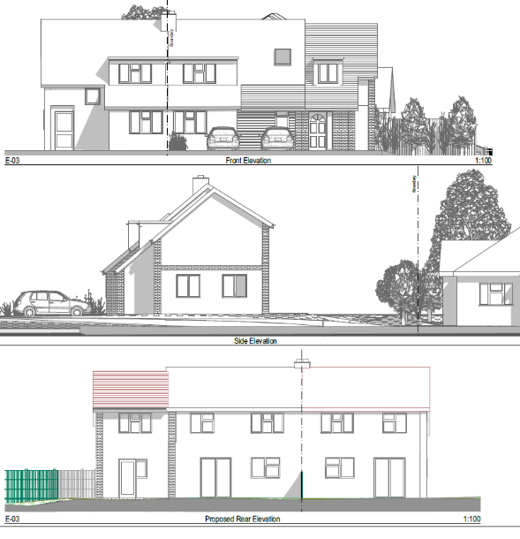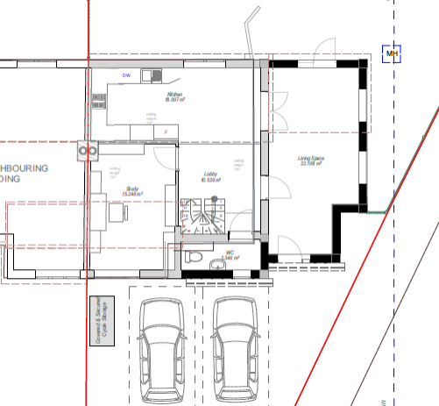

Amendments were provided by the agent on 15th October and were considered acceptable by the Officer. No re-consultation was undertaken as the proposal was smaller than the original.

Plans Considered:

as received 26th July 2019:
- Location Plan - Drawing no: PL-01
- Existing Floor Plans – Drawing no: PL-04
- Proposed Block Plan – Drawing no: Drawing no: PL-03
- Existing Elevations - Drawing no: PL-05
- Proposed Site Plan - Drawing no: PL-06
- Proposed Ground Floor Plan A3 – Drawing no: PL-07
- Proposed First Floor Plan A3 – Drawing no: PL-08
- Proposed Roof Plan – Drawing no: PL-09
- Proposed Elevations – Drawing no: PL10

Amended plans as received 15th October 2019:
- Proposed Block Plan – Drawing no: Drawing no: PL-03 Rev A
- Proposed Site Plan - Drawing no: PL-06 Rev A
- Proposed Ground Floor Plan A3 – Drawing no: PL-07 Rev A
- Proposed First Floor Plan A3 – Drawing no: PL-08 Rev A
- Proposed Roof Plan – Drawing no: PL-09 Rev A
- Proposed Elevations – Drawing no: PL10 Rev A

Relevant Planning History:
91-00396-FUL - Single storey extension - Approved.
06-00164-FUL - Replacement roof for a games room - Approved.

Consultation Responses: No. 4 Fontwell Drive and 40A Hogarth Avenue were consulted. A site notice was displayed. On comment was received as follows:

- I believe that this is total over-development of the site and inappropriate for the area. Would this development not be in front of the existing building/sight line?

Equality Act 2010:
In determining this application the Council is required to have regard to its obligations under the Equality Act 2010. However, there is no indication or evidence (including from consultation on the application) that the protected groups identified by the Act have or will have different needs, experiences, issues and priorities in relation to this particular planning application. Therefore in terms of the key equalities protected characteristics it is considered there would be no significant adverse impacts as a result of the development.

Relevant Planning Policy and Guidance
Section 38(6) of the Planning and Compulsory Purchase Act 2004 requires that proposals be determined in accordance with the development plan unless material considerations indicate otherwise. Material considerations include relevant policies in the National Planning Policy framework (NPPF) - among them the 'presumption in favour of sustainable development'.

The following local and national planning policy and guidance is relevant to this application:

Reading Borough Local Plan (2019)
CC7: Design and the Public Realm
CC8: Safeguarding Amenity
H9: House Extensions and Ancillary Accommodation
TR5: Car and Cycle Parking and Electric Vehicle Charging

Supplementary Planning Guidance/ Documents:
A Design Guide to House Extensions (2003)

Appraisal Checklist:

H9 states: An extension to a house will be acceptable where it:

- Respects the character of the house in terms of scale, location, materials and design;

To assess this, the following has been considered – would the proposal:
- Detract from the appearance of the original building through the use of ill-matching materials and by not fitting in with the design, scale and proportions of the original building; No –The proposal is half the width of the existing house and is set back and set down and reflects the design of the host dwelling.
- Reduce the amount of usable amenity space for the property to an unacceptable degree; No.
- Require the loss of trees in the garden or put significant trees at risk; No.

B. Respects the character and pattern of neighbouring properties and appearance of the street as a whole in terms of scale, location, materials and design, the arrangement of doors, windows and other principal architectural features and any important existing building line; & C. Does not present an overbearing impact on neighbours or a large blank façade to public areas

To assess this, the following has been considered – would the proposal:

- Significantly reduce the amount of daylight and sunlight enjoyed by neighbouring properties; No.
- Invade the privacy of neighbouring properties through overlooking from windows or balconies; No – There are rear facing windows at first floor, but this arrangement would be no different to the existing dwelling with respect to its relationship with the infill property (within part of former garden of the application site) 40A Hogarth Avenue.
- Detract from the character of neighbouring properties through siting, excessive bulk, ill-matching materials or inconsistent design; No
- Detract from the appearance of the street or area by using ill-matched materials, glazing and detailing; No.

D. Does not result in a loss of biodiversity within garden – No.

E. Ancillary accommodation, such as granny annexes, will be acceptable where it would not be capable of operating as a separate dwelling which could be let or sold separately – N/A.

CC8: states: Development will not cause a detrimental impact on the living environment of existing residential properties or unacceptable living conditions for new residential properties, in terms of:

• Privacy and overlooking; No
• Access to sunlight and daylight; No
• Visual dominance and overbearing effects of a development; No
• Harm to outlook; No
• Noise and disturbance; No
• Artificial lighting; No
• Vibration; No
• Dust and fumes; No
• Smell; No
• Crime and safety; No or
• Wind, where the proposals involve new development of more than 8 storeys – N/A.

Other Matters

RECOMMENDATION:

APPROVE
3
- TL1 – Time Limit 3 yrs
- AP1 – Approved plans
3) M1 – Matching materials

Informatives:

- Terms and Conditions
- Building Control
- Encroachment
- IF1 – Positive and Proactive

