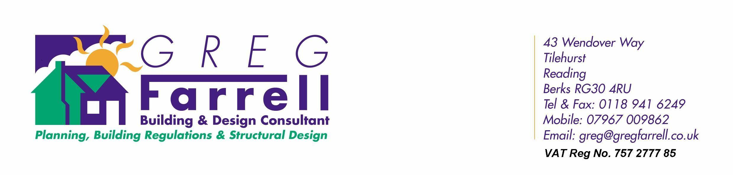

DESIGN AND ACCESS STATEMENT FOR

14 Church Street
Caversham
Reading
Berks RG4 8AR

THE PROPERTY

14 Church Street, Caversham is a 19th century mid terrace building situated within the main shopping arcade area of Caversham itself and close to shops & bus routes etc.

PROPOSALS

The property at present has mixed use A1 Shop at the ground floor and first and second floor B1 Office use. The application proposes to convert the first and second floors into three one bedroom apartments with alterations to the interior of the building only.

Externally the building will remain unchanged.

COMPLIANCE WITH BUILDING REGULATIONS

The first and second floor will require refurbishment in order to meet the requirements of the Building Regulations in particular Fire & Sound and it is proposed to soundproof the floor and walls (including Party Walls) to meet current regulations. Sound testing will be required and Electrical Certification will be provide on completion of the work. In addition to the above the two floors will be brought up to meet current energy efficient regulations.

WASTE COLLECTION

This is carried out by Reading Borough Council and will remain unchanged.

~~ Page 1 ~~

SECTION 106

Agreement with Reading Borough Council for the collection of a suitable Section 106 to be agreed and the applicant has confirmed his agreement to pay this as necessary.

SUMMARY

With the current reduced Office requirement in the area and the necessity to keep building such as this in use the application seeks to provide three one bedroom apartments within the existing first and second floors and it is hoped that this will contribute to the housing needs in the area.

~~ Page 2 ~~

