Design and Access Statement

This Design and Access Statement has been produced to accompany and support a Householder Planning Application for the addition of a single storey glass canopy to the rear elevation of the Property.

The existing residential property is located at 3 Park Lane, Tilehurst, Reading, RG31 5DJ. The multi-storey house comprises red brick and cream-coloured render, with white doors and window frames. The property benefits from an existing rear extension. Access to the site is via Park Lane. The driveway allows access for parking and routes around the site. The main point of access into the property is via the front elevation. The site of the proposal is on the rear elevation, situated in the garden.

The design of the Glass Canopy has a gutter system built into the supporting posts. This is an elegant design, which does not detract from the existing building and is both functional and sleek. The 5.2° pitch of the roof enables rainwater to roll down and into the gutter, rather than lying flat on the roof and therefore is essential to the design.

Whilst the floor space of the Glass Canopy will be 13.5m², no additional living space is being created. The Glass root comprises WT 029/60740 metallic ‘Chestnut Brown’ posts and profiles and a clear glazed roof.

The character of the existing dwelling is preserved, through the addition of the clear glass. The original building is unharmed as the construction of the proposal is demountable, with unobtrusive fixings. The proposal is aesthetically pleasing with the colour choice.

The proposed Glass Canopy is an elegant solution to the client’s requirements, providing a sheltered area in the garden, with minimal disturbance of the building both visually and materially. This discreet design is both elegant and fitting for the function and site.

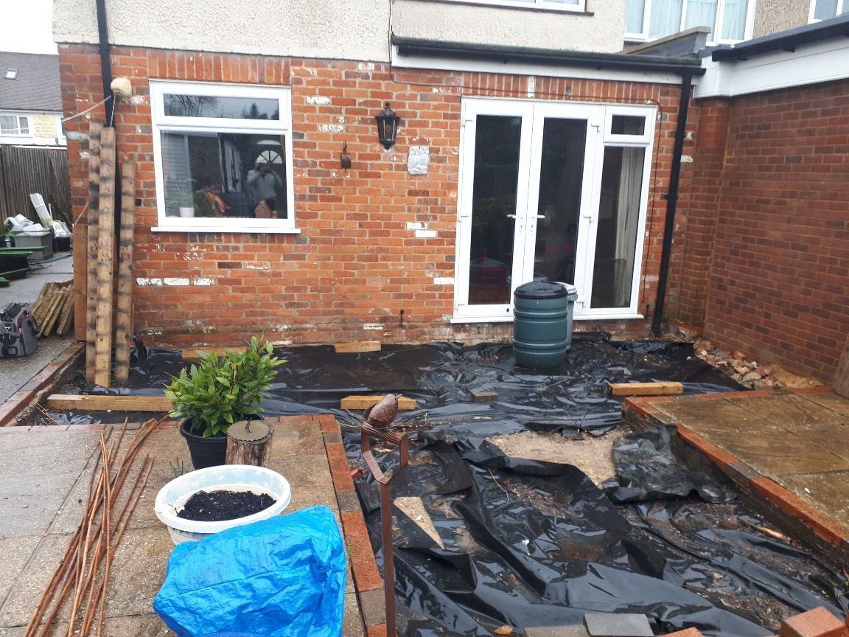

Photograph of site of the proposal at the front of the Property.

