Mr Thomas Berresford (Owner)
37 Southview Avenue
Reading
Berkshire
RG4 8NS
22nd June 2020

DESIGN & ACCESS STATEMENT 37 Southview Avenue, Reading
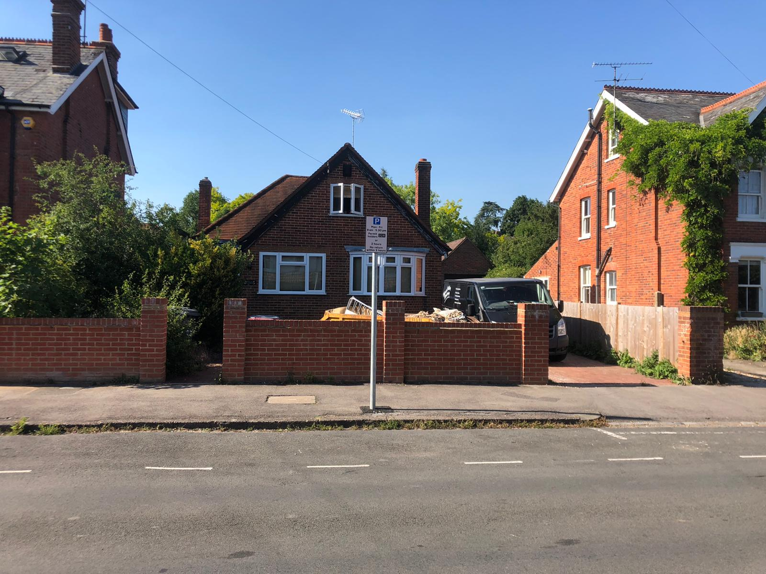
CONTENTS
1.0 Introduction
2.0 History
3.0 Design
4.0 Site Access
5.0 Disabled Access
6.0 Landscaping
7.0 Appearance
8.0 Section 106 & Affordable Housing
9.0 Conclusion

1. Introduction
1.1 The following Design and Access Statement has been prepared in support of a householder planning application for the demolition of an existing four-bedroom 2-story bungalow and the erection of two new five bedroom semi-detached dwellings in its place.
1.2 The Statement aims to provide the local authority with the relevant supporting information upon which we have based our proposals. The process of survey analysis, and to show the design aims to create an integrated approach to the proposal in keeping with the surrounding area, which has a large variety of family homes and flats. 37 Southview Avenue is the only bungalow on the street and either side of the side 3 story town houses are located. Please see examples below of the variety of properties on the street.
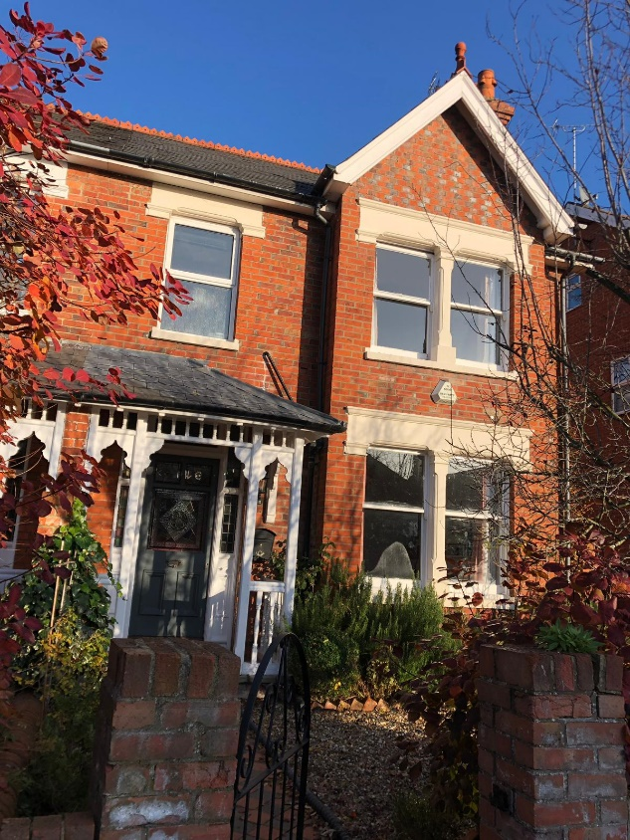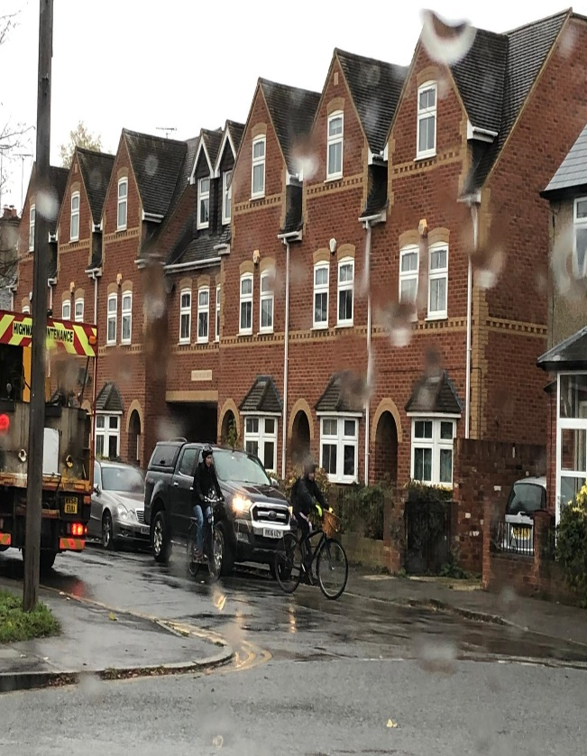
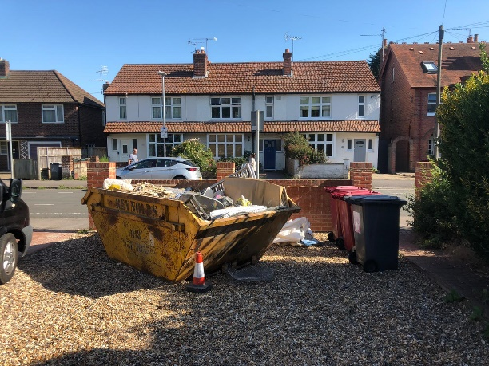
1.3 The statement will also show that the proposed development is in keeping with all current planning legislation in relation to design and access and is in an area with no planning restriction.

2. History
2.1 The existing property, 37 Southview Avenue is of traditional brick and block construction with a tiled pitched and gabled roof. The bungalow is a four bedroom detached house with an oversized garden to the rear. The Site has been in Mr Berresfords family since his grandparents constructed the bungalow in the 1960’s. The current bungalow is dwarfed by the surrounding properties, which are large four and five bedroom homes to either side. Therefore, I believe the proposed development to be much more in keeping with the surrounding area. The majority of the front garden is hard standing an currently set up as parking for four vehicle and has no significant architectural significance or design. The proposed design will retain adequate parking in accordance with current planning law as well as reinstating a landscaped area to reintroduce some foliage to the front garden of both proposed properties.
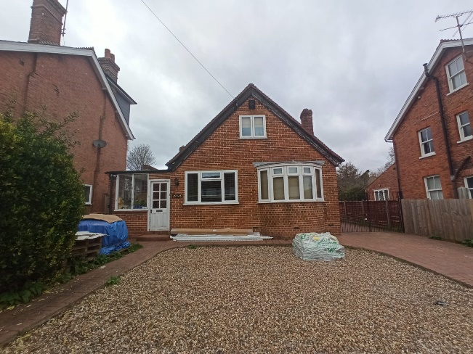
2.2 The proposed two new dwelling will be sited centrally on the plot of 37 Southview Avenue and on the same footprint of the existing building with side access to the rear garden for both properties. The proposed development will be set back 5 meters from the front of the plot as to allow adequate parking and to align with the adjacent properties.
2.3 The surrounding area is made up of a number of detached, semi-detached, terraced houses and flats of varying size and scale with no particular architectural style or openness being prominent within the street scene. The proposed design has incorporated similar materials and features as the surrounding buildings, which will include stone cills, pitched clay tile roofs and gable ends etc.
2.4 The surrounding area inclusive of the planning application site is not in a designated conservation area; it is not subject to a low-density policy and does not lie within the Green Belt. The area surrounding the plot is very diverse in the styles of construction. Please see the attached photos for reference. The proposed development is in keeping with the large family home that surround the site either side.
3. Design
3.1 The main design philosophy has been to create two dwellings that will complement and enhance the site and surrounding area whilst also remaining in keeping with the neighbouring properties in both scale and style.
3.2 The proposed design is a two-story semi-detached house with a loft conversion, which is similar in size and scale to the surrounding properties. They look to have been extended numerous time, the proposed design would have the same roof height as the adjacent properties and due to the length of the garden to the rear I believe would be no more intrusive than the surrounding properties currently are.
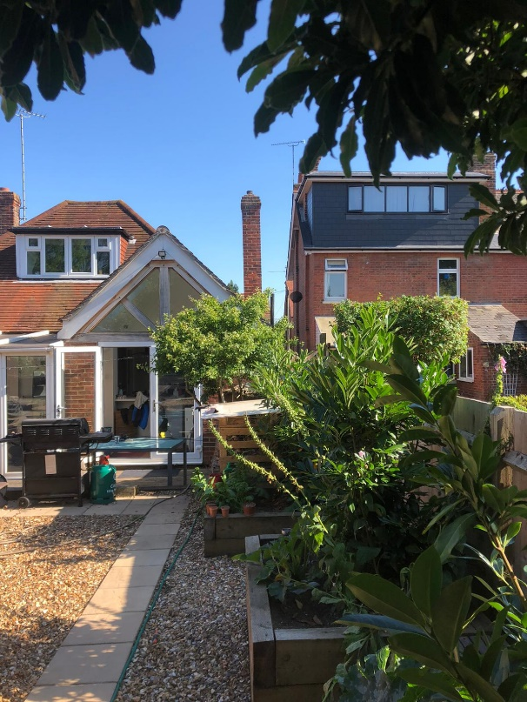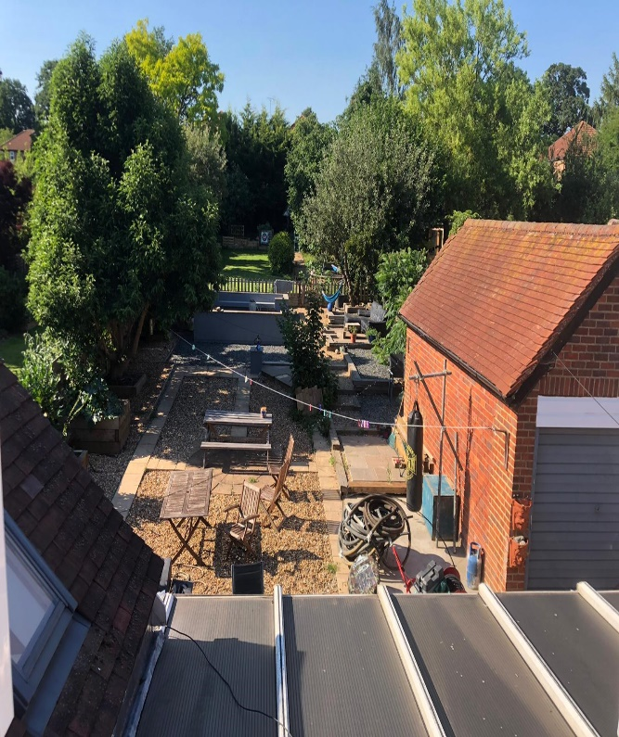
3.03 The gap between the proposed dwellings and the existing properties would be within all current legislation and would match the surrounding area, in fact, many surround properties do not have rear access to the garden so the proposed space would be relatively large as to not restrict light or overlook the surrounding properties.
3.4 The Designs of the proposed properties have similar door and window sizes as well as ceiling and roof heights. The two properties will be constructed out of similar materials such as red facing brick, render and sandstone cills.
3.5 The proposed dwellings are designed so that there are no windows to habitable rooms on side elevations thus eliminating any potential overlooking issues with nabouring properties.
3.6 Overall the proposal represents two comprehensive family dwelling which efficiently uses the site within a sustainable location providing residential accommodation the scale of which is not detrimental to the character of the area and I believe will in fact enhance the character of the area.
4. Site Access
4.01 The application proposal will utilise the existing vehicular access off Southview Avenue for one of the proposed properties and for the second, access will be adapted to give both properties 2 off road parking spaces. This is to keep in line with the requirements of Reading Borough Council’s parking provision guidelines.
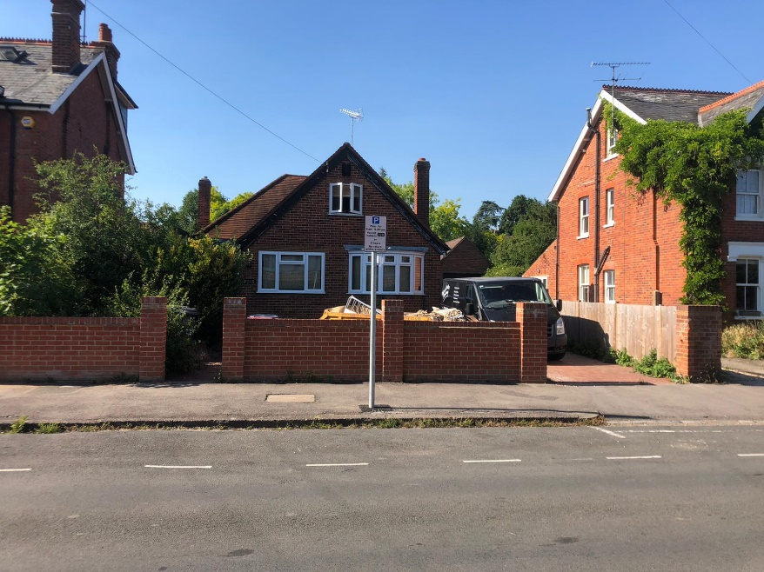
4.2 To achieve parking standards set out by the Council, each property requires two parking spaces therefore the proposed design achieves compliance with current planning guidelines. The proposed design also aims to reinstate a landscaped area to the front of both properties as to reinstate some foliage to a residential street.
4.3 Refuse will be placed by the entrance to the site, It will be collected from the road which meets with the criteria of the local authorities refuse collection guidelines and in accordance with current collection schedules.
5. Disabled Access
5.1 The proposed application is designed to comply with all current requirements for disabled bodies to access the site with or without a vehicle.
5.2 The dwelling will have a level threshold at the front and rear doors and the staircase will be fully compliant with Part M of the building regulations. In addition the will be a level threshold at the plot entrance to ensure easy disability access to the site.
6. Landscaping
6.1 The proposed development will be landscaped (in accordance with details to be approved by the LPA under condition once conditional approval has been granted). The current garden is very well established and the design look to maintain as much of that as possible with the plot being divided centrally.

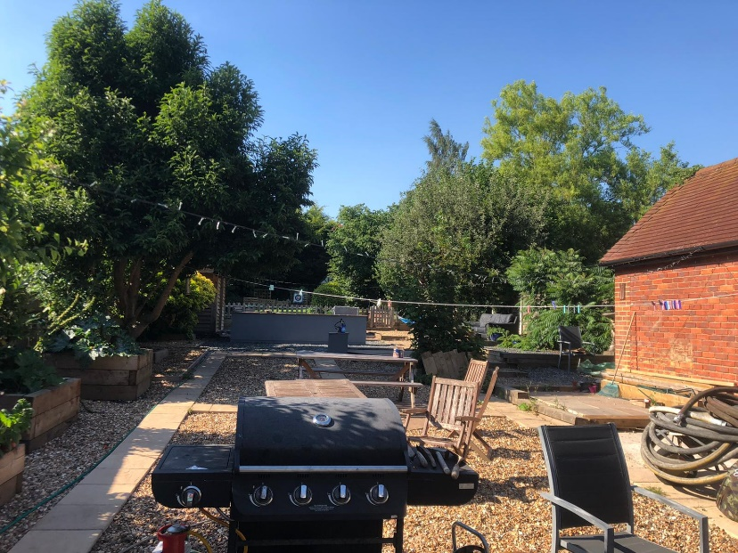
6.2 There are no Tree Preservation Orders (TPO) trees on this site, but during construction, any trees that have roots near the building zone will be protected with suitable fencing.
6.3 in addition trees will be planted in both the front and rear gardens to help maintain privacy and a natural environment that is conducive to family living.
7. Appearance
7.1 The appearance of the dwelling will complement the aesthetic values of the existing properties currently surrounding the site. Using a variety of finishes and materials to stay in keeping with the area. Such as red facing brick, stone cills and render. Please see examples below.
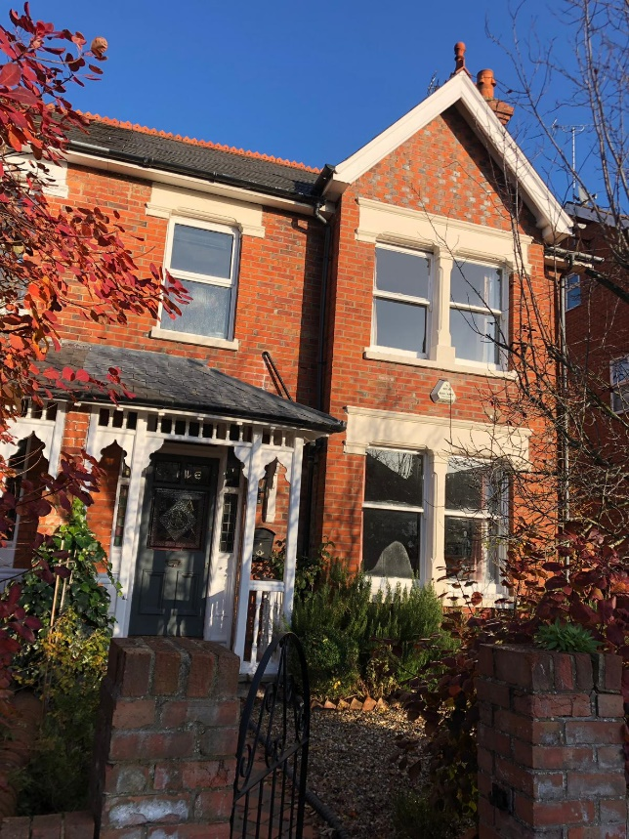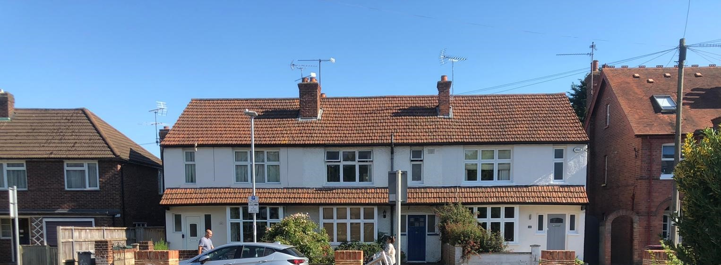
7.02 The materials and external finishes for the proposed dwelling will be chosen to match and harmonise with surrounding properties. These are subject to local authority approval and we are happy to liaise with the LPA to agree on external finishes and hard landscaping.
7.3 The owner has lived at this address for the duration of his life. It was his grandparent and parents home, He is looking to create much needed family accommodation in the area, which will only enhance the area and increase the family atmosphere in the street.
8. Section 106 Agreement & Affordable Housing
The applicant is happy to enter into a Section 106 agreement with a contribution being made towards affordable housing if legally required to. Once the valuations have been submitted negotiations can commence. Once LPA have submitted documentation this matter can be moved forward.
9. Conclusion
9.1 We believe that the proposed new dwellings provides an improvement to the local area and will enhance and create a more aesthetically pleasing street scene, as the current bungalow seems out of place surrounded by large detached and semi-detached houses with loft conversions. The bungalow was only originally constructed to meet the needs of Mr Berresfords aging grandparents and as the area has developed, it seems more and more out of character with the local environment and surrounding properties.

