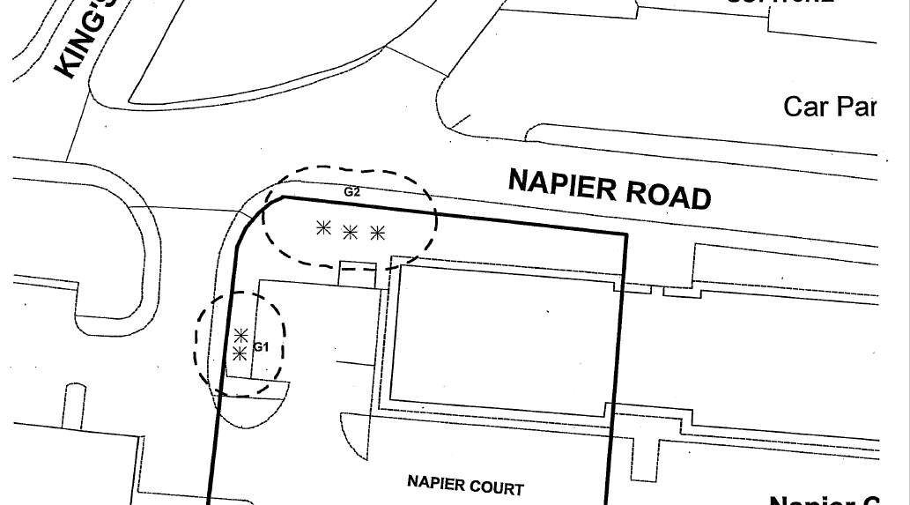

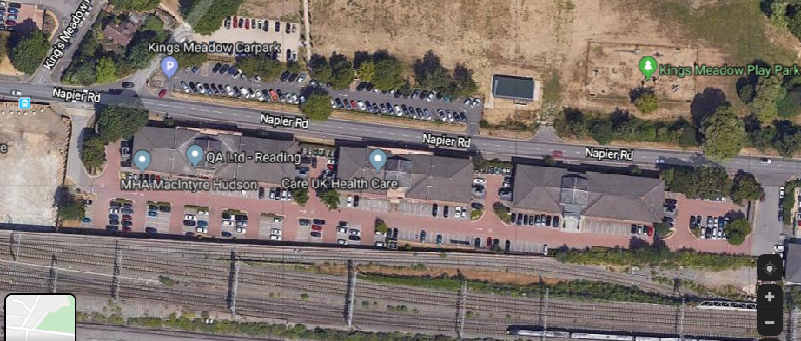
Protected trees – 5 Maple)
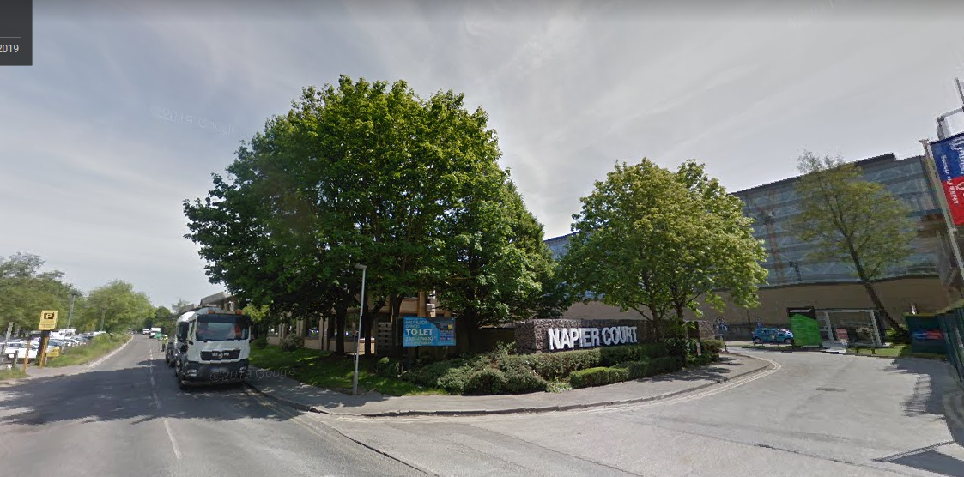

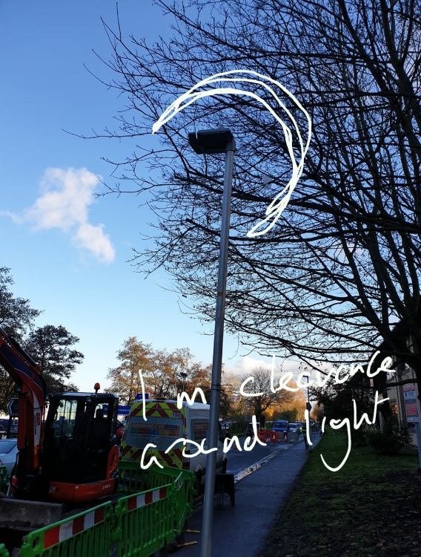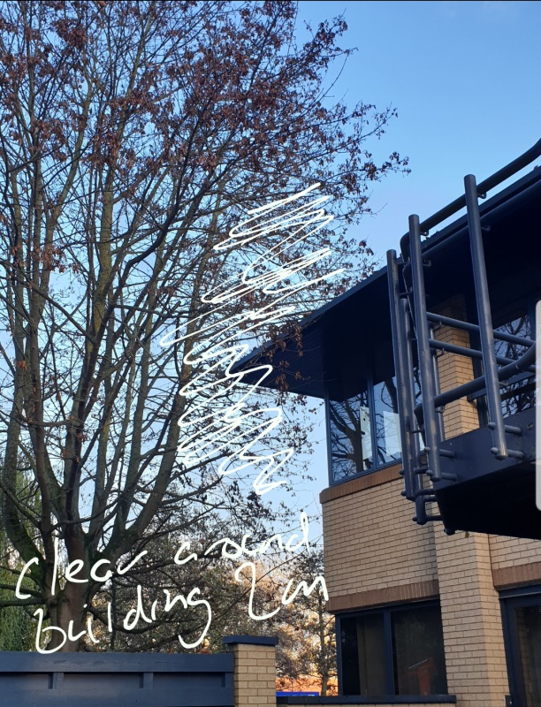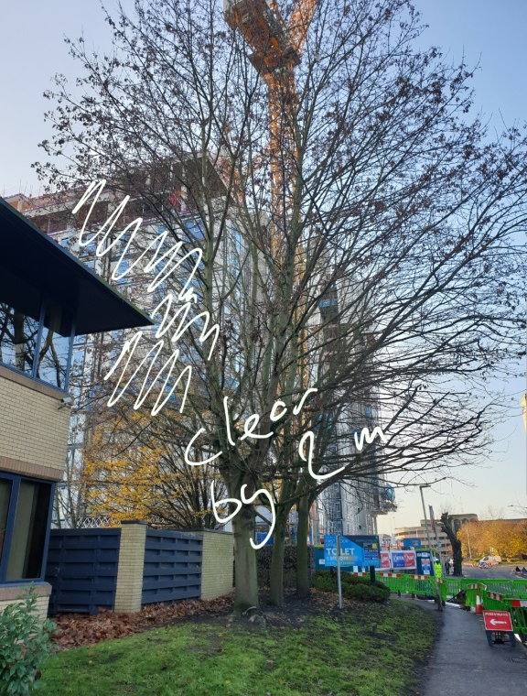
G2 proposed works:
- Prune to give 1m clearance from lamppost
- Prune to give 2m clearance from building
- Selective branch reduction to crown lift to ensure 5.5m over the road
- Remove dead wood
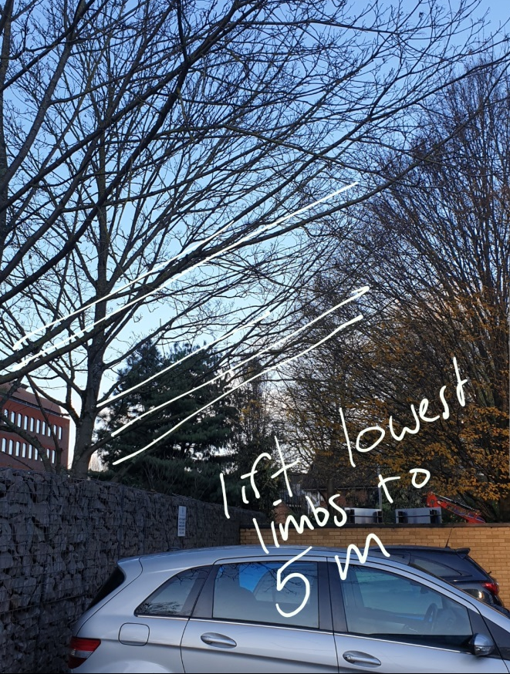
G1 proposed works:
Crown lift to 5m over the car park by removing lowest limbs indicated.

Napier Court
191856/TPO

