Maintenance Requirements

- Artificial Turf Pitch (ATP)
Testing:
On completion of construction, provision should be made to test the ATP to the FIH performance standards, in accordance with their requirements to accommodate match play and training, and then the Operator should commission subsequent testing every three years to ensure the facility remains fit for purpose.

It is the Operator’s responsibility to ensure maintenance measures and pitch usage comply with surface manufacturer warranty requirements.

Should the surface fail testing, rectification measures should be considered in consultation with the manufacturer and retesting undertaken. If these are impractical provision should be made by the Operator for turf replacement. This should be carried out as soon as possible. At time of writing a standard pitch resurface will take approximately 6 weeks.

During any given 12 months period

Please thoroughly read the attached Field Turf maintenance guide for the playing surface.

Copied below is the maintenance frequency table. Essentially, the operations in green can be undertaken by site Grounds Staff. The operations in red would be undertaken by a FieldTurf accredited maintenance company. S&C Slatter are able to offer this, as well as the machinery needed for routine maintenance by Grounds Staff.
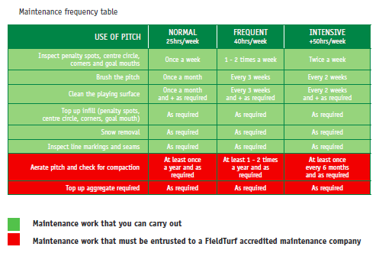
Specialist Maintenance Services
We also strongly recommend for quarterly visits to site to decompact the surface by a specialist such as S&C Slatter, weekly maintenance we assume shall be carried out by ‘Grounds Staff’. The de-compaction process ensures that the surface retains the FIH testing and is an important factor when maintaining artificial turf surfaces.

Lighting Maintenance
We can provide an annual lighting maintenance cost for the pitch.

- Natural Turf Pitch
Handover to 12 Months
Annual Maintenance
Given below are general outline maintenance procedures relating to annual maintenance and pitch renovation works required at the end of the season.

Cutting: Playing Area
During the playing season the pitches should be maintained with a height of cut of between 25 mm and 30 mm and during the summer months between 30 mm and 50 mm. The sward should not be allowed to grow beyond 60 mm between cuts. If growth has been excessive between cuts then the height of cut should be gradually lowered in stages of 5 mm -10 mm until the desired height is obtained. Grass clippings should either be removed or dispersed. Mowing should ideally be undertaken with cylinder mowers of either self propelled or towed gang units. There should be at least 6 blades in each cylinder and achieve at least 100 cuts per metre. If possible clippings should be removed. Alternatively rotary mowers are acceptable but the quality of cut will be reduced. Cutting direction should be alternated through 90 degrees between each cut. Generally the direction should follow the same line as the side or base lines of the pitches. If grass clippings are not removed then the frequency of cut should be sufficient to prevent the accumulation of dense grass clippings on the surface which would be detrimental to future grass growth.

Cutting: Other Areas
The off-pitch areas including banks should be maintained with a height of cut of no higher than 50 mm – 60 mm. Mowing should be undertaken using a suitable rotary or cylinder mower. The frequency of cut should be sufficient to prevent the accumulation of dense grass clippings on the surface which would be detrimental to future grass growth. Aeration The area should be aerated on an eight weekly basis using 13 mm solid tines at a spacing of 100 x 100 mm and to a minimum depth of 200 mm. This should be supplemented with shallow surface aeration using a suitable punch-action aerator fitted with micro-tines. The aeration equipment should not cause surface disruption or damage through wheel marking. Operations should be suspended in inclement weather conditions.

Fertiliser Applications
It is difficult to estimate the precise application requirements but the guidelines below may be useful and additional fertiliser applications should been included if necessary.

Autumn Fertiliser Applications
Apply an autumn fertiliser of no greater than 4% Nitrogen content at a rate of 35g/m2 . Phosphorus should be no greater than 6% and potassium 10%. Iron and Magnesium may be within the formulation. The equipment for application should be accurately calibrated and suitable to apply a uniform application. Fertiliser application should occur during late October and again in November with a low nitrogen slow release fertiliser. Cutting should not follow within two days. Ideally, fertilisation should occur prior to a forecasted period of rainfall.

Spring and Summer Fertiliser Applications
Apply a spring fertiliser of no greater than 12% Nitrogen content at a rate of 35g/m2 . Phosphorus should be no greater than 6% and potassium 10%. Iron and Magnesium may be within the formulation. Application should be as for Autumn application Fertiliser application should occur during late March and provisionally every six to eight weeks depending on sward health. Cutting should not follow within two days. Ideally, fertilisation should occur prior to a forecasted period of rainfall. Late Summer Fertiliser Application Apply a late summer fertiliser of no greater than 4% Nitrogen content at a rate of 35g/m2 . Phosphorus should be no greater than 6% and potassium 10%. Iron and Magnesium may be within the formulation. Application should be as for autumn application. Fertiliser application should occur during September and cutting should not follow within two days. Ideally, fertilisation should occur prior to a forecasted period of rainfall.

End of Season Pitch Renovations
During the end of season renovation period the following works should be undertaken sequentially. Scarification The playing surface should be scarified or lightly harrowed to remove any thatch accumulation. The maximum depth of scarification should be no more than 5 mm into the turf surface and the depth of thatch should not be allowed to exceed 5 mm.

Top dressing
The facility should be top-dressed with approved salt free medium fine sports turf sand ideally with a particle size distribution within the central recommended range of the Grading Curve; shown in Appendix 2. The selection of top-dressing materials should however take into account compatibility with existing materials used in the construction of the facility. The dressings should be applied in dry weather and ground conditions in a uniform layer of no more than 10.0 mm deep from suitable top-dressing equipment. Any drain lines showing subsidence should be top-dressed level with a suitable approved top-dressing sand or tennis loam.

Verti-draining
The surface should be verti-drained using 19 mm solid tines set to penetrate at least 200 mm. The amount of heave should be as great as possible to prevent surface disruption. The site should be in a suitable condition to accept the level of tine penetration as above but not too soft that the equipment causes surface disruption from wheel marks. The verti-drain should be used to reduce hardness of the playing surface which should be between 35 g and 200 g when measured by the STRI method of test using a 0.5 kg Clegg Impact Hammer from a drop height of 0.55 m. Note: If the drainage properties of the facilities have deteriorated to a significant degree then consideration should be given to the installation of sand bands so long as a clean connection between the sand bands and the existing pipe and/or slit drains can be achieved.

Brushing and levelling
Following the application the top-dressing sand it should be thoroughly brushed into the grass surface and levelled using a lute which will help to work the top-dressing into the vertidrain tine holes. Levelling should be progressive and a target surface evenness should be within 20 mm deviation along a 3.0 m straight edge. Overseeding The playing surface should be over-seeded at a rate of 20 g/m2 using suitable equipment.

Fertiliser Application
Apply a Spring fertiliser of no greater than 12 % Nitrogen content at a rate of 35g/m2 . Phosphorus should be no greater than 6 % and potassium 10 %. Iron and Magnesium may be within the formulation. The chosen fertiliser should be approved and based on annual topsoil nutrient status analysis. The equipment for application should be accurately calibrated and suitable to apply a uniform application. Fertiliser application should occur during late April or early May and cutting should not follow within two days. Ideally, fertilisation should occur prior to a forecasted period of rainfall.

Weed & Pest Control
The need for weed control should be assessed and a selective turf herbicide applied to the surface if required. Ideally the playing surface should be maintained so that broadleaved weed does not exceed 10 %. Application should use suitable low drift equipment and by a certified operator. A risk assessment and spray records should be made. Application should be undertaken only in ideal conditions and once a threshold level of weeds has been identified. Application should only be made during active weed growth and at time to prevent exposure to the site users and general public to the herbicide. Users are required by law to take all reasonable precautions when using pesticides to protect the health of human beings, creatures and the environment. Advice on how to meet their responsibilities under this legislation is given in the statutory Code of Practice for Using Plant Protection Products. This is available on the Health & Safety Executive website together with other relevant guidance and regulations. The need for pest control should also be assessed and if required the appropriate pesticide applied. The use, supply, storage and advertisement of pesticides are regulated by a number of pieces of legislation including, for Great Britain, the Control of Pesticides Regulations (COPR) and Plant Protection Products Regulations (PPPR). PPPR is the newer legislation and implements a European Directive (91/414/EEC) which regulates ‘Plant Protection Products’, these include agricultural pesticides and growth regulators. The use of pesticides is also regulated by COSHH (the Control of Substances Hazardous to Health).

After 12 month Period – Repeat.

Equipment Required for Maintenance

Maintenance Machinery for In-House Maintenance for ATP
We can undertake the provision of a maintenance tractor with associated equipment which (with appropriate use) will help maximise the performance and lifetime of the facility.

We propose the John Deere unit (as shown below) with drag brush.

At only 117cm high, 145cm wide and 176cm long the drive unit is extremely manoeuvrable and fits most standard housings.
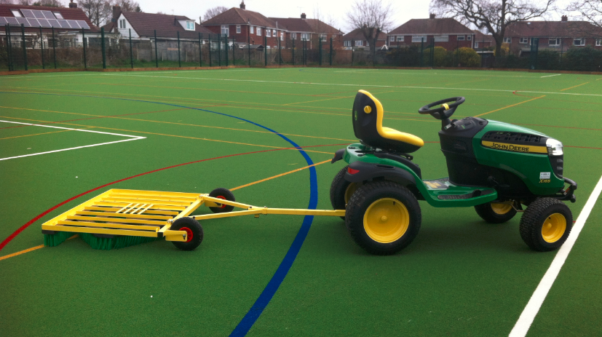

Hand-held Maintenance Equipment
For routine maintenance a leaf blower and simple jet washer are routine pieces of equipment. A backpack sprayer to administer algae and weed control may also be useful.

Natural Turf Pitches – Turf Equipment
Presented below is a list of maintenance equipment. This is presented as a general guide and the amount and type of equipment required will depend on a number of factors, such as experience of grounds team – access to shared equipment.

Depending on the experience and budget, it may be more economical to hire in certain equipment required to undertake infrequent tasks, such as verti-draining and top-dressing. The equipment procured should however be kept in good condition be adequately maintained.

- Three gang cylinder mower with verti-cutters and clipping collectors or rotary mower.
- Tractor with grass tyres – 40 - 60 hp
- Tractor with grass tyres – 30 - 40 hp
- Equipment for grooming, raking and light rolling.
- Slitter Punch action aerator with micro-tines
- Scarifier with collector
- Sweeper collector
- Fertiliser spreader
- Top-dresser
- Verti-drain
- Trailer
- Strimmers
- Brush
- Light roller Sprayers /Line marking equipment
- Storage areas for equipment and materials including fertilisers, sands and chemicals
- Personal protective and first aid equipment
- Chemsafe storage box
- Hand equipment, including rakes, forks, spades, buckets etc…

Equipment Training:
We take a proactive approach as to the requirements of maintenance in the short and long term. Our submittal includes for the training of the required maintenance equipment to IOG level 1 in artificial turf and natural sportsturf maintenance.

