Design and Access Statement / Grove Barn, Old Barn Close, Emmer Green, Reading, RG4 8QY

I purchased this Grade II listed barn in November 2018. The survey undertaken by Countrywide identified that the wood on several of the window frames was beginning to rot, and would need replacement.

In 2019, I engaged the Sash Window Company (in Bracknell) to manufacture and install four replacement windows. Reading Borough Council granted listed building consent for that work, application 191293, on the 22 October 2019.

A year later, I have identified that four more windows could benefit from being replaced, due to deterioration. I will again be using the Sash Window Company.

As was the case in 2019, the current window frames and glass will be replaced with identical ones. The following paragraphs are identical to my previous Design and Access Statement, but they remain valid to this application.

The new frames will be constructed exactly the same as the current ones. They will protrude no further out than the current ones and will be the same colour. The replacement window frames will be made of Accoya timber, which is more durable than the current wood - which is good for the long term maintenance of the barn. Visually, any observer will not be able to identify that any changes have taken place.

The walls of the barn, which the window frames are built into, comprise of weather boarding, as can be seen from the photo submitted. Failure to address the window issue may result in water penetration that could potentially impact on the weather boarding too. Clearly, it is necessary to replace the windows subject to the rot to prevent any other deterioration, and to preserve the good condition of the barn generally.

Photos

Photo 1 – Lounge window to be replaced

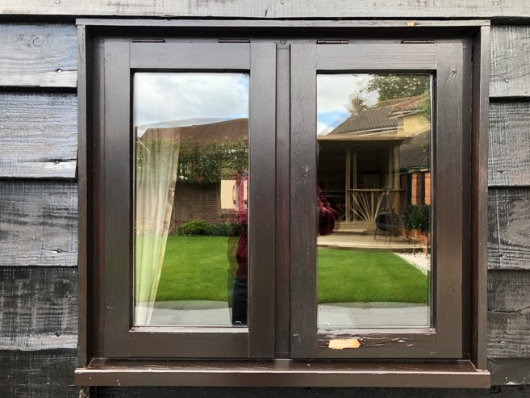

Photo 2 – Lounge window adjacent to photo 1 to be replaced

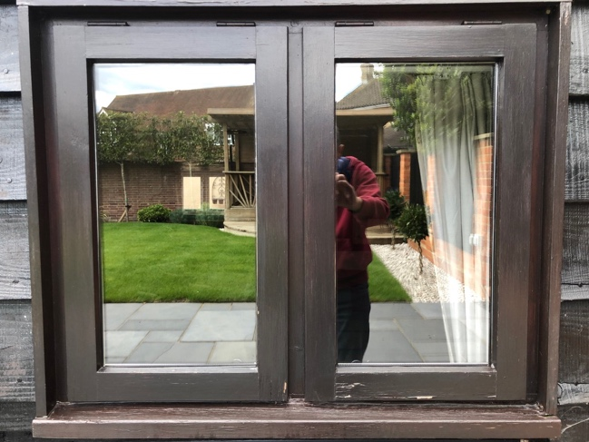

Photo 3 – Room above Garage to be replaced

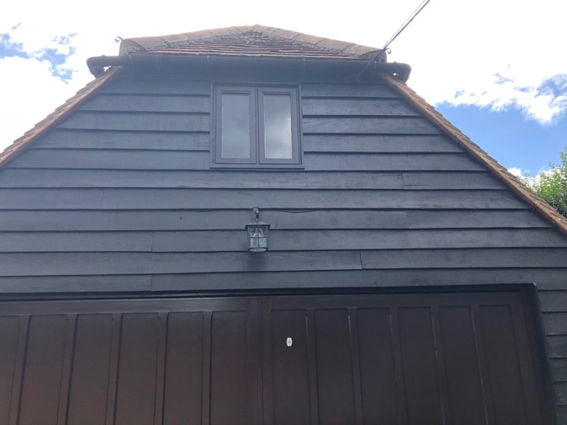

Photo 4 – Cloakroom window to be replaced

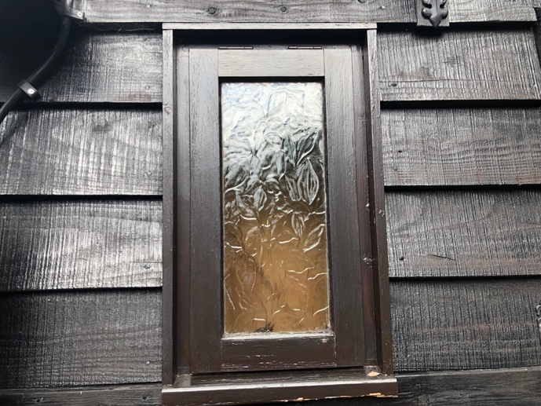

Photo 5 – Kitchen window replaced as part of the 2019 works, provided for comparison purposes

