DELEGATED HOUSEHOLDER APPLICATION REPORT
Ward: Tilehurst
App Ref: 200464/FUL
Address: 3 Old Elm Drive, Tilehurst
Case Officer: Richard Eatough
Applicant: Mr and Mrs Furgeson
Date received (valid from): 16/3/20 Target Decision date: 11/5/20

1. INTRODUCTION
Old Elm Drive is a private road. Similar properties along it, although No. 3 is currently very discreet at the end. No. 16 Tyle Road is adjacent to the property (to its NW) and has a back-to-front relationship with the present bungalow. Site and surroundings are flat.

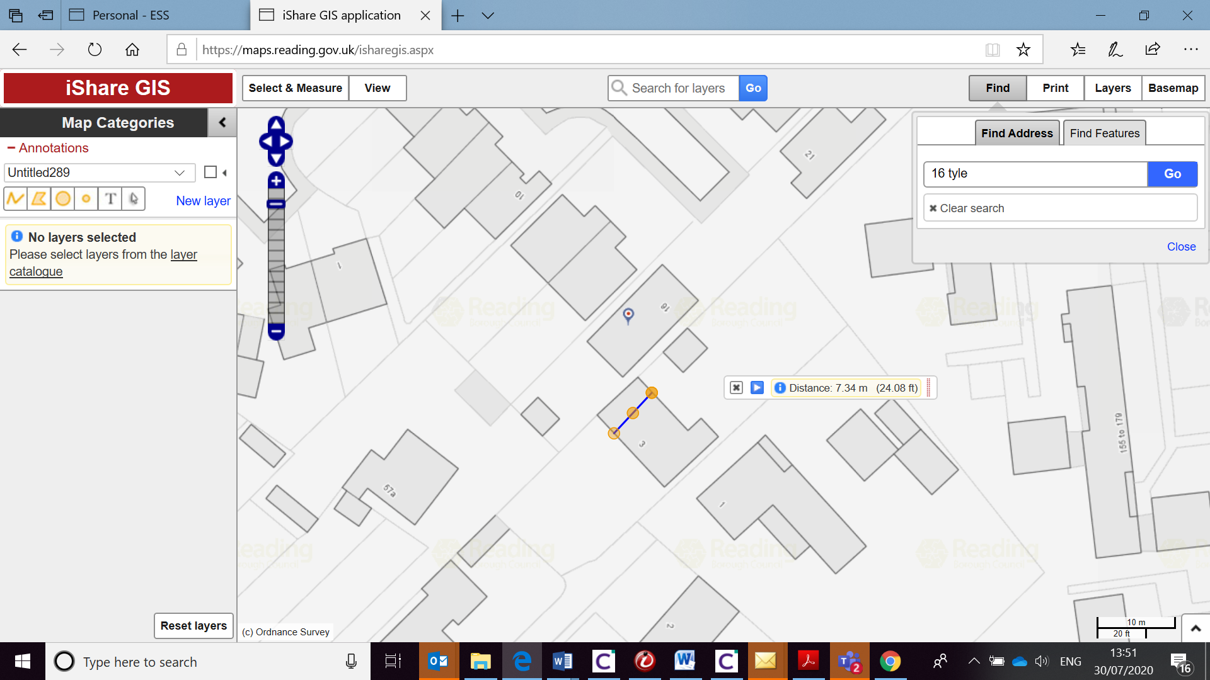

Property is presently a modest 2-bed bungalow, probably 1950s. Brick with interlocking tile roof, regular transverse pitch, ends are a hip and a half-hip. Single, flat roof garage is attached to side, up to boundary. Enclosed back garden, 1.8 fencing to sides. Front garden is entirely tarmac with an apple tree. Side approaches to front and back gardens. Rear garden approach (side gate) appears to be over No.1’s land.

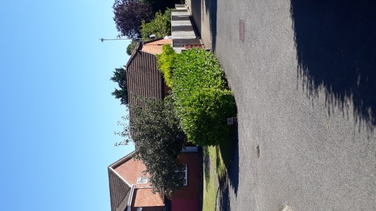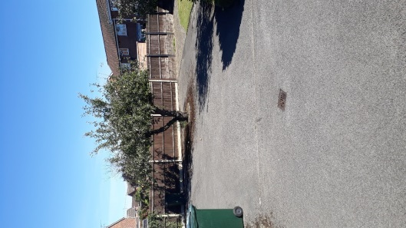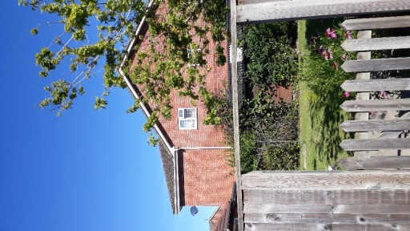

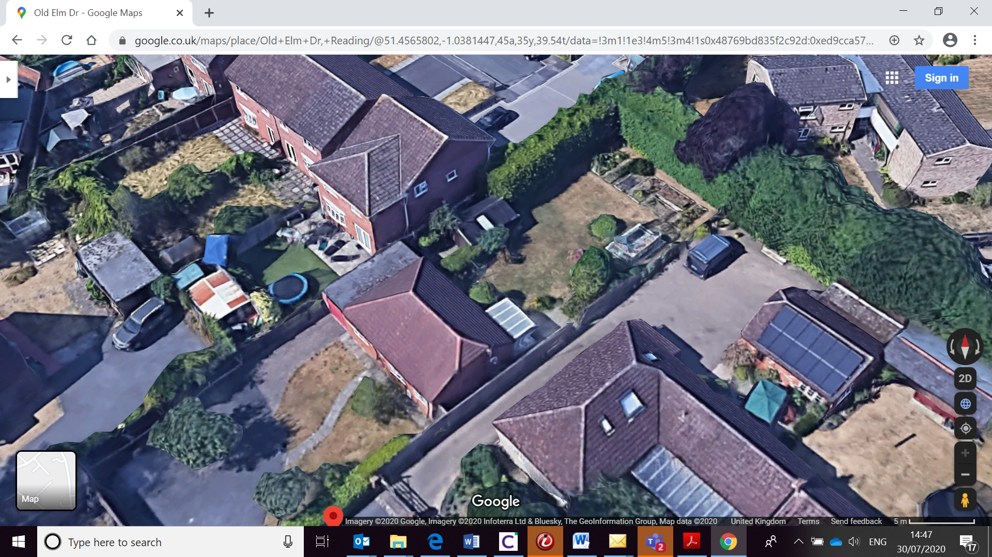

2. PROPOSAL AND SUPPORTING INFORMATION
Various alterations and additions including first floor extension to bungalow and erection of garage/car port.
Proposal is twofold:

Plans considered ‘Alterations & Additions’ ref. 19…4…6 dated on RBC system: 23/3/2020

The CIL form confirms that the additional floorspace created will be below 100sq.m for not liable for payment.

- RELEVANT PLANNING HISTORY

192047/HOU Part one, part two storey extension and erection of garage/car port WITHDRAWN 17/4/20

4. CONSULTATIONS

4.1 The following addresses were consulted by letter:

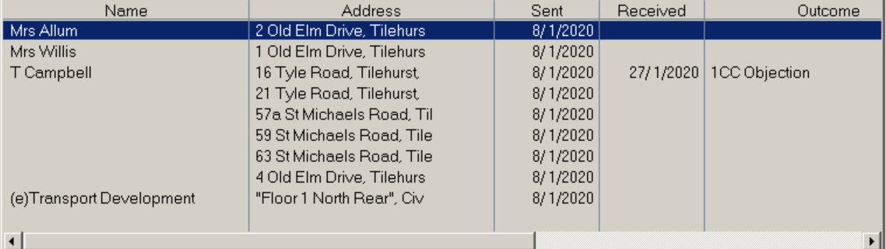

4.2 One letter of representation has been received, raising the following issues:

- Object to a bungalow being turned into a two storey house affecting the private use of adjacent garden
- Object to proposals encroaching closer to adjacent property with the removal of the garage.
- Concerned for windows be able to be opened and have unrestricted views adjacent back garden.
- Not considered to be in keeping of the area as the plots are bungalows not two story houses.
Equality Act 2010:
In determining this application the Council is required to have regard to its obligations under the Equality Act 2010. However, there is no indication or evidence (including from consultation on the application) that the protected groups identified by the Act have or will have different needs, experiences, issues and priorities in relation to this particular planning application. Therefore in terms of the key equalities protected characteristics it is considered there would be no significant adverse impacts as a result of the development.

- LEGAL AND PLANNING POLICY CONTEXT

Section 38(6) of the Planning and Compulsory Purchase Act 2004 requires that proposals be determined in accordance with the development plan unless material considerations indicate otherwise. Material considerations include relevant policies in the National Planning Policy framework (NPPF) - among them the 'presumption in favour of sustainable development'. The following local and national planning policy and guidance is relevant to this application:

National Policy
National Planning Policy Framework
National Planning Practice Guidance

Reading Borough Local Plan (2019)
CC7 (Design and the Public Realm)
CC8 (Safeguarding Amenity)
H9 (House Extensions and Ancillary Accommodation)
Parking Stds policy and SPD are also relevant.

SPG/SPD
- A Design Guide to House Extensions SPG (2003)

6. APPRAISAL

H9 states: An extension to a house will be acceptable where it:

- Respects the character of the house in terms of scale, location, materials and design;

To assess this, the following has been considered – would the proposal:
- detract from the appearance of the original building through the use of ill-matching materials and by not fitting in with the design, scale and proportions of the original building; NO. First floor alterations and addition of dormers are an acceptable design response. 1 and 2 Old Elm Dr are bungalows, but No. 4 is a chalet bungalow. All properties are also a long way from the street view on St Michael’s Rd.
- reduce the amount of usable amenity space for the property to an unacceptable degree; NO
- require the loss of trees in the garden or put significant trees at risk; Loss of one x apple tree, but this is acceptable as replacements could be planted elsewhere.

- Respects the character and pattern of neighbouring properties and the street as a whole in terms of scale, location, materials and design, and any important existing building line; Respects neighbour’s amenities and does not present a large blank façade to public areas.

To assess this, the following has been considered – would the proposal:
- significantly reduce the amount of daylight and sunlight enjoyed by neighbouring properties; NO. In terms of impact on No. 1, main elements of proposals are some 8-10m distant to existing side window, which looks to be a kitchen. This house has other windows front and back in this area too. No. 3 has an obs glazed window at ff (bathroom) and what looks to be a secondary bedroom window. The pitches of the roof of the proposal lean away from this window, if indeed it were a habitable room and the proposal is unlikely to reduce light or outlook to this room to a harmful extent.
- invade the privacy of neighbouring properties through overlooking from windows or balconies; NO. new window to rear overlooks own private garden. New dormer to front would allow a very oblique view over rear garden of 16 Tyle Road, but this would otherwise be a normal domestic situation (if the houses weren’t facing opposite directions) and it would affect only the end of that garden anyway. 2x side dormers to WCs proposed, both will need to be approved with obscure glazing via condition.
- detract from the character of neighbouring properties through siting, excessive bulk, ill-matching materials or inconsistent design; NO. Semblance of bungalow retained. Design is suitable and relatively sympathetic. No one design style in the locality
- detract from the appearance of the street or area by using ill-matched materials, glazing and detailing; NO. Matching materials condition suggested.

CC8: Safeguarding Amenity states an extension to a house will be acceptable where it will not cause a significant detrimental impact to the living environment of existing or new residential properties.

To assess this, the following has been considered – would the proposal cause a significant detrimental impact to the living environment of existing or new residential properties in terms of:

- Privacy and overlooking; covered above
- Access to sunlight and daylight; NO.
- Visual dominance and overbearing effects of a development; NO. Rear bedroom of 16 Tyle Rd would see the new development at first floor at approx. 45 degrees. Given hipped roof forms, not considered to be detrimental to that property.
- Noise and disturbance; NO
- Artificial lighting; NO
- Vibration; NO
- Dust and fumes; NO
- Smell; NO
- Crime and safety. NO

- CONCLUSION
Carport/garage: would involve the loss of the fruit tree, which is regrettable, but space within the site to plant replacement(s). Spaces produced would actually be undersized, but given remaining space available for parking, the Highway Authority does not object. In design terms, this is a relatively sympathetic structure, does not harm any surrounding amenity and there is no obvious pattern of development constraint to its siting.

Extensions: in terms of design, the works are suitable. There would be no appreciable harm to No. 1’s amenity. There would be a minor effect on the amenity of 16 Tyle Road via the presence of the proposal, but not to an extent that privacy, amenity or unacceptable overbearing would occur.

Proposals involve works to roof, but this is not an old property and in a medium-density suburban area and no risk to bats is identified. A standard informative can be used.

The proposed development has been assessed and the proposed works are considered to be in accordance with the above relevant policies and planning permission can be granted.

RECOMMENDATION:
GRANT planning permission, subject to conditions.

