Design and Access statement- Listed building consent: 55 Brunswick Street Reading
I am requesting permission to replace the communal front door of the property (55 Brunswick Street) due to the current door’s state of disrepair. As the owner of one of the properties within the building I believe that the existing door (pictured) is no longer fit for purpose as it has become rotten, ill-fitting and allows damp into the interior of the building. There is also a safety issue as I believe the combination of disrepair and a missing letterbox makes the property and it’s occupents unneccasarily vunerable.
I contacted Reading Borough council with my concerns last year asking for advice on how to proceed and received a response from Anthony Scholes on 12/09/19 recommending finding a like for like replacement in terms of material and style. Following this recommendation I have searched and found a like for like wooden door from another heritage property which I believe is fit for purpose and inkeeping with the style of the building (pictured below).

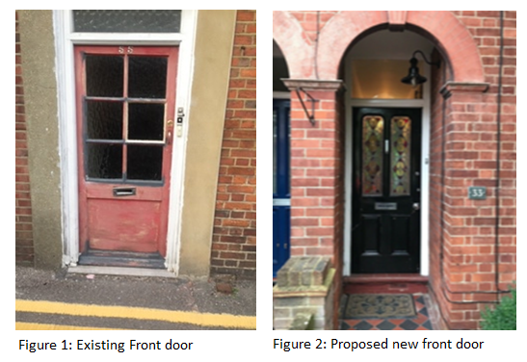
Heritage Statement
The property is registered on the Historic England site as BRUNSWICK STREET 1. 5128 Nos 49 to 55 (odd) (The Brunswick Arms) SU 7072 13/32 II 2. Mid to late C18. Former terrace cut down and altered. 2½ storeys. Red brick with blue brick band over ground floor. Brick block eaves cornice. Mansard old tile roof with 2 brick stacks. 3 dormers (2 are glazing bar sashes). A narrow panel of silver grey bricks and 2 tripartite windows, a further panel and another window on 1st floor, glazing bar sashes. Segmental heads to ground floor openings (altered). Royal Insurance Mark to right of inn sign. The site lies within a conservation area on a one way street.
The planned work is to upgrade the front door to access both flats. Whilst the property has been the subject of some external maintenance work i.e. replacement of the sash windows under a planning approval dating back to 2010, the property is in general need of some maintenance externally.
The upper floor windows have been repainted. The front door is not an original, it is poor quality and is in a very poor state of repair. The proposed replacement is far more in keeping with the property and will be painted in either grey or red to compliment the other front doors at 51 and 53 that front the property.
On completion, these works will significantly improve and restore this Heritage Asset.

