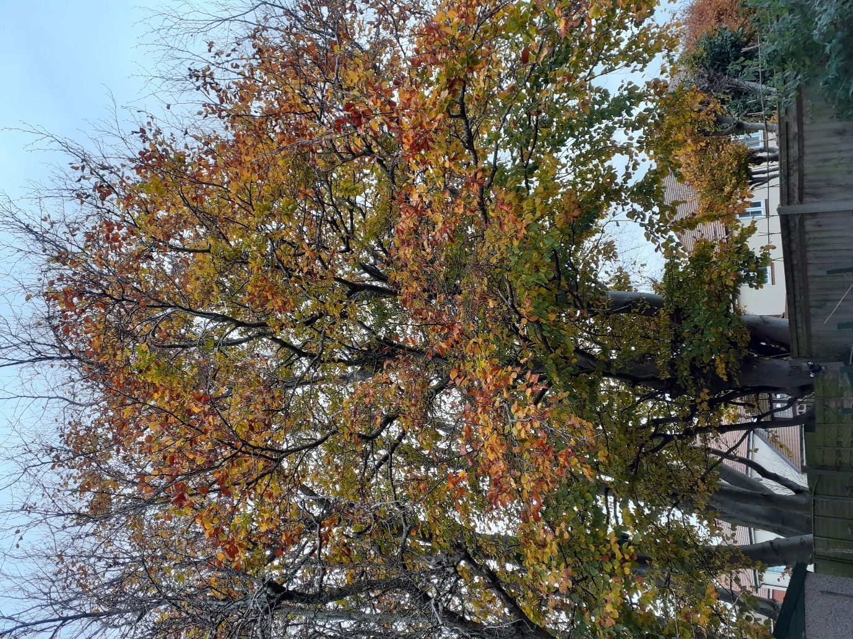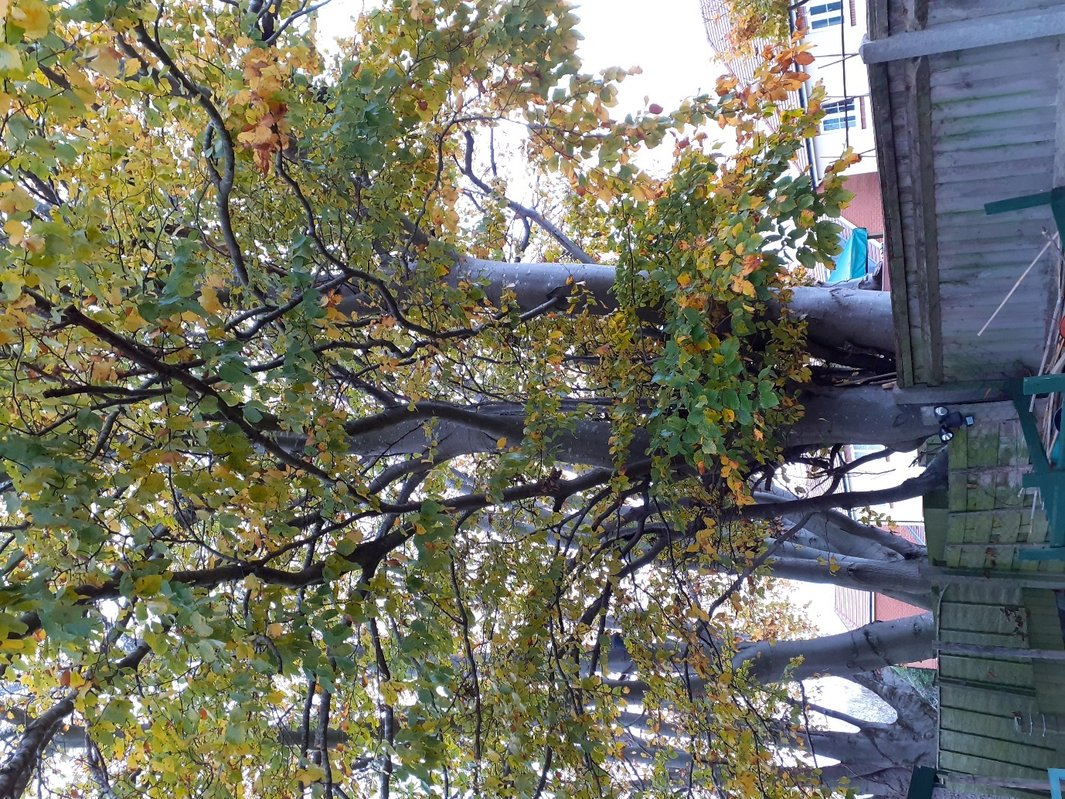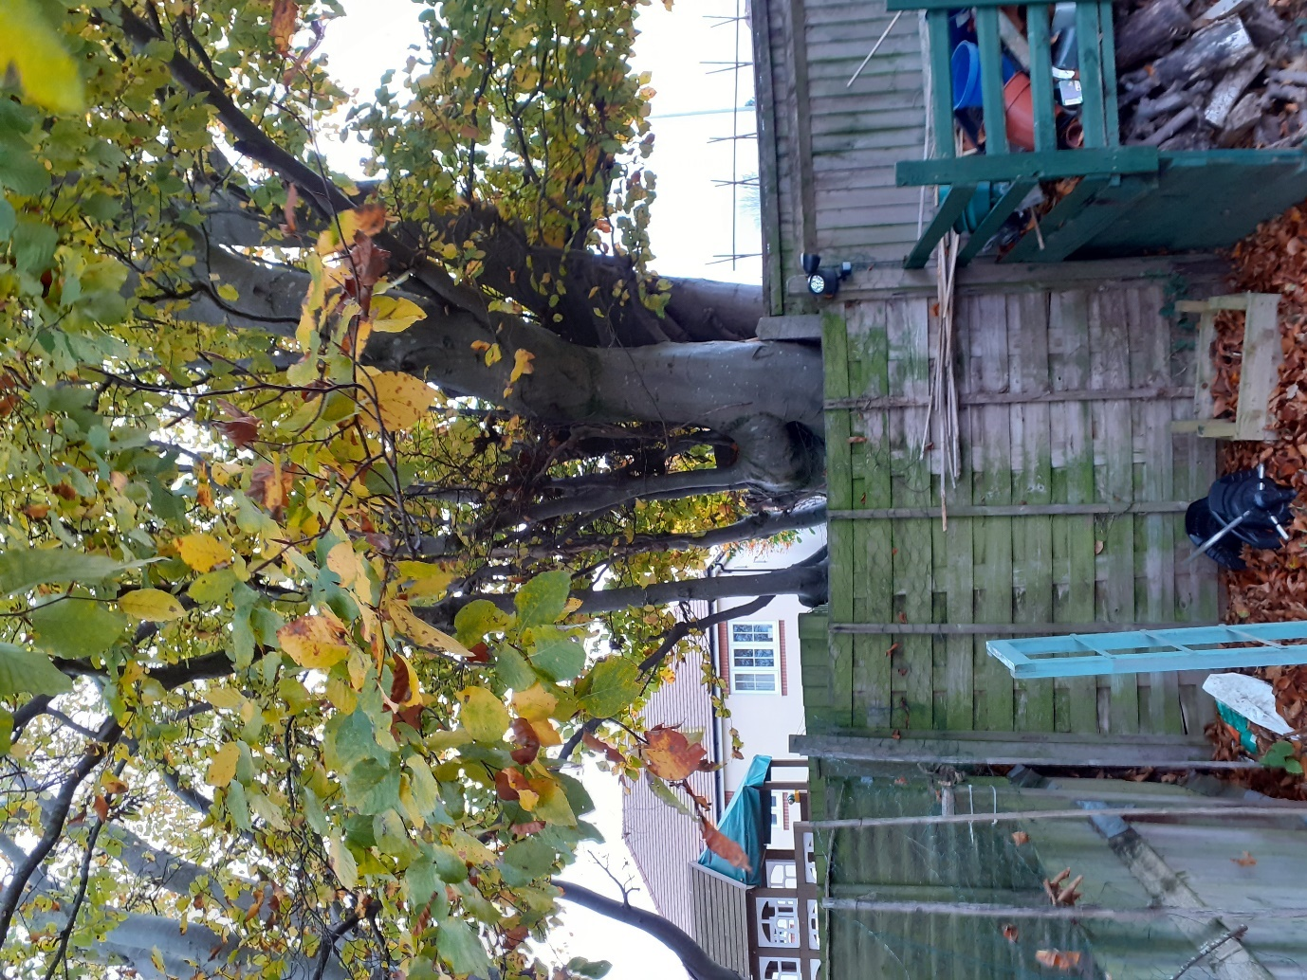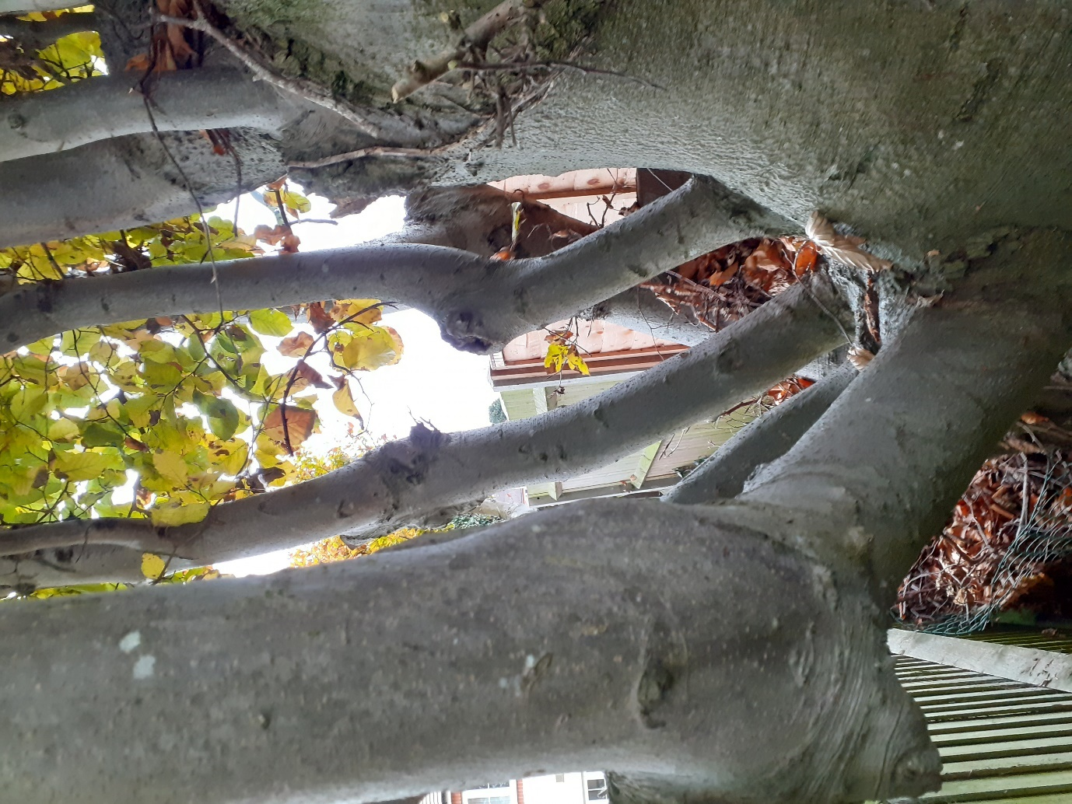
Crown lift both main stems over the garden of 160 Westwood Road including the branches indicated (up to the height of the higher branch)
Main, low branch to be removed
Low, main branch to be removed

Beech r/o 160 Westwood Road
11/11/20
2011488/TPO

