memo

To: Giles Sutton
From: Alex Powell (RPS Group)
Date: 16th November 2020
Re: Planning application ref: 200734
Address: 19 Ogmore Close, Tilehurst, Reading RG30 4SX
Description: Erection of a single dwelling with associated parking and amenity space.

In review of the comments to the ecology report, a response is provided illustrating how the construction of a single dwelling within an already developed area would not have a significant detrimental impact on the woodland.

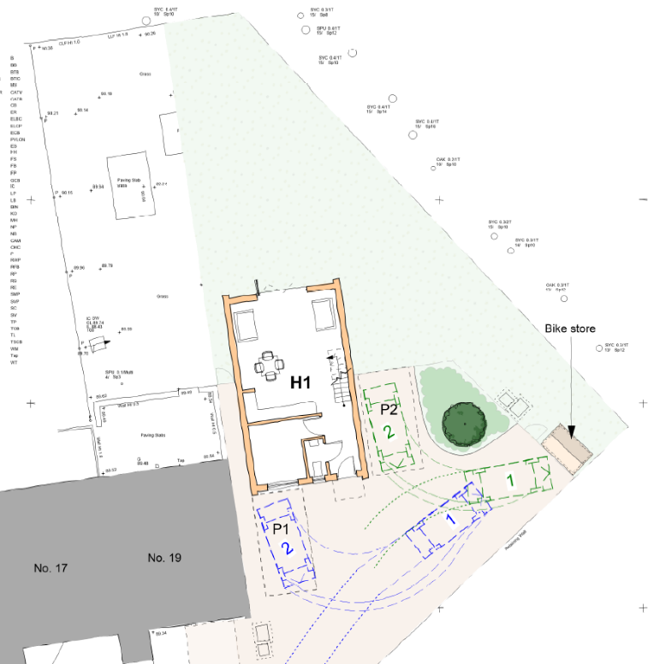

Conservation Status
Reference is made to Natural England’s Standing Advice which is relevant to ancient woodland, ancient trees and veteran trees (Forestry Commission and Natural England, 2018). The guidance is therefore not relevant to this application as the woodland at Blundell’s Copse is not ancient woodland and there are no ancient or veteran trees within close proximity. The need for a 15m semi-natural buffer therefore does not apply to this application.
Blundell’s Copse is a Local Nature Reserve (LNR) and Local Wildlife Site (LWS) and the woodland qualifies as a priority habitat. The applicant is committed to ensuring the proposed development of a single dwelling would not significantly effect the conservation status or biodiversity value of the woodland and would comply with policy Para 174 of the NPPF and policies EN12 and EN14 in the 2019 Reading Borough Local Plan.
The proposed development is located along Ogmore Road, a road comprising eight properties that already border the woodland. In addition, neighbouring roads; Teviot Road and Thicket Road have approximately 30 additional properties bordering the woodland.
Given that the existing pressures of being in close proximity to a suburban area have not significantly impacted the woodland’s conservation status or biodiversity value, the addition of one property is very unlikely to have a significant effect. Particularly when the proposal is located within the existing suburban area and does not result in the loss of previously undeveloped land.

Further details are provided below in response to the comments received.
Reducing the amount of semi-natural habitats next to the woodland
The comment reads:
‘’An established garden is a semi natural habitat that provides an important buffer zone to the woodland…
Furthermore, the proposals will result in the loss of two groups of trees, which although (according to the tree report) are of limited arboricultural merit, they are an important part of the buffer of semi natural habitat adjacent to the woodland.’’
Where an established garden may be semi-natural habitat and provide a buffer zone to adjacent habitats, the garden within 19 Ogmore Close consists mainly of species poor lawn with a few scattered trees consisting of willow Salix cinerea and Lawson cypress Cupressus lawsoniana, which is a non-native species. The garden is therefore of minimal ecological value. A 6ft wooden fence runs along the boundary between the garden and woodland which limits any buffer effect the garden may possess.
The proposed plan also shows the majority of the garden will be retained as grass. However, some native species planting will be introduced in the car parking area to replace the lost trees. The proposals would result in a smaller area of garden being present but the introduction of native species would provide a higher value semi-natural habitat than that already present. In addition, the provision of a biodiverse roof would compensate for the loss of some of the lawn by providing an alternative habitat of at least equal value.
The comment reads:
‘’…although a green roof is proposed (it should be noted that the applicant has not provided any convincing evidence that a green roof would be successful – it will only receive limited sunlight for example) this would still be a significant area of new artificial habitat directly adjacent to the woodland.’’
The green roof will provide greater biodiversity to the footprint of the project. The roof of the proposed building will not be overshadowed by the woodland which is situated to its north west, even so biodiverse roofs are suited to both full and partial sun.
Although biodiverse roofs are artificial, the woodland is situated in an urban environment and the majority of the surrounding habitat is also artificial. The addition of a green roof increases the biodiversity within the proposed development. Biodiverse roofs have a long flowering period and provide an excellent source of nectar for invertebrates.
It should be noted that details of a possible green roof solution have been submitted to RBC in response to comments received from their Ecological advisors. These covered green systems manufactured by Bauder for both an intensive and an extensive biodiverse roof system. Unfortunately, no response to these submissions have been received.
The comment reads:
‘’ The provision of the bat loft (the only reference to the bat loft appears to be a dotted box on the side/ east elevation and the likelihood of such a small loft being used seems minimal – also how will the bats enter the loft if there is a sealed green roof??)’’
The current development has no potential for bats and limited potential for nesting birds. The proposal to install bird boxes and a bat loft significantly increases the potential habitat for these species within the development footprint.
The creation of the green roof will have no impact on the bats entering the loft as the bat loft can be designed with specialised entrances to work around the biodiverse roof. ‘Bat roost creation opportunities in Greater London’ (Waite 2005), illustrates bat loft design (figure 2) and varying designed entrances (figure 1) into bat lofts. Regardless of the green roof the bat loft can be designed with access points into the loft via the Soffit boxes and gable end of the roof.

Increasing the amount of built form adjacent to the woodland resulting in overshadowing
The comment reads:
‘’ The site is orientated east west and the woodland edge, including the garden, will therefore receive morning sunlight (despite the fence and particularly when the trees are not in leaf). The new development will result in an increase in shading adjacent to the woodland (i.e. the semi-natural garden habitat next to the woodland) and an increase in shading inside the woodland. Over the winter, when the sun is in the south, this shading will likely extend to the north.
This will have an adverse impact on the woodland, for example in spring before the trees have come into leaf, when the ground flora on the woodland floor grows. It will also change the microclimate and could affect other groups such as invertebrates.’’
It is unlikely that the proposed building will provide additional significant overshadowing to the woodland as the existing 6ft fence along the garden boundary already completely overshadows the ground flora within the adjacent woodland boundary. In addition to this the woodland located adjacent to the building is of a lower condition with the ground flora consisting of mainly bramble which is already likely to outcompete spring flowering plants.
The overshadowing within the garden will not negatively impact the biodiversity, in fact on the contrary the shaded garden will mimic the light levels within the woodland and create habitat suitable for that of woodland species, which will be planted as part of the landscape proposals. Many north facing gardens are designed around that of woodland planting with ferns and other woodland foliage. This will in turn create a better buffer zone than the existing garden.

Increasing the amount of light and noise pollution
The comment reads:
‘’The proposals will almost certainly significantly increase light and noise into the woodland. There are side windows facing the woodland and the new owners are very likely to want to have external lighting. As the garden is smaller any external lighting would be closer to the woodland. The owners may use the side of the house as an access to the rear for example and may want to install security lights…
Lighting has been shown to have adverse impacts on many species, including bats, birds and invertebrates, and recent studies suggest that light pollution may be one of the causes behind a very significant reduction in invertebrate abundance and diversity1 over the last 20 years. As the adjacent woodland is likely to support these species the proposals will have an adverse impact upon them.’’
The majority of the woodland is surrounded by residential buildings, with residential buildings either side of the proposed development. Wildlife within the woodland will already be acclimatised to low levels of light spill from these building. The addition of a single dwelling within the already developed surrounding will result in a negligible increase in the overall levels of artificial light and have minimal impact on wildlife. In addition, the potential increase in light levels from security lights will be short term and insignificant as security lights are generally on sensors and turn on for short periods of time. Given the very small area that would be affected and the negligible increase in background light, this will not have a significant impact on the woodland.

Increased disturbance to wildlife
The comment reads:
‘’The proposals will clearly result in more human activity next to the woodland and hence disturbance to the woodland and its wildlife.’’
As there is currently already a garden next to the woodland the level of activity within the garden from the development is likely to remain the same.
The increased footfall from a single dwelling is not significant enough to cause a detrimental impact on the woodland. The woodland is within an urban environment and is already subject to heavy use with well-worn paths throughout the woodland.

Increasing in damaging activities like fly tipping
The comment reads:
‘’The proposals, as a result of their being an additional household, will almost certainly increase the likelihood of fly tipping and the cumulative effect of this with the other proprieties is a serious consideration. The argument appears to be that because the other houses fly tip then when (if) the new one does then this is somehow acceptable.’’
Fly tipping is a concern that is already affecting the condition of the woodland, however this is a subjective argument, one could equally argue that houses surrounding the woodland are less likely to fly tip in their own back yards and as the contents of the fly tipping were mainly building materials that it is equally likely to come from outside the immediate area and not from the residents themselves.

Introduction of non-native species from the garden
The comment reads:
‘’The council has no way of controlling what people plant in their gardens. The garden at present is a lawn. It would be quite feasible for owners of the new house to plant a garden with non-native species and as this is a new house the developer may well employ a landscape company to plant a variety of non-native plants.
There is a risk that there will be an increase in non-native plants in the woodland as a result of the development. This would have an adverse impact upon the woodland.’’
Non-native ornamental species were identified around the boundaries of the woodland to the north. The gardens here in many cases had no fences and backed directly onto the woodland. It was here that the garden species were found to be within the woodland. However, this was isolated to the immediate boundary to the woodland and were not identified within the wider woodland. In addition, with gardens that were fenced off, no garden escapes were found and therefore it is likely that the 6ft fence will act as a barrier to dispersal of garden species.
The developer will provide new planting within the car parking area that will comprise of native planting, no invasive species will be used that could spread into the woodland.

Summary
The comments against the proposal do not consider the scale of the development in relation to the woodland and the very small length of woodland boundary the proposal adjoins and in many cases are opinion based. The proposed development will have no significant detrimental effect to the adjacent woodland due to the measures that have been designed into the proposals and because of the very small length of woodland boundary affected. On the contrary the enhancement proposed will increase the biodiversity within the immediate area and provide suitable habitat for both bat and bird species, of which the existing development currently has no potential.

References
Forestry Commission and Natural England (2018). Ancient woodland, ancient trees and veteran trees: protecting them from development, [https://www.gov.uk/guidance/ancient-woodland-and-veteran-trees-protection-surveys-licences#avoid-impacts-reduce-mitigate-impacts-and-compensate-as-a-last-resort].

Mike Waite (2016). Bat roost creation opportunities in Greater London. Greater London Authority.

