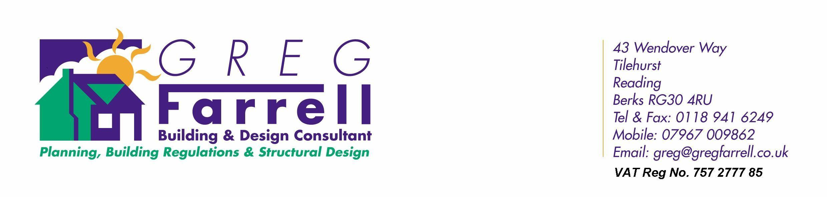

PLANNING STATEMENT

For: 124 and 126 Whitley Street, Reading, Berks, RG2 0EQ

Planning application numbers 201236/FUL and 201239/FUL

RELAVENT PLANNING POLICIES AND UPDATES

Policy CC7 and H9 of the Reading Borough Local Plan (2019).

The above revised drawings address the previous reasons for refusal in that the separation addresses the issue of scale and proportion and is in keeping with other dormers in the area. The dormer cheeks will be built with slate to match the existing roof so the proposal will now blend with the Location.

