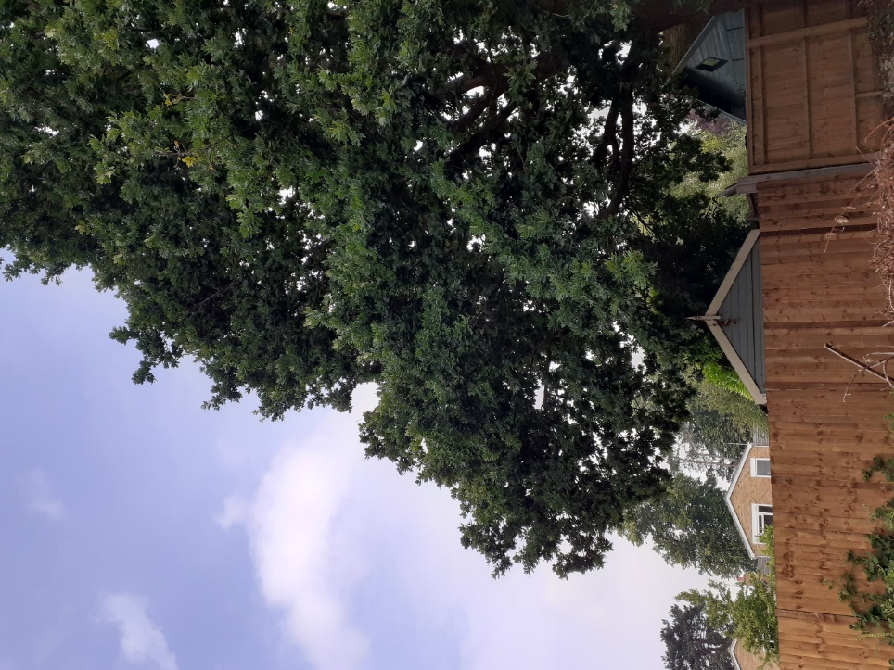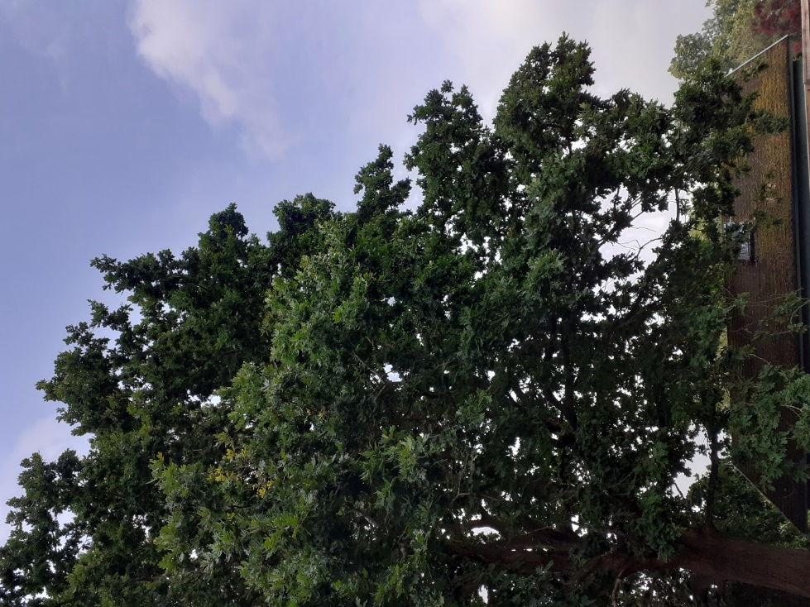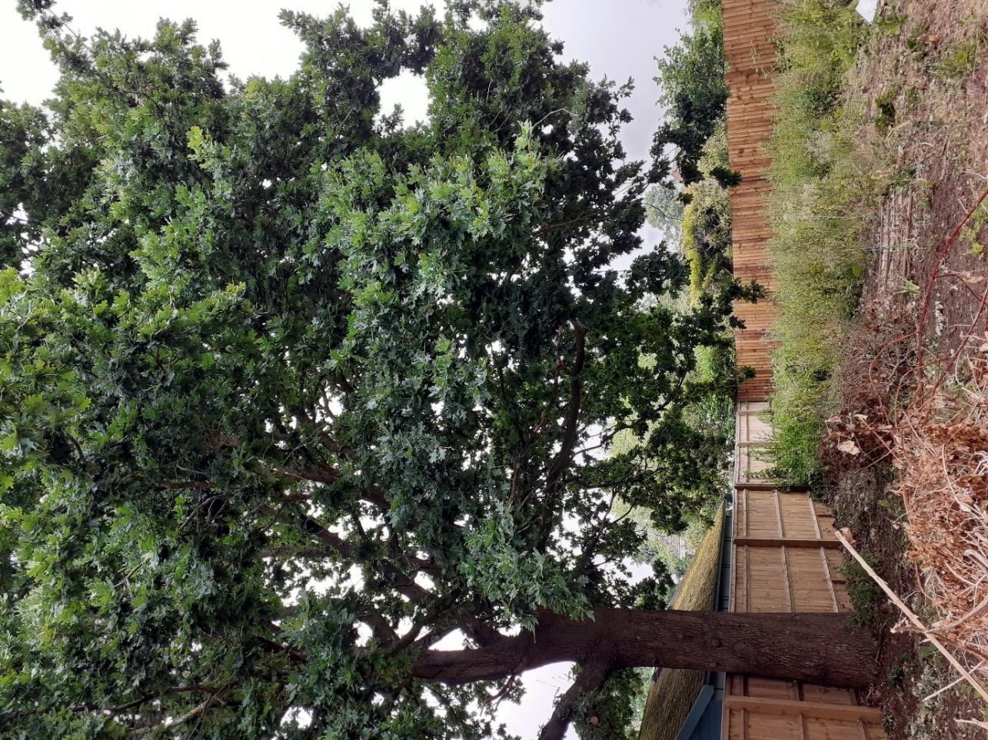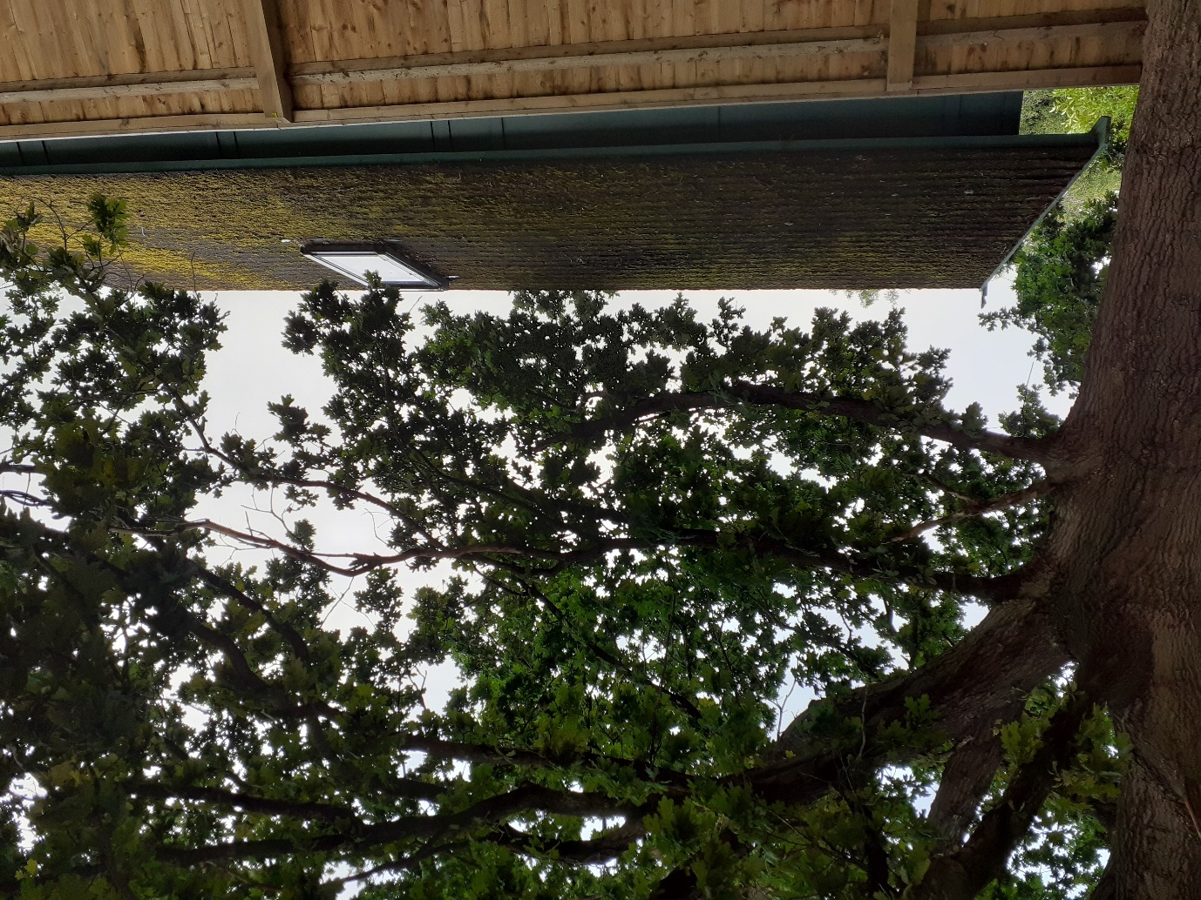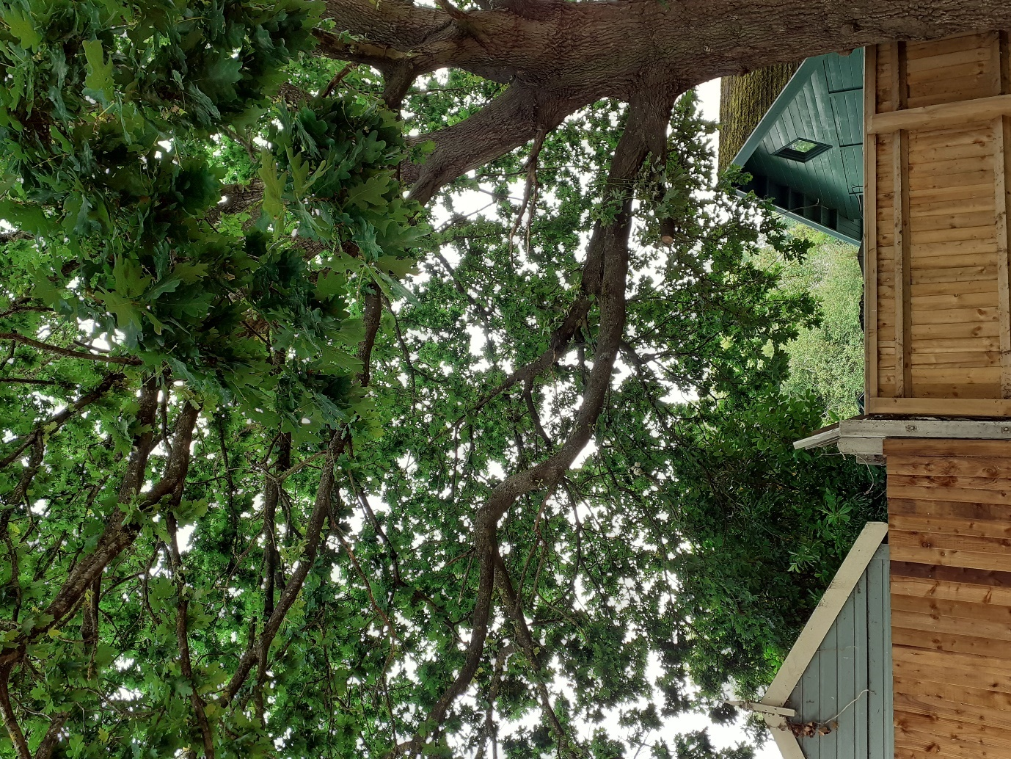
Indicative pruning to bring extended laterals into the main crown line on south-west (top) and north-east (bottom) side.
Crown lift over the garden to approx. 2m above fence height – secondary / minor growth only
Remove one low limb over shed at 10 Woodford Close, back to source and prune all other (minor/secondary/tertiary) branches to give 1-1.5m clearance from shed
Crown lift over the garden of 10 Woodford Close (if desired) to ridge height of shed

T4 Oak – 37 Richmond Road
200452/TPO

