DELEGATED APPLICATION REPORT - Application No.: 200252/FUL
Address: 85-87 Basingstoke Road
Proposal: Proposed ground floor windows on south elevation
Case officer: Alison Amoah
Target Expiry: 6/8/2020 (ext)

Site Description and Surrounding Area:
The vacant office building is located on the western side of Basingstoke Road in a mixed-use area. Prior approval was granted for 23 flats under ref: 190358.

It is not within a Conservation Area nor a listed building.

Proposal:
The amended scheme is for 3 no. ground floor windows on the rear (eastern elevation – facing 2 Winchester Road)
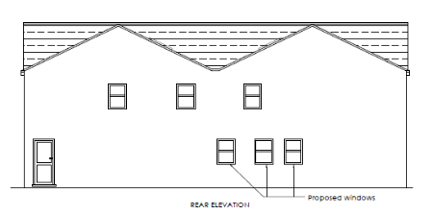
Discussion with agent:
The original elevation showed windows further back on the elevation, but Officers raised concern over additional loss of privacy for the rear garden of no 2. Winchester Road. An aerial photo was used to establish this, but a site visit was not possible due to Covid-19 restrictions.

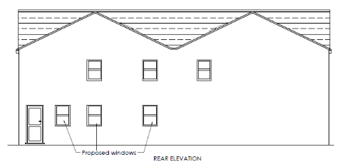
Original submission

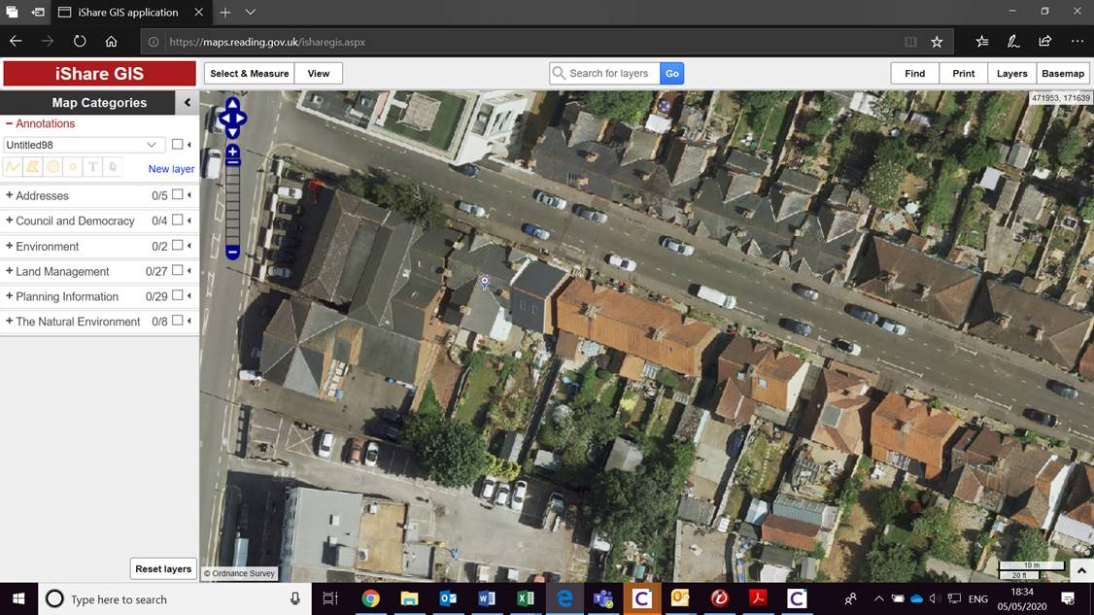

The amended plans showed the windows further forwards towards Winchester Road. As the proposed windows would then be right on the boundary with no. 2 Winchester Road and facing a blank elevation, and a side way serving that property, is was agreed with the agent that the windows could only serve as ventilation for future flats and would need to be conditioned to be obscure glazed, with any opening above 1.7m above floor level and inward opening.

Plans and documents considered:
As received 18th February 2020:
- Proposed Block Plan – Drawing no: 143 Rev P1
- Proposed Ground Floor Plan – Drawing no: 141 Rev P1
- Proposed Elevations - Drawing no 142 Rev P1

Amended as received 9th July 2020:
- Proposed Block Plan – Drawing no: 143 Rev P2
- Proposed Ground Floor Plan – Drawing no: 141 Rev P2
- Proposed Elevations - Drawing no 142 Rev P2

Relevant Planning History:
182091/PRIOR APPROVAL – Change of use of part ground, first and second floors from Class B1(a) (offices) to C3 (dwelling houses) to comprise of 17 flats. Prior Notification under Class O, Part 3 of Schedule 2 of the Town and Country Planning (General Permitted Development) Order 2015 - Prior Approval given 23/1/19
190358/PRIOR APPROVAL - Change of use of part ground, first and second floors from Class B1(a) (offices) to C3 (dwelling houses) to comprise of 23 flats. Prior Notification under Class O, Part 3 of Schedule 2 of the Town and Country Planning (General Permitted Development) Order 2015 – Prior Approval given 30/4/19
191036/FUL - Shutter replacement to window at ground floor to serve a C3 residential unit as granted under 190358 – Approved 23/12/19

Public Consultation Responses:
89-91 Wokingham Road, Flats 1-12 Katesgrove Court and no.2 Winchester Road were consulted. No comments were received.

Other consultation responses:
None.

Equality Act 2010:
In determining this application the Council is required to have regard to its obligations under the Equality Act 2010. In terms of the key equalities protected characteristics it is considered there would be no significant adverse impacts as a result of the development.

Relevant Planning Policy and Guidance:
Section 38(6) of the Planning and Compulsory Purchase Act 2004 requires that proposals be determined in accordance with the development plan unless material considerations indicate otherwise. Material considerations include relevant policies in the National Planning Policy framework (NPPF) - among them the 'presumption in favour of sustainable development'.

The following local and national planning policy and guidance is relevant to this application:

National Planning Policy Framework 2019
National Planning Guidance

Reading Borough Local Plan November 2019
Policy CC7: Design and the Public Realm
Policy CC8: Safeguarding Amenity

APPRAISAL:

The main issues to be considered are:
- Principle
- Design & appearance
- Impact on residential amenity

- Principle
The principle of three new windows for the existing office use or to serve the approved, but not yet implemented, conversion to residential as approved under ref: 190358, is considered acceptable.

- Design, Appearance & Scale
Policy CC7: Design requires all development to be of high design quality that maintains and enhances the character and appearance of the area of Reading in which it is located. The proposed windows are minor development, and are proposed to match existing windows and would therefore be acceptable.

- Impact on Residential Amenity
The proposed windows would be at ground floor and would provide windows for a future residential unit/s as approved under 190358. The amended scheme includes windows in the portion of building which is immediately adjacent to the existing side wall of no. 2 Winchester Road. Due to the relationship, a condition is included which limits these windows to being obscure glazed, with any opening section 1.7m above flor level and any opener being inward opening. This was confirmed as acceptable by the agent in an email 28th July 2020. Permitted development rights will also be removed so that any further windows or doors would require permission.

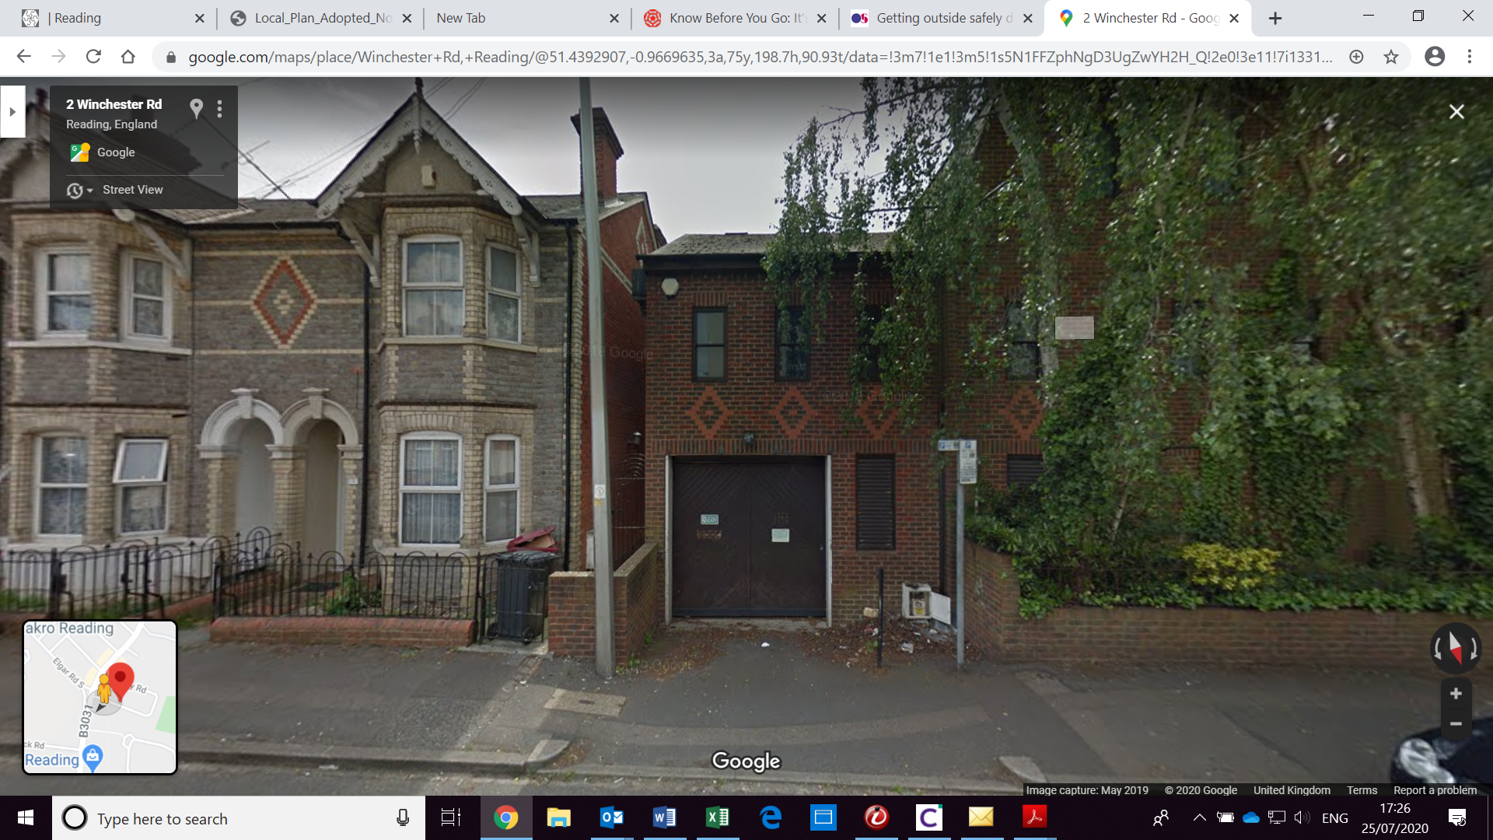

RECOMMENDATION:
APPROVE
Conditions:

- TL1 – Standard time limit
- AP1 – Approved plans–
- Windows to be obscure glazed with opening sections 1.7m above floor and inward opening
- PD for further windows and doors to be removed

Informatives:
IF5 - Terms & Conditions
IF6 – Building Control
Encroachment
IF1- Positive and proactive

